At Excelsior MAT we are starting our days with a short assembly in our bubbles. The aim is to serve an injection of hope each day for our children. We are now using the assembly videos in our bubbles each morning so that children at home access the same assembly as those in school. https://www.excelsiormat.org/pd-at-excelsior/agents-of-hope-assemblies
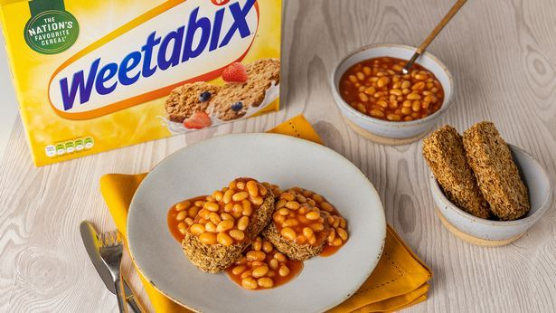
https://www.birminghammail.co.uk/whats-on/food-drink-news/police-weigh-weetabix-baked-beans-19803919

A few weeks ago, Weetabix went viral for tweeting this photo and asking, “Why should bread have all the fun, when there’s Weetabix?” They suggested people try beans on Weetabix rather than beans on toast.

Thousands of people joined in the debate and commented including West Midlands Police, who said, “We’ve been made aware of an ongoing incident taking place on the Weetabix twitter feed. We are working hard to understand what we are witnessing and we ask that people avoid the area indefinitely.”

West Yorkshire Police tweeted, “Even though this is criminal, please do not ring us to report it.”

The NHS added, “That tweet should come with a health warning”

- What is Weetabix?
- What do people usually add to Weetabix?
- Why do you think many people are so horrified at this advert?
- What would Weetabix and beans taste like? Would it work?
- Do you think the police were being serious about this ad being a crime?
- Why did the NHS say the picture was a health warning?
- Why do you think Weetabix tweeted this when there was such a negative response? (was the response negative for them?)
- What does this story tell us about people in the UK today and humour?
- Why do you think so many people joined in the humour, was anyone truly upset?
- What can we learn from Weetabix (be inventive, be brave, try new things)
- What can we learn from the police forces and from the NHS and their responses?
- What is this a story of hope? (because it shows people joining in and finding humour in little things to cheer each other up.)

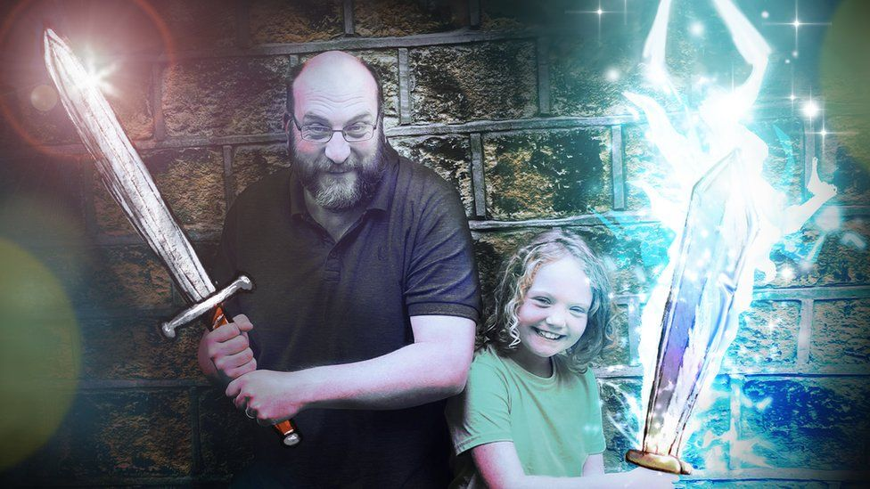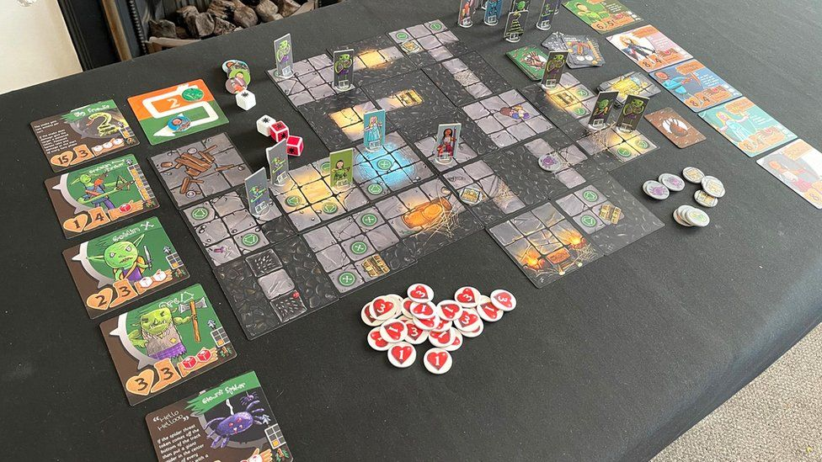
https://www.bbc.co.uk/news/uk-england-leeds-56013280

Cora Hughes and her dad live in Huddersfield. They became bored during lockdown last year and inbetween online lessons, they created a new adventure board game called Cora’s Quest on their kitchen table.

When they completed the game, Cora and her Dad likied it so much that they decided to try and make it properly so they started up a crowdfunding page to raise £12,000. The target was reached in 4 hours and currently they have £80,000 to set up the game, with over 2700 orders.

Cora said, “We did it because we were bored. Then we started to realise it was actually quite a good board game, so we wanted to share it with other people.”

In the game players fight their way through a dungeon facing different adventures along the way.

Cora and her Dad are happy that their game is a success but don’t want to become game-makers full time. Their next project is a lock down lego movie.

- What board games do you know?
- What ingredients do you think makes a good board game?
- Cora could have watched TV or played on a play station when she was bored, why do you think she created a board game?
- Why do you think so many people responded to the crowdfund?
- Cora and her Dad have had 2700 orders and made £80,000. Why don’t they make more games and become full time game designers?
- Cora is maing a lego movie next; what does this suggest about Cora (she likes to try new things, she wants to learn new skills)
- What can we learn from Cora and her Dad?
- Why is this a story of hope?

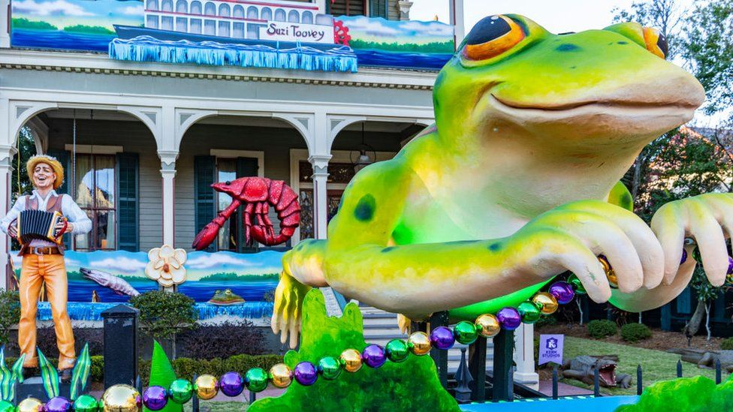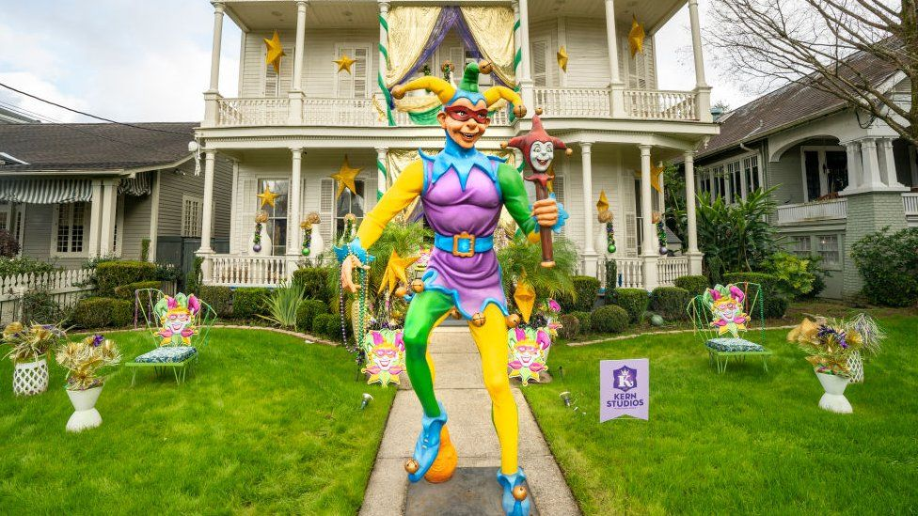
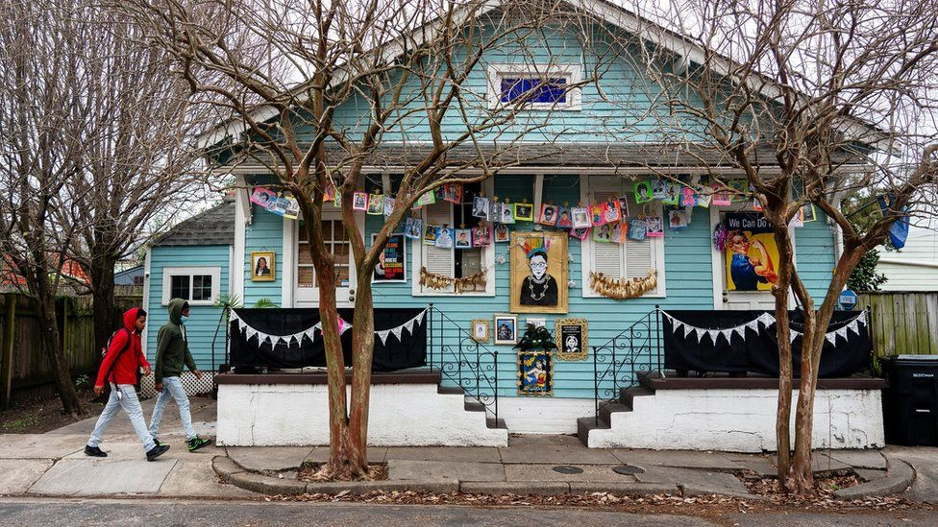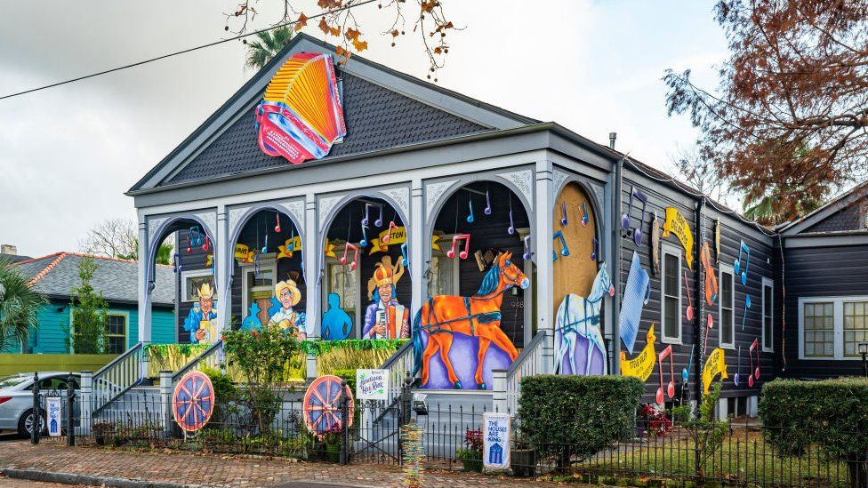
https://www.bbc.co.uk/news/world-us-canada-55835720

Every year people in New Orleans hold a Mardi Gras where streets are turned in to a huge party and floats parade through the city.

This year Covid has stopped the event but people in the town did not want to give up so instead they have decorated their houses. The city has produced a map of all the decorated houses and are encouraging people to go on (socially distant) walks to tour the area and visit them all.

After the Mayor announced the cancellation in November, carnival regular Megan Joy Boudreaux suggested to some friends on twitter that they should decorate houses instead. Megan said, “It doesn’t matter if your budget is zero and you’re recycling cardboard boxes or whether your budget is tens of thousands of dollars and you’ve got a mansion on St Charles. We want everyone who wants to do this to participate.”

Megan expected a few friends and neighbours to join in but by the end of January 9000 people had signed up, including people who didn’t live in New Orleans. People in the UK and in Australia also signed up.

- Where is New Orleans?
- What is a Mardi Gras?
- What sort of things do you think would be on the floats? (what is a float?)
- why do you think Megan decided to decorate her house and ask others to join in, they could have just cancelled Mardi Gras this year.
- why do you think so many people joined in?
- why does Megan say it doesn’t matter how much money you have or the kind of house you have?
- why is this an example of inclusion?
- Why did people who don’t even live in New Orleans join in?
- What does this show about people around the world during Covid?
- What can we learn from Megan and the people of New Orleans?
- why is this a story of hope?

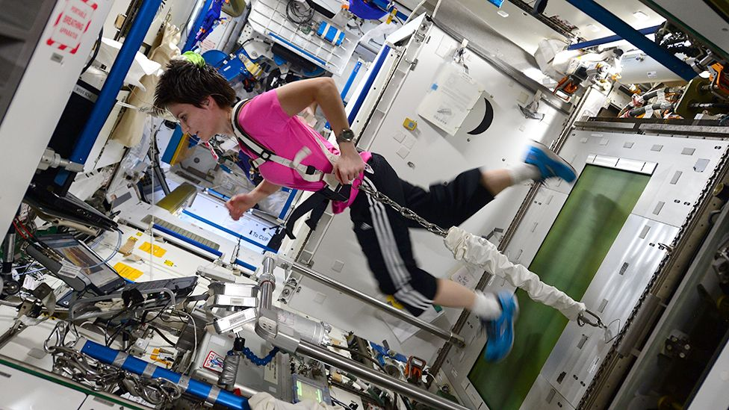
https://www.bbc.co.uk/news/science-environment-56072219
The European Space Agency is calling for new recruits to their astronaut training programme and for the first time they are asking for people with disabilities to apply. Previously people with disabilities were not allowed to apply.
Dr David Parker, director of human spaceflight programme says, “This is not about tokenism. We have to be able to justify to all the people who fund us – which is everybody including people who happen to be disabled – that what we’re doing is somehow meaningful to everybody.”
EAS recognises it needs to be better at diversity and inclusion. Currently only one of its astronauts is female (Samantha Cristoforetti pictured above) and they have only one female senior director. The last call for astronauts was in 2008 and then only 16% of applicants were female.
These are the things you need to apply to be an astronaut:
- A Masters Degree in Natural Sciences, Medicine, Engineering, Mathematics or Computer Sciences, or to be qualified as an experimental test pilot
- Fluent in English and a second language. You will also be taught Russian as part of the training because Russian is the other language used on the space station

Samantha says, “We did not evolve to go in to space so when it comes to space travel, we are all disabled. What brings us from being disabled to go to space to being able to go to space is just technology.”

- What is an astronaut?
- Why do you think in the past, so few women have been astronauts?
- Why is this changing today – what does this show us about ideas changing?
- What does inclusion mean?
- “This is not about tokenism” what is tokenism, what does Dr Parker mean by this statement?
- “What we are doing is meaningful to everyone” why?
- “We did not evolve to go in to space so when it comes to space travel, we are all disabled.” What does this mean?
- “What brings us from being disabled to go to space to being able to go to space is just technology.” What is Samantha saying about differences in people?
- What can we learn from the ESA?
- Why is this about No Outsiders?
- Why is this a story of hope?

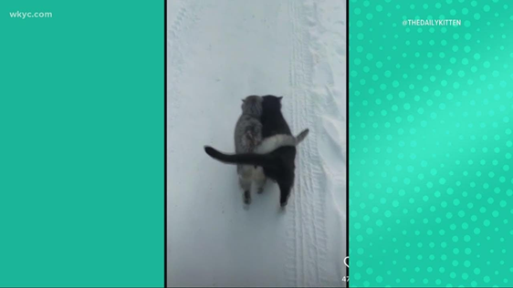

https://www.sapeople.com/2021/02/15/watch-happy-cats-walk-together-in-the-snow-original/

A video has gone viral in the last week showing two cats walking side by side with over 11 million views on tiktok, but there have also been disagreements on social media about the real story behind the video.

In the video we see two cats walking side by side, as though helping each other along.
https://www.youtube.com/watch?v=PM2wDKFRTEI

One explanation was that one cat was blind and the other was helping it along, however some people argued the cats were freezing because of the snow and were simply keeping each other warm.

But the real story behind the video appears to be much simpler. Annie from Ukraine has taken more videos of the two cats including some taken when the weather was warm. She says the simple reason why the cats are together is because they love each other.

- (before explaining the real reason) why do you think the cats are walking together?
- (give the reason) why do you think so many people thought there was another reason?
- Why do you think the video went viral so quickly?
- What does this show us about animals and humans?
- How does the video make you feel?
- Why do you think this video is so popular right now around the world?
- What can we learn from these two cats?
- Why is this a story of hope?

