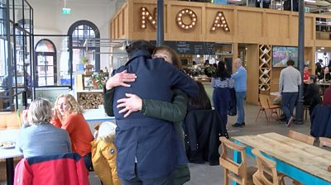
https://www.bbc.co.uk/news/av/world-europe-isle-of-man-55894179

The Isle of Man in the UK has come out of lockdown and the photo shows people meeting in a restaurant for the first time after months of lockdown. Things are getting back to normal.

The Isle of man has had 20 days without an unexplained Covid case so the government has eased restrictions there. Residents say Lock down was worth it, even though it has been really hard. One said that “having coffee with a friend is amazing.”

- What do you see in the picture?
- Whare is it, what is happening, how are people feeling?
- Why is this picture unusual today?
- Why has the government been able to end lockdown on the Isle of Man? Why is “20 days without an unexplained Covid case” significant?
- How do you think the residents of the Isle of man felt during lockdown, how do they feel now?
- Do you think residents used to feel lockdown would never end? What do they know now?
- What can we learn from the Isle of Man?
- Why is this a story of hope?

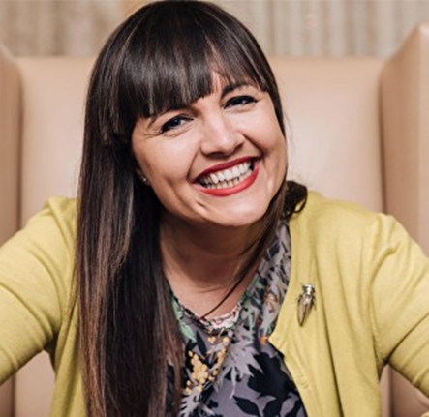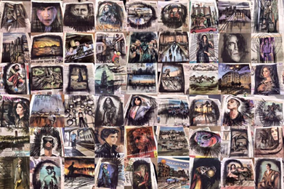
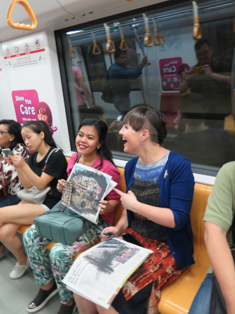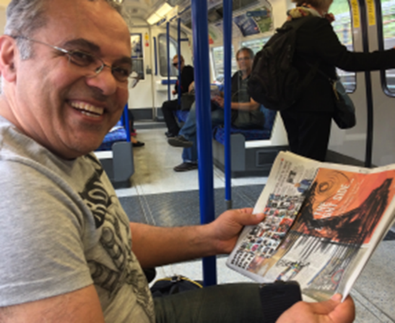

This is Liz Atkin, she is an artist living in London. Liz has given away 17,000 #compulsivecharcoal drawings on used newspapers as acts of kindness to commuters on public transport in London, New York, San Francisco, Singapore, Cologne and more.
Here Liz talks about how focusing on textures around her and creating art helps her to support anxiety and mental health. https://www.youtube.com/watch?v=uN9BEnTA6No

Liz says she photographs tiny detail and textures around her; “This scrutiny helps keep me in the moment. It’s mindful and soothing, slowing down my thoughts.”
“Next time you go out, cultivate a sense of awe for the tiny. Look up and look down, become a texture hunter gatherer wherever you are.”
“Art is a valuable tool for my recovery. Drawing has become one of the best ways to refocus my hands and calm tension and anxiety.”
- Where are the photos taken?
- How are people feeling, why do you think they are smiling?
- Why do you think the drawing help Lis to feel better?
- Why does she use used newspapers?
- Liz talks about scrutiny – what is scrutiny and how does it help to keep her ‘in the moment’ what does that mean?
- Liz asks for us to “cultivate a sense of awe for the tiny. Look up and look down, become a texture hunter gatherer wherever you are.” What does this mean?
- “Art is a valuable tool for my recovery” how?
- Could we become texture hunter gatherers to help our anxiety?
- How can we become texture hunter gatherers? How can we use the textures that we gather?
- What can we learn from Liz?
- Why is this a story of hope?

Below are some examples of texture boards. These show how we can all become texture hunter gatherers and use tiny details to create art and calm our anxiety.

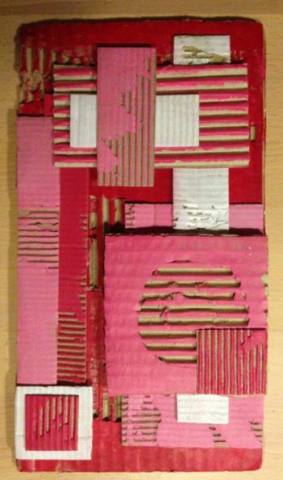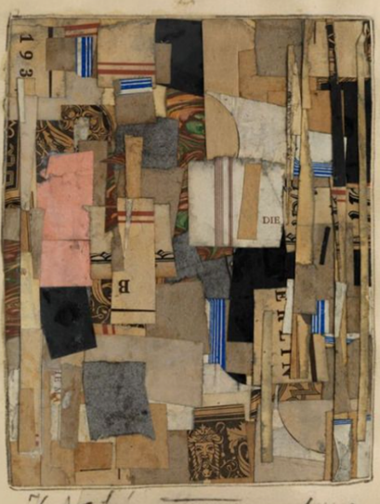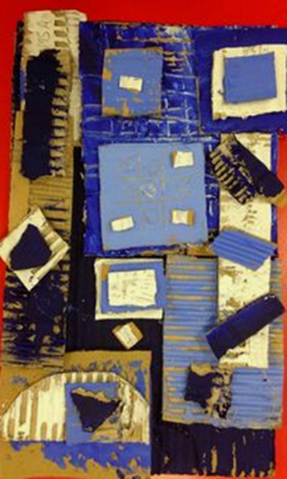

See this video lesson by Head Teacher David Wearing on “Texture Hunter Gatherers” art. Send photos of your art work to me by next Wednesday to be included in the Friday art video.
https://www.youtube.com/watch?v=ddfROamsLm0

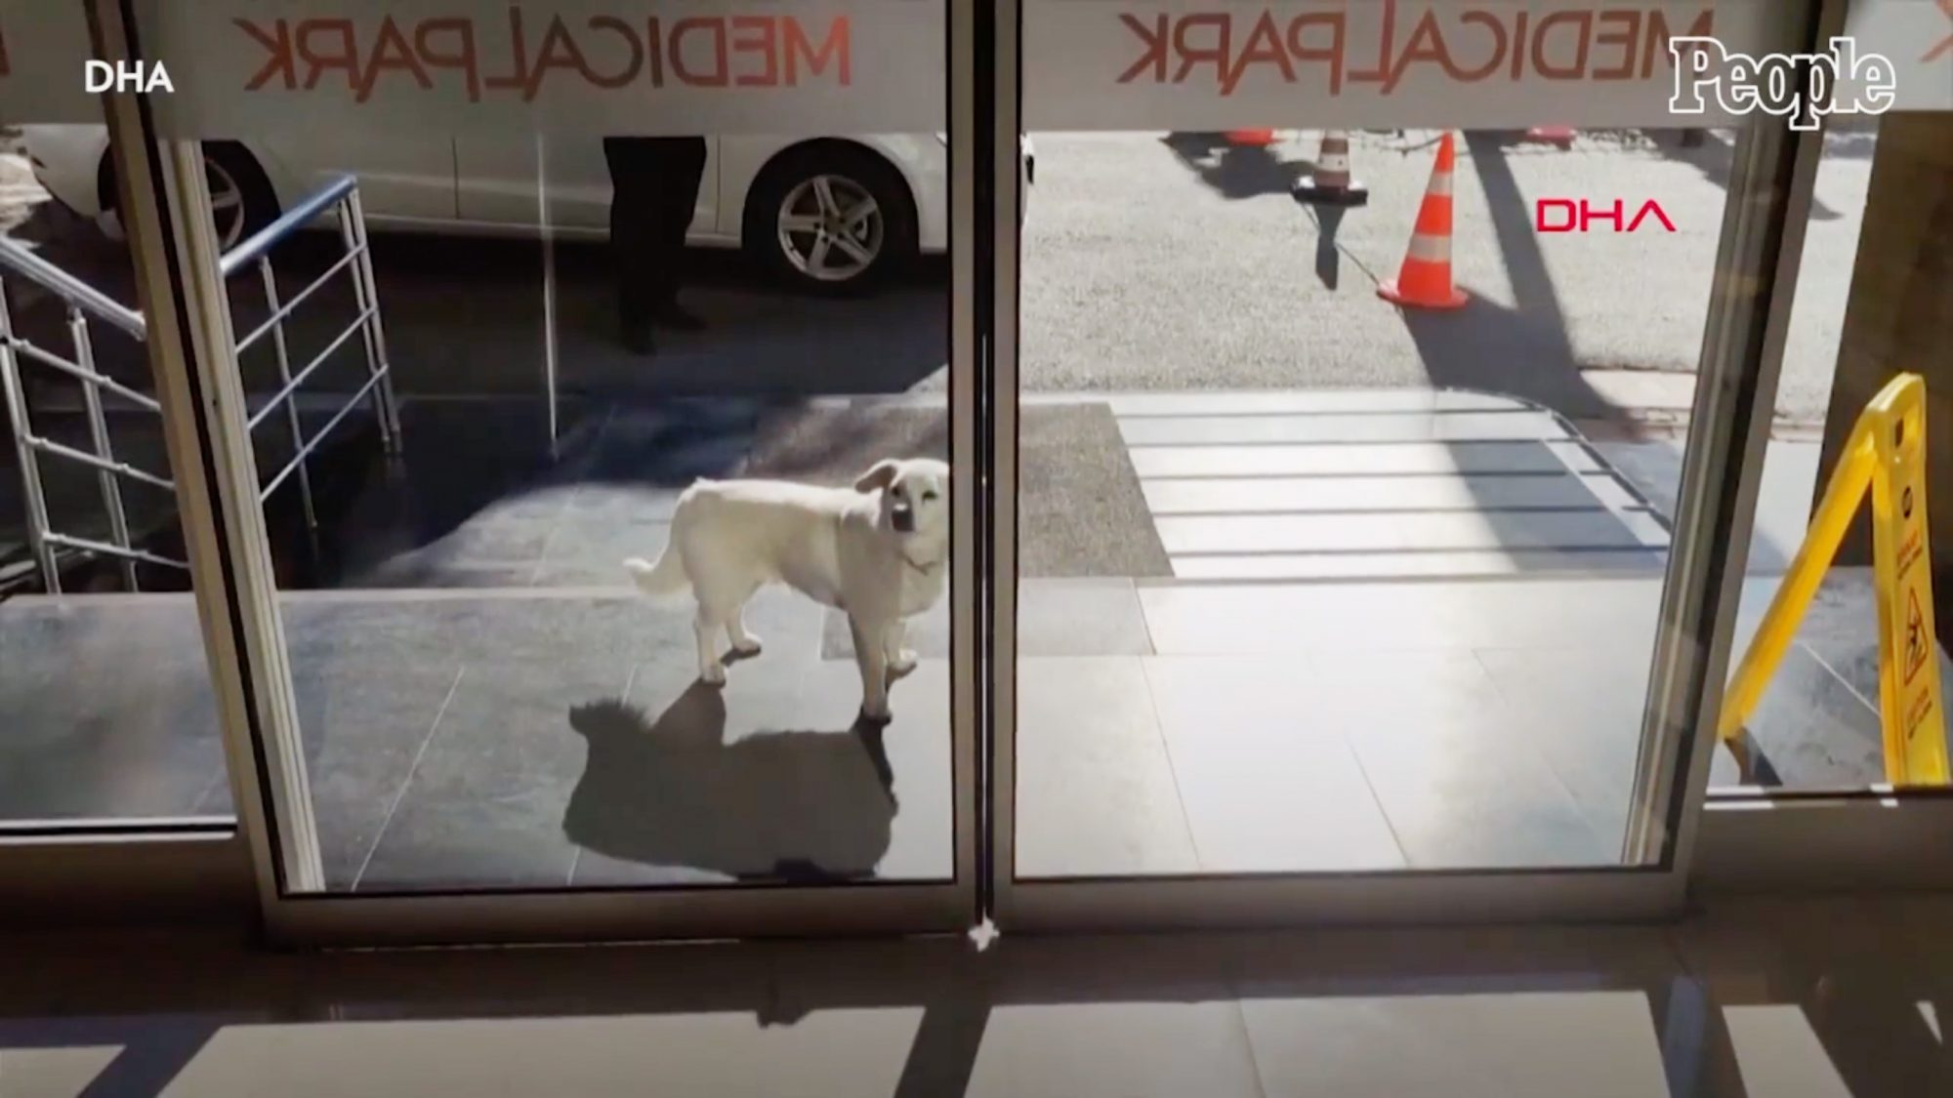
The picture shows Boncuk, a dog who lives in Turkey with his owner Cemal. Recently Cemal had to go into hospital and Boncuk became famous as for 6 days as she sat waiting for her owner outside the building.
Every day Boncuk arrived at the hospital at 9:00 and every time the door opened, she would look inside.
Staff at the hospital fed her as she waited.
When Cemal came out of the hospital he met Boncuck and she jumped around his wheelchair. Cemal said, “It makes a person very happy. The dog is very close to us like a human being.”

You can see Cemal and Boncuk in this news clip
https://www.bbc.co.uk/news/av/world-europe-55779275

- Why do you think the dog waited for 6 days?
- Cemal says the dog is “close to us like a human being.” How can dog be like a human?
- Why did the dog keep looking through the door?
- Why do you think the dog didn’t go inside the hospital to look for her owner?
- Why do you think staff fed the dog?
- What does this show us about people today helping out?
- Why do you think the story went viral?
- How is this story relevant to us and what is happening today?
- What can we learn from Boncuk?
- Why is this a story of hope?

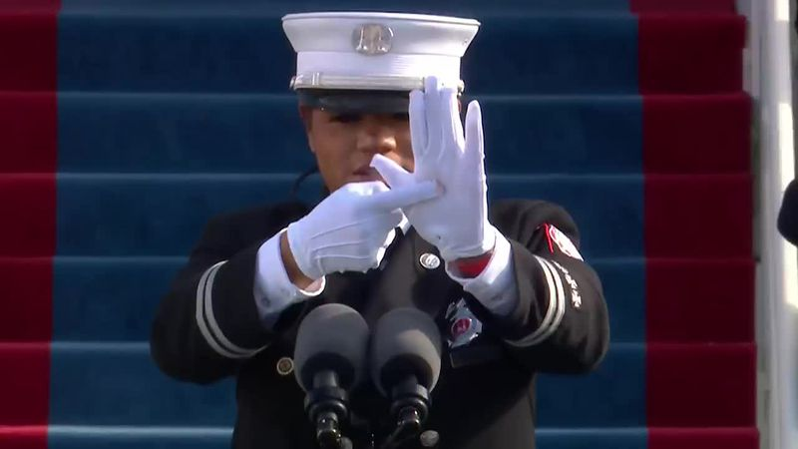
https://www.bbc.co.uk/news/av/world-us-canada-55847420

Andrea Hall is a Fire Captain, and the first African American woman to serve as a Fire Captain. She was invited to deliver the Pledge of Allegiance at the Inauguration of Joe Biden as President of America. This photo of Andrea went viral as people asked what she was doing and why.

What do you think she was doing with her hands?

Andrea signed the pledge as she spoke. She later explained; “Here I am sandwiched between J-Lo and Lady Gaga. And I’m thinking, ‘How do you make the pledge exciting on the heels of Lady Gaga?”

Andrea decided to use sign language to honour her late father who was deaf. Andrea says because she can communicate using sign language she is bilingual, and she wanted other people who used sign language, “to be able to receive that information in our native language.”

Andrea says she felt intense nervousness and was worried that she might forget what she had been saying. But she wanted her delivery to be “as inclusive as the pledge itself.”

“It was written for little children who were immigrants. And in some ways we are all immigrants. We’re a mishmash of people from all over and it’s a way to unify us, by speaking those 31 words.”

- What was the inauguration?
- What is the American pledge and where is it used?
- “Sandwiched between J-Lo and Lady Gaga” what does she mean?
- Why do you think Andrea decided to sign the pledge?
- Andrea calls sign language a “native language”; what does she mean by that?
- “We’re all immigrants” how can this be?
- How can saying 31 words unite people?
- Why is it significant that Andrea is the first African American woman to serve as Fire captain? What does this show us about history, ideas, and equality?
- What can we learn from Andrea?
- Why is this a story of hope?

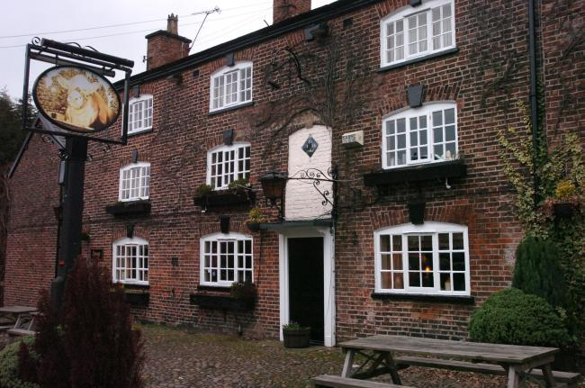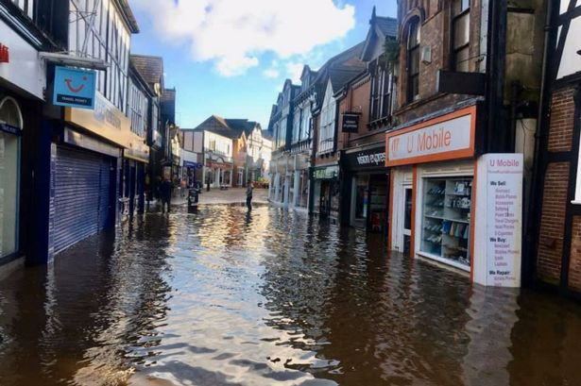
https://www.northwichguardian.co.uk/news/19029667.northwich-pub-offers-free-meals-residents-hit-floods/

A pub in Northwich, Cheshire, has been praised for showing community spirit and helping people out during lockdown and recent floods.
Many residents woke up to severe flooding last week and the Bull’s Head Pub stepped up to offer free meals to anyone who was left without cooking facilities.
Before last week the pub served take-away meals during lockdown. But when the floods hit the area, they decided to give all their meals away free of charge.
Landlady Julie Robinson said, “We just wanted to help out in any way we could.”
Julie put a message on social media saying, “If anyone is in need of help, just give us a ring and we’d supply them with a hot meal”
Over the weekend they supplied meals to many families and people who had to leave flooded homes and were staying in hotels.
Julie says, “It just comes naturally just to help people”

- Why was the Bull’s Head serving only take away meals?
- Why do floods happen?
- What is the impact on a family who are flooded?
- Why do you think the pub decided to give away their meals free of charge?
- What does that show about people today during lockdown?
- How will people receiving a free meal feel about their community?
- What might they do next time they see someone that needs help?
- “It just comes naturally just to help people” is that true? Can you think of examples?
- What can we learn from Julie?
- Why is this a story of hope?

