At Excelsior MAT we are starting our days with a short assembly in our bubbles. The aim is to serve an injection of hope each day for our children. We are now using the assembly videos in our bubbles each morning so that children at home access the same assembly as those in school. https://www.excelsiormat.org/pd-at-excelsior/agents-of-hope-assemblies
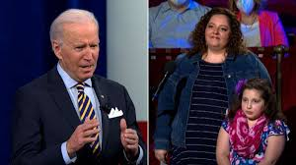
https://www.upworthy.com/joe-biden-response-girl-asking-about-covid

Last week the new US President Joe Biden led a press conference where members of the public could ask questions. A mum asked a question from her eight year old daughter, who you can see in the photo. The question was, “"My children, Layla 8, here, and my son Mateo, 7, at home, often ask if will they catch Covid, and if they do, will they die?"
Joe replied directly to Layla. He said,
"First of all, kids of all don't get Covid very often, it's unusual for that to happen. The evidence is children aren't the people most likely to get Covid. We haven't even done tests yet on whether certain vaccines would work or not work. So, you're the safest group of people in the whole world."
"Number two, you're not likely to be exposed to something and spread it to mommy or daddy," And it's not likely mommy or daddy are able to spread it to you, either. So, I wouldn't worry about it baby, I promise you."
"You don't get to go to school, you don't get to see your friends … When things change people get really worried and scared. But don't be scared, honey. Don't be scared. You're gonna be fine. And we're gonna make sure mommy is fine, too."
This question and Joe Biden’s response is being called the most important exchange of the night. Joe Biden was praised for showing empathy, for speaking with Layla with respect and dignity and for listening to her worries.

- Why is Joe Biden seen on a separate screen to the mother and daughter?
- How do you think the mother and daughter felt speaking to the president of America?
- Why did Joe Biden talk to Layla when it was Mum who had asked the question?
- what did Layla learn about covid from Joe Biden?
- Why are kids “the safest group of people in the world”?
- Look at the words Joe used – why does he use words like “honey” and “baby”?
- Why does he say “Don’t be scared” twice?
- “We’re gonna make sure mommy is fine too” why does he say that?
- How do you think Layla and Mommy felt after speaking to Joe?
- What can we learn from Joe Biden?
- Why is this a story of hope?

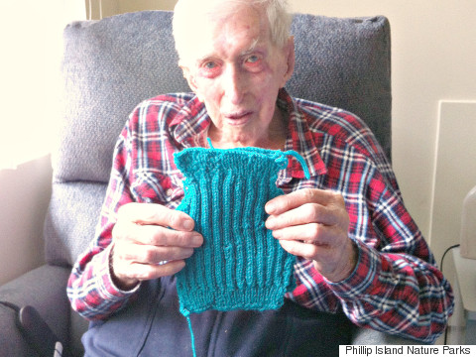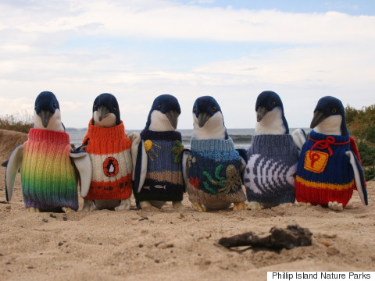
https://www.huffingtonpost.co.uk/entry/australias-oldest-man-sweaters-penguins-oil_n_6660962?ri18n=true

https://www.dailymail.co.uk/news/article-3570787/Australia-s-oldest-man-Alfie-Date-dies-peacefully-110-nursing-home-NSW-Central-Coast.html

A few years ago a group of volunteers got together to knit sweaters for penguins who were affected by an oil spill and one of them was Australia’s oldest man, Alfie Date, who was 110 years old.

Alfie learned to knit after moving in to his care home and then heard about the “Knits for nature” programme. An oil spill near Phillips island put penguins in danger as when they preened themselves they would ingest the oil. Workers dressed the penguins in sweaters to stop them becoming ill.

Alfie died in 2016 but he is remembered today for his knitting which made him famous around the world. He said at the time that he liked to make sure his jumpers for the penguins were up to par; “I like to make it without mistakes and I don’t excuse myself for doing it but I think there is an excuse for a person who has gone beyond the normal span of life.”

When asked if there was a secret to living to 110, he said, “waking up every morning!”

- What is an oil spill?
- How will an oil spill affect a penguin?
- How will a jumper help?
- Why do you think Alfie learned to knit at such an old age?
- Do you think he found it easy? (he didn’t at first; he explains in the video in the link above how hard it was)
- Why didn’t Alfie just give up and watch TV instead?
- Why do you think this story went viral around the world?
- When asked what is the secret to old age we can see that Alfie has a sense of humour- why?
- What can we learn from Alfie?
- Why is this a story of hope?

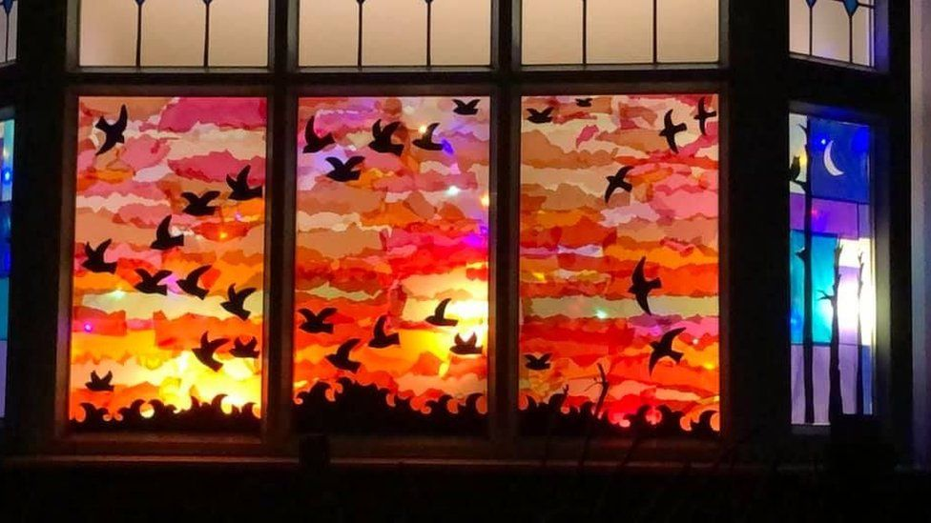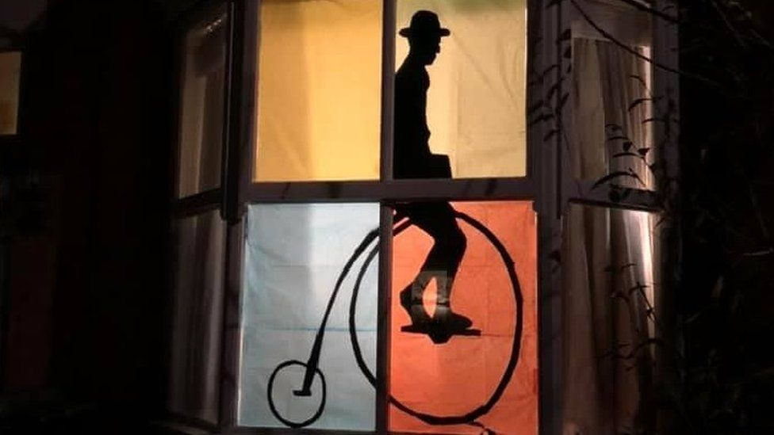
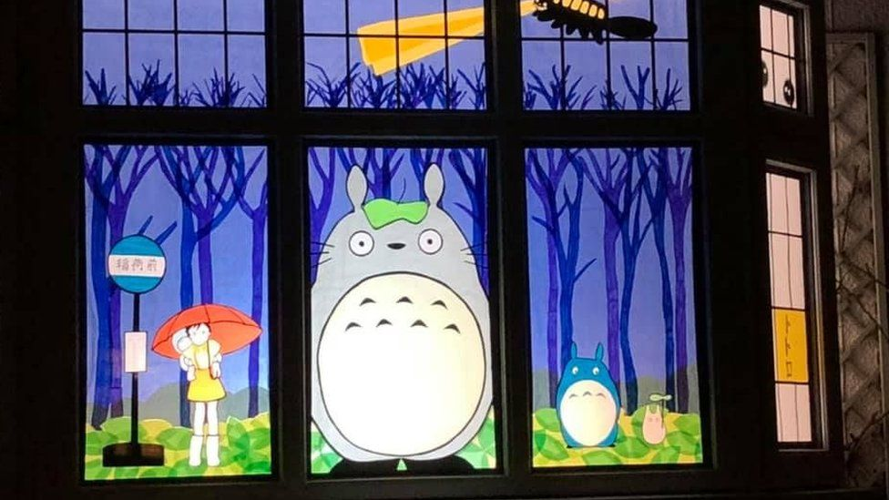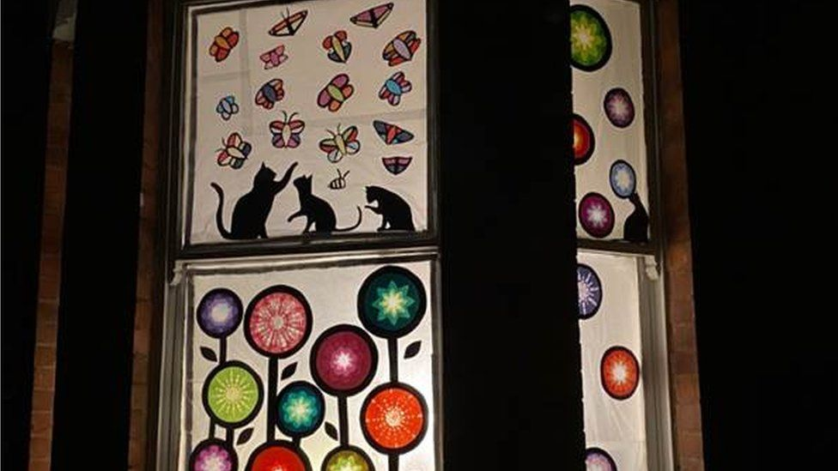

https://www.bbc.co.uk/news/uk-england-coventry-warwickshire-56154866

Hundreds of people in Coventry have brightened up lockdown by joining in Window Wanderland this month. The event started in 2015 and the aim was to transform Coventry in to a magical outdoor gallery.

This year over 300 homes have got involved. The orgnaisers say, “It’s so important to do something in your local area at the moment.”

Walking tours have been organised so that people can see all the windows and an online gallery has also been set up.

- Why do you think the event is called Window Wanderland?
- What materials do you think people use to create their windows?
- Why have so many joined in this year?
- What are people showing the rest of the UK about getting through lockdown?
- If only one house joiend in, would it have the same impact? What has made this event work?
- It’s so important to do something in your local area at the moment.” Why?
- What can we learn from Coventry?
- Why is this a story of hope?

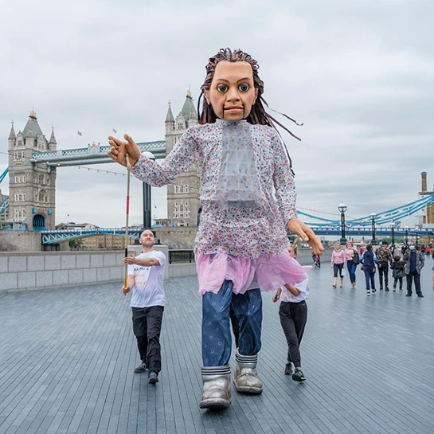
https://www.walkwithamal.org/

https://www.bbc.co.uk/news/entertainment-arts-54447475

A huge puppet is being walked across the length of Europe to raise awareness of refugees. The puppet will walk 5000 miles from Syria to the UK.

The puppet is named Little Amal and is 3.5m high and the project is being called the most ambitious art project ever attempted.

Little Amal will set off from Turkey/ Syria border and travel through Greece, Italy, Switzerland, Germany, Belgium and France. All along the journey Amal will be met with street parades, like a “traveling festival of art and hope.” They will not be alone on their travels. The organisers hope to “rewrite the narrative about refugees.”

The puppet will be operated by three people; one inside the body on stilts and another two each side.

- What is a refugee?
- What is travelling like for a refugee?
- Why is the puppet walking, why don’t they drive between each country or get a plane?
- Why do you think the organisers want to have street parades and festivals for Little Amal?
- Why call the puppet little Amal when it is so huge? Why do you think the organisers chose to use a big puppet rather than a small hand held puppet?
- Why do they want to “rewrite the narrative about refugees”? what do you think the narrative is about refugees currently?
- Why do you think those countries were chosen? Why not go through Russia or Spain?
- “A festival of art and hope” what does that mean? What will it look like?
- What can we learn from this art project?
- Why is this a story of hope?

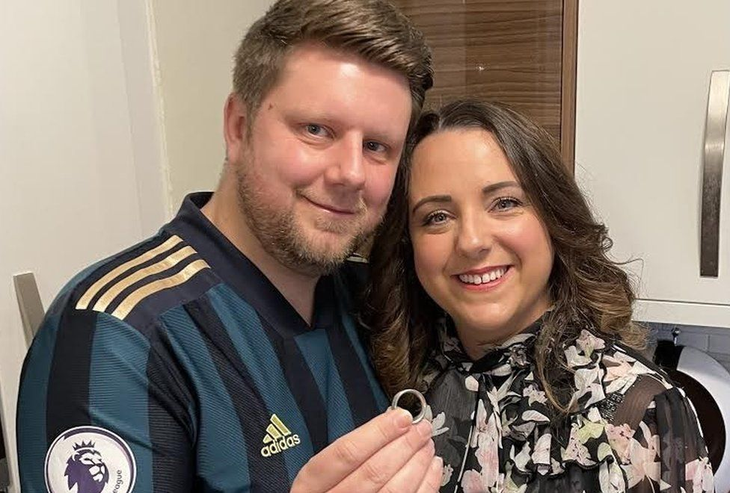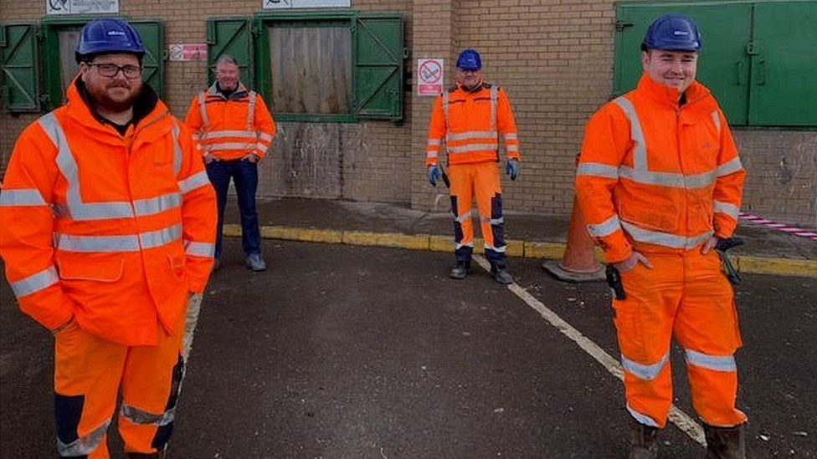
https://www.bbc.co.uk/news/uk-england-tyne-56117907

When James Ross was dropping of cardboard at his local recycling centre in North Shields, his wedding ring slipped off his finger and in to the dump.

James said, “My hands were cold and as I was shaking out the box, suddenly the ring was just gone. I don’t know if it caught the edge of the box but my heart just sank. It wasn’t what it cost – it was laser engraved with my wife’s handwriting and the date we got married in 2009. It was irreplacable.”

James thought all was lost but then the workers at the centre got together and helped him. They shut down the machinery and pulled out a huge pile of rubbish and checked it over and over again.

“It was like looking for a needle in a haystack” one of them commented.

But suddenly the ring was spotted! James said he was “Over the moon”

- Why do people wear wedding rings?
- Why do you think it came off?
- Why doesn’t James just buy another ring if he loses this one?
- James uses lots of interesting language in his comments; what is meant by the following:
My heart sank / It was irreplaceable / Like looking for a needle in a haystack / James was over the moon
- Why do you think the workers helped James; they could have said, “bad luck, mate!”
- What can we learn from these workers?
- Why is this a story of hope?

