Home Learning Workbook
F2


Week 8
1st March – 5th March

Name:
Dear Apples, Oranges and Parents,

It’s World Book Day this week!
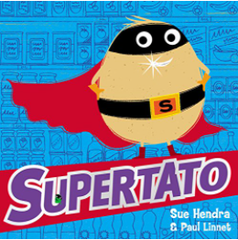
There are some activities at the end of the booklet to go with Supertato. We will be reading a different Supertato book each day so look out on the school website and our Facebook group. There are also lots of stories and activities on the World Book Day website:
www.worldbookday.com
We’d love to see some photos of your Book day activities…


Apples and Oranges – Asquith Primary School

Email: newstarters@asquith.notts.sch.uk

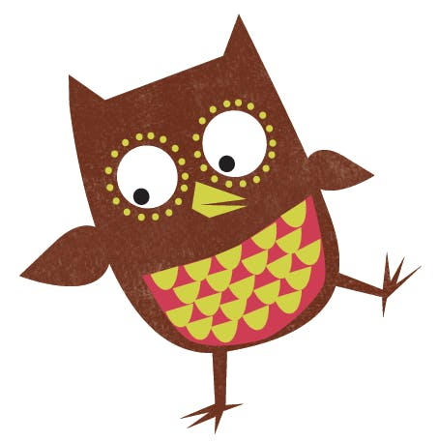
Don’t forget to tell us what you’ve been reading.
www.oxfordowl.co.uk
Username: Asquithf2 Password: 2020

Love from Mrs Bradley, Mrs Denton, Mrs Hough,
Mrs Hallam, Ms Kyte, Miss Bowler, Miss Goodwin and Miss Yerolemou xxx

Tell us about the books you’ve been reading this week…

Monday
Tuesday
Wednesday
Thursday
Friday

Monday 1st March – Maths
Today’s Numberblocks:
Series 2 Episode 4 – Nine

Building 9 and 10. Week 1
Watch the video for Session 1 – Representing and Sorting 9 and 10 from the link sent to you on the SchoolApp.
Or you can type this into your browser: https://whiterosemaths.com/homelearning/early-years/building-9-10-week-1/
The same link includes all sessions for this week.
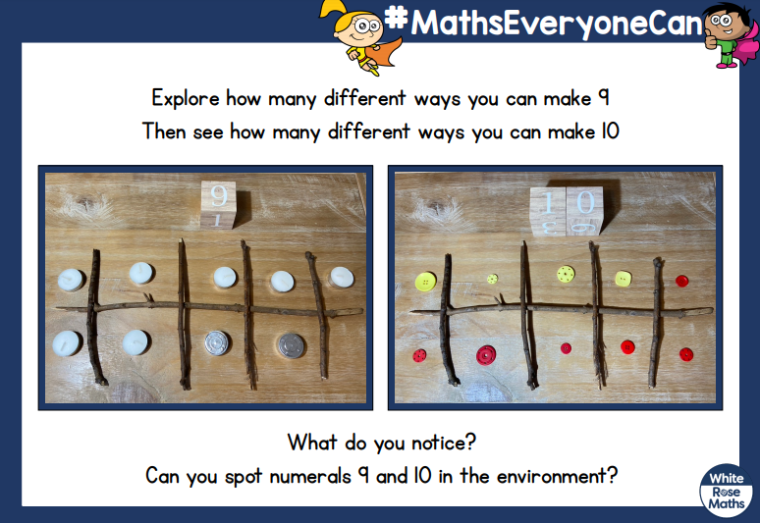

Monday 1st March
Phonics – watch the RWI lessons that Mrs Denton will send you on the SchoolApp this morning.
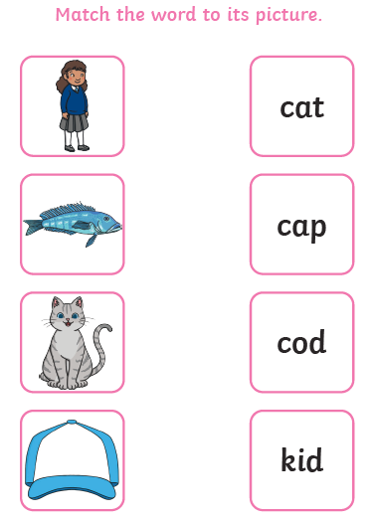

Grown-ups: ask your child to sound out and read each word and draw a line to the picture that matches the word.
Tuesday 2nd March – Maths
Today’s Numberblocks:
Series 2 Episode 10 – The Three Threes

Watch the video for Session 2 – Representing and Sorting 9 and 10 from the link sent to you on the SchoolApp. The same link includes all sessions for this week.

Activity:
9 or 10?
Cut out the cards on the next page.
Have a look at each card – does it represent 9 or 10?
Sort the cards into 2 groups.

Then make your own cards representing 9 and 10.
Have a go at sorting these cards too.

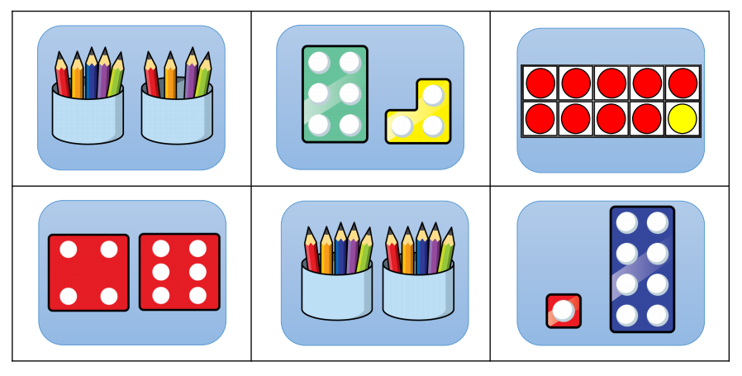
Blank page

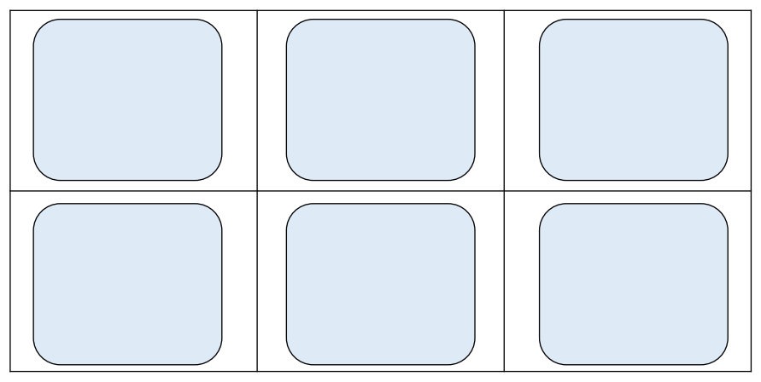
Blank page
Tuesday 2nd March
Phonics – watch the RWI lessons that Mrs Denton will send you on the SchoolApp this morning.


Watch Mrs Denton’s Fred Fingers video on the school website or Facebook and do your writing here…
-----------------------------------------------------------------------
-----------------------------------------------------------------------
-----------------------------------------------------------------------
-----------------------------------------------------------------------
-----------------------------------------------------------------------
-----------------------------------------------------------------------
-----------------------------------------------------------------------
-----------------------------------------------------------------------
Wednesday 3rd March – Maths
Today’s Numberblocks:
Series 2 Episode 6 – Just Add One

Watch the video for Session 3 – Ordering Numerals to 10 from the link sent to you on the SchoolApp. The same link includes all sessions for this week.

Activity:
Number Line
Cut out the number cards on the next page.
Order the cards 1-10

Now ask your grown up to change something on your number line.
Can you spot the mistake and put it right?

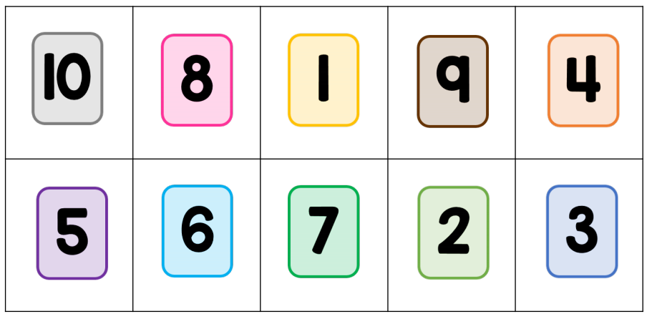
Blank page
Wednesday 3rd March
Phonics – watch the RWI lessons that Mrs Denton will send you on the SchoolApp this morning.
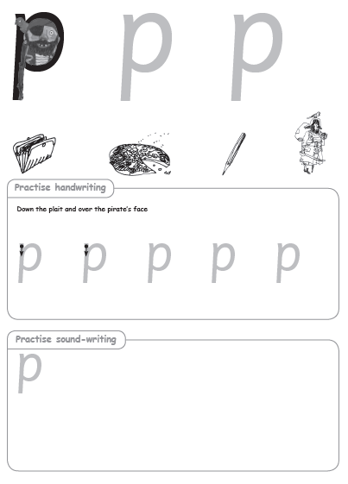

Thursday 4th March – Maths
Today’s Numberblocks:
Series 2 Episode 7 – Blast Off

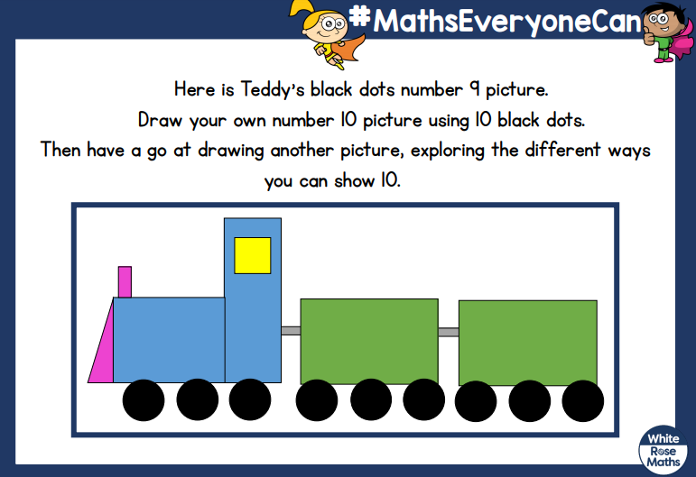
Watch the video for Session 4 – Composition of 9 and 10 from the link sent to you on the SchoolApp. The same link includes all sessions for this week.

Here are 10 black dots. Ask your grown up to help you cut them out so you can stick them to your picture.



Blank page
My Number 10 Picture
Thursday 4th March
Phonics – watch the RWI lessons that Mrs Denton will send you on the SchoolApp this morning.

Watch Mrs Denton’s Fred Fingers video on the school website or Facebook and do your writing here…
-----------------------------------------------------------------------
-----------------------------------------------------------------------
-----------------------------------------------------------------------
-----------------------------------------------------------------------
-----------------------------------------------------------------------
-----------------------------------------------------------------------
-----------------------------------------------------------------------
-----------------------------------------------------------------------
Friday 5th March – Maths
Today’s Numberblocks:
Series 2 Episode 5 – Ten

Watch the video for Session 5 – Numbers to 10 Bingo from the link sent to you on the SchoolApp. The same link includes all sessions for this week.

Activity:
Bingo
2 Players
Carefully take the Bingo boards out of the booklet.
Each player has a board.
Cut out the Bingo cards and put them face down in the middle.
Turn a card over.
What number is represented on the card?
If you have the number on your board, put a counter on it.
Turn another card over and do the same.
The first one to cover all their numbers is the winner!
Blank page

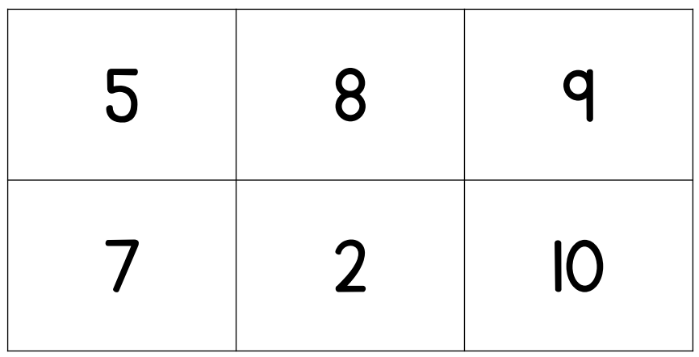
Bingo Board

Blank page

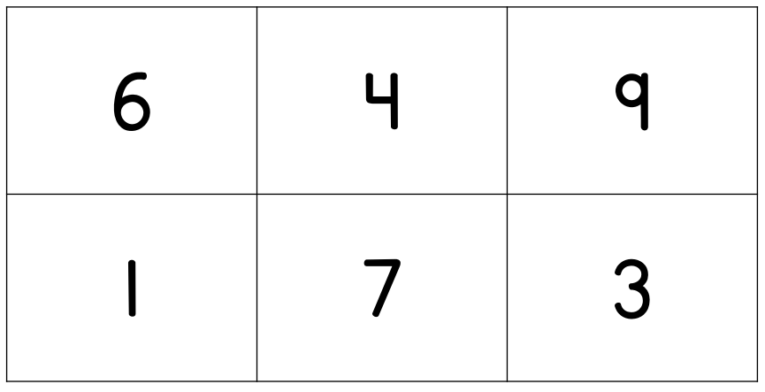
Bingo Board

Blank page
Cut out these cards and use them for your Bingo game

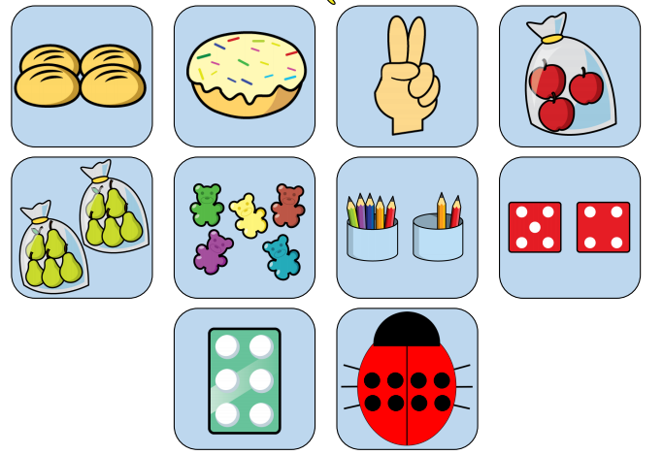

Blank page
Friday 5th March
Phonics – watch the RWI lessons that Mrs Denton will send you on the SchoolApp this morning.

Use your Fred Fingers to have a go at writing the words to go with the pictures.
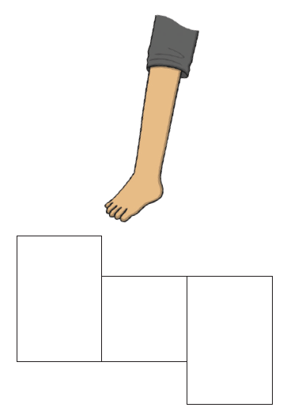
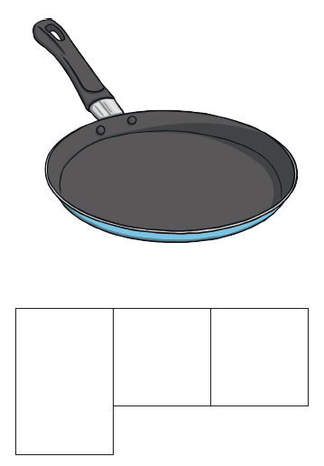

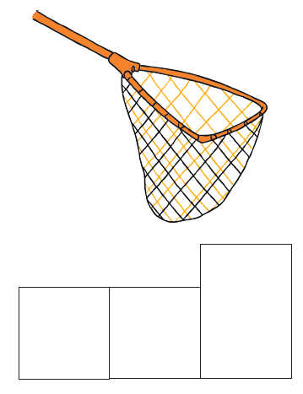
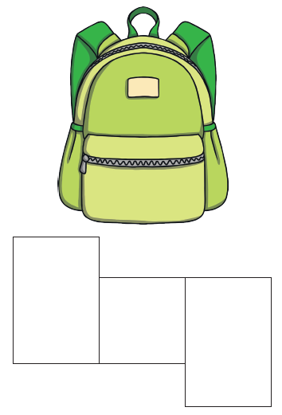

World Book Day Activities. . .

Make you own Supertato – cut out the clothes and accessories and dress your own Supertato - if you have a potato at home, you could use this or cut out eh potato on the sheet instead.

Supertato Maze – can you help Supertato find his way through the maze to find Broccoli? Follow the paths carefully with your pencil – try not to go over any lines.

Spot the Difference – look at the 2 pictures carefully and put a circle around any differences you find.

Word Search – be a Supertato Detective and find the hidden words.
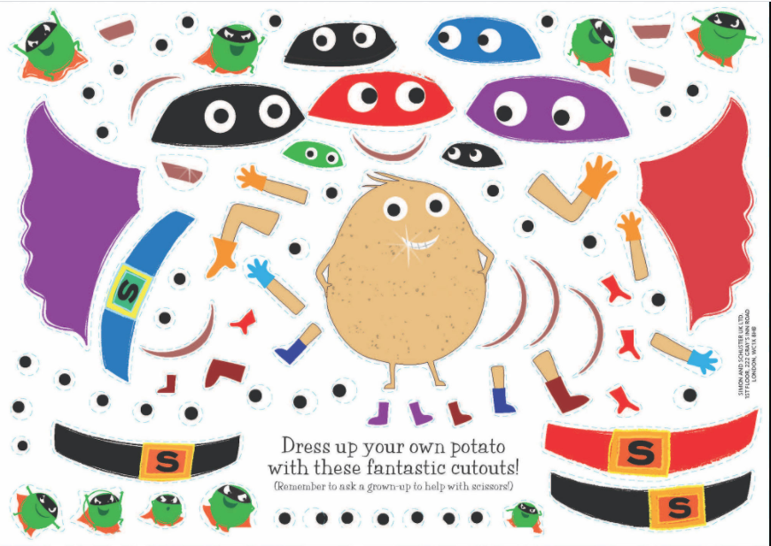
Blank page


