Home Learning Workbook
F2


Week 7
22nd February – 26th February

Name:
Dear Apples, Oranges and Parents,
We hope you all had a lovely half term and did lots of fun activities.
Here’s your Week 7 pack to help you with your learning.
Don’t forget to return the completed booklet to school when you collect your new one each week.


Wow! What a lot of Green faces we’re giving out! Keep sending us your pictures.
Email: newstarters@asquith.notts.sch.uk
If you haven’t already joined our private Facebook Group, send us a join request and then you can share your pictures on there too.

Apples and Oranges – Asquith Primary School


Don’t forget to tell us what you’ve been reading.
www.oxfordowl.co.uk
Username: Asquithf2 Password: 2020
Log in to Oxford Owl and select Read Write Inc phonics to find the "Sound Blending" books and "Ditty Sheets" that the children can read to you.

As always, we’re still here for you so any worries or concerns, please get in touch.
Love from Mrs Bradley, Mrs Denton, Mrs Hough,
Mrs Hallam, Ms Kyte, Miss Bowler, Miss Goodwin and Miss Yerolemou xxx

Tell us about the books you’ve been reading this week…

Monday
Tuesday
Wednesday
Thursday
Friday

Monday 22nd February – Maths

Growing 6, 7, 8. Week 3
Watch the video for Session 1 – Comparing Height from the link sent to you on the SchoolApp.
Or you can type this into your browser: https://whiterosemaths.com/homelearning/early-years/growing-6-7-8-week-3/
The same link includes all sessions for this week.
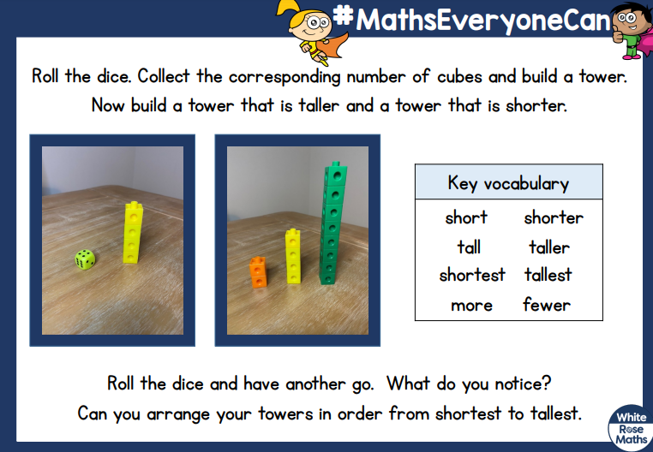
You could use Lego bricks or wooden blocks if you don’t have cubes at home. Or anything that you can stack on top of each other.

Monday 22nd February
Phonics – watch the RWI lessons that Mrs Denton will send you on the SchoolApp this morning.
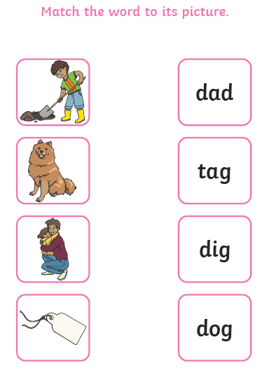

Grown-ups: ask your child to sound out and read each word and draw a line to the picture that matches the word.
Tuesday 23rd February – Maths

Watch the video for Session 2 – Comparing Length from the link sent to you on the SchoolApp. The same link includes all sessions for this week.
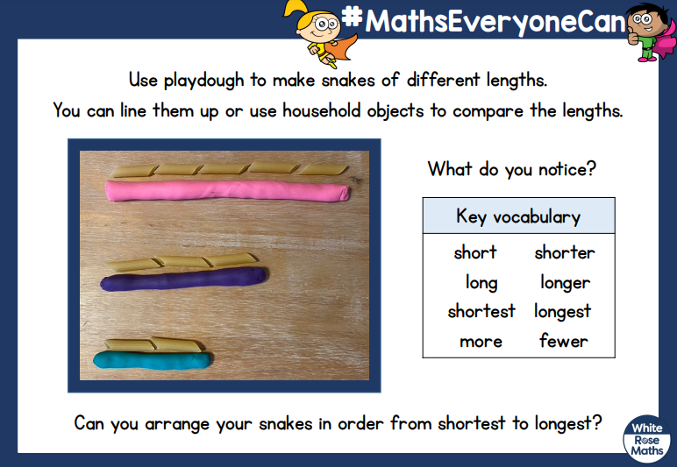

Tuesday 23rd February
Phonics – watch the RWI lessons that Mrs Denton will send you on the SchoolApp this morning.


Watch Mrs Denton’s Fred Fingers video on the school website or Facebook and do your writing here…
-----------------------------------------------------------------------
-----------------------------------------------------------------------
-----------------------------------------------------------------------
-----------------------------------------------------------------------
-----------------------------------------------------------------------
-----------------------------------------------------------------------
-----------------------------------------------------------------------
-----------------------------------------------------------------------
Wednesday 24th February – Maths

Watch the video for Session 3 – Days of the Week from the link sent to you on the SchoolApp. The same link includes all sessions for this week.

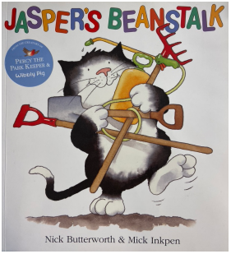
Look out for a link to Jasper’s Beanstalk on the SchoolApp or if you have a copy at home, you could read that.

Now have a go at putting the days of the week in the correct order. . .
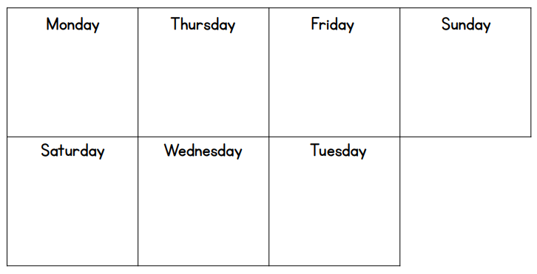
Cut out the days and stick them in the correct order on the next page.
Then, can you draw a picture of something you do each day?
Blank page

Days of the Week
Wednesday 24th February
Phonics – watch the RWI lessons that Mrs Denton will send you on the SchoolApp this morning.
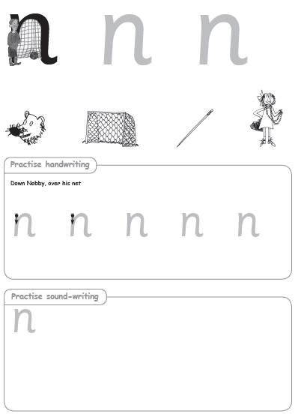

Thursday 25th February – Maths

Watch the video for Session 4 – Measuring Height from the link sent to you on the SchoolApp. The same link includes all sessions for this week.

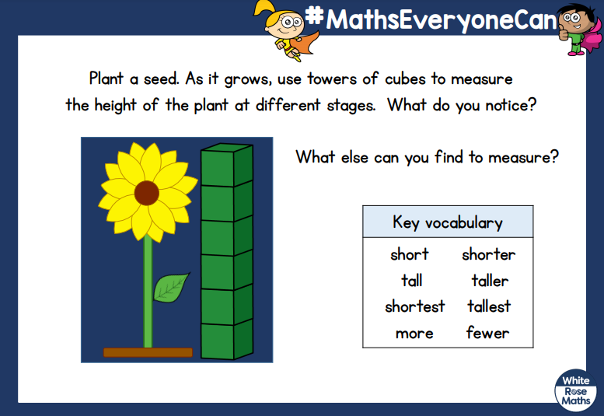
There are some seeds with your pack this week. You can use compost or soil out of your garden to plant them in. You will need to keep watering them and wait for them to grow before you can measure them!

Thursday 25th February
Phonics – watch the RWI lessons that Mrs Denton will send you on the SchoolApp this morning.

Watch Mrs Denton’s Fred Fingers video on the school website or Facebook and do your writing here…
-----------------------------------------------------------------------
-----------------------------------------------------------------------
-----------------------------------------------------------------------
-----------------------------------------------------------------------
-----------------------------------------------------------------------
-----------------------------------------------------------------------
-----------------------------------------------------------------------
-----------------------------------------------------------------------
Friday 26th February – Maths

Watch the video for Session 5 – Measuring Time from the link sent to you on the SchoolApp. The same link includes all sessions for this week.

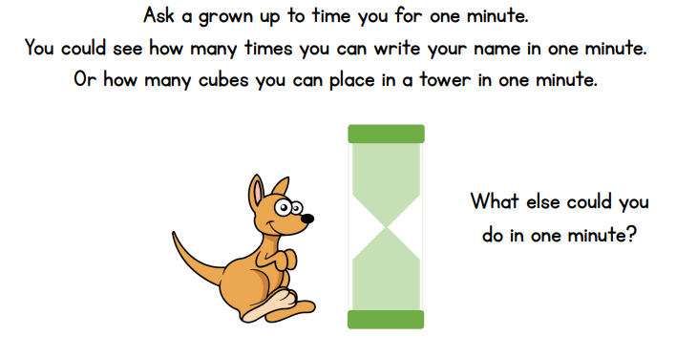
Keep a record of what you did and how many in a minute on the next page.

You could use the timer on a phone or computer to time one minute.

Activity | How many in a minute
Friday 26th February
Phonics – watch the RWI lessons that Mrs Denton will send you on the SchoolApp this morning.

Use your Fred Fingers to have a go at writing the words to go with the pictures.
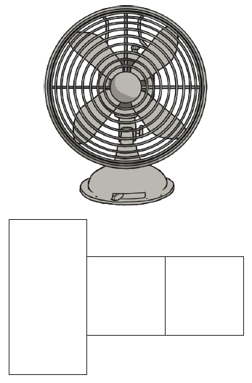
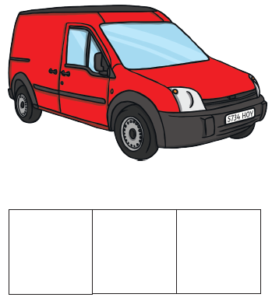

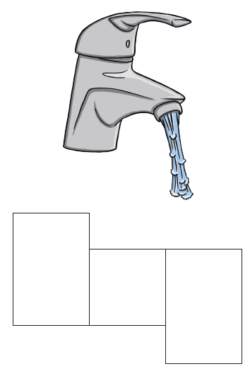
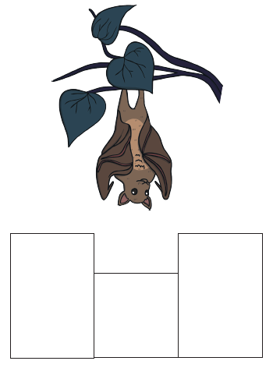

Challenge of Week. . .

Can you colour the Numberblocks in using the right colours for each one?

After you have coloured them, cut them out, mix them up and try to put them back in the right order.

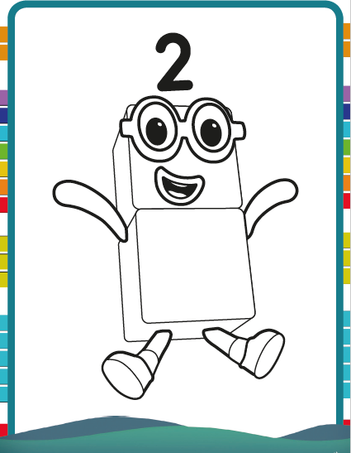

Blank page

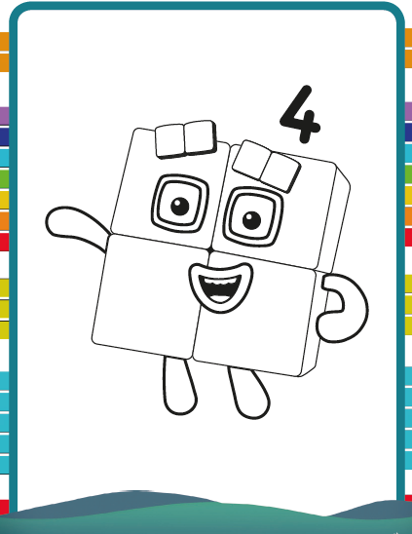

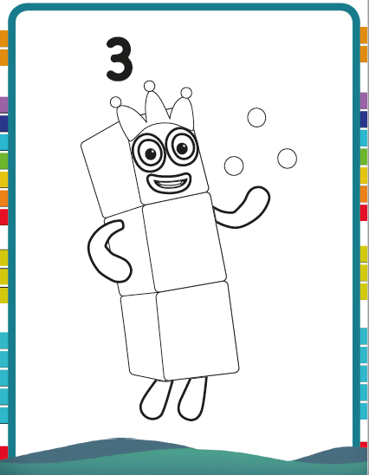

Blank page

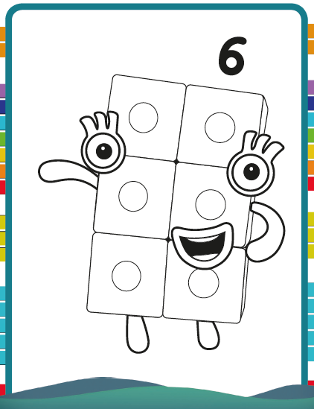

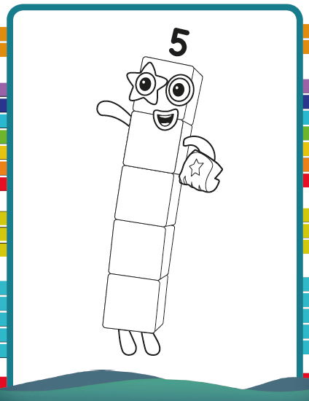

Blank page

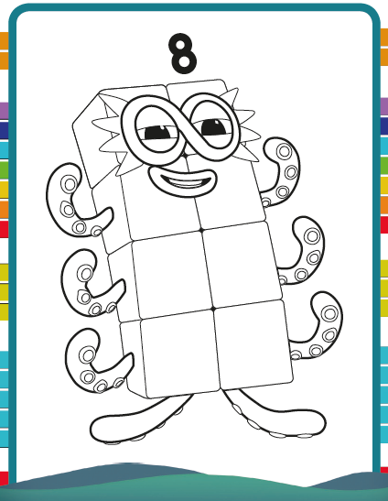

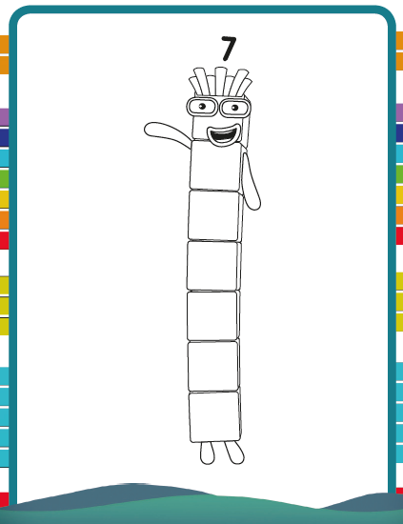

Blank page

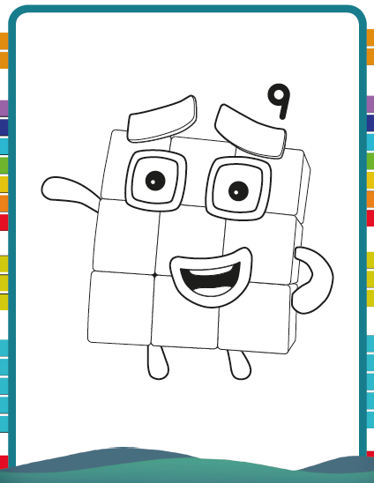
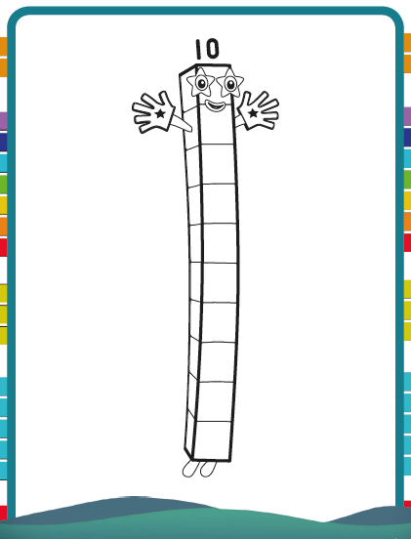
Blank page

Just for Fun. . .

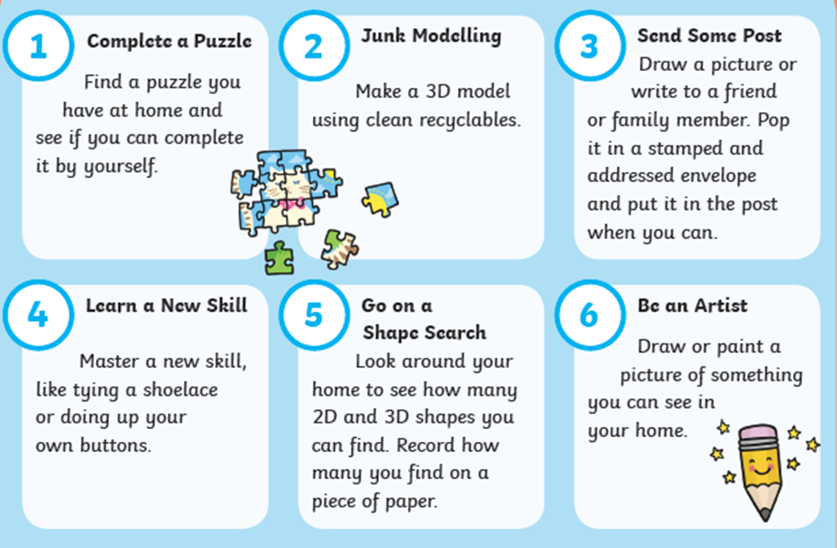

Choose one (or more) to have a go at. Send us some pictures of what you do.

