Home Learning Workbook
F2
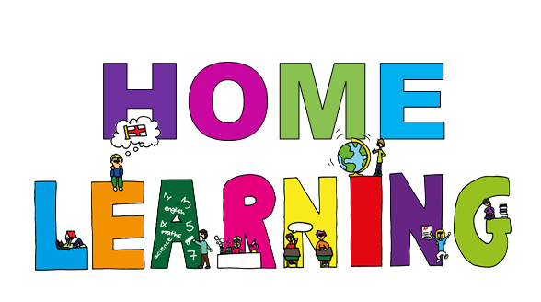

Week 6
8th February – 12th February

Name:
Dear Apples, Oranges and Parents,
Keep up the hard work – you’re all doing a fantastic job.
Here’s your Week 6 pack to help you with your learning.
Don’t forget to return the completed booklet to school when you collect your new one each week.


Wow! Lots of you are getting Green Faces for your work. We love seeing what else you’re doing as well. Keep sending your pictures to us!
Email: newstarters@asquith.notts.sch.uk
We have set up a private Facebook Group to share our work and pictures. You will need to send us a request to join.

Apples and Oranges – Asquith Primary School

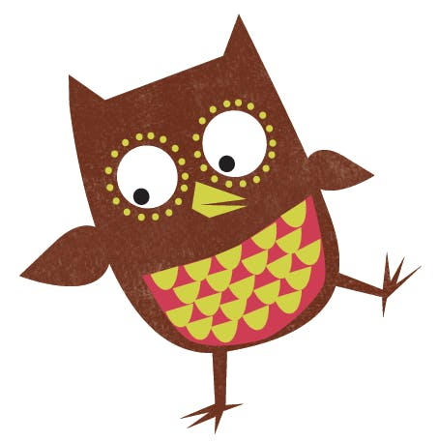
This week we’ve added a reading book log into the pack so you can tell us what you’ve been reading.
www.oxfordowl.co.uk
Username: Asquithf2 Password: 2020
Log in to Oxford Owl and select Read Write Inc phonics to find the "Sound Blending" books and "Ditty Sheets" that the children can read to you.
As always, we’re still here for you so any worries or concerns, please get in touch.
Love from Mrs Bradley, Mrs Denton, Mrs Hough,
Mrs Hallam, Ms Kyte, Miss Bowler, Miss Goodwin and Miss Yerolemou xxx

Tell us about the books you’ve been reading this week…

Monday
Tuesday
Wednesday
Thursday
Friday

Numberblocks


This week you will also be sent a link on the SchoolApp to Numberblocks episodes each day. You can watch these at any time during the day.
At school we often watch them with our snack!

You can find all the Numberblocks episodes by going onto BBC iPlayer and searching for Numberblocks.

The maths page for each day in the booklet will tell which episodes go with each session.

Monday 8th February – Maths
Today’s Numberblocks:
Series 3 Episode 13 – Five and Friends

Growing 6, 7, 8. Week 2
Watch the video for Session 1 - Matching 6, 7 and 8 from the link sent to you on the SchoolApp.
Or you can type this into your browser: https://whiterosemaths.com/homelearning/early-years/growing-6-7-8-week-2/
The same link includes all sessions for this week.
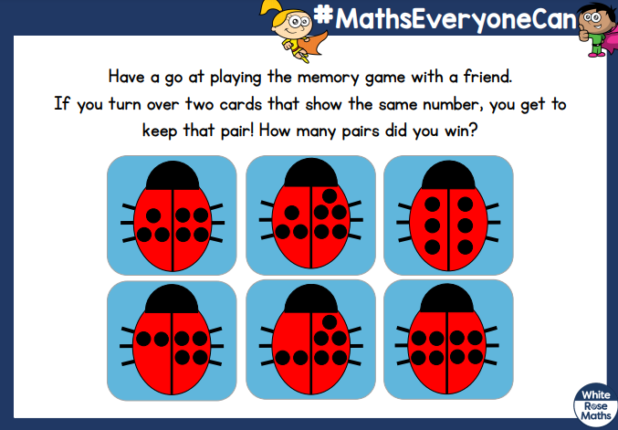

Blank page
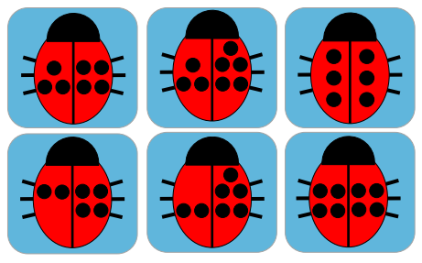
Blank page
Now have a go at designing your own cards to play a memory game with.

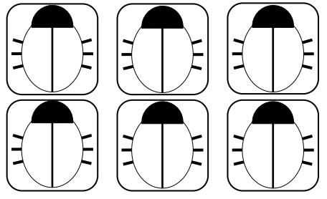

Blank page
Monday 8th February
Phonics – watch the RWI lessons that Mrs Denton will send you on the SchoolApp this morning.
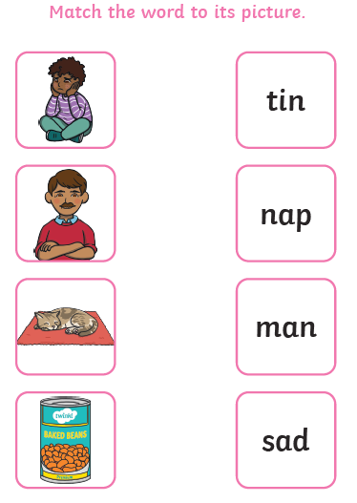

Grown-ups: ask your child to sound out and read each word and draw a line to the picture that matches the word.
Tuesday 9th February – Maths
Today’s Numberblocks:
Series 2 Episode 7 – Blast Off

Watch the video for Session 2 - Making pairs from the link sent to you on the SchoolApp. The same link includes all sessions for this week.

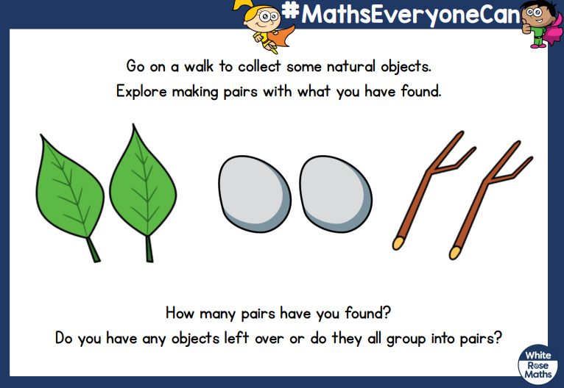

Draw some pictures of the pairs of things you find on your walk:
Tuesday 9th February
Phonics – watch the RWI lessons that Mrs Denton will send you on the SchoolApp this morning.


Watch Mrs Denton’s Fred Fingers video on the school website or Facebook and do your writing here…
-----------------------------------------------------------------------
-----------------------------------------------------------------------
-----------------------------------------------------------------------
-----------------------------------------------------------------------
-----------------------------------------------------------------------
-----------------------------------------------------------------------
-----------------------------------------------------------------------
-----------------------------------------------------------------------
Wednesday 10th February – Maths
Today’s Numberblocks:
Series 3 Episode 10 – Hiccups

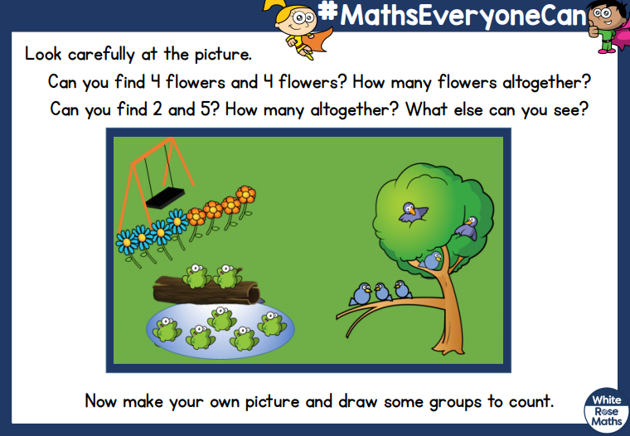
Watch the video for Session 3 - Combining 2 groups from the link sent to you on the SchoolApp. The same link includes all sessions for this week.

Draw your own picture with groups of objects to count here…
Wednesday 10th February
Phonics – watch the RWI lessons that Mrs Denton will send you on the SchoolApp this morning.
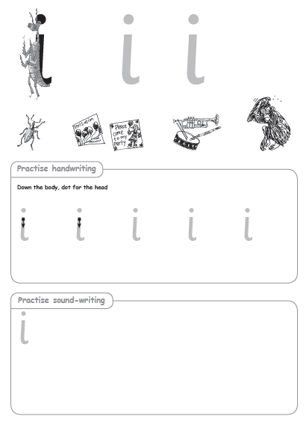

Thursday 11th February – Maths
Today’s Numberblocks:
Series 3 Episode 14 – Octoblock to the Rescue

Watch the video for Session 4 - Combining 2 groups from the link sent to you on the SchoolApp. The same link includes all sessions for this week.

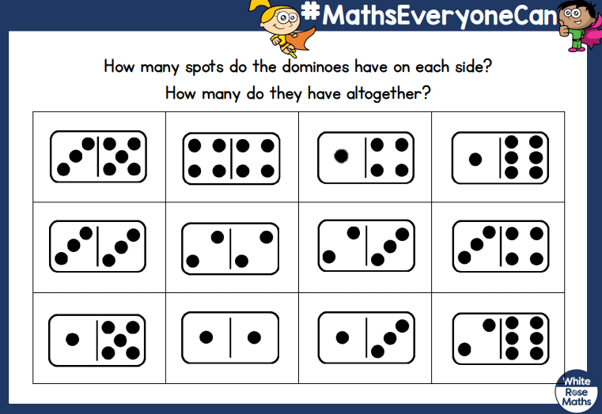

Have a go at playing the game on the next page…
Cut out these dominoes to play the game:
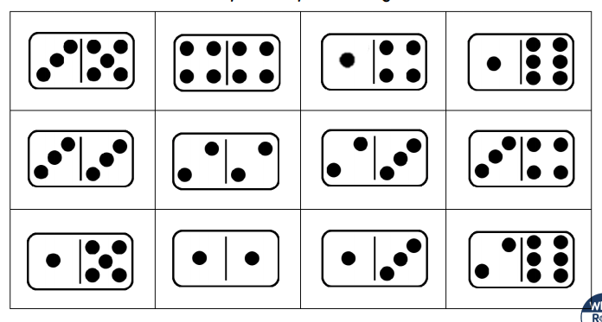
Blank page
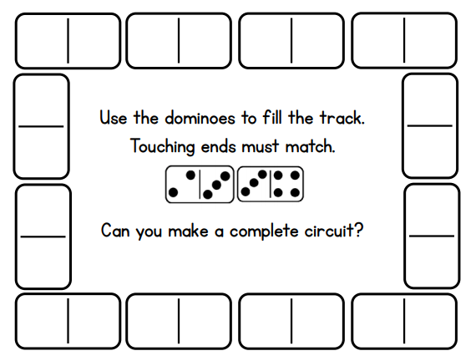
Blank page
Thursday 11th February
Phonics – watch the RWI lessons that Mrs Denton will send you on the SchoolApp this morning.

Watch Mrs Denton’s Fred Fingers video on the school website or Facebook and do your writing here…
-----------------------------------------------------------------------
-----------------------------------------------------------------------
-----------------------------------------------------------------------
-----------------------------------------------------------------------
-----------------------------------------------------------------------
-----------------------------------------------------------------------
-----------------------------------------------------------------------
-----------------------------------------------------------------------
Friday 9th February – Maths
Today’s Numberblocks:
Series 2 Episode 14 – Numberblock Castle

Watch the video for Session 5 - Adding more from the link sent to you on the SchoolApp. The same link includes all sessions for this week.

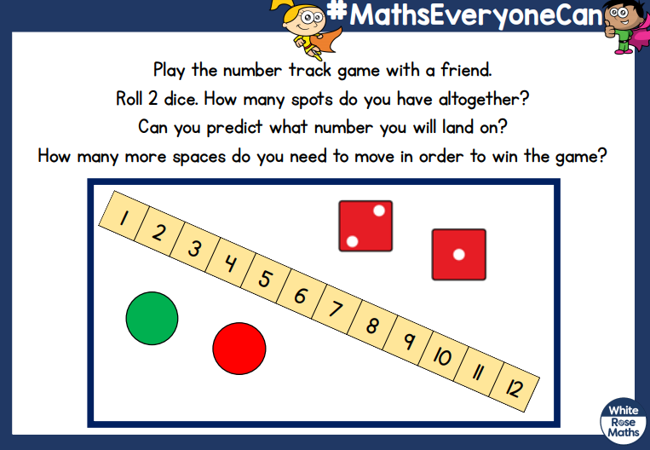

Friday 9th February
Phonics – watch the RWI lessons that Mrs Denton will send you on the SchoolApp this morning.

Use your Fred Fingers to have a go at writing the words to go with the pictures.
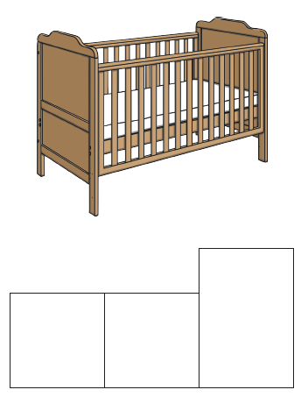
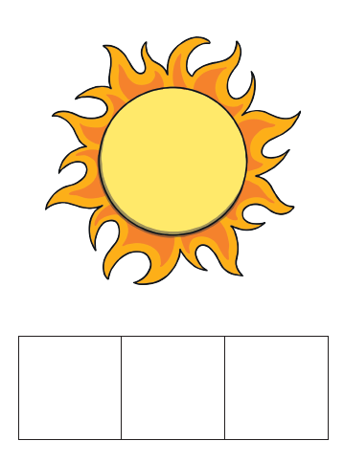

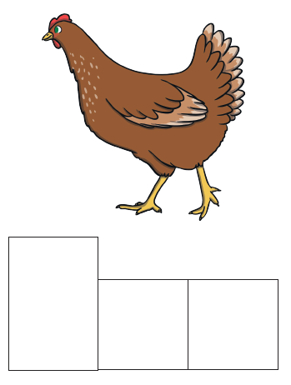
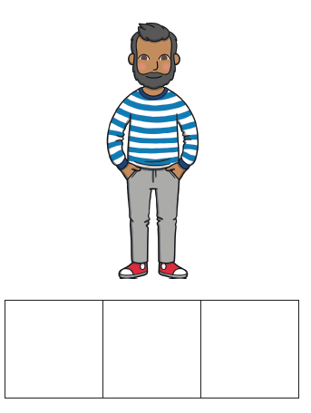

Challenge of the week. . .

Join the dots to complete the pictures and then colour them in.
Which is your favourite?
Do you have one of these animals as a pet?
Do you have a different pet?

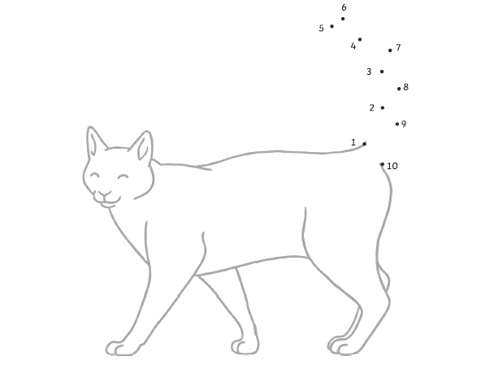

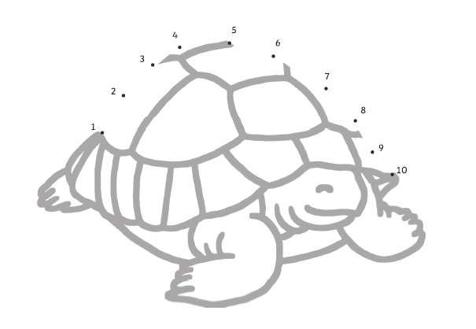

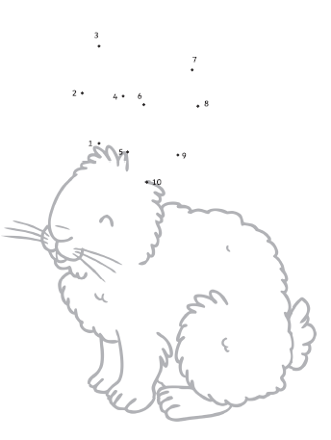

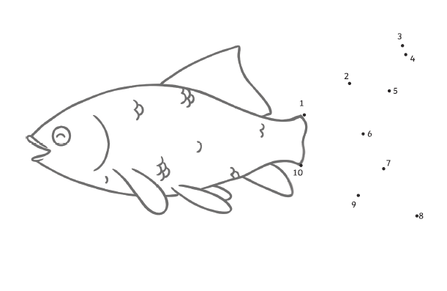

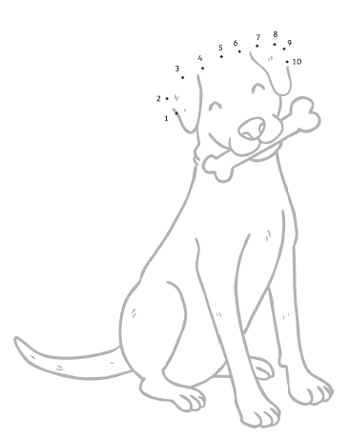

Blank page
Just for fun. . .

Cut out the items and decide whether they would be better for winter or summer. Stick them on to the correct sheet.

Can you think of anything else to draw for winter or summer?

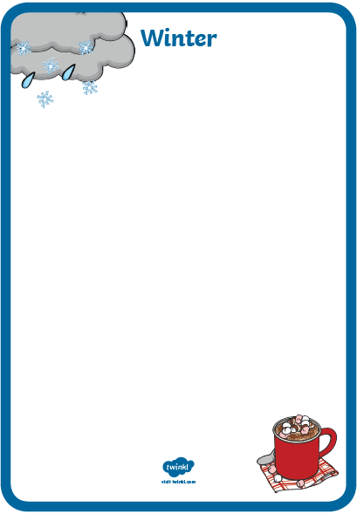
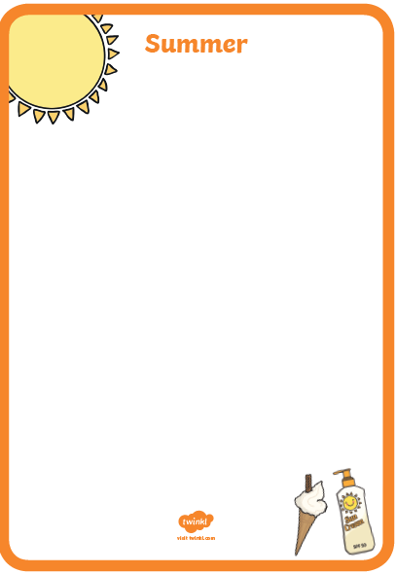
Blank page


Blank page

