Name: Class:

Walliams
Workbook:
World Book Day

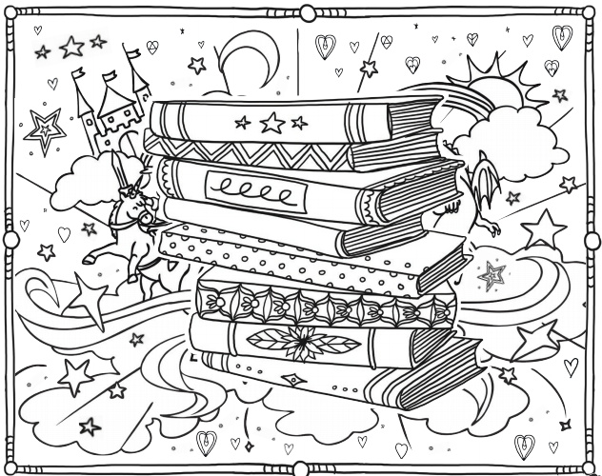

Contents
Day 1 | English – 45 minutes - 1 hour
Day 1 | Maths – 45 minutes – 1 hour
Day 1 | Flashback 4 – 5 minutes
Day 1 | Reading Comprehension – 30minutes
Day 1 | Topic– 45 minutes
Day 2 | English – 45 minutes - 1 hour
Day 2 | Maths – 45 minutes – 1 hour
Day 2 | Flashback 4 – 5 minutes
Day 2 | GPS – 30 minutes
Day 2 | Topic– 45 minutes
Day 3 | English – 45 minutes - 1 hour
Day 3 | Maths – 45 minutes – 1 hour
Day 3 | Flashback 4 – 5 minutes
Day 3 | Spellings – 30 minutes
Day 3 | *Live Session with Your Teacher*
Day 4 | English – 45 minutes - 1 hour
Day 4 | Maths – 45 minutes – 1 hour
Day 4 | Flashback 4 – 5 minutes
Day 4 | Reading Comprehension – 30 minutes
Day 4 | Topic– 45 minutes
Day 5 | English – 45 minutes - 1 hour
Day 5 | Maths – 45 minutes – 1 hour
Day 5 | Flashback 4 – 5 minutes
Day 5 | GPS – 30 minutes
Day 5 | Topic– 45 minutes
Optional Projects + Extra Educational Websites
Have you completed your weekly homework? |  | Date  Completed
Spellings Practise
On Spelling Shed or handwritten
Timetables Rock Stars Task
3 Reads (at least 10 minutes out loud with a grown-up)

OPTIONAL
Any comments or messages from grown-ups that you would like to share with your teacher:
Any comments or messages from the student that you would like to share with your teacher:
Day 1 | English
For hundreds of years, people all over the world have feared monsters and told tales of how terrible we are. Well, I’m here to tell you that we are not really that bad. In fact, we’re marvellous! I’m going to tell you all about us and inspire you to write about your own marvellous monster. Read on and find out more or listen to a recording here: https://soundcloud.com/talkforwriting/marvellous-monsters/s-C35T3UjlRZC
Monsters
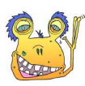

What is a monster?
A monster is a colossal creature that usually scares people.
Appearance
Most monsters are enormous and can reach a height of 12 metres. However, some can be the size of an average human and grow to approximately 1.67 metres (five and a half feet tall). All monsters look different. Many are hairy, whereas some have scales. Additionally, monsters can come in many different colours. They range from a simple brown colour to being multicoloured, like the rainbow monster. Amazingly, some monsters have six eyes, eight legs and two sets of arms.

Habitat
Monsters are found across the world. They live in all sorts of different environments and can thrive in extreme heat or cold. The North Pole Monster loves to live under the snow, in icy crevices. However, most monsters prefer living under beds, inside cupboards or up in cosy attics.
Diet
All monsters are omnivores, which means they will eat anything. Furthermore, monsters love ‘fast food’ and will often raid McDonalds or KFC to grab burgers or chicken buckets. A small minority of monsters are super healthy and always ensure they eat their ‘5-a-day’ and keep sugary items to a minimum. Surprisingly, monsters love tea and have been known to drink gallons of it, especially in the mornings.

What do they do?
Monsters are best known for scaring people and wreaking havoc. However, this is a popular misconception. Monsters are actually gentle creatures who love to read, take walks and play

Day 1 | English
board games. They are also skilled bakers and make amazing bread and cupcakes. Unfortunately, because monsters look so scary, people often overreact when they see them and want to fight them off. In addition to this, monsters speak a language made up of roars, growls and howls which simply sounds scary to humans. Finally, monsters are extremely clumsy and, as they try to get away from people, they tend to knock things down or crush things under their feet by accident. All of these unfortunate things make monsters seem very hostile when, in fact, they are not.

Fast facts
- The oldest monster lived to be 1003 years old.
- Monsters have tiny thorns on their tongues which help them to groom.
- Monsters have amazing hearing and can hear the slightest noise five miles away.
- Monsters become adults at the age of eight.

Monster advice
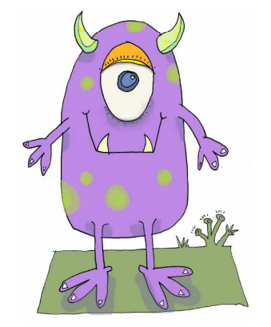
If you happen to meet a monster or find one under your bed, do not fret! Simply smile at them, give them a little wave and offer them a cup of tea. They really are lovely creatures and you’ll soon be friends for life!

Day 1 | English
small |  |  |  | big |  |  |  | bad |  |  |  |  | nice
tiny | minute | miniature | pocket-sized | enormous | gigantic | mammoth | thundering | appalling | atrocious | awful | gross | enjoyable |  | marvellous | lovely | delightful
microscopic | meagre | modest | insufficient | monumental | whopping | colossal | giant | dreadful | frightful | horrendous | hideous | great |  | wonderful | excellent | brilliant
slight | diminutive | petite | teensy | large | huge | sizeable | vast | nasty | terrible | Unacceptable | shocking | pleasant |  | charming | pleasurable | swell
quiet |  |  |  | loud |  |  |  | fast |  |  |  |  | slow
silent | peaceful | muted | soft | deafening | intense | raucous | resounding | speedy | rapid | brisk | nimble | gradual |  | moderate | reluctant | leisurely
hushed | muffled | mute | reserved | roaring | thundering | booming | crashing | swift | dashing | flashing | hurried | sluggish |  | crawling | dawdling | idle
noiseless | speechless | soundless | inaudible | ear-piercing | piercing | deep | boisterous | hypersonic | agile | quick | racing | plodding |  | slack | creeping | lagging
old |  |  |  | young |  |  |  | hard (not easy) |  |  |  |  | angry
ancient | aged | decrepit | elderly | youthful | infant | juvenile | tender | puzzling | challenging | difficult | tricky | enraged |  | resentful | irate | wound up
mature | deliberate | getting on | seasoned | childish | budding | inexperienced | new | mind-boggling | complicated | complex | laborious | worked up |  | indignant | seething | furious
venerable | enfeebled | wasted | fossil | blooming | blossoming | fledgling | recent | problematic | arduous | troublesome | tough | touchy |  | grumpy | infuriated | bitter

Day 1 | English
Adjectives are describing words. We use them to help build a picture in the reader’s mind.
Using the adjective mat on the previous page, draw, label and create a word bank of adjectives for your monster.
Word bank: (Come up with atleast 9 adjectives for your monster)

________________ ________________ ______________
________________ ________________ ______________
________________ ________________ ______________

Draw and label your monster:

Day 1 | English
Using your word bank, create 4 sentences to describe your monster.

Example:
The Jelly Monster has long, squiggly arms that can reach 10m away from their purple, spotted body.

Your turn:
_________________________________________________________________________________________________________________________________________________________________________________

_________________________________________________________________________________________________________________________________________________________________________________

_________________________________________________________________________________________________________________________________________________________________________________

_________________________________________________________________________________________________________________________________________________________________________________

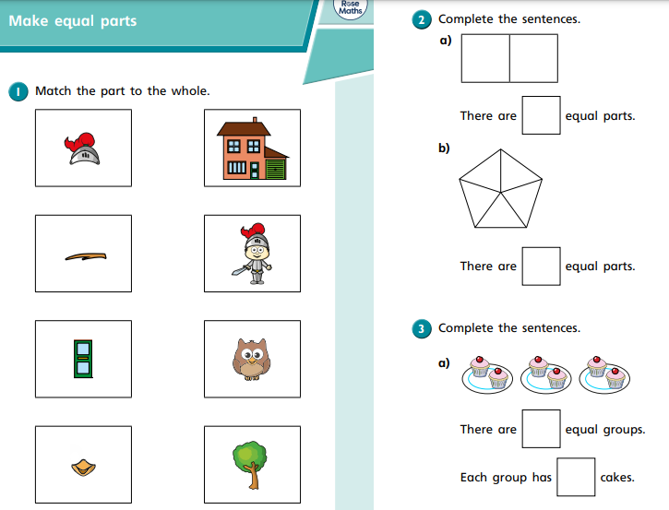

Day 1 | Maths
Today’s video: https://vimeo.com/510671507

Day 1 | Maths
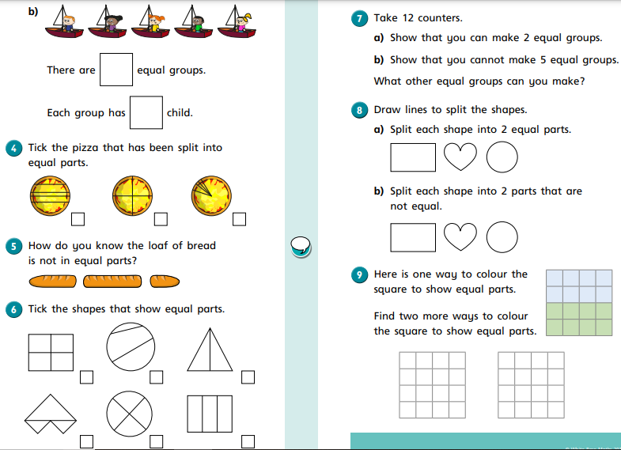
Day 1 | Flashback 4
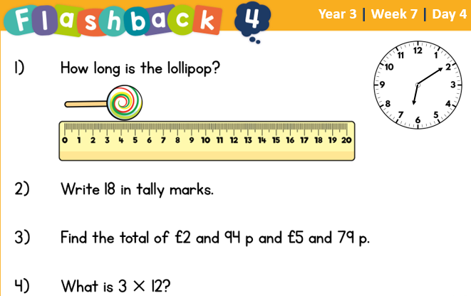


Day 1 | Reading Comprehension
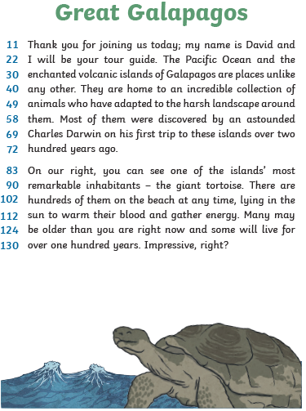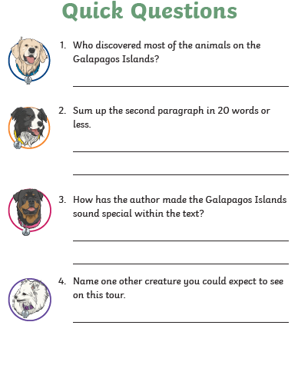
Day 1 | Topic
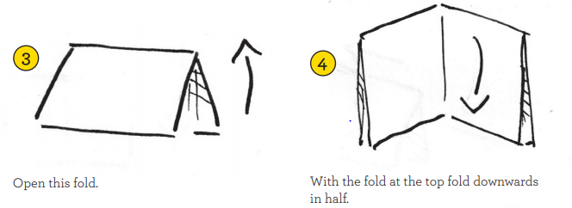
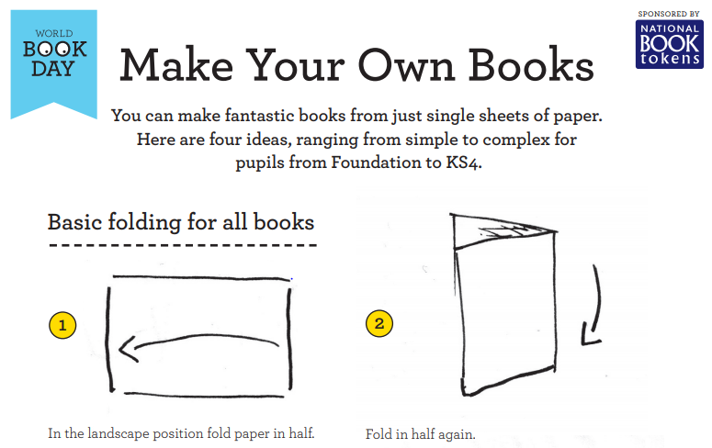

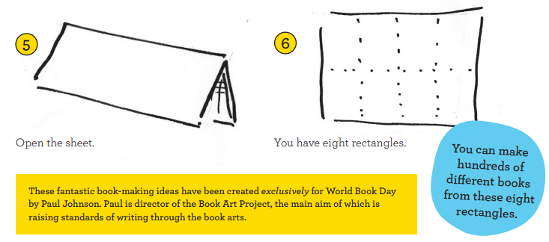
Day 2 | English
Today, you need to plan your report about the monster you have created. Use the gird below to help you.
Underlying structure - Jot down your ideas in note form
Type of Monster  Name the monster after yourself e.g. The Maria Monster | _______________________________________
What is it?  Tell the reader what type of monster it is | _______________________________________  _______________________________________  _______________________________________
Appearance  Information about what your monster looks like | _______________________________________  _______________________________________  _______________________________________  _______________________________________
Habitat  Information about where your monster lives | _______________________________________  _______________________________________  _______________________________________  _______________________________________
Diet  Information about what your monster likes to eat | _______________________________________  _______________________________________  _______________________________________  _______________________________________
What they do  Information about what your monster likes to do | _______________________________________  _______________________________________  _______________________________________  _______________________________________
Fast Facts  Some fascinating facts about your monster | _______________________________________  _______________________________________  _______________________________________  _______________________________________
Monster Advice  Any useful tips to give to your reader | _______________________________________  _______________________________________  _______________________________________  _______________________________________

Day 2 | Maths
Today’s video: https://vimeo.com/511155603
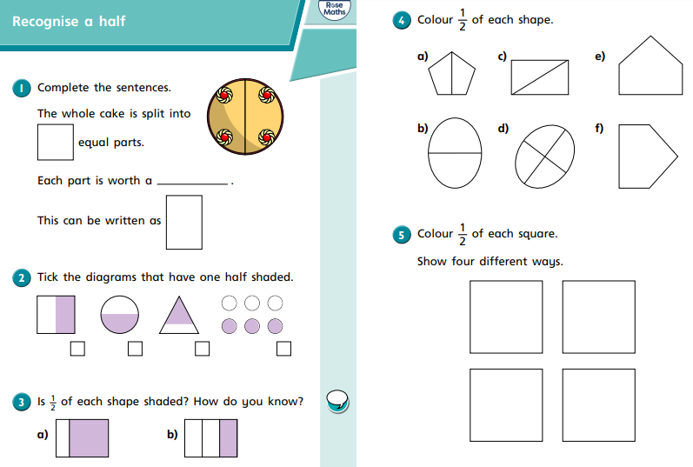
Day 2 | Maths
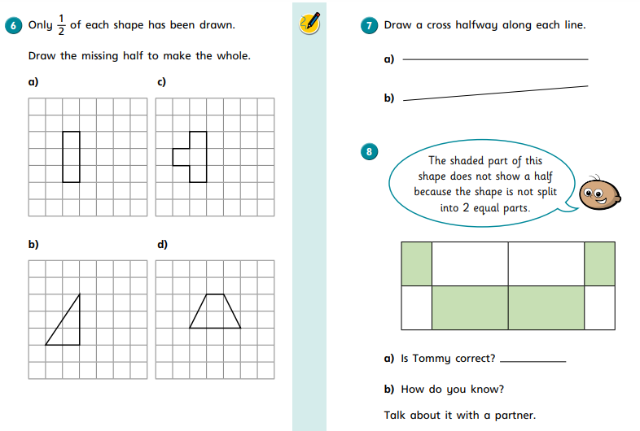

Day 2 | Flashback 4
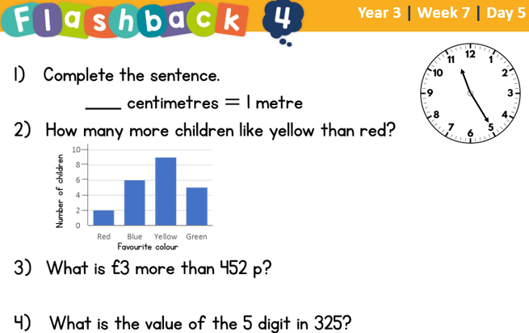
Day 2 | GPS

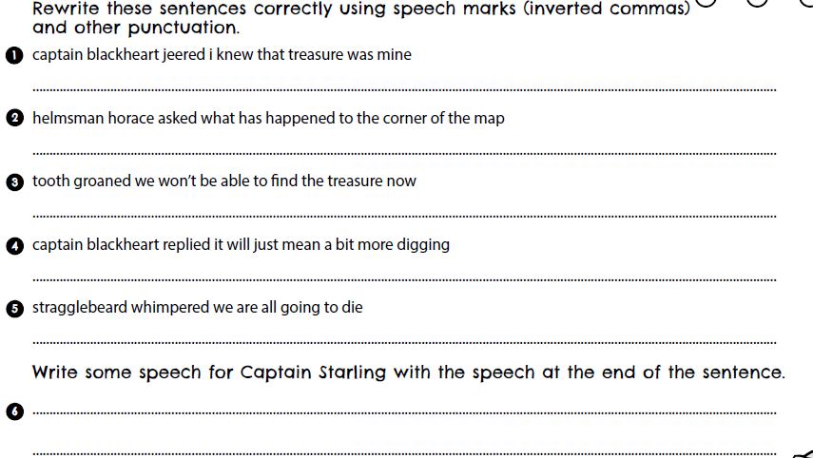

Day 2 | Topic
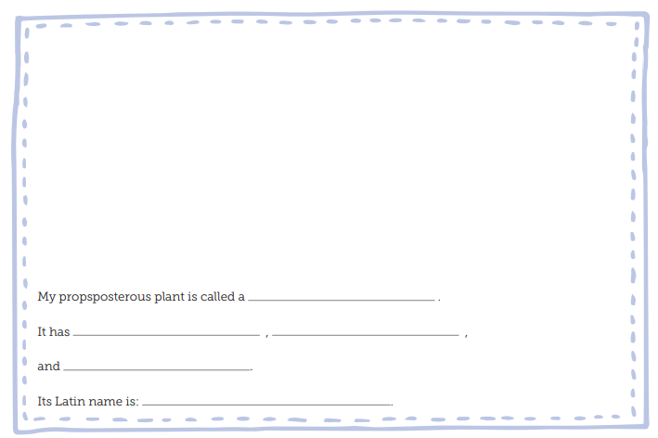
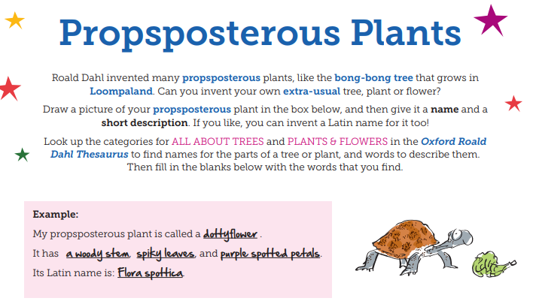
Day 3 | English
Use the sentence starters below to help you plan your report. Use your boxing up grid from Day 2 to help you!

What is a ___________monster?
A ___________ monster is … ____________________________________
___________________________________________________________
Appearance:
Most ___________ monsters are_________________________________
___________________________________________________________ However, some ________________________________________________
___________________________________________________________
All ___________ monsters _____________________________________
___________________________________________________________
Amazingly, some ___________ monsters have _______________________
___________________________________________________________
Habitat:
___________monsters are found _________________________________
___________________________________________________________
However, some ___________ monsters prefer _______________________
___________________________________________________________
What do they eat?
All ___________ monsters are __________________________________
___________________________________________________________
Furthermore, a small minority of ___________ monsters _______________
___________________________________________________________
Surprisingly, ___________ monsters love ___________________________
___________________________________________________________
Day 3 | English
What do they do?
___________ monsters are best known for __________________________
___________________________________________________________
However, they are also __________________________________________
___________________________________________________________
Finally, ___________ monsters are ________________________________
___________________________________________________________
Fast Facts
1. _________________________________________________________
2.__________________________________________________________
3.__________________________________________________________
4.__________________________________________________________
5. _________________________________________________________
Monster advice
If you happen to meet a ___________monster _______________________
___________________________________________________________.

Day 3 | Maths
Today’s video: https://vimeo.com/511156128
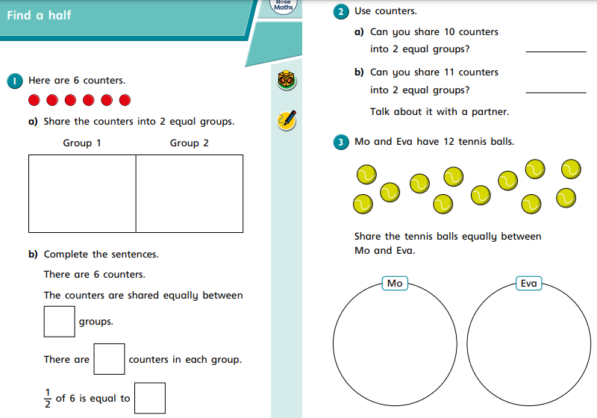
Day 3 | Maths
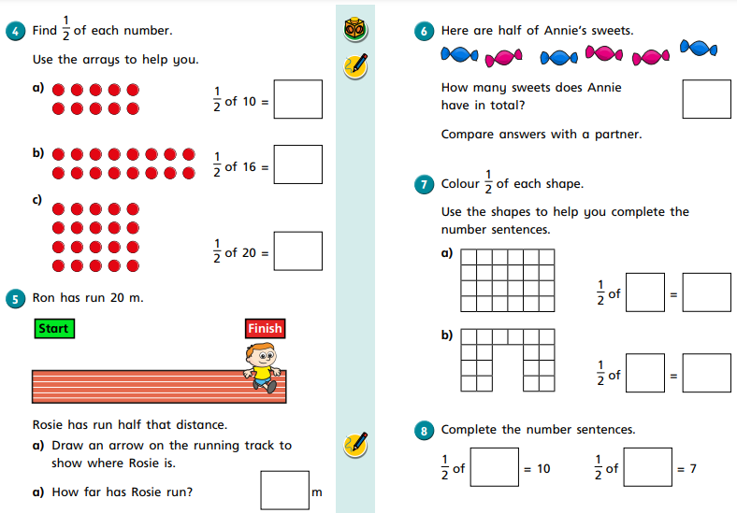
Day 3 | Flashback 4
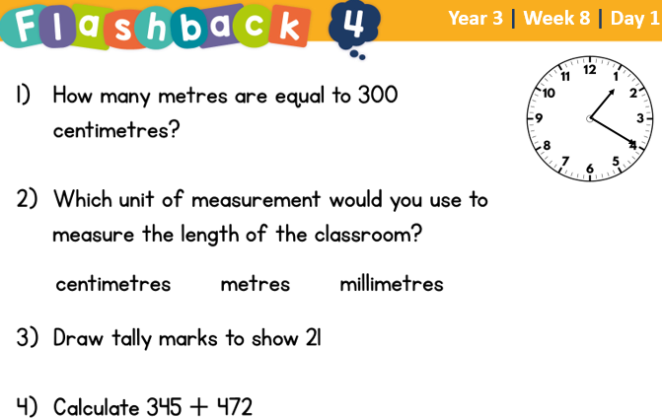

Day 3 | Spellings

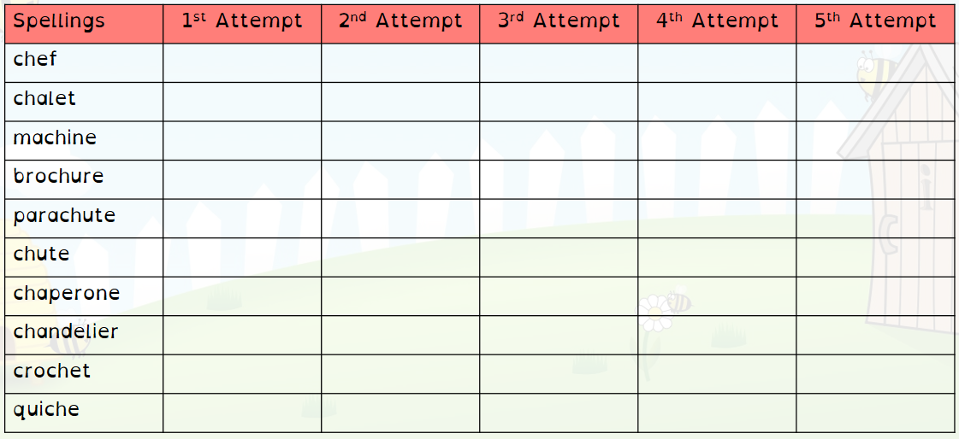
Day 3 | *Live Session with Your Teacher*

It’s live session day! Here are the times you need to be logged in for your classes’ live session:

3T – 1.05
4B – 1.30
3/4K – 2.00

Please be logged in by the time the meeting begins. Remember, we use TEAMS for our sessions. If you do not have it downloaded on your device, you can access it on the school website:

https://www.asquith.notts.sch.uk/home-learning/

If you’ve lost your child’s login information, please email your teacher for more information at least 15 minutes before the session begins.
Miss Thomas – sthomas@asquith.notts.sch.uk
Mr Bellamy – mbellamy@asquith.notts.sch.uk
Mrs Keim – mkeim@asquith.notts.sch.uk

Day 4 | English
Happy world book day!
Go onto our website: https://www.asquith.notts.sch.uk/key-stage-2/ to watch some of your favourite authors and illustrators talk about why WBD is so important.
We know that WBD is different this year and you might not get to do the usual things we enjoy but books can take us anywhere in the world if we use our imagination! Today, I’d like you to create a poem about where your imagination has taken you using books to inspire!
Example:
Today, I battled a dragon and rescued a princess.
Today, I conquered Lord Voldemort and met Harry Potter.

See how many things you can do today with your imagination!
Use the space below to plan your ideas then write up your best copy and draw a picture to go with your poem. There will be a prize for the best poem// illustration.

Planning space:
What famous books can you think of that you can use in your poem? You can use the internet to get ideas.

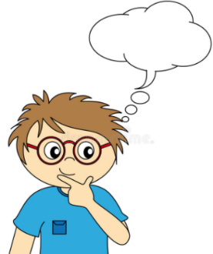

Day 4 | English

Name: __________________
Today I read a book
__________________________________________________________________________________________________________________________________________________________________________________________________________________________________________________________________________________________________________________________________________________________________________________________________________________________________________________________________________________________________________________________________________________________________________________________________________________________________________________________________________________________________________________________________________________________________________________________________________________________________________________________
Day 4 | Maths
World book day Maths!

Working out room
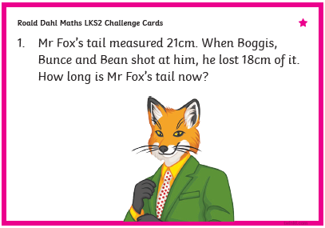
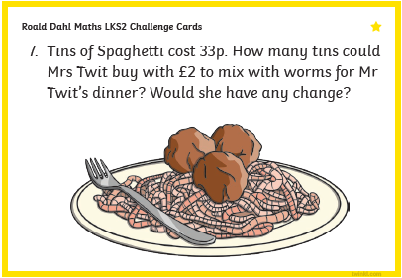
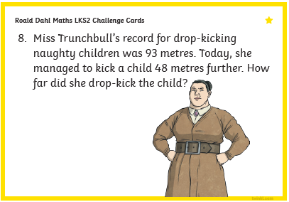
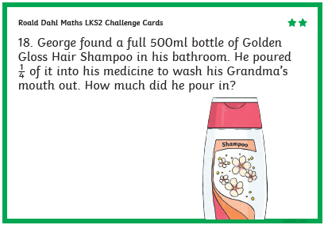
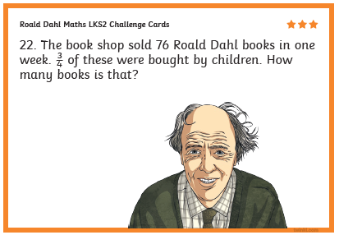

Day 4 | Flashback 4
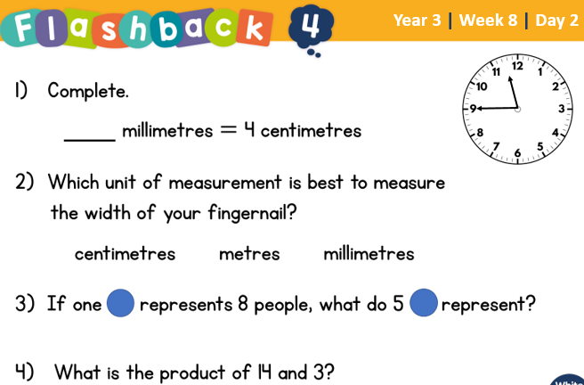

Day 4 | Reading Comprehension
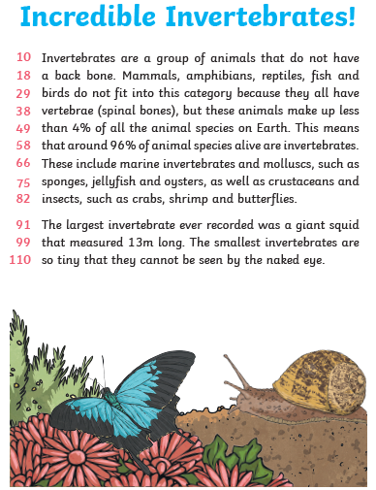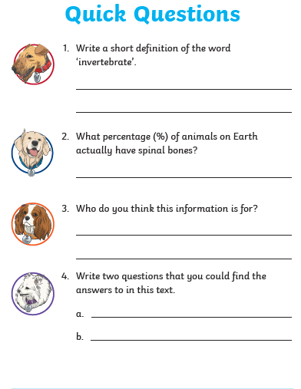
Day 4 | Topic
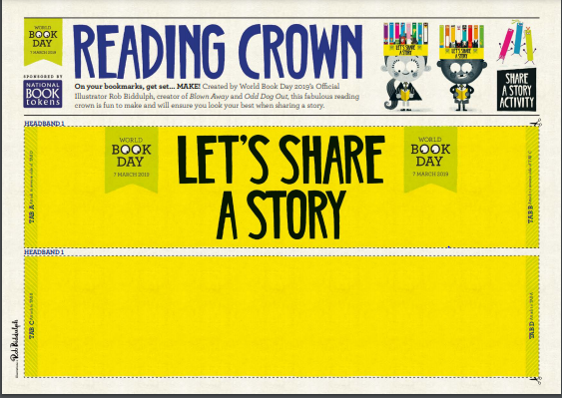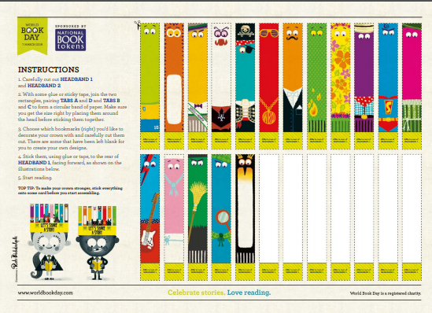

Day 5 | English
Using your work from Day 1, Day 2 and Day 3, write your final report about your monster below. Your work should take up the whole page and possibly another page too. You need to cover all the sections in the boxing up grid.

Title:___________________

Day 5 | English
Day 5 | Maths
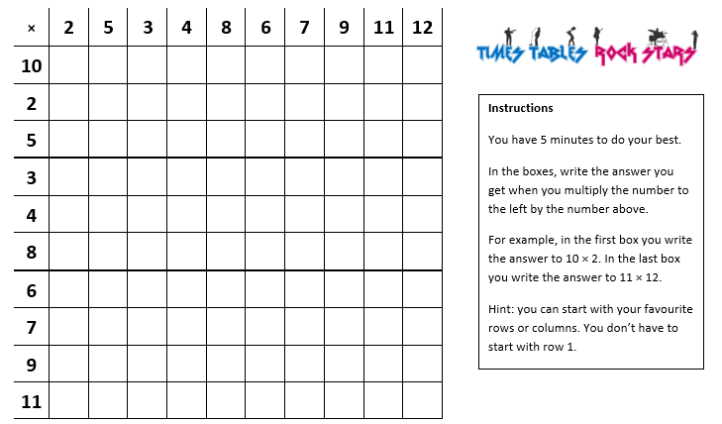
Once complete, spend atleast 30 minutes on TTRockstars. Get in touch with your teacher if you can’t remember your log in details.

Day 5 | Flashback 4
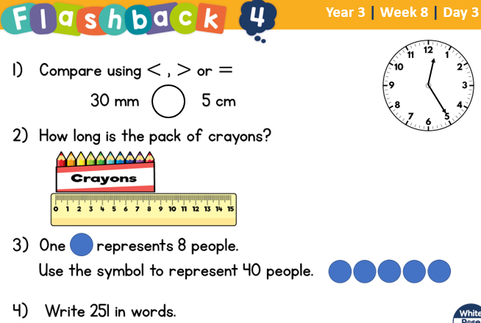

Day 5 | GPS

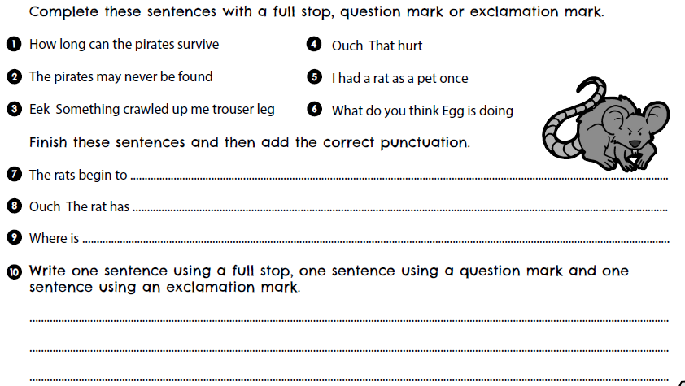
Day 5 | Topic
Create a review of your favourite book with illustration and star rating!
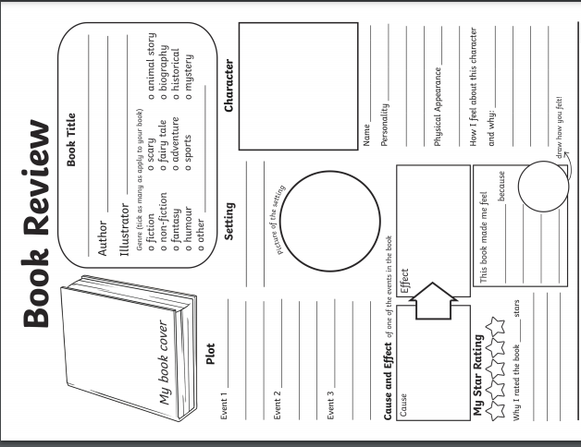
Read your book review to an adult or sibling. Try your best to persuade them to read it themselves!
Optional Projects

Want to absolutely confuse and ‘confuddle’ your brother, sister or adult?
Grab your favourite reading book and choose a section to focus on. Listen carefully, as here is your task! While reading the extract you have to change adjectives, verbs and nouns to make your brother, sister or adult laugh out loud!

For example:

Captain Underpants flew through the sky with the grace of an eagle, while spying people in trouble far down below. “I can use my superpowers to help those citizens!” he exclaimed, as he glided headfirst into a particularly fluffy cloud. Having regained his composure, and sense of direction, he swooped down towards those helpless people, and with a mighty punch, that even Thor would be proud of, the menacing minion was blasted into the stratosphere. “Yay!” cried the crowd. “Captain Underpants is our hero!”

Colonel Undercrackers swam through the jelly with the gentle flow of a baboon, while listening to cats croon just around the corner. “I can employ my marshmallow pants to help those feisty felines!” he sang, as he slid feet-first into an angry sausage. Having got back his bearings, and with the little birds now stopped flying above his head – cartoon style – he beamed down towards the commotion, and with a humungous burp, blasted the cantankerous cats into next Christmas. “Woof!” yelled the canines. “Colonel Undercrackers dogs’ best friend!”
Create a World Book Day rap!  Watch this video from World Book Day 2017 for some inspiration:  https://www.youtube.com/watch?v=No4EUYkJME0 | Imagine that the characters from two different books meet in the same story. What might they get up to? Write a story and ‘wow’ your grown-ups with such an inventive narrative!  For example:  Harry Potter hangs out with the Gruffalo  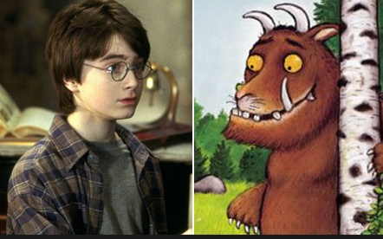
Choose one of your sibling’s books, one that you would never, ever, ever, ever, ever read! I dare you! Have a go at reading it, you might be pleasantly surprised that you are enjoying it.  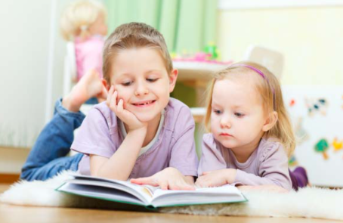 | Invite an adult to read to you. They can choose anything that is appropriate for you to listen to. Think about how the text is being read to you. Could you read it better? Have a go! Have a conversation about the text. Ask each other questions about it.
Finished your work but still need something to do?
Check out these educational websites below:

Educational games
https://www.bbc.co.uk/cbeebies/games
Want to learn how to type properly on a keyboard?
https://www.typingclub.com/
Learn coding online
https://scratch.mit.edu/
Maths Games
https://www.topmarks.co.uk/maths-games/7-11-years/ordering-and-sequencing
Learn your maths facts fast!
https://www.topmarks.co.uk/maths-games/hit-the-button
Primary Games
https://www.bbc.co.uk/bitesize/collections/primary-games/1
Love music? Play these instruments online:
https://www.virtualmusicalinstruments.com/
Loads of maths challenges:
http://www.mathematicshed.com/
Loads of literacy things:
https://www.literacyshedplus.com/en-gb#resources
Like maths challenges? Try these!
https://www.transum.org/Software/SW/Starter_of_the_day/index.htm
Do you love to write? Check out this picture site, choose a picture and write, write, write!
https://www.onceuponapicture.co.uk/
List of sites/games
https://www.popsugar.co.uk/parenting/free-online-educational-resources-for-kids-47312329

Some of these websites are updated daily. Check them out every day!

*Found another website that you want to share with other students? Email it to your teacher and we’ll add it to the list!*

