Name: Class:
Dahl
Workbook:
World Book Day

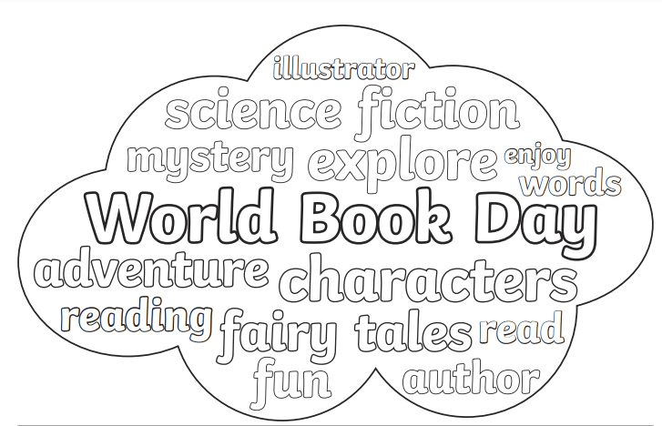

Contents
Day 1 | English – 45 minutes
Day 1 | Maths – 45 minutes
Day 1 | Flashback 4 – 5 minutes
Day 1 | Reading Comprehension – 30 minutes
Day 1 | Topic– 45 minutes
Day 2 | English – 45 minutes
Day 2 | Maths – 45 minutes
Day 2 | Flashback 4 – 5 minutes
Day 2 | GPS – 30 minutes
Day 2 | Topic– 45 minutes
Day 3 | English – 45 minutes
Day 3 | Maths – 45 minutes
Day 3 | Flashback 4 – 5 minutes
Day 3 | Spellings – 30 minutes
Day 3 | *Live Session with Teacher*
Day 4 | English – 45 minutes
Day 4 | Maths – 45 minutes
Day 4 | Flashback 4 – 5 minutes
Day 4 | Reading Comprehension – 30 minutes
Day 4 | Topic– 45 minutes
Day 5 | English – 45 minutes
Day 5 | Maths – 45 minutes
Day 5 | Flashback 4 – 5 minutes
Day 5 | GPS – 30 minutes
Day 5 | Topic– 45 minutes
Optional Projects + Extra Educational Websites
Have you completed your weekly homework? |  | Date  Completed
Spellings Practise
On Spelling Shed or handwritten
Timetables Rock Stars Task
3 Reads (at least 10 minutes out loud with a grown-up)

OPTIONAL
Any comments or messages from grown-ups that you would like to share with your teacher:
Any comments or messages from the student that you would like to share with your teacher:
Day 1 | English
Watch the video: https://www.youtube.com/watch?v=94aFcx6oliY
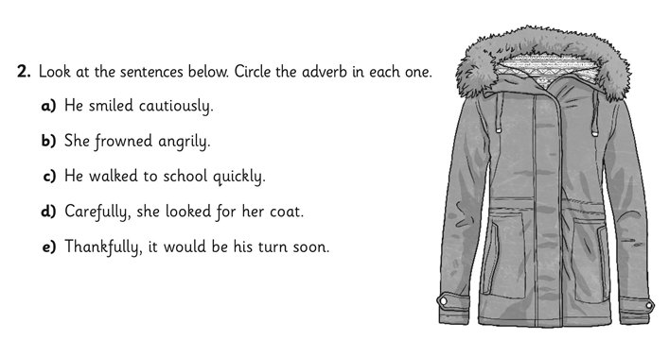
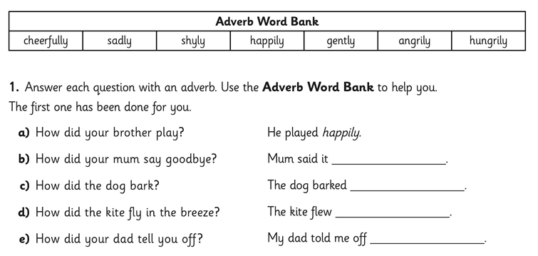
Write 2 sentences of your own containing adverbs
_____________________________________________________________________________________________________________________________________________________________________________________________________________________________________________________________________________________________________________________________________________________________________________________________________________________________

Day 1 | Maths
Today’s video: https://vimeo.com/510671507
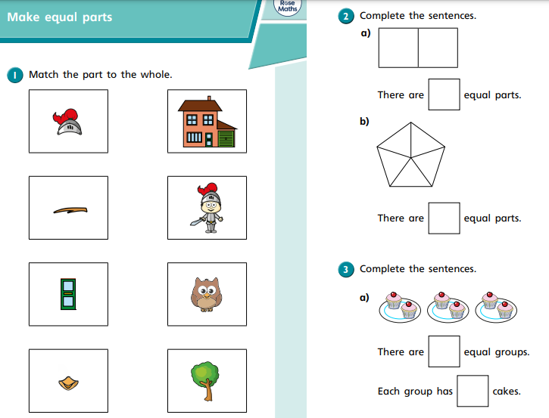
Day 1 | Maths
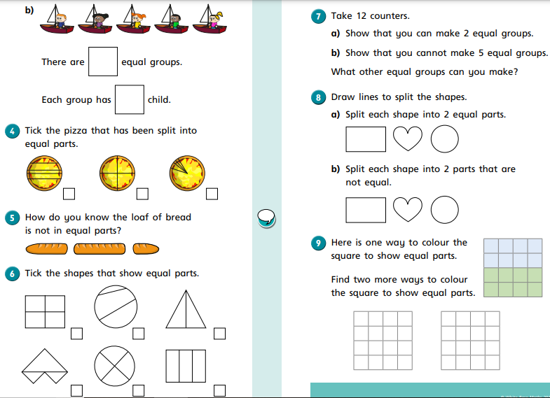

Day 1 | Flashback 4
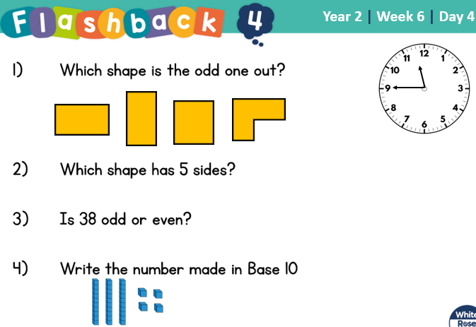


Day 1 | Reading Comprehension
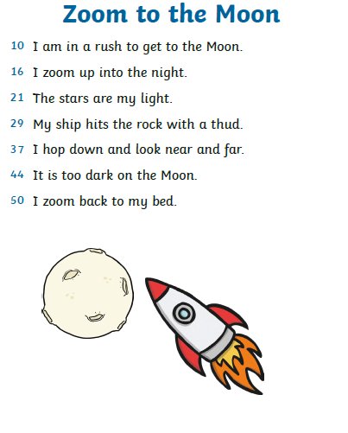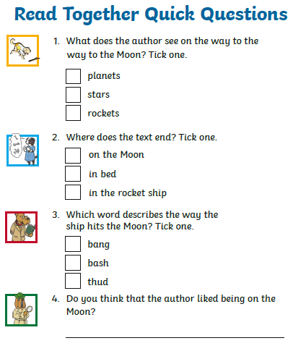
Day 1 | Topic
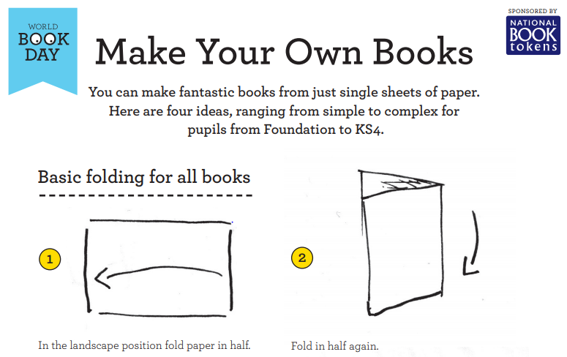
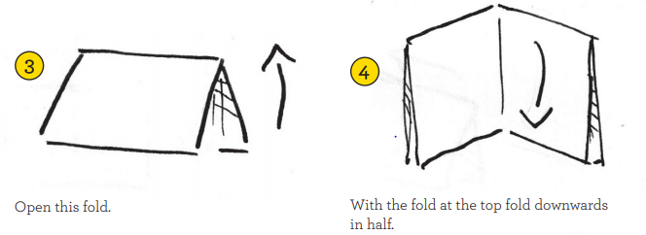
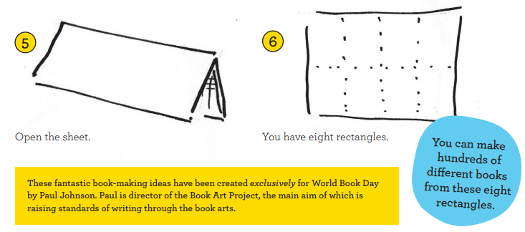

Day 2 | English

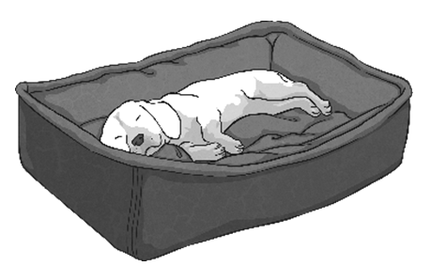
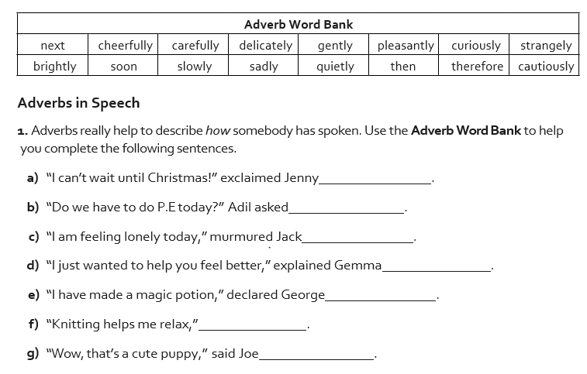
See if you can identify the correct adverb for the sentence.

Day 2 | Maths
Today’s video: https://vimeo.com/511155603
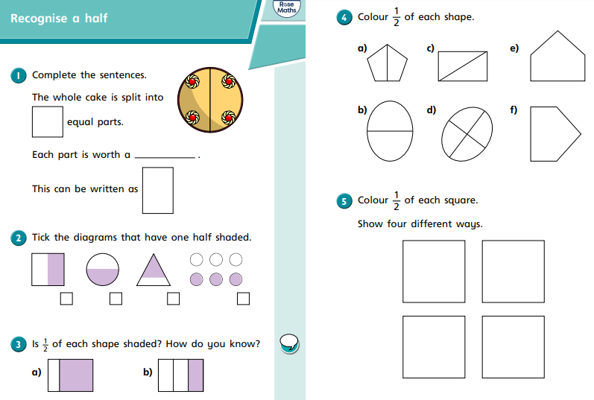

Day 2 | Maths
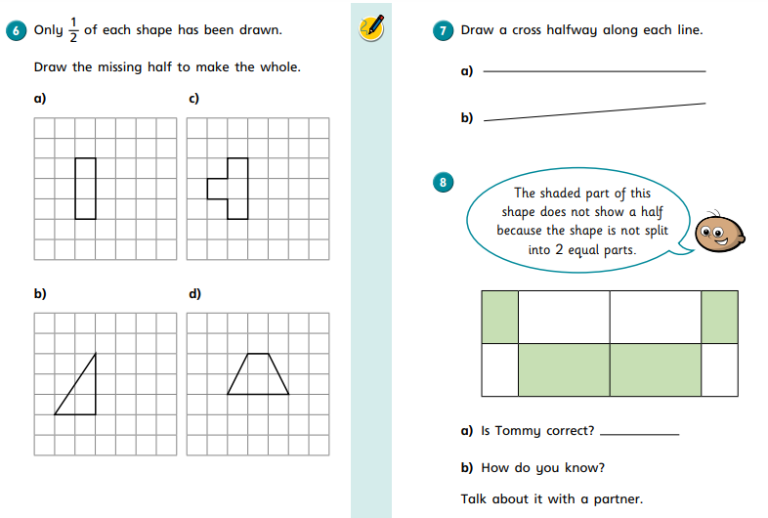
Day 2 | Flashback 4
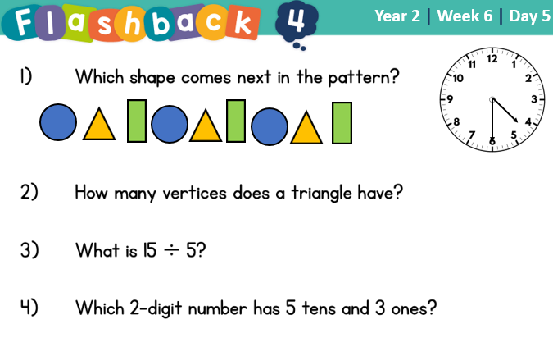
Day 2 | GPS

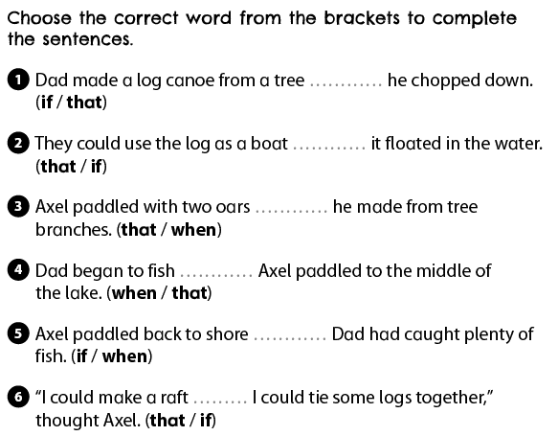

Day 2 | Topic
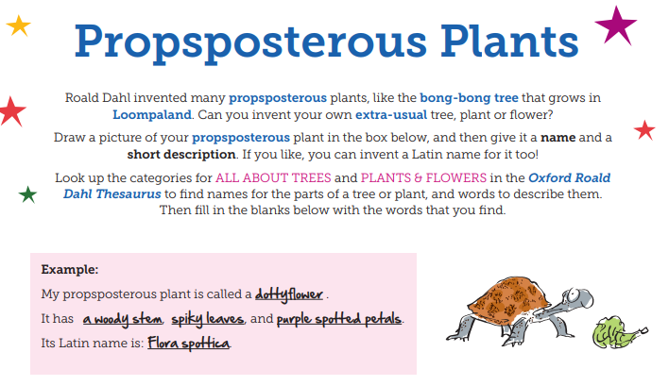
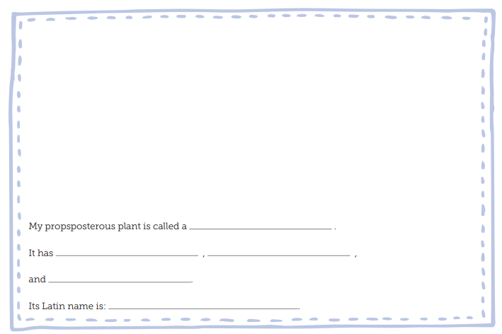
Day 3 | English
Watch this video to help you: https://www.youtube.com/watch?v=5z-f1O8sFas

Read the simple sentences, and then have a go at expanding them using adjectives and adverbs.
Adjectives describe nouns. Adverbs describe verbs.
- An owl hooted.

____________________________________________________________________________________________________________________________________________
- A boy shouted.

____________________________________________________________________________________________________________________________________________

- The witch laughed.

____________________________________________________________________________________________________________________________________________
- My uncle sneezed.

____________________________________________________________________________________________________________________________________________

- The teacher talked.

____________________________________________________________________________________________________________________________________________
- A dog barked.
____________________________________________________________________________________________________________________________________________

Day 3 | Maths
Today’s video: https://vimeo.com/511156128
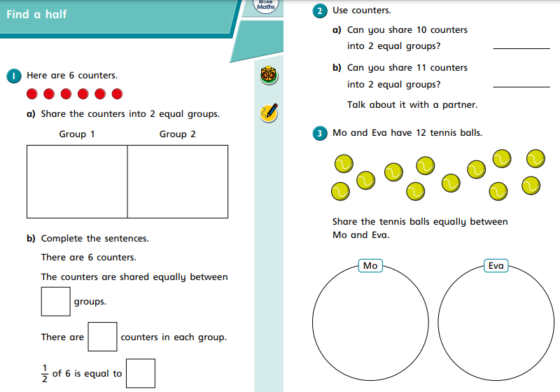
Day 3 | Maths
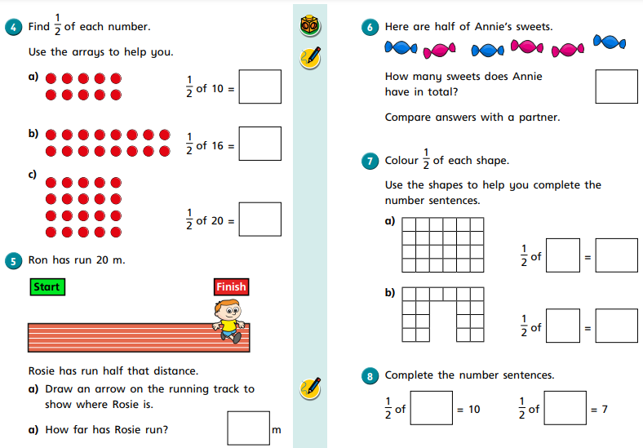

Day 3 | Flashback 4
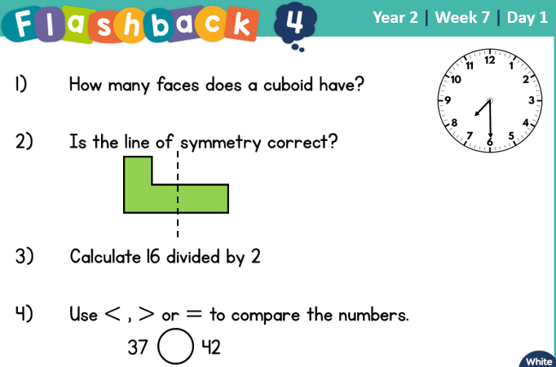

Day 3 | Spellings

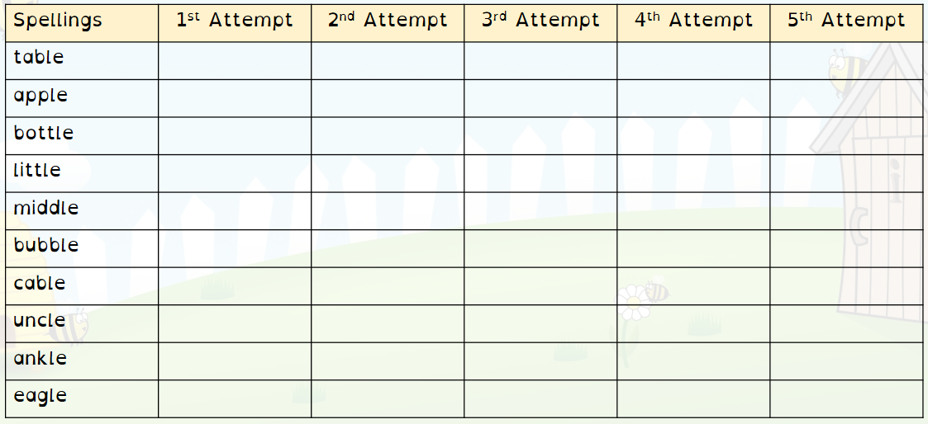
Day 3 | *Live Session with Your Teacher*

It’s live session day! Here are the times you need to be logged in for your classes’ live session:

3T – 1.05
4B – 1.30
3/4K – 2.00

Please be logged in by the time the meeting begins. Remember, we use TEAMS for our sessions. If you do not have it downloaded on your device, you can access it on the school website:

https://www.asquith.notts.sch.uk/home-learning/

If you’ve lost your child’s login information, please email your teacher for more information at least 15 minutes before the session begins.
Miss Thomas – sthomas@asquith.notts.sch.uk
Mr Bellamy – mbellamy@asquith.notts.sch.uk
Mrs Keim – mkeim@asquith.notts.sch.uk

Day 4 | English
Write your own sentences using one of the adverbs below in each sentence. Ensure you remember your capital letters and full stops!
1.
____________________________________________________________________________________________________________________________________________
2.
____________________________________________________________________________________________________________________________________________
3.
____________________________________________________________________________________________________________________________________________
4.
____________________________________________________________________________________________________________________________________________
5.
____________________________________________________________________________________________________________________________________________
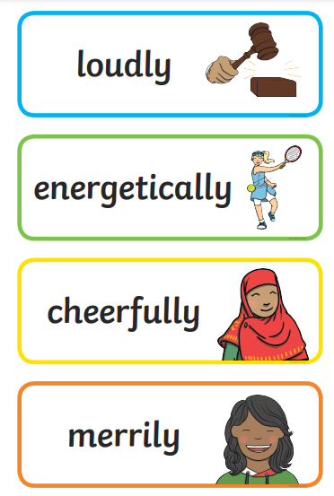
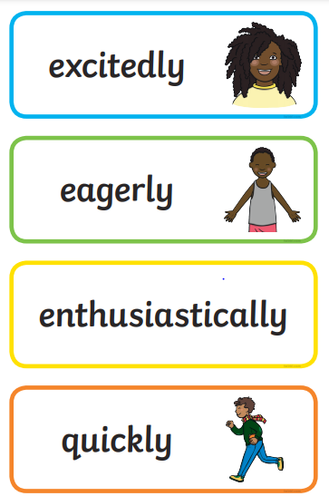

Day 4 | Maths
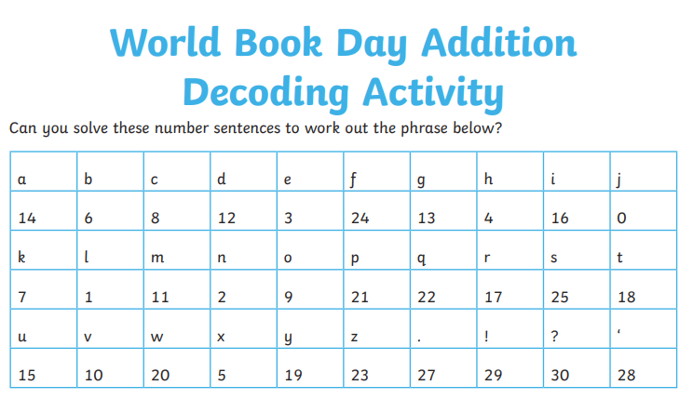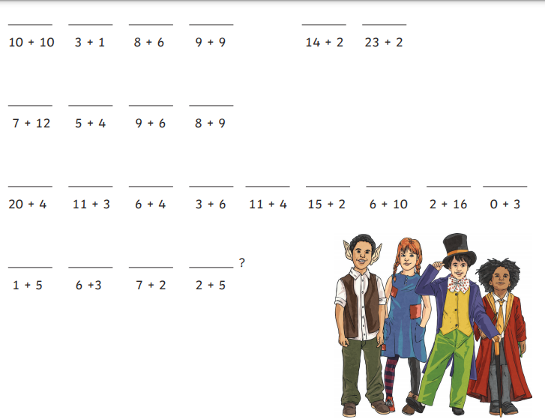
Day 4 | Flashback 4
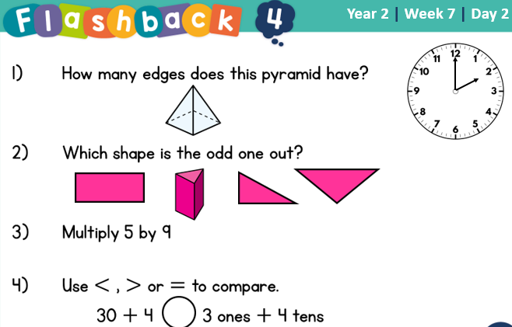

Day 4 | Reading Comprehension
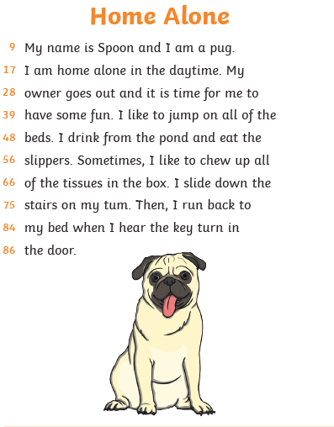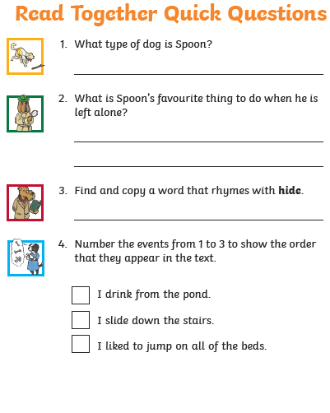
Day 4 | Topic
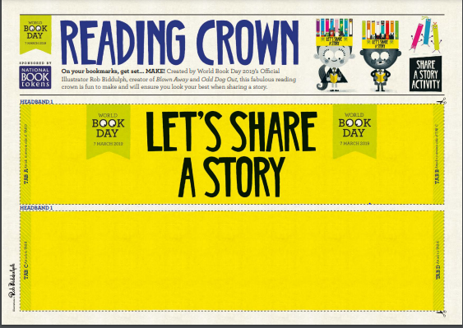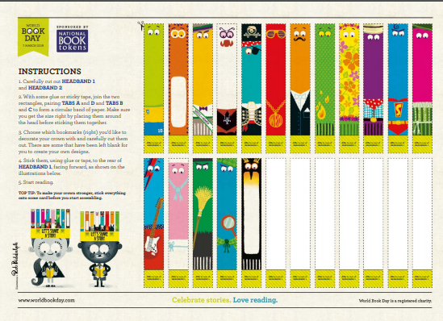

Day 5 | English
Using what you know about nouns, adjectives, verbs and adverbs, write a short story about the following picture:


Day 5 | Maths
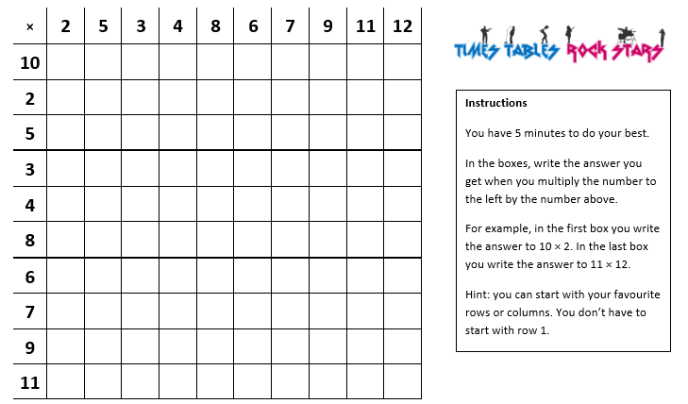 Once complete, spend atleast 30 minutes on TTRockstars. Get in touch with your teacher if you can’t remember your log in details.

Day 5 | Flashback 4
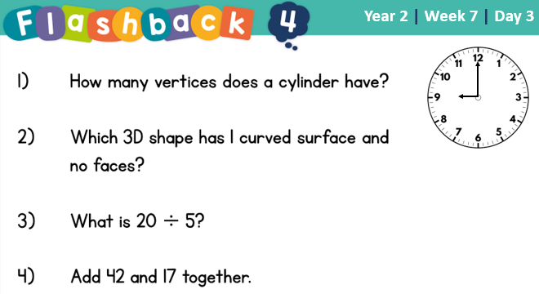

Day 5 | GPS

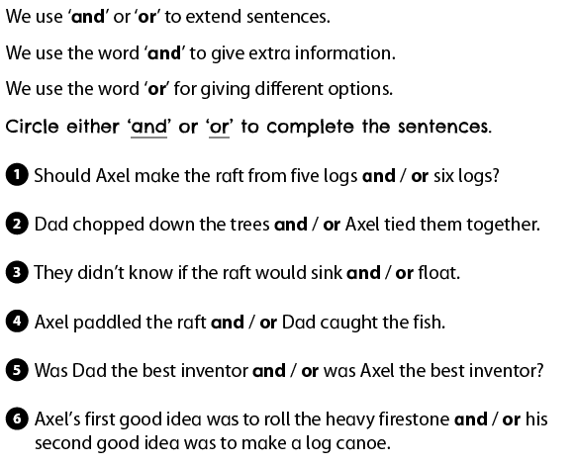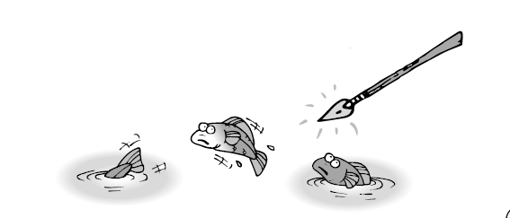
Day 5 | Topic
Create a review of your favourite book with illustration and star rating!
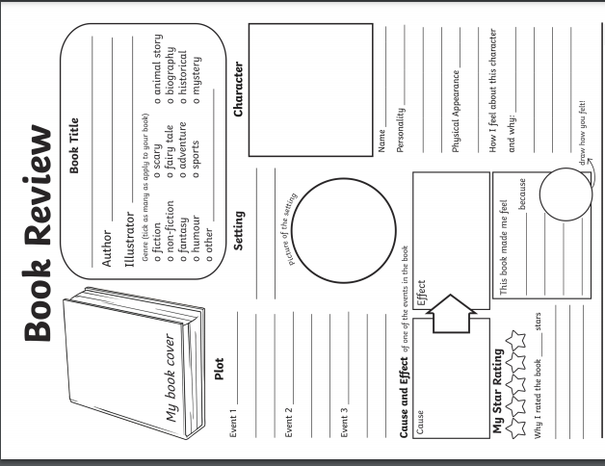
Read your book review to an adult or sibling. Try your best to persuade them to read it themselves!
Optional Projects

Want to absolutely confuse and ‘confuddle’ your brother, sister or adult?
Grab your favourite reading book and choose a section to focus on. Listen carefully, as here is your task! While reading the extract you have to change adjectives, verbs and nouns to make your brother, sister or adult laugh out loud!

For example:

Captain Underpants flew through the sky with the grace of an eagle, while spying people in trouble far down below. “I can use my superpowers to help those citizens!” he exclaimed, as he glided headfirst into a particularly fluffy cloud. Having regained his composure, and sense of direction, he swooped down towards those helpless people, and with a mighty punch, that even Thor would be proud of, the menacing minion was blasted into the stratosphere. “Yay!” cried the crowd. “Captain Underpants is our hero!”

Colonel Undercrackers swam through the jelly with the gentle flow of a baboon, while listening to cats croon just around the corner. “I can employ my marshmallow pants to help those feisty felines!” he sang, as he slid feet-first into an angry sausage. Having got back his bearings, and with the little birds now stopped flying above his head – cartoon style – he beamed down towards the commotion, and with a humungous burp, blasted the cantankerous cats into next Christmas. “Woof!” yelled the canines. “Colonel Undercrackers dogs’ best friend!”
Create a World Book Day rap!  Watch this video from World Book Day 2017 for some inspiration:  https://www.youtube.com/watch?v=No4EUYkJME0 | Imagine that the characters from two different books meet in the same story. What might they get up to? Write a story and ‘wow’ your grown-ups with such an inventive narrative!  For example:  Harry Potter hangs out with the Gruffalo  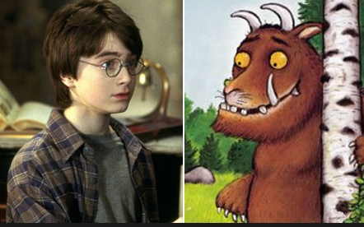
Choose one of your sibling’s books, one that you would never, ever, ever, ever, ever read! I dare you! Have a go at reading it, you might be pleasantly surprised that you are enjoying it.   | Invite an adult to read to you. They can choose anything that is appropriate for you to listen to. Think about how the text is being read to you. Could you read it better? Have a go! Have a conversation about the text. Ask each other questions about it.
Finished your work but still need something to do?
Check out these educational websites below:

Educational games
https://www.bbc.co.uk/cbeebies/games
Want to learn how to type properly on a keyboard?
https://www.typingclub.com/
Learn coding online
https://scratch.mit.edu/
Maths Games
https://www.topmarks.co.uk/maths-games/7-11-years/ordering-and-sequencing
Learn your maths facts fast!
https://www.topmarks.co.uk/maths-games/hit-the-button
Primary Games
https://www.bbc.co.uk/bitesize/collections/primary-games/1
Love music? Play these instruments online:
https://www.virtualmusicalinstruments.com/
Loads of maths challenges:
http://www.mathematicshed.com/
Loads of literacy things:
https://www.literacyshedplus.com/en-gb#resources
Like maths challenges? Try these!
https://www.transum.org/Software/SW/Starter_of_the_day/index.htm
Do you love to write? Check out this picture site, choose a picture and write, write, write!
https://www.onceuponapicture.co.uk/
List of sites/games
https://www.popsugar.co.uk/parenting/free-online-educational-resources-for-kids-47312329

Some of these websites are updated daily. Check them out every day!

*Found another website that you want to share with other students? Email it to your teacher and we’ll add it to the list!*

