Name: Class:

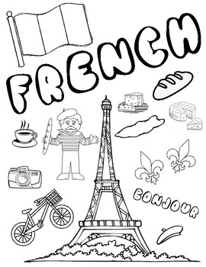

Dahl
Workbook:
Adventures

Contents
Day 1 | English – 45 minutes
Day 1 | Maths – 45 minutes
Day 1 | Flashback 4 – 5 minutes
Day 1 | Reading Comprehension – 30minutes
Day 1 | Topic– 45 minutes
Day 2 | English – 45 minutes
Day 2 | Maths – 45 minutes
Day 2 | Flashback 4 – 5 minutes
Day 2 | GPS – 30 minutes
Day 2 | Topic– 45 minutes
Day 3 | English – 45 minutes
Day 3 | Maths – 45 minutes
Day 3 | Flashback 4 – 5 minutes
Day 3 | Spellings – 30 minutes
Day 3 | *Live Session with your Teacher*
Day 4 | English – 45 minutes
Day 4 | Maths – 45 minutes
Day 4 | Flashback 4 – 5 minutes
Day 4 | Reading Comprehension – 30 minutes
Day 4 | Topic– 45 minutes
Day 5 | English – 45 minutes
Day 5 | Maths – 45 minutes
Day 5 | Flashback 4 – 5 minutes
Day 5 | GPS – 30 minutes
Day 5 | Topic– 45 minutes
Optional Projects + Extra Educational Websites
Have you completed your weekly homework? |  | Date  Completed
Spellings Practise
On Spelling Shed or handwritten
Timetables Rock Stars Task
3 Reads (at least 10 minutes out loud with a grown-up)

OPTIONAL
Any comments or messages from grown-ups that you would like to share with your teacher:
Any comments or messages from the student that you would like to share with your teacher:
Day 1 | English
Can you help fix these simple sentences? There is either spelling mistakes, punctuations mistakes or they do not make sense! Put up your super helper cape and solve this problem!
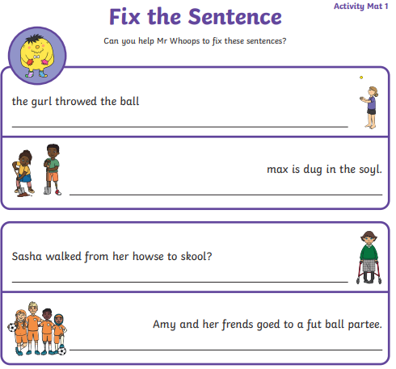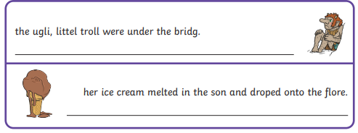
Day 1 | Maths
Today’s video: https://vimeo.com/501669795
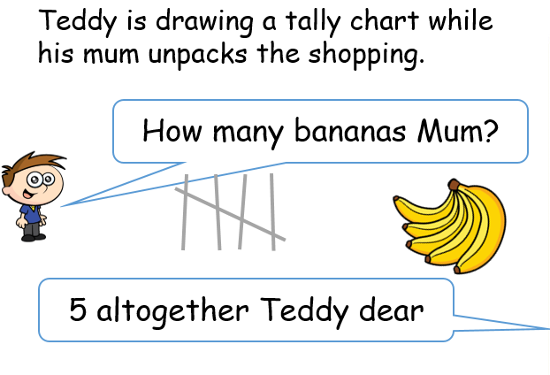
Can you help Teddy count how much other fruit mum has bought? Remember to represent your numbers as a tally.
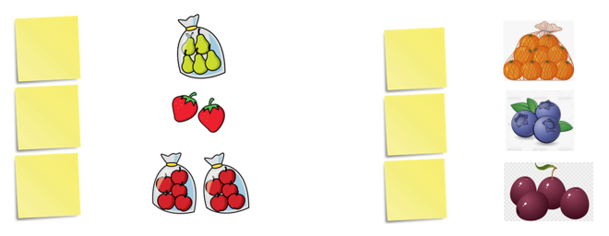
Day 1 | Maths
Create your own tally!
Looking outside your window, can you count how many cars go past with these colours?
Fill in the tally below
Colour | Tally
White
Black
Red
silver
Other

Day 1 | Flashback 4
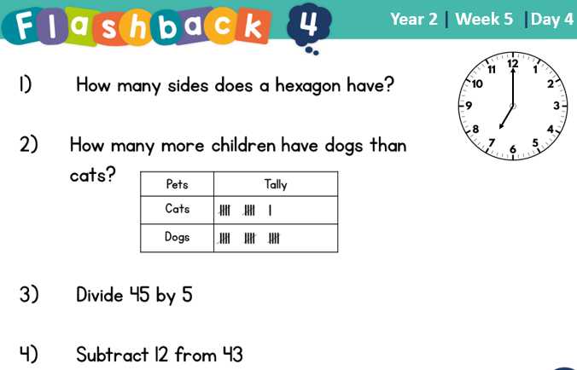


Day 1 | Reading Comprehension
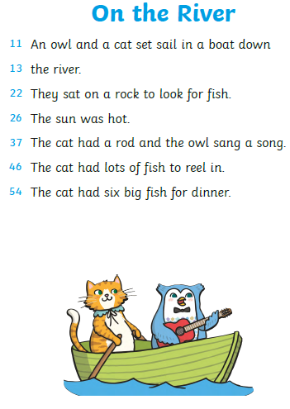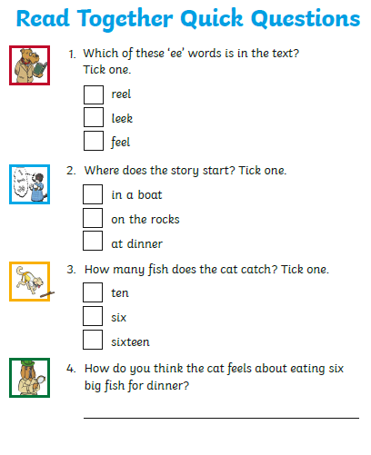
Day 1 | Topic
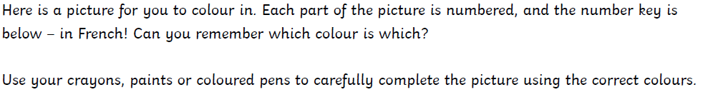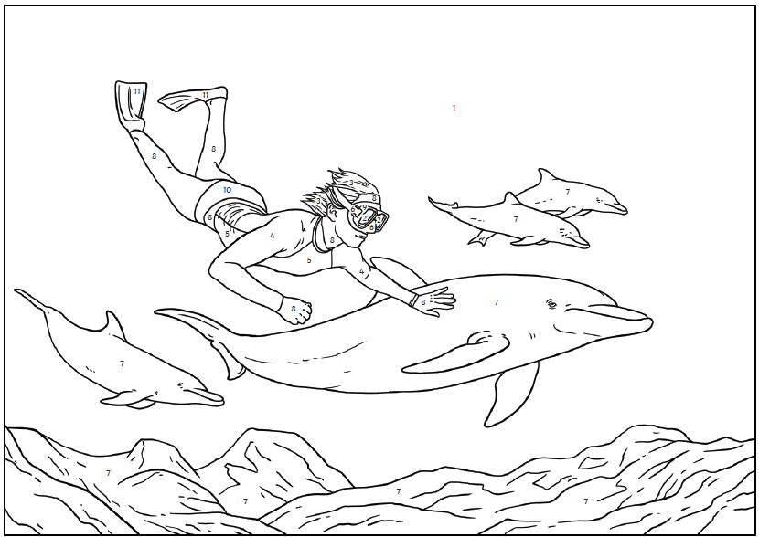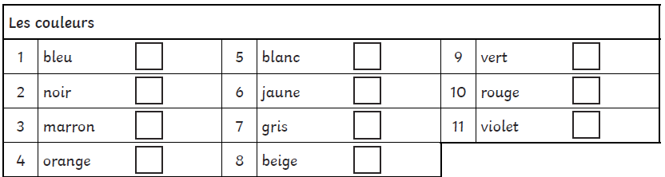
Colours – Take a long look at the splashes of colour and take a mental note of the French word. Complete the French colouring activity. Use Google if any of the colours are not there!
Watch the following video: https://www.youtube.com/watch?v=acvUtipaC5Y

Day 2 | English
Helpful video: https://www.youtube.com/watch?v=qxmcbB_H2TE
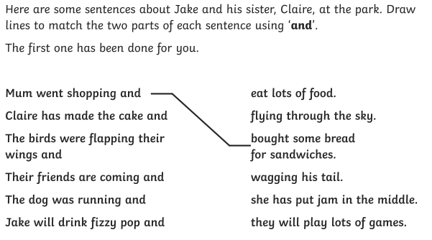
Now have a go at this: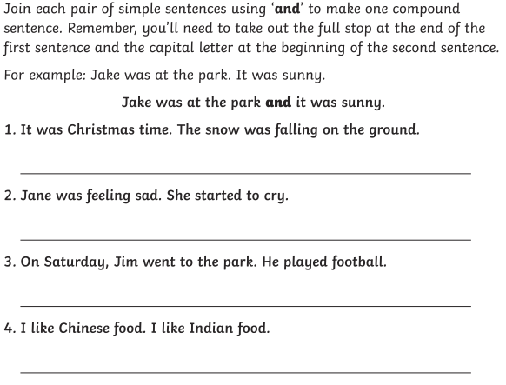

Day 2 | Maths
Today’s video: https://vimeo.com/501671369
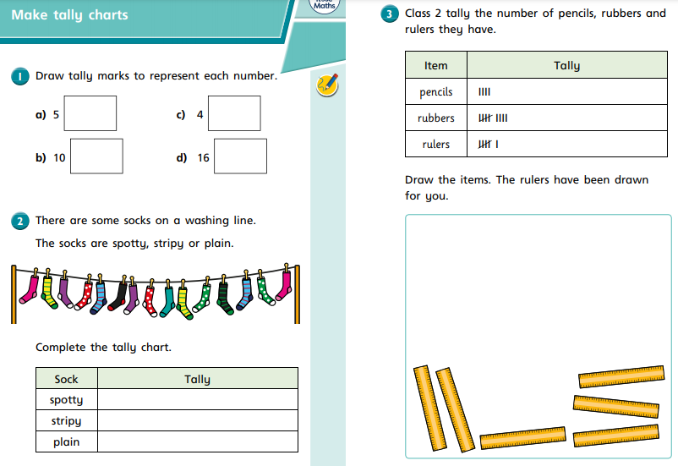

Day 2 | Maths
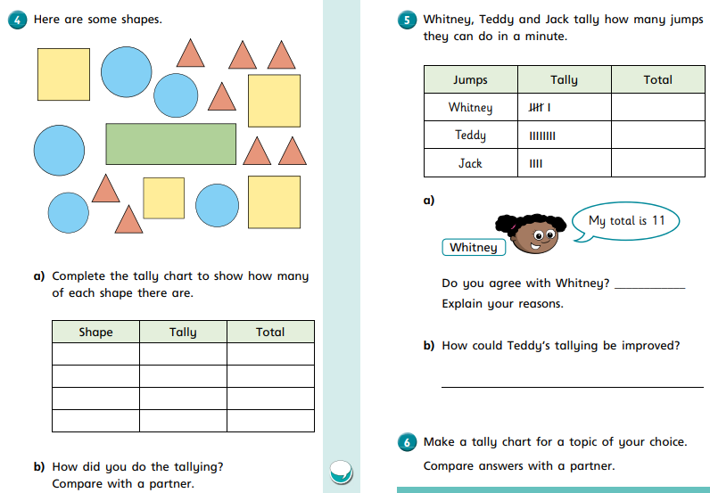

Day 2 | Flashback 4
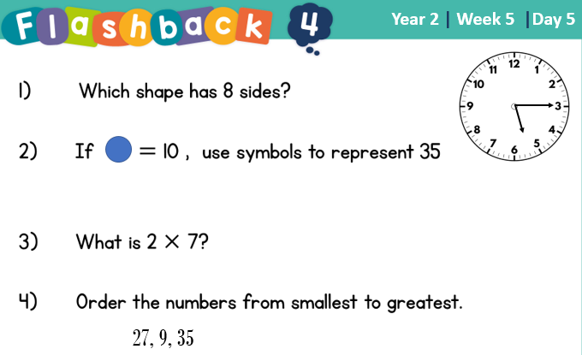
Day 2 | GPS

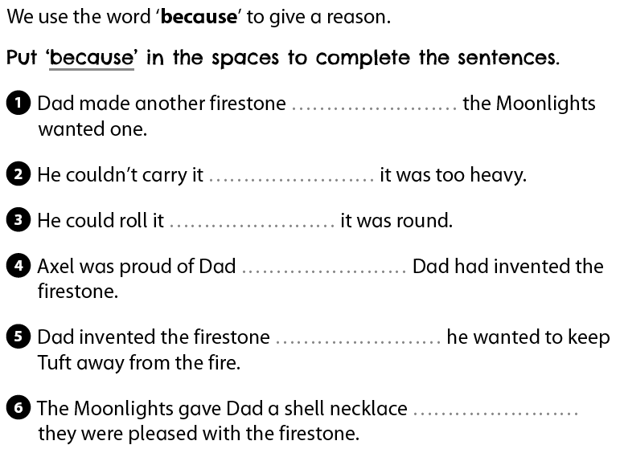
Day 2 | Topic
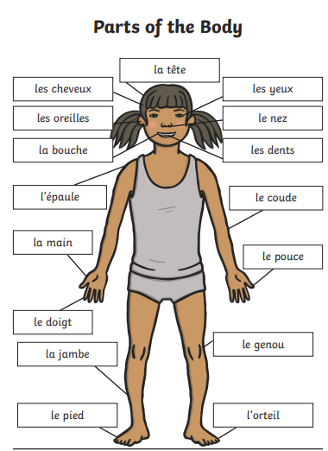
My body – Study the illustration of the human body and make a mental note of the French names for the body parts. Identify and write the correct French name in the gaps.

Watch the following video: https://www.youtube.com/watch?v=8PQr0hLXksI

Day 2 | Topic
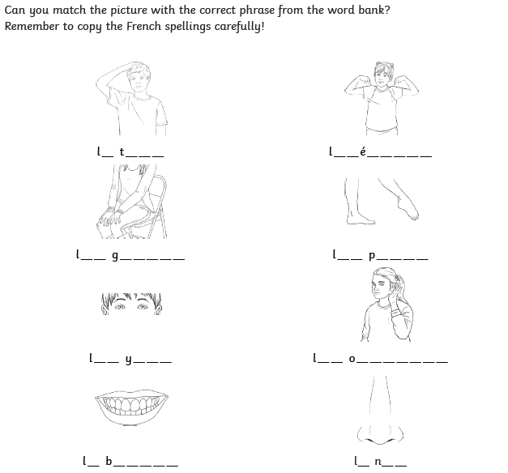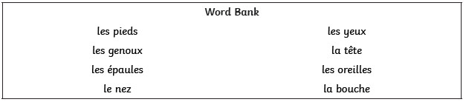

Day 3 | English
Helpful video: https://www.youtube.com/watch?v=o1PbHPSphwE
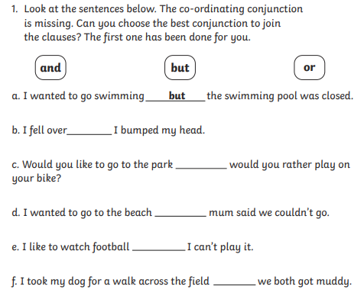
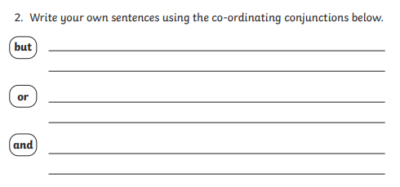

Day 3 | Maths
Today’s video: https://vimeo.com/501672753
Look at the flowers below, carefully counting how many of each flower there are.
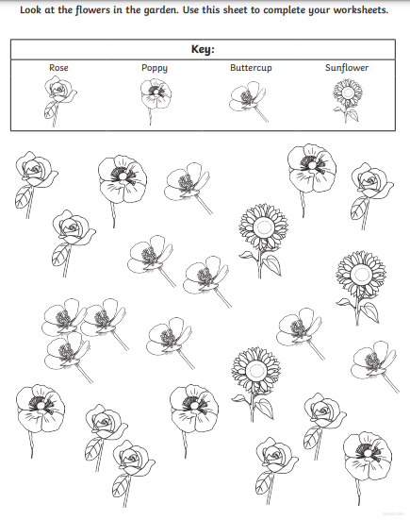

Day 3 | Maths

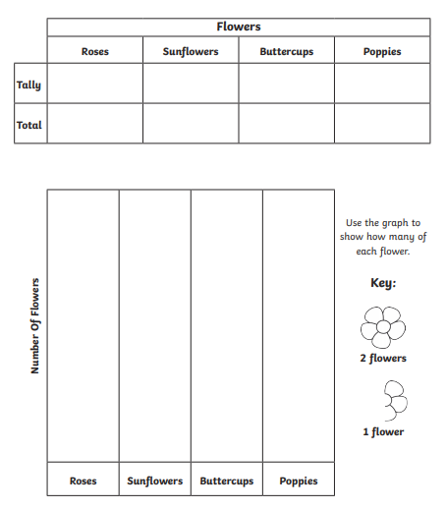 You can colour in the flowers when finished.

Day 3 | Flashback 4
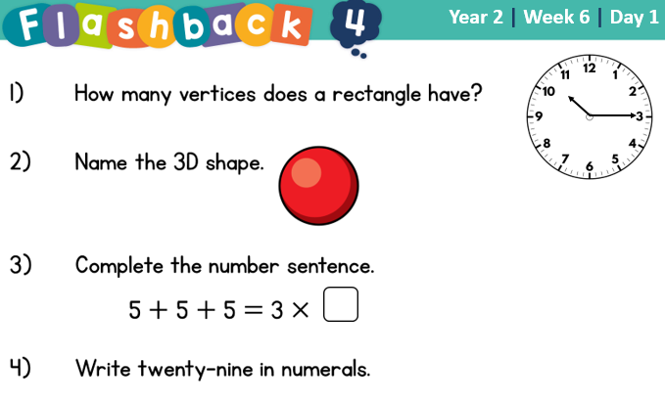

Day 3 | Spellings

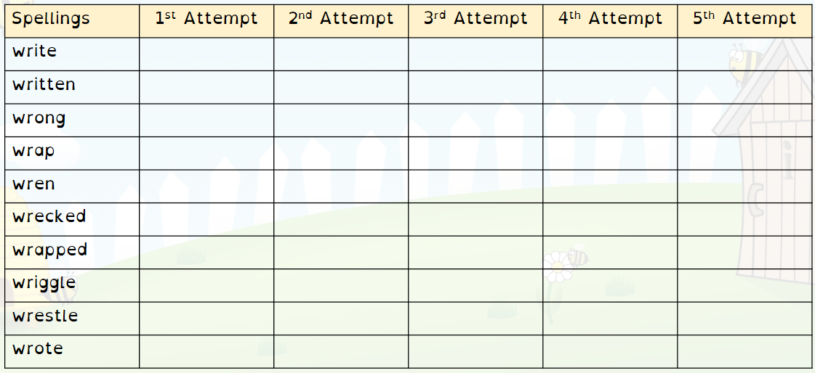
Day 3 | Live Session

It’s live session day! Here are the times you need to be logged in for your classes’ live session:

3T – 1.05
4B – 1.30
3/4K – 2.00

Please be logged in by the time the meeting begins. Remember, we use TEAMS for our sessions. If you do not have it downloaded on your device, you can access it on the school website:

https://www.asquith.notts.sch.uk/home-learning/

If you’ve lost your child’s login information, please email your teacher for more information.
Miss Thomas – sthomas@asquith.notts.sch.uk
Mr Bellamy – mbellamy@asquith.notts.sch.uk
Mrs Keim – mkeim@asquith.notts.sch.uk

Day 4 | English
Helpful video: https://www.youtube.com/watch?v=nNGiDfCX7PI
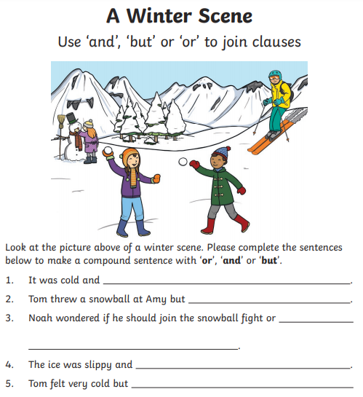 Create your own sentence for this picture using and, but, or.
________________________________________________________________________________________________________
Day 4 | Maths
Today’s video: https://vimeo.com/501673699
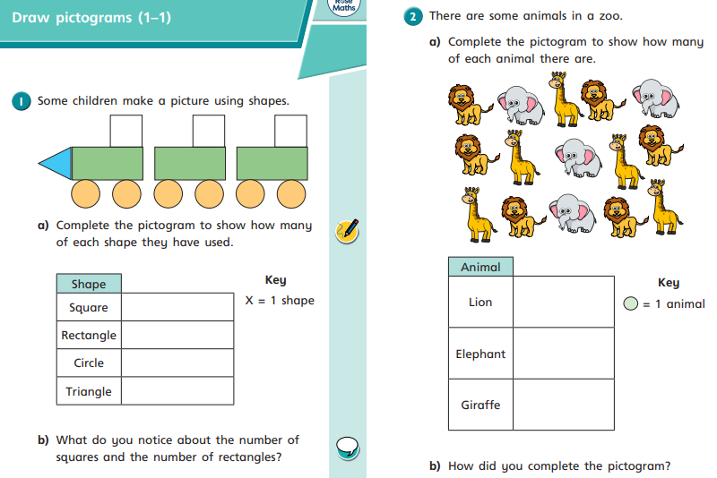
Day 4 | Maths
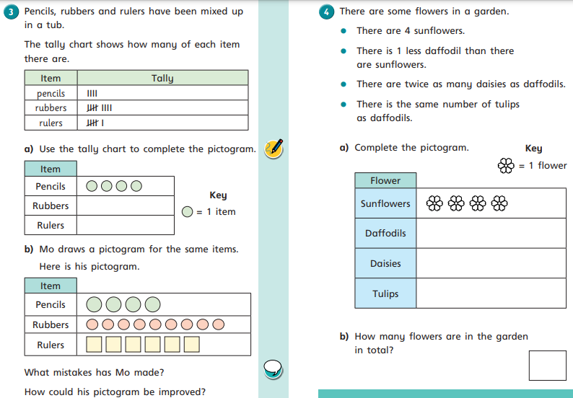

Day 4 | Flashback 4
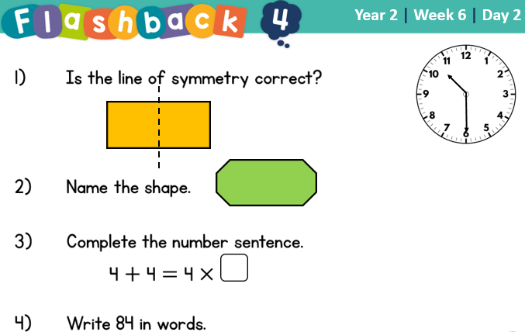

Day 4 | Reading Comprehension
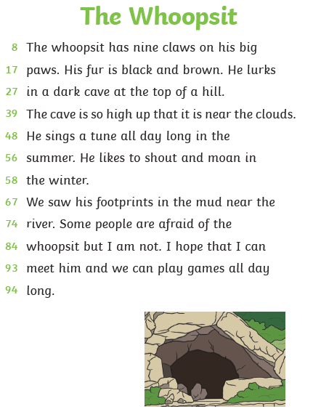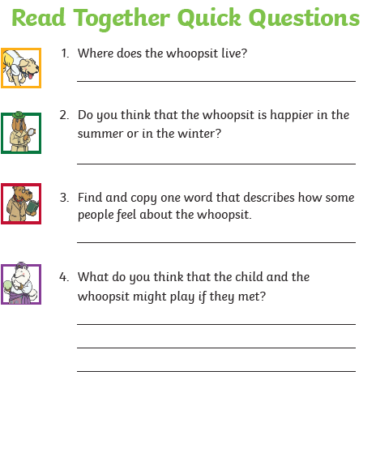
Day 4 | Topic

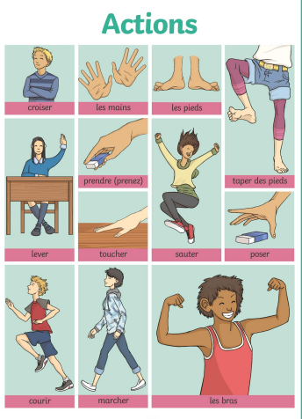
Actions – Using your detective skills, take gaze at the action pictures and their French names. Use this, and Mr. Google if you need to, to help you complete the action word activity.

Watch the following video: https://www.youtube.com/watch?v=7Cq-W1Kzan8

Day 4 | Topic
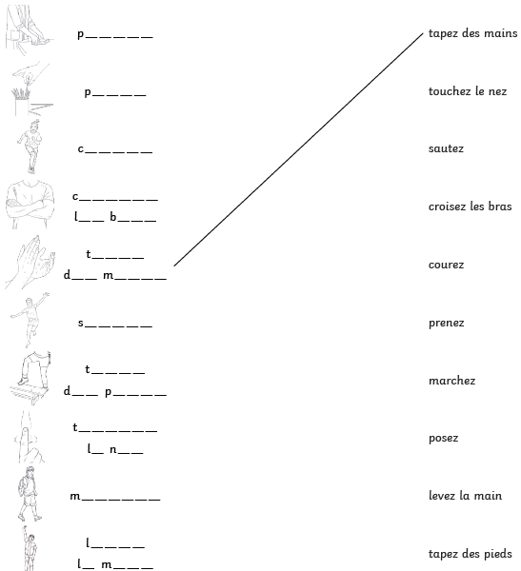

Day 5 | English
Helpful video: https://www.youtube.com/watch?v=yH3R9pyIU8M
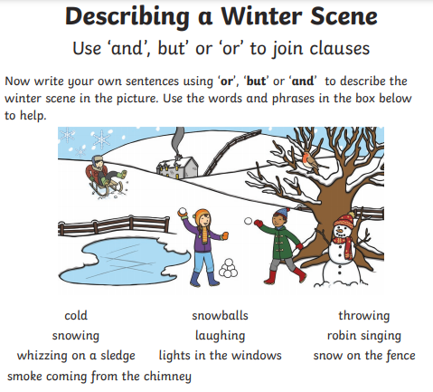

Day 5 | Maths
5 x 10 =_______ 7 x 10 = _______ 9 x 10 = _______ 1 x 10 = _______

6 x 10 ________ 2 x 10 = _______ 4 x 10 = _______ 8 x 10 = _______
4 x 2 = __________ 3 x 2 = ________ 10 x 2 = ________ 1 x 2 = _________

2 x 2 = _________ 12 x 2 = ________ 8 x 2 = ________ 6 x 2 = ________

2 x 5 = _________ 12 x 5 = ________ 8 x 5 = ________ 6 x 5 = ________

11 x 5 = ________ 5 x 5 = ________ 7 x 5 = ________ 9 x 5 = ________

Once complete, go onto TTRockstars or Numbots for atleast 30 minutes.

Day 5 | Flashback 4
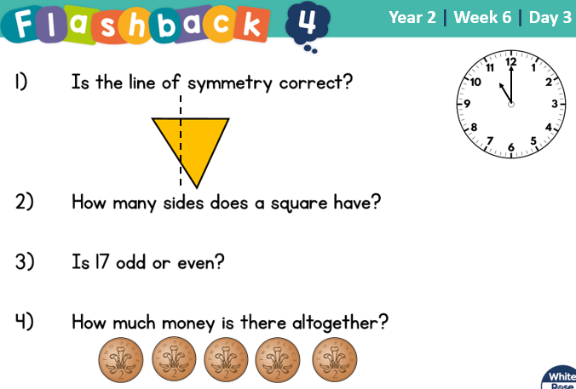

Day 5 | GPS

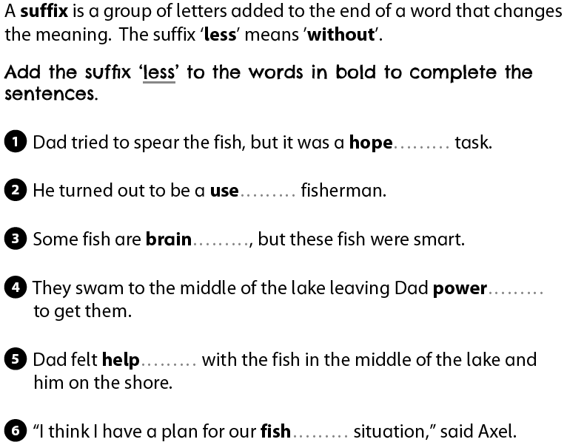
Day 5 | Topic
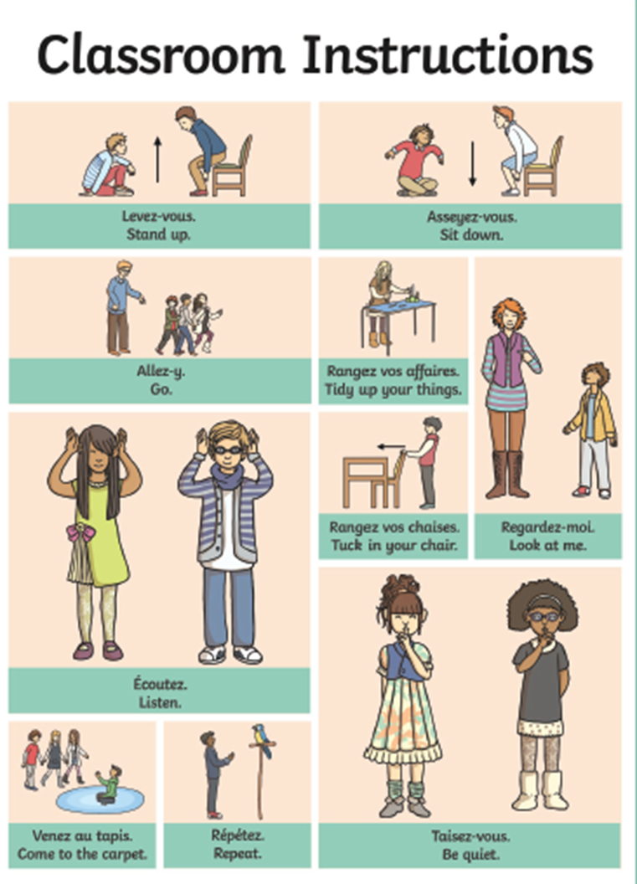
Classroom instructions – take a series of mental photographs of the classroom instructions and their French names. Use this to help you complete the classroom instructions activity.
Watch this video: https://www.youtube.com/watch?v=Ug4kWxjvfkU

Day 5 | Topic

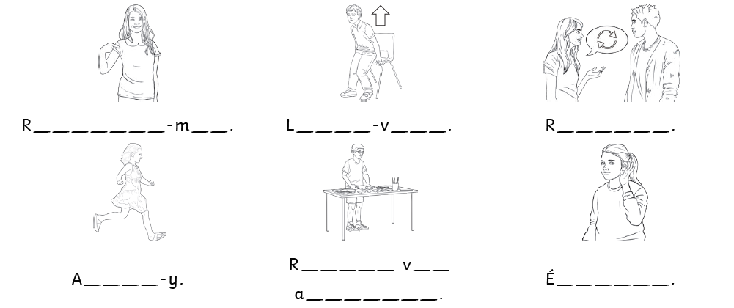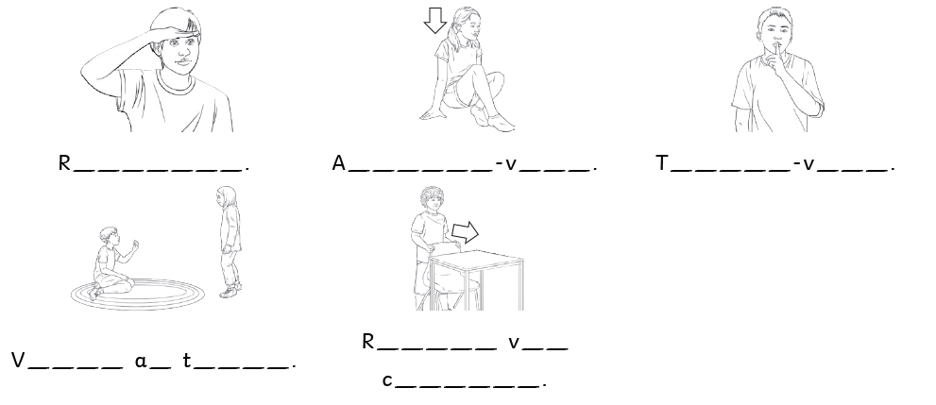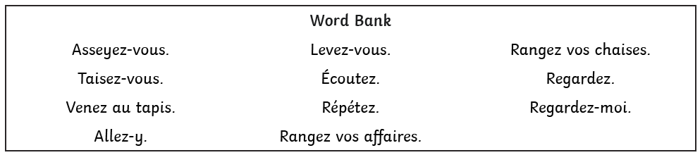

Optional Projects

Build something!  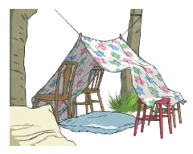  Use building blocks, recycled materials, chairs, a deck of cards or anything else you can find to build a den, a tower, a vehicle or a robot. How will you interact with this creation? Go on, use your imagination! | Play a board game!  Dig out your board games and have fun playing with the family. Do your adults have any old board games from their childhood? You could even design and make your own board game. How cool would that be! You could become a millionaire by inventing a new game!  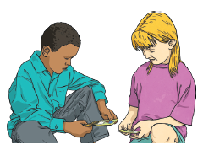
Keep a diary!  Write a paragraph everyday about something that you have done. Try to make it as interesting as possible. Don’t let your siblings read it though!  | Read, Read, Read!  Try to read a little every day. Reread old favourites or pick up that book that you have never opened! Read to yourself, an adult or a sibling. Perhaps, you could write a book review to recommend it someone else!  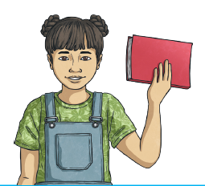
Finished your work but still need something to do?
Check out these educational websites below:

Educational games
https://www.bbc.co.uk/cbeebies/games
Want to learn how to type properly on a keyboard?
https://www.typingclub.com/
Learn coding online
https://scratch.mit.edu/
Maths Games
https://www.topmarks.co.uk/maths-games/7-11-years/ordering-and-sequencing
Learn your maths facts fast!
https://www.topmarks.co.uk/maths-games/hit-the-button
Primary Games
https://www.bbc.co.uk/bitesize/collections/primary-games/1
Love music? Play these instruments online:
https://www.virtualmusicalinstruments.com/
Loads of maths challenges:
http://www.mathematicshed.com/
Loads of literacy things:
https://www.literacyshedplus.com/en-gb#resources
Like maths challenges? Try these!
https://www.transum.org/Software/SW/Starter_of_the_day/index.htm
Do you love to write? Check out this picture site, choose a picture and write, write, write!
https://www.onceuponapicture.co.uk/
List of sites/games
https://www.popsugar.co.uk/parenting/free-online-educational-resources-for-kids-47312329

Some of these websites are updated daily. Check them out every day!

*Found another website that you want to share with other students? Email it to your teacher and we’ll add it to the list!*

