Name: Class:

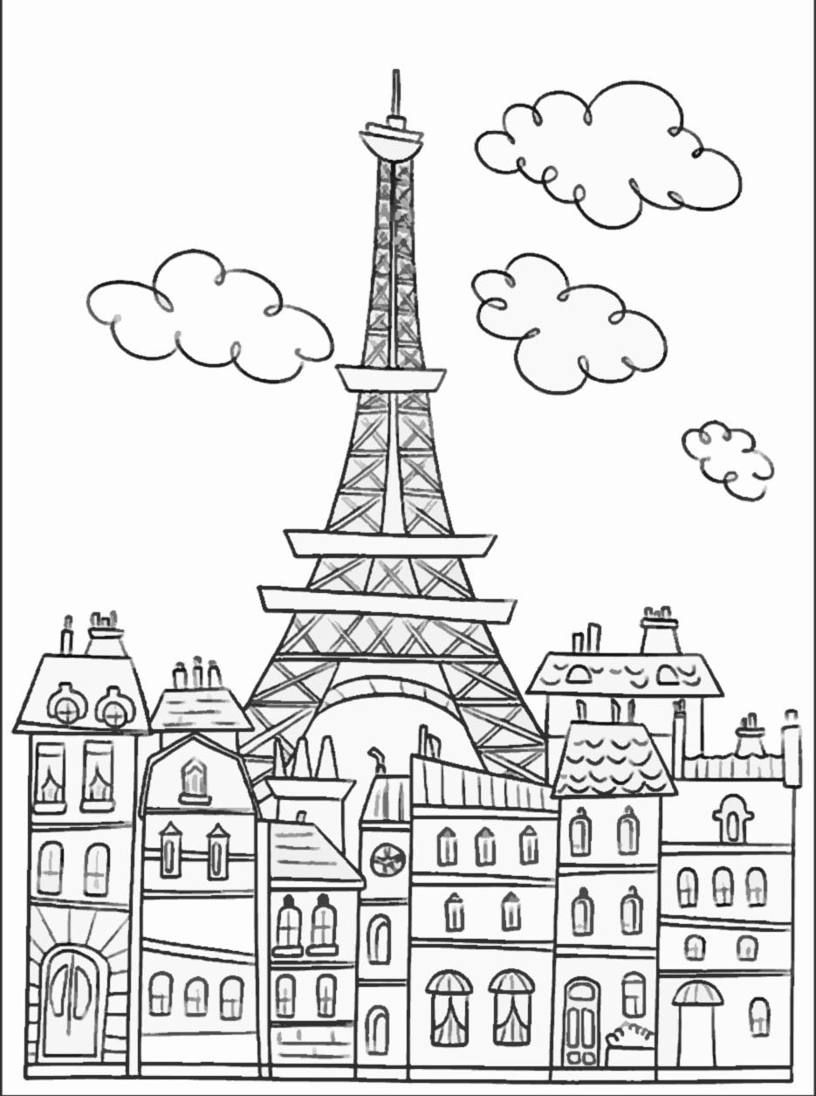

Rowling
Workbook:
Bonjour!

Contents
Day 1 | English – 45 minutes - 1 hour
Day 1 | Maths – 45 minutes – 1 hour
Day 1 | Flashback 4 – 5 minutes
Day 1 | Reading Comprehension – 30minutes
Day 1 | Topic– 45 minutes
Day 2 | English – 45 minutes - 1 hour
Day 2 | Maths – 45 minutes – 1 hour
Day 2 | Flashback 4 – 5 minutes
Day 2 | GPS – 30 minutes
Day 2 | Topic– 45 minutes
Day 3 | English – 45 minutes - 1 hour
Day 3 | Maths – 45 minutes – 1 hour
Day 3 | Flashback 4 – 5 minutes
Day 3 | Spellings – 30 minutes
Day 3 | *Live Session with Your Teacher*
Day 4 | English – 45 minutes - 1 hour
Day 4 | Maths – 45 minutes – 1 hour
Day 4 | Flashback 4 – 5 minutes
Day 4 | Reading Comprehension – 30 minutes
Day 4 | Topic– 45 minutes
Day 5 | English – 45 minutes - 1 hour
Day 5 | Maths – 45 minutes – 1 hour
Day 5 | Flashback 4 – 5 minutes
Day 5 | GPS – 30 minutes
Day 5 | Topic– 45 minutes
Optional Projects + Extra Educational Websites
Have you completed your weekly homework? |  | Date  Completed
Spellings Practise
On Spelling Shed or handwritten
Timetables Rock Stars Task
3 Reads (at least 10 minutes out loud with a grown-up)

OPTIONAL
Any comments or messages from grown-ups that you would like to share with your teacher:
Any comments or messages from the student that you would like to share with your teacher:
Day 1 | English
For hundreds of years, people all over the world have feared monsters and told tales of how terrible we are. Well, I’m here to tell you that we are not really that bad. In fact, we’re marvellous! I’m going to tell you all about us and inspire you to write about your own marvellous monster. Read on and find out more or listen to a recording here: https://soundcloud.com/talkforwriting/marvellous-monsters/s-C35T3UjlRZC
Monsters
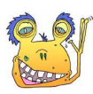

What is a monster?
A monster is a colossal creature that usually scares people.
Appearance
Most monsters are enormous and can reach a height of 12 metres. However, some can be the size of an average human and grow to approximately 1.67 metres (five and a half feet tall). All monsters look different. Many are hairy, whereas some have scales. Additionally, monsters can come in many different colours. They range from a simple brown colour to being multicoloured, like the rainbow monster. Amazingly, some monsters have six eyes, eight legs and two sets of arms.

Habitat
Monsters are found across the world. They live in all sorts of different environments and can thrive in extreme heat or cold. The North Pole Monster loves to live under the snow, in icy crevices. However, most monsters prefer living under beds, inside cupboards or up in cosy attics.
Diet
All monsters are omnivores, which means they will eat anything. Furthermore, monsters love ‘fast food’ and will often raid McDonalds or KFC to grab burgers or chicken buckets. A small minority of monsters are super healthy and always ensure they eat their ‘5-a-day’ and keep sugary items to a minimum. Surprisingly, monsters love tea and have been known to drink gallons of it, especially in the mornings.

What do they do?
Monsters are best known for scaring people and wreaking havoc. However, this is a popular misconception. Monsters are actually gentle creatures who love to read, take walks and play

Day 1 | English

board games. They are also skilled bakers and make amazing bread and cupcakes. Unfortunately, because monsters look so scary, people often overreact when they see them and want to fight them off. In addition to this, monsters speak a language made up of roars, growls and howls which simply sounds scary to humans. Finally, monsters are extremely clumsy and, as they try to get away from people, they tend to knock things down or crush things under their feet by accident. All of these unfortunate things make monsters seem very hostile when, in fact, they are not.

Fast facts
- The oldest monster lived to be 1003 years old.
- Monsters have tiny thorns on their tongues which help them to groom.
- Monsters have amazing hearing and can hear the slightest noise five miles away.
- Monsters become adults at the age of eight.

Monster advice
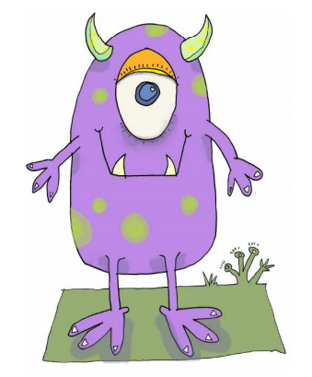
If you happen to meet a monster or find one under your bed, do not fret! Simply smile at them, give them a little wave and offer them a cup of tea. They really are lovely creatures and you’ll soon be friends for life!

Day 1 | English
Respond to the text
I was really interested in …  1. _______________________________  _________________________________  2. _______________________________  _________________________________  3. _______________________________  _________________________________ | I would like to know more about …  1. _______________________________  _________________________________  2. _______________________________  _________________________________  3. _______________________________  _________________________________
My top facts were …  1. _______________________________  _________________________________  2. _______________________________  _________________________________  3. _______________________________  _________________________________ | Questions I would like to ask about monsters …  1. _______________________________  _________________________________  2. _______________________________  _________________________________  3. _______________________________  _________________________________



Draw what you think a monster looks like, based on what you have read:

Day 1 | Maths
Today’s video: https://vimeo.com/502315136
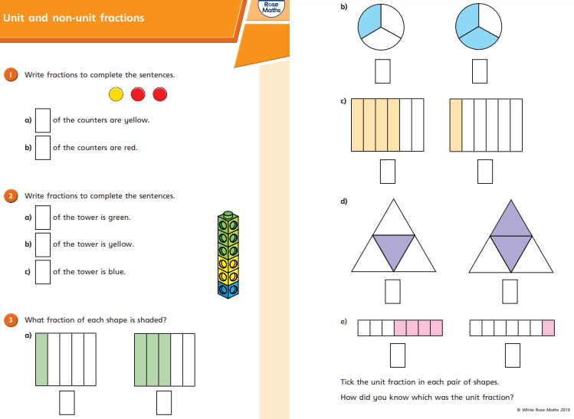
Day 1 | Maths
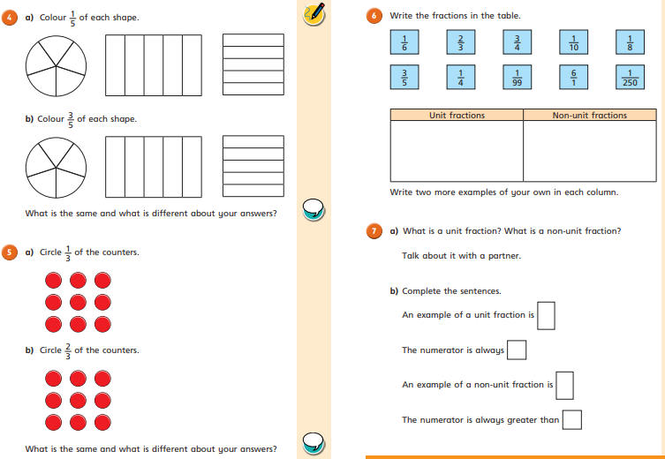

Day 1 | Flashback 4
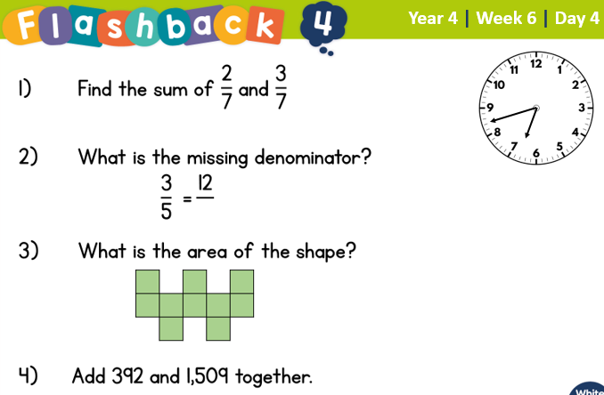


Day 1 | Reading Comprehension
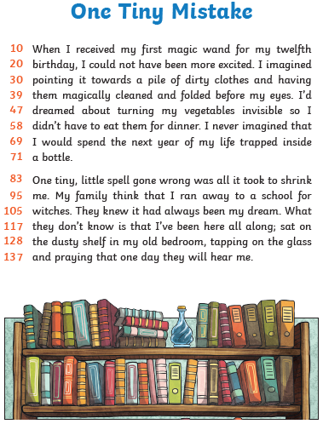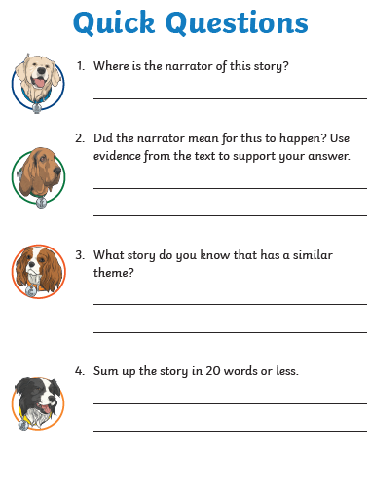
Day 1 | Topic
Colours – Take a long look at the splashes of colour and take a mental note of the French word. Complete the French colouring activity. Use Google if any of the colours are not there!
Watch the following video: https://www.youtube.com/watch?v=acvUtipaC5Y

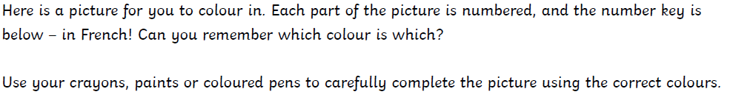
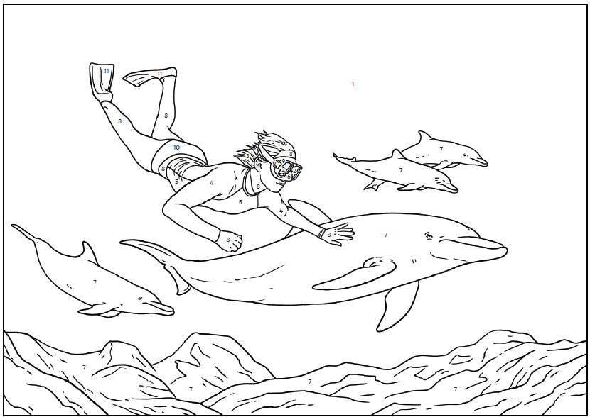
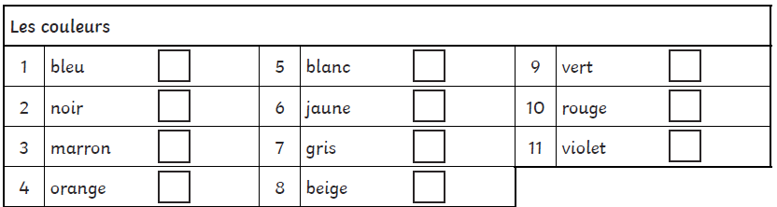
Day 2 | English
What do the words mean?
Let’s take a look at the meaning of some of the words from the monster text.
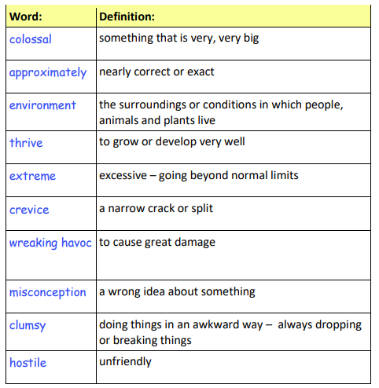

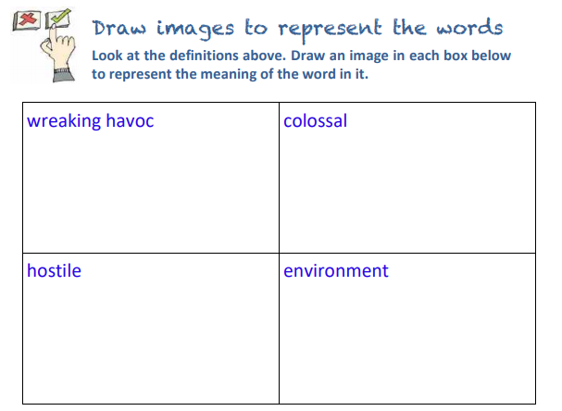

Day 2 | English
Write the following words into sentences. Use the definition provided to help you! The first one has been done for you.

Crevice
Unfortunately, my coin fell into the dark crevice in the pavement.

Colossal
__________________________________________________________________________________________________________________________________________
Extreme
__________________________________________________________________________________________________________________________________________

Wreaking havoc
__________________________________________________________________________________________________________________________________________

Your choice __________________
__________________________________________________________________________________________________________________________________________

Day 2 | Maths
Today’s video: https://vimeo.com/502527306
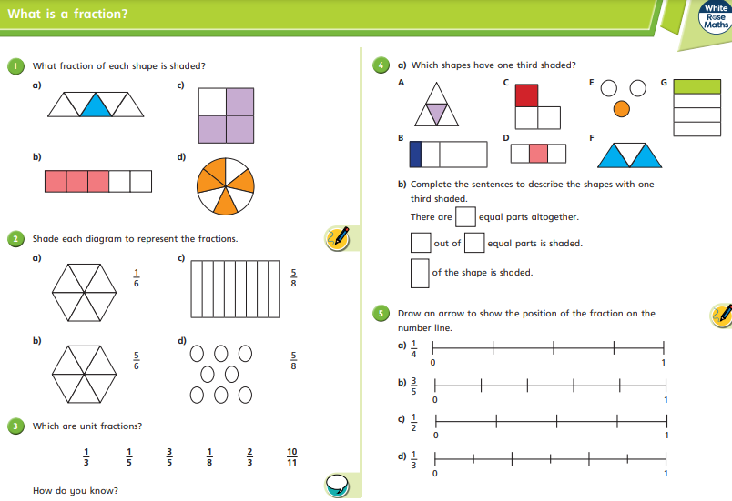

Day 2 | Maths
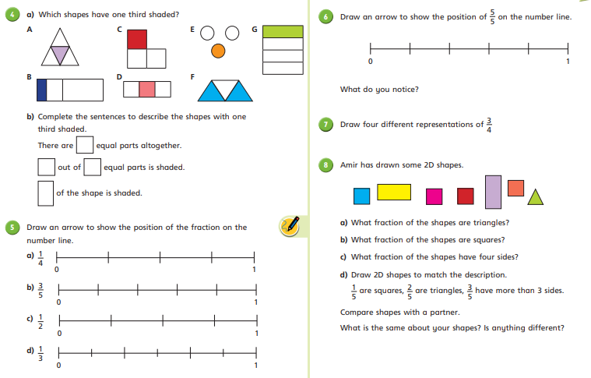

Day 2 | Flashback 4
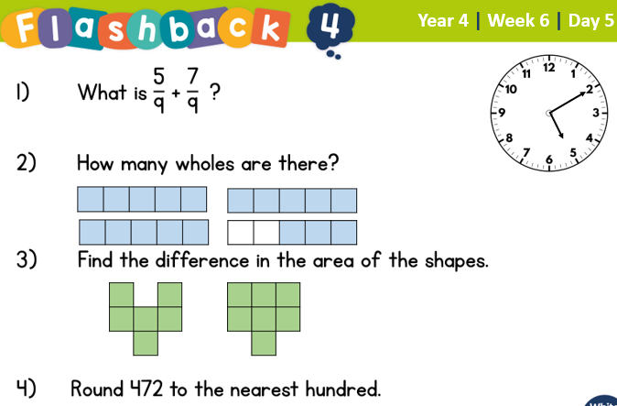
Day 2 | GPS

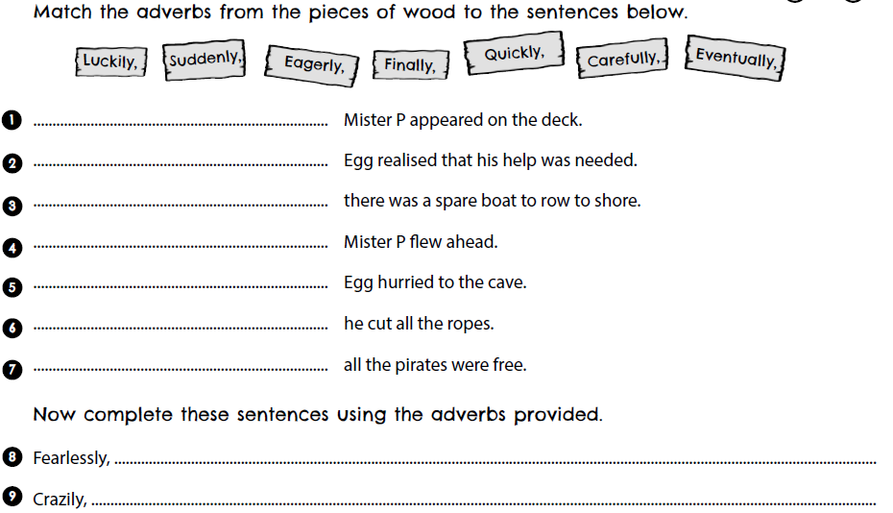

Day 2 | Topic
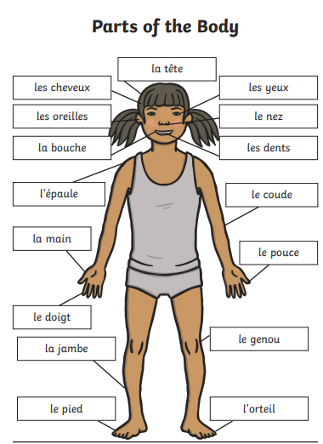
My body – Study the illustration of the human body and make a mental note of the French names for the body parts. Identify and write the correct French name in the gaps.

Watch the following video: https://www.youtube.com/watch?v=8PQr0hLXksI

Day 2 | Topic
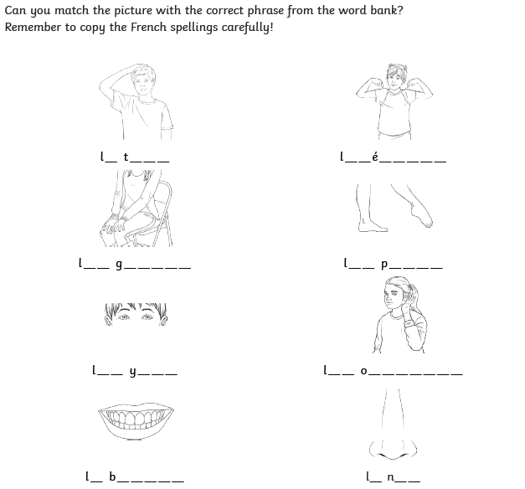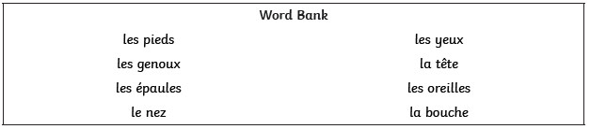
Day 3 | English
Monster comprehension! Here’s a quick-fire reading quiz about monsters. How many can you answer?
1. How old was the oldest monster?
---------------------------------------------------------------------------------------------------------------------------------------------------------------------------------------------------------------
2. What colour are monsters?
---------------------------------------------------------------------------------------------------------------------------------------------------------------------------------------------------------------
3. What do monsters like to eat?
----------------------------------------------------------------------------------------------------------------------------------------------------------------------------------------------------------------
4. Which word in the text means the same as enormous?
----------------------------------------------------------------------------------------------------------------------------------------------------------------------------------------------------------------
5. What is the name of the monster who likes to sleep in extremely cold places?
----------------------------------------------------------------------------------------------------------------------------------------------------------------------------------------------------------------
6. Monsters love to drink milk. True or false?
-------------------------------------------------------------------------------------------------------
7. What type of food might be on a monster’s shopping list?
----------------------------------------------------------------------------------------------------------------------------------------------------------------------------------------------------------------
8. Why do humans assume monsters are scary?
---------------------------------------------------------------------------------------------------------------------------------------------------------------------------------------------------------------
9. What should you do it you meet a monster?
----------------------------------------------------------------------------------------------------------------------------------------------------------------------------------------------------------------
10.Where do monsters prefer to live?
----------------------------------------------------------------------------------------------------------------------------------------------------------------------------------------------------------------

Day 3 | Maths
Today’s video: https://vimeo.com/502315833
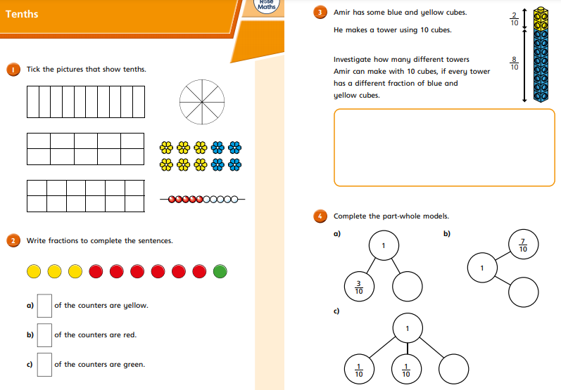
Day 3 | Maths
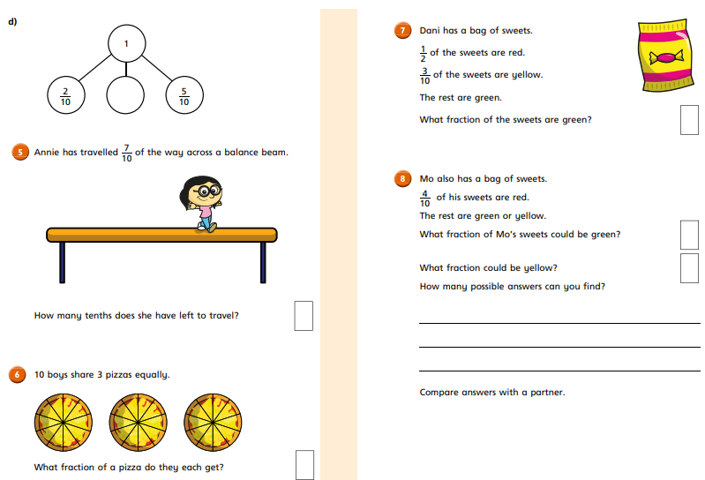

Day 3 | Flashback 4
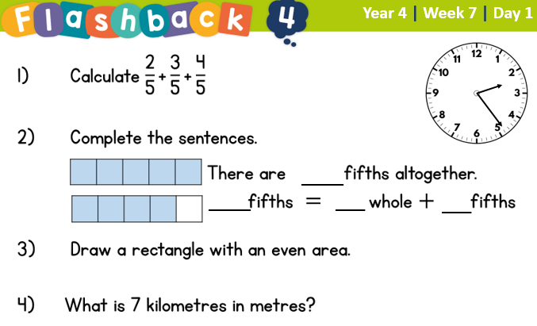

Day 3 | Spellings

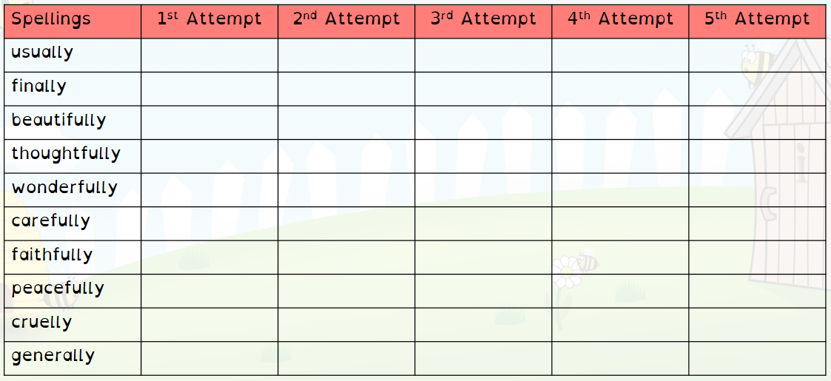
Day 3 | Live Session
It’s live session day! Here are the times you need to be logged in for your classes’ live session:

3T – 1.05
4B – 1.30
3/4K – 2.00

Please be logged in by the time the meeting begins. Remember, we use TEAMS for our sessions. If you do not have it downloaded on your device, you can access it on the school website:

https://www.asquith.notts.sch.uk/home-learning/

If you’ve lost your child’s login information, please email your teacher for more information.
Miss Thomas – sthomas@asquith.notts.sch.uk
Mr Bellamy – mbellamy@asquith.notts.sch.uk
Mrs Keim – mkeim@asquith.notts.sch.uk

Day 4 | English
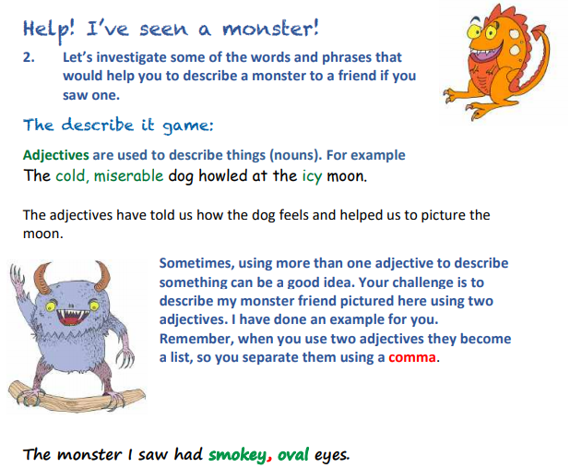
Write some interesting adjectives to describe different bits of the monster. The monster I saw had:
__________________ , ___________________ fur.
__________________ , ___________________ teeth.
__________________ , ___________________ claws.
__________________ , ___________________ horns.
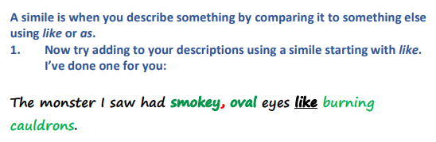

Day 4 | English
The monster I saw had:
__________________ , ___________________ fur like ________________________
_____________________________________________________________________
__________________ , ___________________ teeth like ______________________
_____________________________________________________________________

__________________ , ___________________ claws like _______________________
_____________________________________________________________________

__________________ , __________________ horns like _______________________
_____________________________________________________________________
Now try describing this monster using the skills you have just practised.
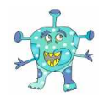
______________________________________________________________________________________________________________________________________________________________________________________________________________________________________________________________________________________________________________________________________________________________________________________________________________________________

Day 4 | Maths
Today’s video: https://vimeo.com/502686139
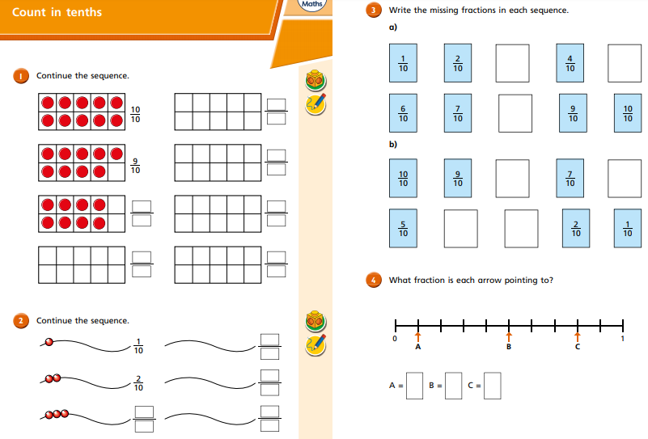

Day 4 | Maths
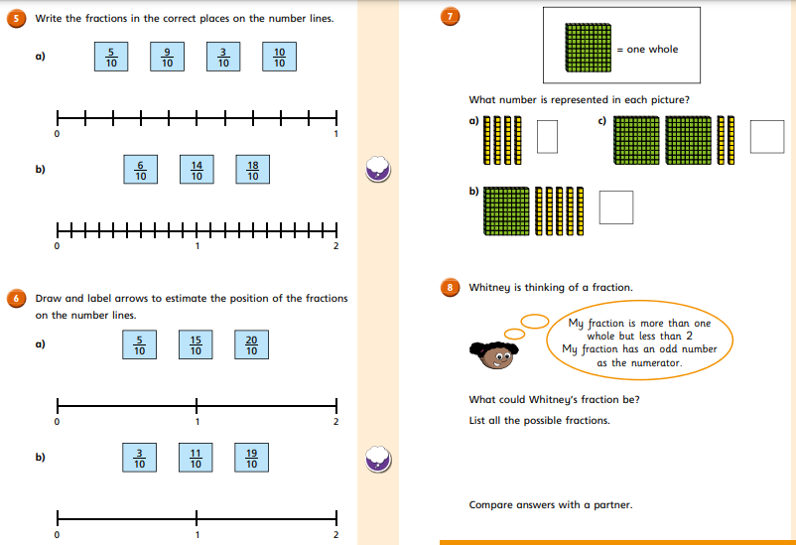

Day 4 | Flashback 4
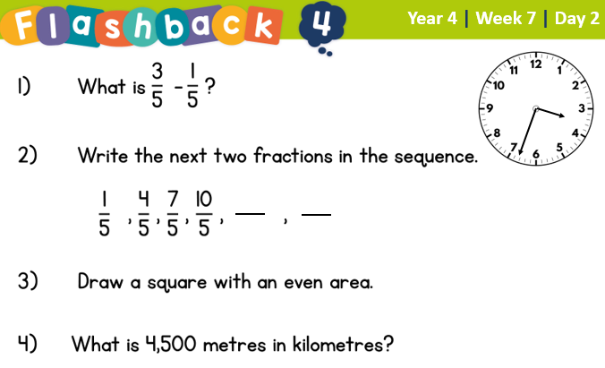

Day 4 | Reading Comprehension
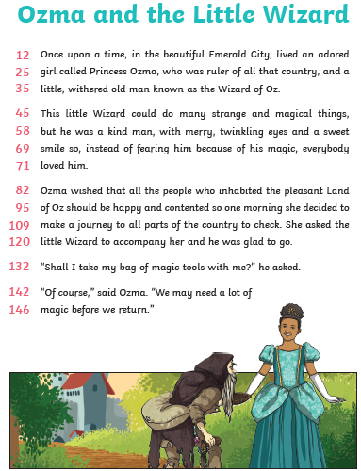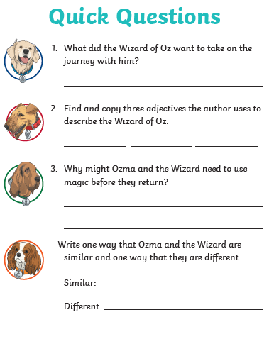
Day 4 | Topic
Actions – Using your detective skills, take gaze at the action pictures and their French names. Use this, and Mr. Google if you need to, to help you complete the action word activity.

Watch the following video: https://www.youtube.com/watch?v=7Cq-W1Kzan8

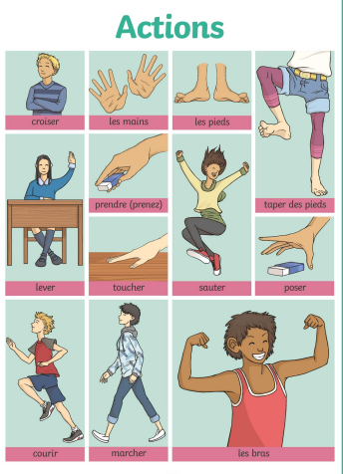
Day 4 | Topic
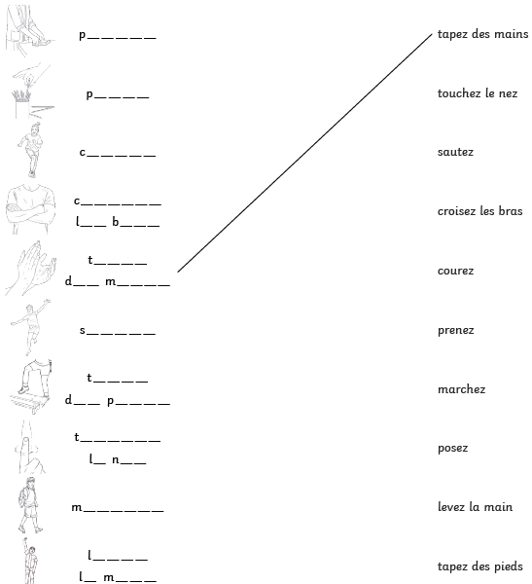

Day 5 | English
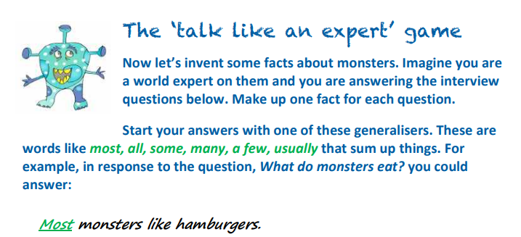 Where do monsters go on holiday?
--------------------------------------------------------------------------------------------------------------------------------------------------------------------------------------------------------------------------------------------------------------------------------------- ----------------------------------------------------------------------------------------------------------------------------------------------------------------------------------------
What do monsters like to do to relax?
--------------------------------------------------------------------------------------------------------------------------------------------------------------------------------------------------------------------------------------------------------------------------------------- -----------------------------------------------------------------------------------------------------------------------------------------------------------------------------------------
How do monsters travel to work?
--------------------------------------------------------------------------------------------------------------------------------------------------------------------------------------------------------------------------------------------------------------------------------------- ----------------------------------------------------------------------------------------------------------------------------------------------------------------------------------------
Why do monsters live in groups?
--------------------------------------------------------------------------------------------------------------------------------------------------------------------------------------------------------------------------------------------------------------------------------------- -----------------------------------------------------------------------------------------------------------------------------------------------------------------------------------------
Challenge: Add to your facts above by using the adverb ‘additionally’. Use it to start a NEW sentence to add to your facts. For example: Most monsters like hamburgers. Additionally, they enjoy eating ice cream covered in gravy.

Day 5 | English
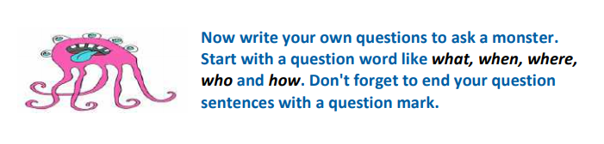________________________________________________________________________________________________________________________________________________________________________________________________________________________________________________________________________________________________________________________________________________________________________________________________________________________________________________________________________________________________________________________________________________________________________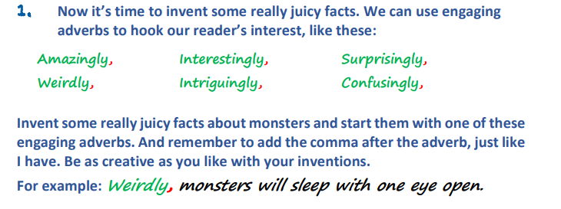_________________________________________________________________________________________________________________________________________________________________________________________________________________________________________________________________________________________________________________________________________________________
_____________________________________________________________________

Day 5 | Maths
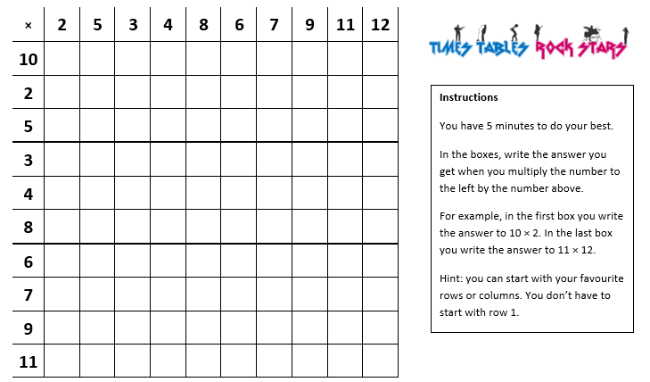
Once complete, spend atleast 30 minutes on TTRockstars. Get in touch with your teacher if you can’t remember your log in details.

Day 5 | Flashback 4
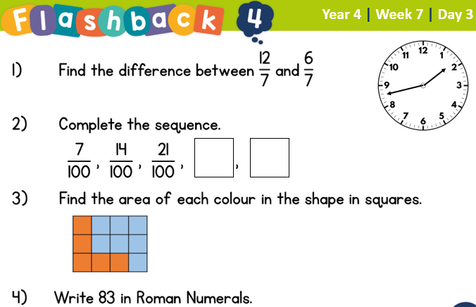

Day 5 | GPS

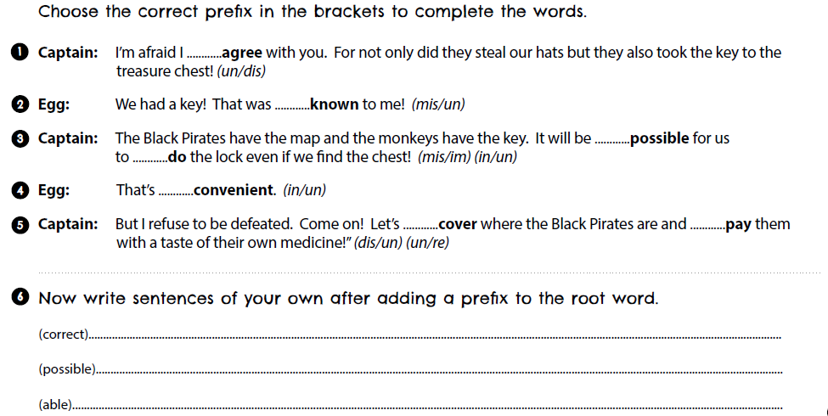
Day 5 | Topic
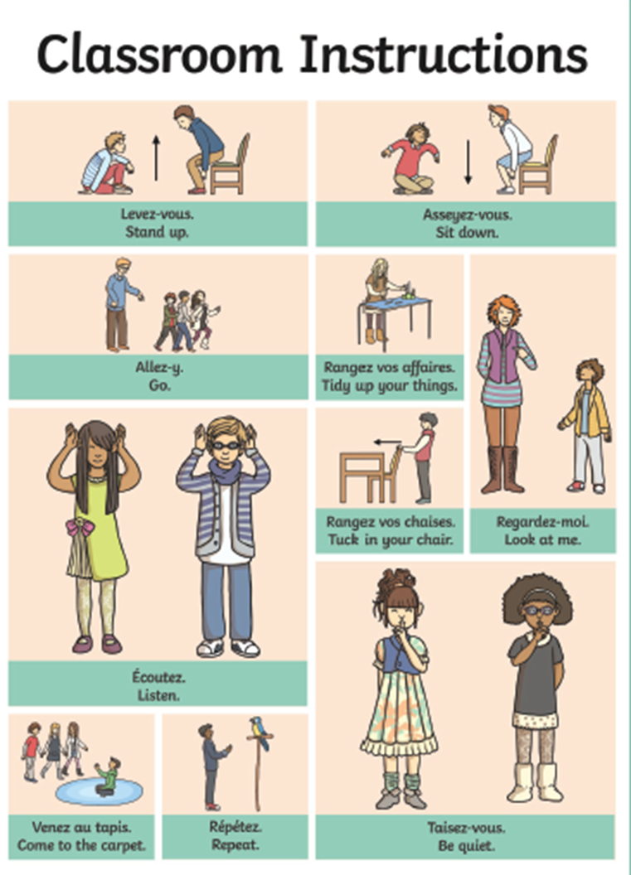
Classroom instructions – take a series of mental photographs of the classroom instructions and their French names. Use this to help you complete the classroom instructions activity.
Watch this video: https://www.youtube.com/watch?v=Ug4kWxjvfkU

Day 5 | Topic

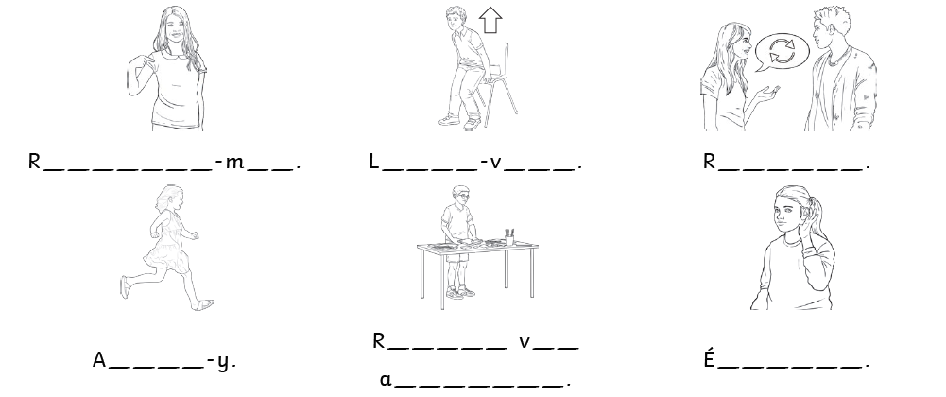
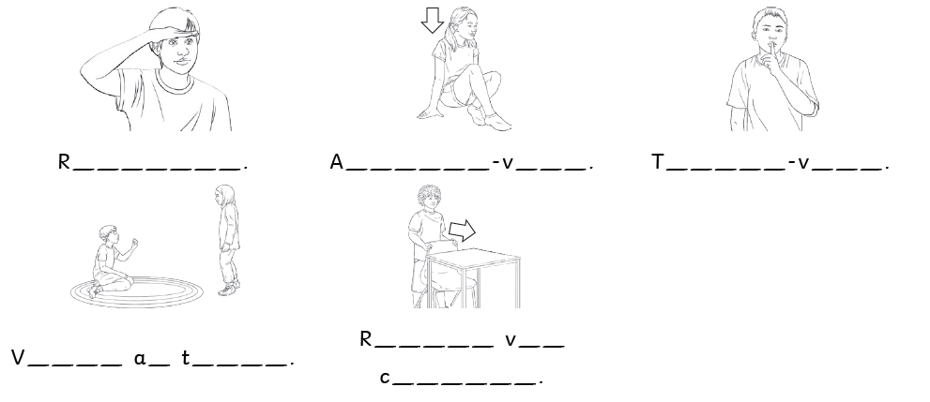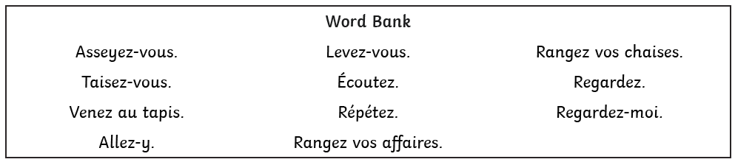

Optional Projects

Build something!  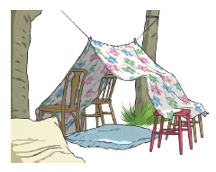  Use building blocks, recycled materials, chairs, a deck of cards or anything else you can find to build a den, a tower, a vehicle or a robot. How will you interact with this creation? Go on, use your imagination! | Play a board game!  Dig out your board games and have fun playing with the family. Do your adults have any old board games from their childhood? You could even design and make your own board game. How cool would that be! You could become a millionaire by inventing a new game!  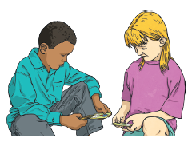
Keep a diary!  Write a paragraph everyday about something that you have done. Try to make it as interesting as possible. Don’t let your siblings read it though!  | Read, Read, Read!  Try to read a little every day. Reread old favourites or pick up that book that you have never opened! Read to yourself, an adult or a sibling. Perhaps, you could write a book review to recommend it someone else!  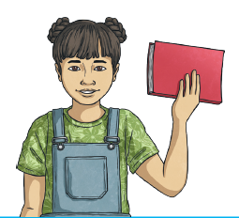
Finished your work but still need something to do?
Check out these educational websites below:

Educational games
https://www.bbc.co.uk/cbeebies/games
Want to learn how to type properly on a keyboard?
https://www.typingclub.com/
Learn coding online
https://scratch.mit.edu/
Maths Games
https://www.topmarks.co.uk/maths-games/7-11-years/ordering-and-sequencing
Learn your maths facts fast!
https://www.topmarks.co.uk/maths-games/hit-the-button
Primary Games
https://www.bbc.co.uk/bitesize/collections/primary-games/1
Love music? Play these instruments online:
https://www.virtualmusicalinstruments.com/
Loads of maths challenges:
http://www.mathematicshed.com/
Loads of literacy things:
https://www.literacyshedplus.com/en-gb#resources
Like maths challenges? Try these!
https://www.transum.org/Software/SW/Starter_of_the_day/index.htm
Do you love to write? Check out this picture site, choose a picture and write, write, write!
https://www.onceuponapicture.co.uk/
List of sites/games
https://www.popsugar.co.uk/parenting/free-online-educational-resources-for-kids-47312329

Some of these websites are updated daily. Check them out every day!

*Found another website that you want to share with other students? Email it to your teacher and we’ll add it to the list!*

