Name: Class:

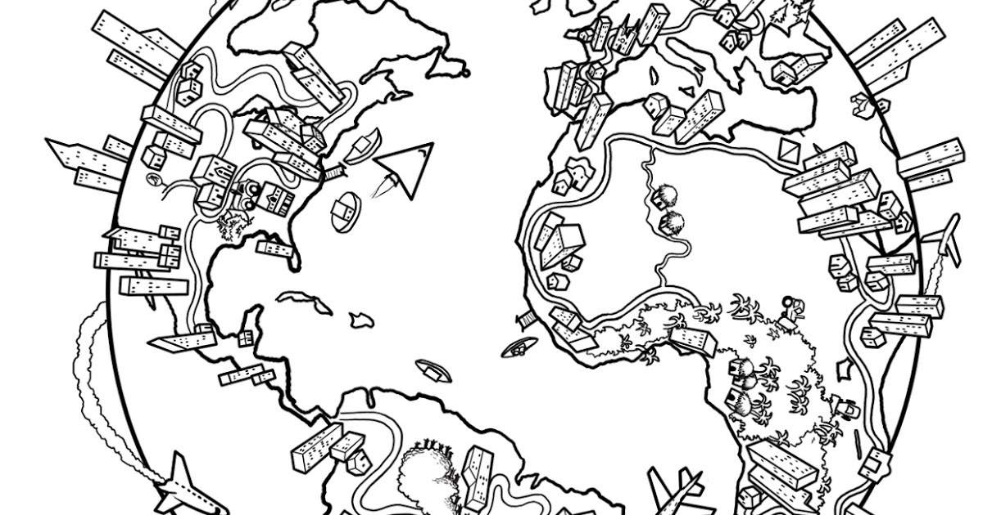

Dahl
Workbook:
Adventures

Contents
Day 1 | English – 45 minutes
Day 1 | Maths – 45 minutes
Day 1 | Flashback 4 – 5 minutes
Day 1 | Reading Comprehension – 30minutes
Day 1 | Topic– 45 minutes
Day 2 | English – 45 minutes
Day 2 | Maths – 45 minutes
Day 2 | Flashback 4 – 5 minutes
Day 2 | GPS – 30 minutes
Day 2 | Topic– 45 minutes
Day 3 | English – 45 minutes
Day 3 | Maths – 45 minutes
Day 3 | Flashback 4 – 5 minutes
Day 3 | Spellings – 30 minutes
Day 3 | Topic– 45 minutes
Day 4 | English – 45 minutes
Day 4 | Maths – 45 minutes
Day 4 | Flashback 4 – 5 minutes
Day 4 | Reading Comprehension – 30 minutes
Day 4 | Topic– 45 minutes
Day 5 | English – 45 minutes
Day 5 | Maths – 45 minutes
Day 5 | Flashback 4 – 5 minutes
Day 5 | GPS – 30 minutes
Day 5 | Topic– 45 minutes
Optional Projects + Extra Educational Websites
Have you completed your weekly homework? |  | Date  Completed
Spellings Practise
On Spelling Shed or handwritten
Timetables Rock Stars Task
3 Reads (at least 10 minutes out loud with a grown-up)

OPTIONAL
Any comments or messages from grown-ups that you would like to share with your teacher:
Any comments or messages from the student that you would like to share with your teacher:
Day 1 | English
Helpful video: https://www.youtube.com/watch?v=IT-G4c2-CHU
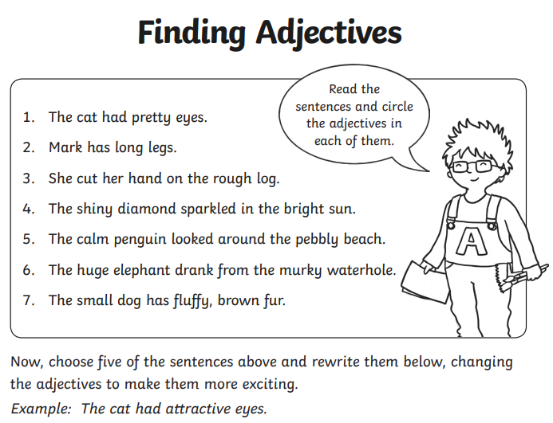______________________________________________________________________________________________________________________________________________________________________________________________________________________________________________________________________________________________________________________________________________________________________________________________________________________________
Day 1 | Maths
Today’s videos: https://vimeo.com/498261586
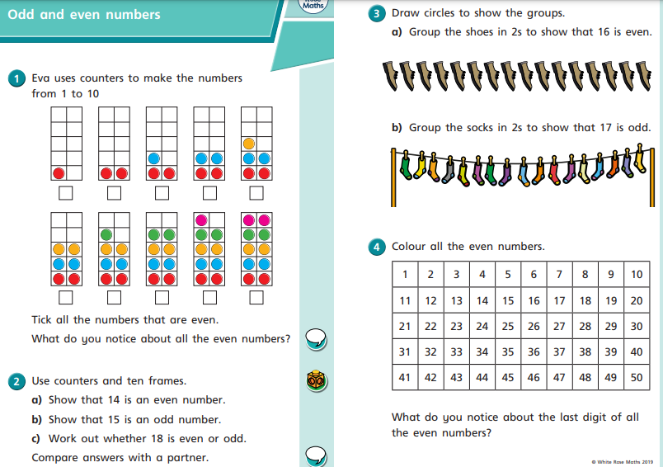
Day 1 | Maths
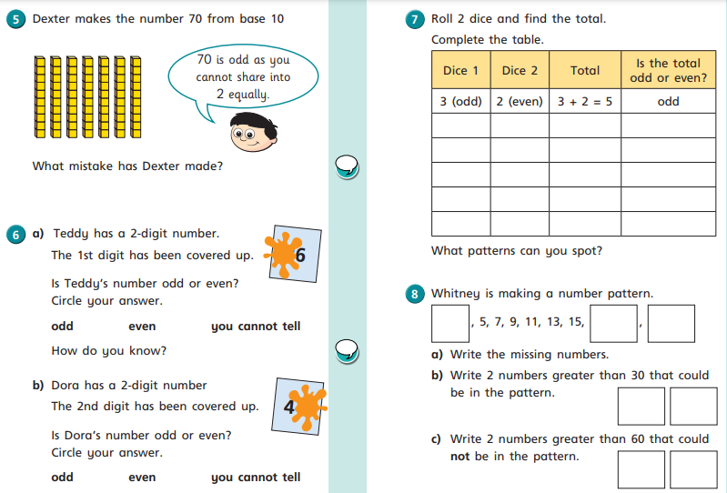

Day 1 | Flashback 4
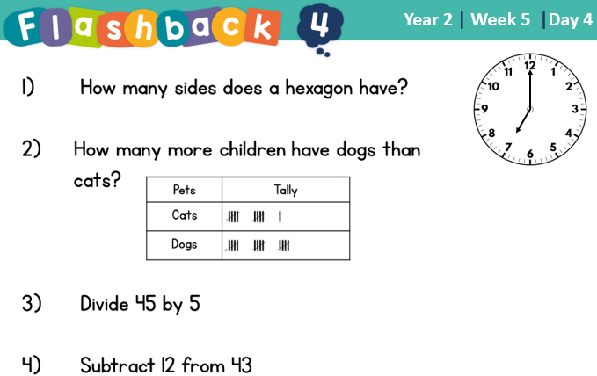


Day 1 | Reading Comprehension
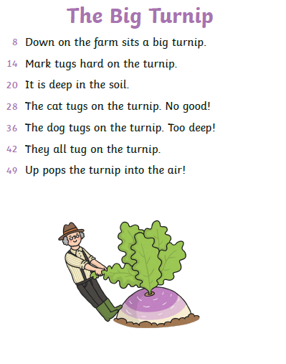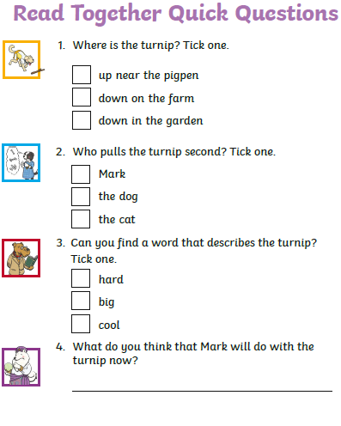
Day 1 | Topic

The seven continents

Go to this website:
https://classroom.thenational.academy/units/seven-continents-cf8c
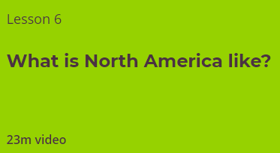
Click on lesson 6 (above). Watch the video.

When you have finished, you can complete the online quiz at the end.

Day 2 | English
Helpful video: https://www.youtube.com/watch?v=QxoDGlPUmyU
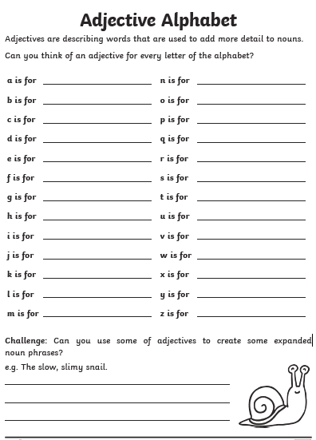

Day 2 | Maths
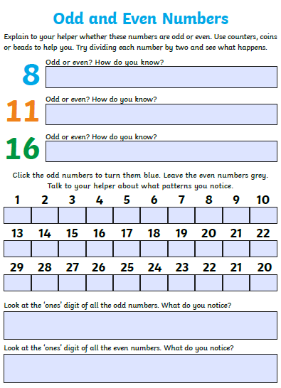
Day 2 | Flashback 4
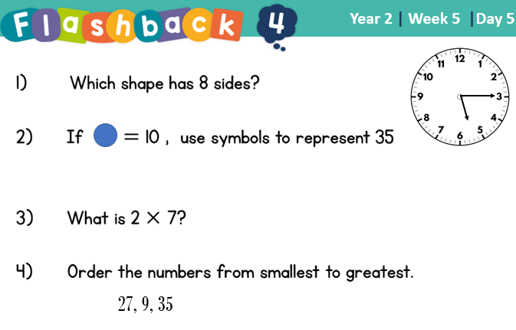
Day 2 | GPS

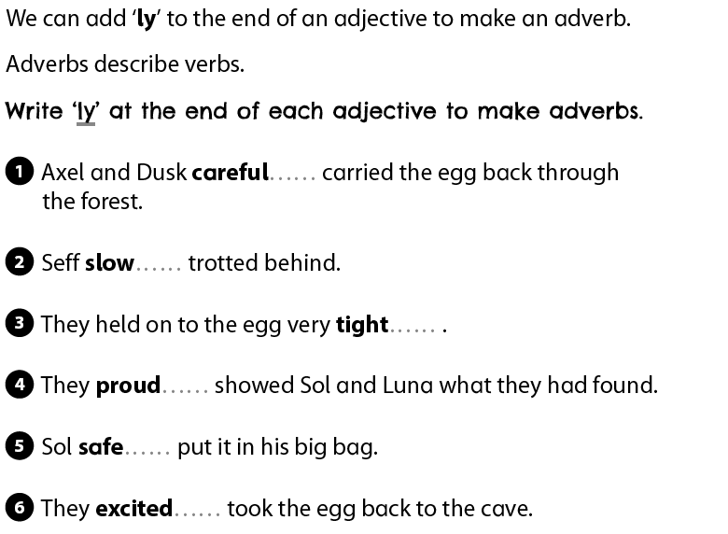
Day 2 | Topic

The seven continents

Go to this website:
https://classroom.thenational.academy/units/seven-continents-cf8c

Click on lesson 7 (above). Watch the video and complete the questions.

When you have finished, you can complete the online quiz at the end.
Day 3 | English
Helpful video: https://www.youtube.com/watch?v=XhwjS4zEZDM
Here are some boring sentences. We have split them into 3 parts. Between each part, can you add some adjectives to add detail and interest?

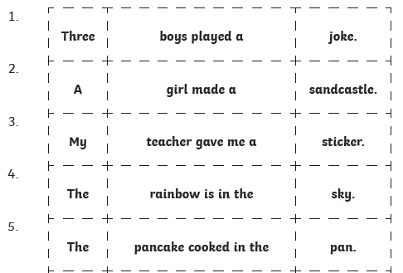

Example:
Three silly, mischievous boys played a dangerous, risky joke.
Your turn:
2. ____________________________________________
______________________________________________
3. ____________________________________________
______________________________________________
4. ____________________________________________
______________________________________________
5. ____________________________________________
______________________________________________

Day 3 | Maths
Today’s videos: https://vimeo.com/498262138
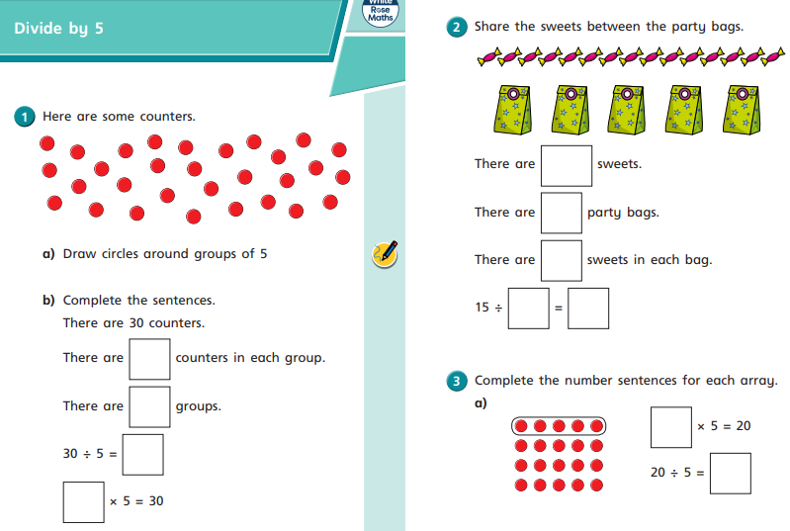
Day 3 | Maths
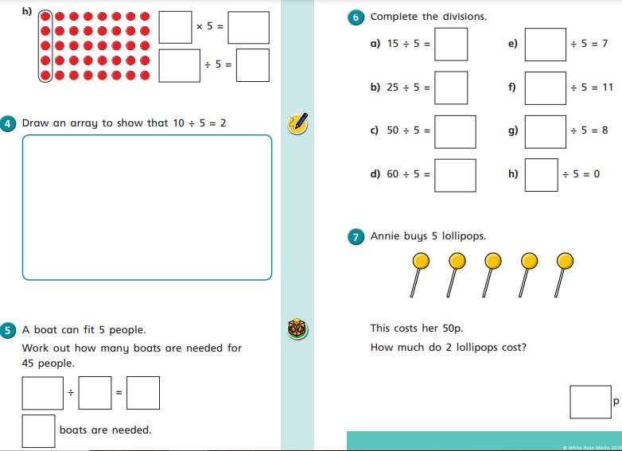

Day 3 | Flashback 4
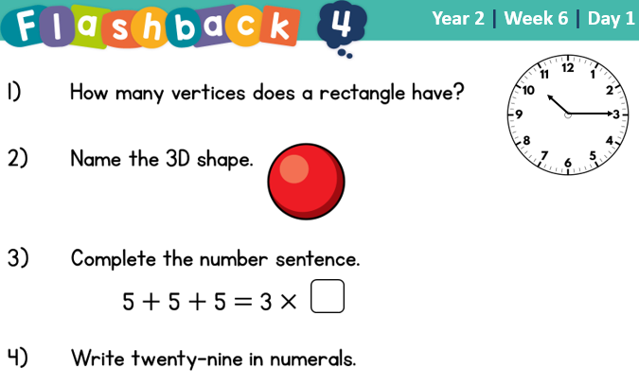

Day 3 | Spellings

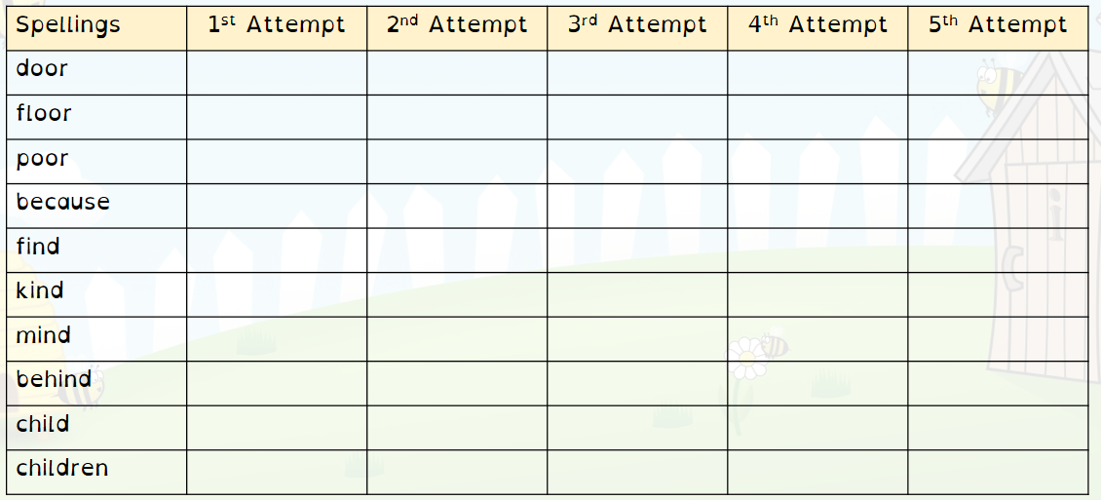
Day 3 | Topic

The seven continents

Go to this website:
https://classroom.thenational.academy/units/seven-continents-cf8c

Click on lesson 8 (above). Watch the video.

When you have finished, you can complete the online quiz at the end.

Day 4 | English
Helpful video: https://www.youtube.com/watch?v=7cwu9rirxV4
Here are some pictures of a setting with an adjective word bank next to them. Can you use some of these adjectives in a sentence to describe the setting.
Here are some pictures of a setting with an adjective word bank next to them. Can you use some of these adjectives in a sentence to describe the setting.
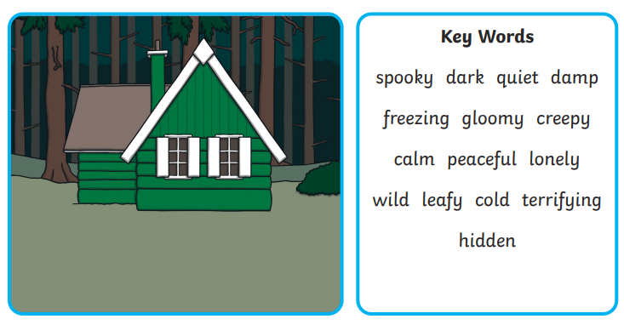
_________________________________________________________________________________________________________________________________________________________________________________
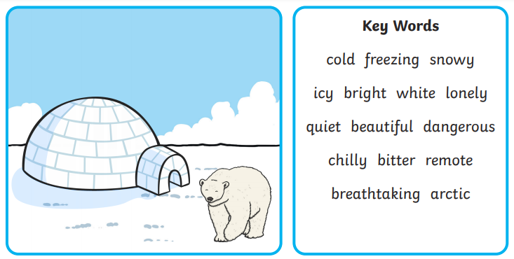
_________________________________________________________________________________________________________________________________________________________________________________
Day 4 | English
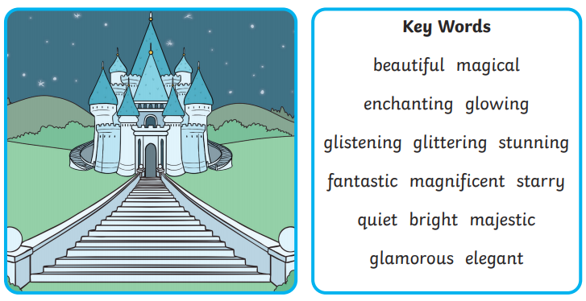

_________________________________________________________________________________________________________________________________________________________________________________
___________________________________________________________

Day 4 | Maths
Today’s videos: https://vimeo.com/498262386
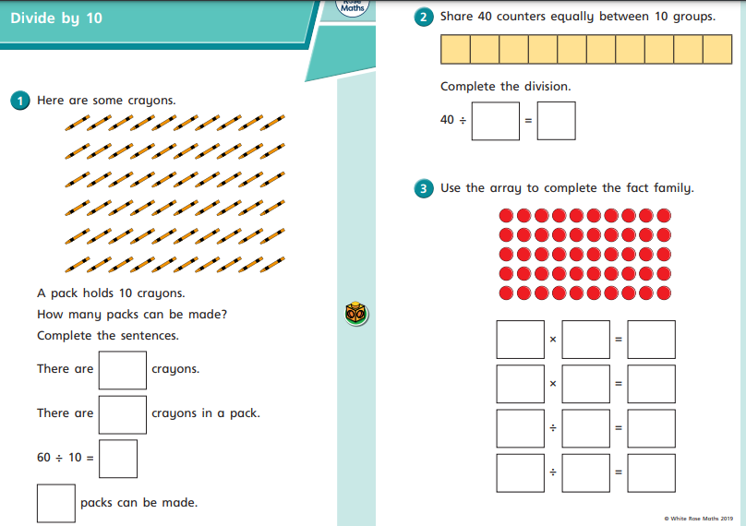
Day 4 | Maths
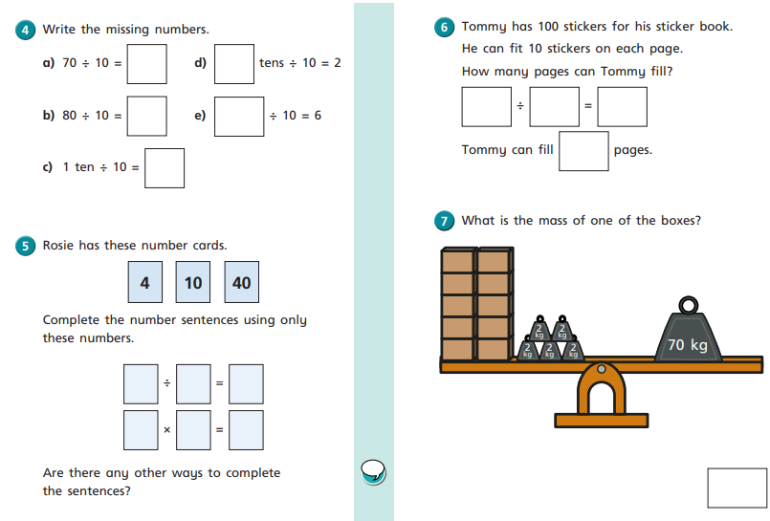

Day 4 | Flashback 4
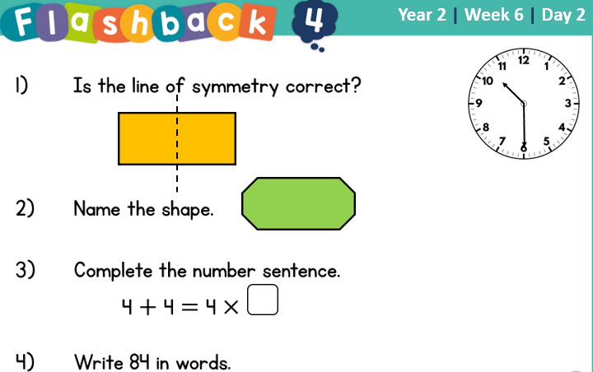

Day 4 | Reading Comprehension
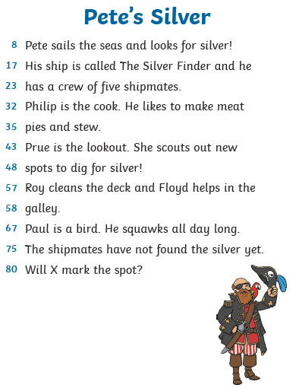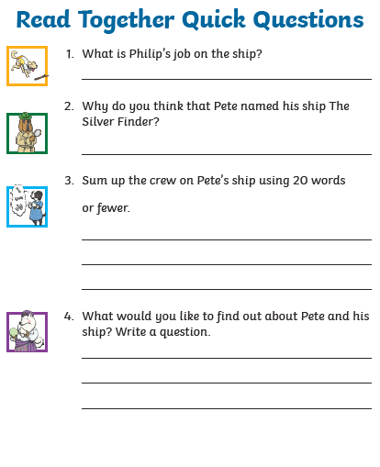
Day 4 | Topic

The seven continents

Go to this website:
https://classroom.thenational.academy/units/seven-continents-cf8c
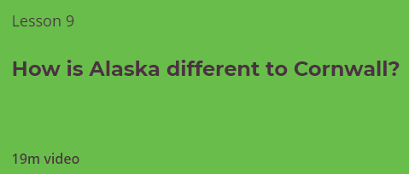
Click on lesson 9 (above). Watch the video.

When you have finished, you can complete the online quiz at the end.

Day 5 | English
Yesterday, you were given a picture with a list of adjectives. Today, you have a picture but have to come up with the adjectives yourself. Once you have written a list of atleast 10 adjectives, write atleast 3 sentences describing the setting.
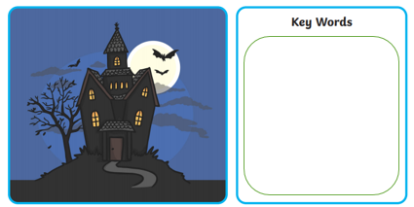

_________________________________________________________________________________________________________________________________________________________________________________
_________________________________________________________________________________________________________________________________________________________________________________
_________________________________________________________________________________________________________________________________________________________________________________

Day 5 | Maths
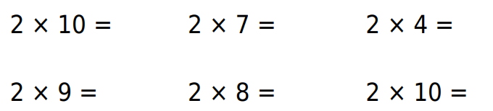
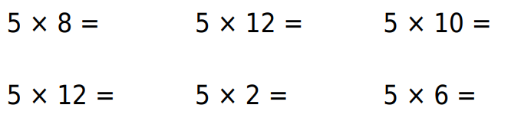
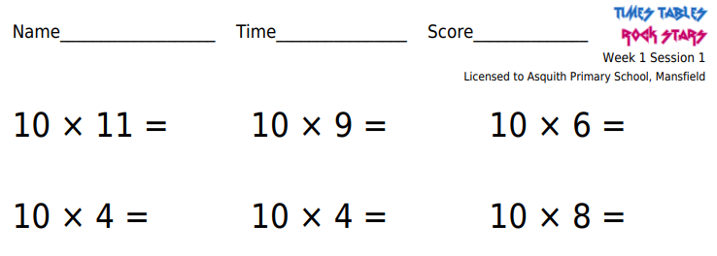

Once complete, go onto TTRockstars or Numbots for atleast 20 minutes. Email your teacher if you have forgotten your log in details.

Day 5 | Flashback 4
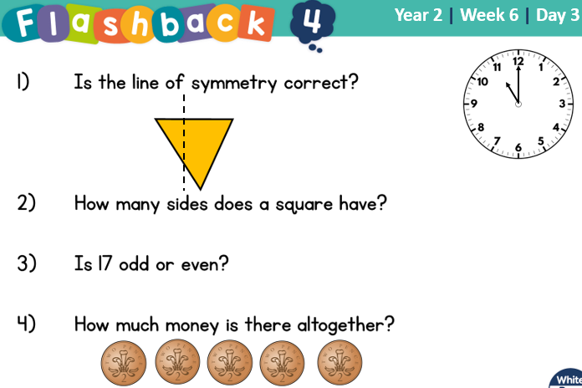

Day 5 | GPS
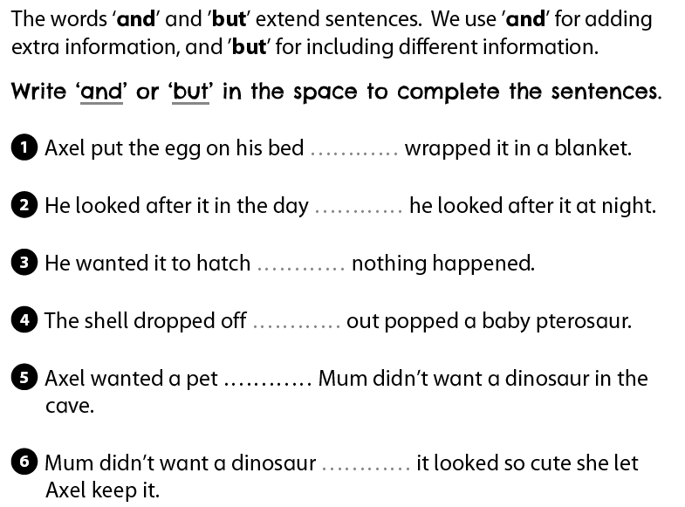
Day 5 | Topic

The seven continents

Go to this website:
https://classroom.thenational.academy/units/seven-continents-cf8c
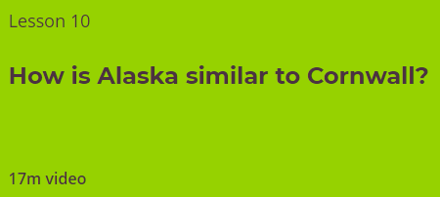
Click on lesson 10 (above). Watch the video.

When you have finished, you can complete the online quiz at the end.

Optional Projects

Using scraps from the cardboard recycle bin, some glue and maybe a dash of paint, choose your favourite continent, and make a 3D model of it, ensuring the shape and terrain is recognizable. Take a photo of it for our Facebook page and bask in the adoration of your friends!  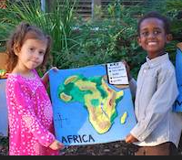 | Imagine if the oceans have overtaken the continents and you have to make a raft from recycled materials. Why not make a model of a raft that can float on water, perhaps out of discarded plastic bottles? How will you attach the bottles together? Think about other scraps of waste material we throw away from packaging. How about using some Lego characters as guinea pigs! If you have adult supervision, and only if you have, why not test your creation in the bath – you don’t have to get in the bath!  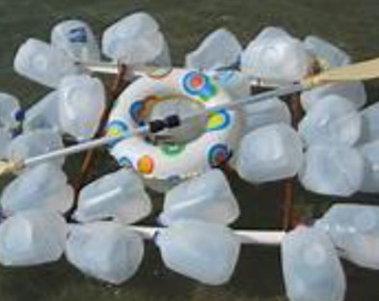  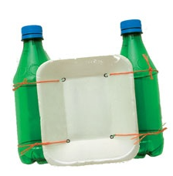
What do you say to getting busy with the felt tips, creating a colour key and exploding a map of the world with crazy colours? You could then photograph your creation, and get your adult to email it to mbellamy@asquith.notts.sch.uk, so Mr. Bellamy can make a montage of all the pictures received to put onto the school’s website! 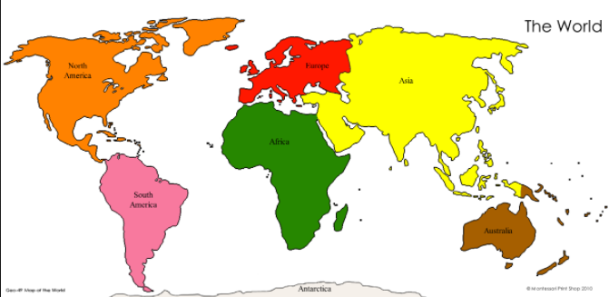https://www.twinkl.co.uk/resource/t-g-273-the-seven-continents-labelling-activity-sheet | 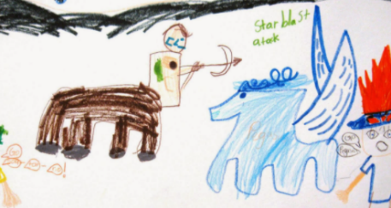  Can you see the cardboard box in the corner? No, not that corner, the other one! Yes, that dog-eared box gathering dust. Take a gentle stroll over to it, and have a peep inside. You have stumbled upon an ancient teleportation device, which allows the traveller – you - to close their eyes, think of a continent, and then a country in that continent, and you will find your self transported to that very spot on the globe. Take a few moments with your eyes wide open to obsorb your surroundings. What you see? What might you hear? How does it feel? Can you teste or smell anything unsual?  Draw a picture to show yourself in this new place surrounded by all that you can imagine! Or, get a cardboard box, and decorate it with illustrations from your travels.
Finished your work but still need something to do?
Check out these educational websites below:

Educational games
https://www.bbc.co.uk/cbeebies/games
Want to learn how to type properly on a keyboard?
https://www.typingclub.com/
Learn coding online
https://scratch.mit.edu/
Maths Games
https://www.topmarks.co.uk/maths-games/7-11-years/ordering-and-sequencing
Learn your maths facts fast!
https://www.topmarks.co.uk/maths-games/hit-the-button
Primary Games
https://www.bbc.co.uk/bitesize/collections/primary-games/1
Love music? Play these instruments online:
https://www.virtualmusicalinstruments.com/
Loads of maths challenges:
http://www.mathematicshed.com/
Loads of literacy things:
https://www.literacyshedplus.com/en-gb#resources
Like maths challenges? Try these!
https://www.transum.org/Software/SW/Starter_of_the_day/index.htm
Do you love to write? Check out this picture site, choose a picture and write, write, write!
https://www.onceuponapicture.co.uk/
List of sites/games
https://www.popsugar.co.uk/parenting/free-online-educational-resources-for-kids-47312329

Some of these websites are updated daily. Check them out every day!

*Found another website that you want to share with other students? Email it to your teacher and we’ll add it to the list!*

