Name: Class:

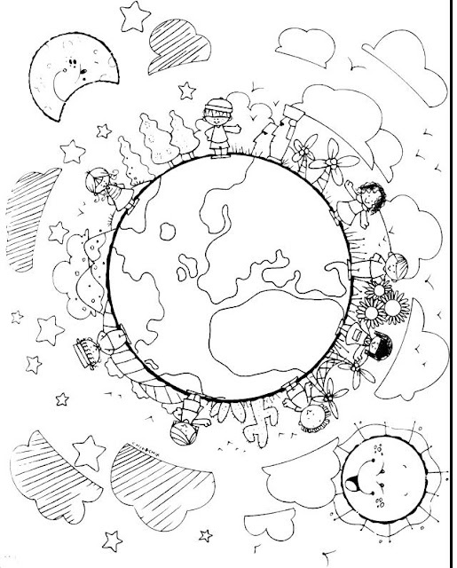

Rowling
Workbook:
Travel the World

Contents
Day 1 | English – 45 minutes - 1 hour
Day 1 | Maths – 45 minutes – 1 hour
Day 1 | Flashback 4 – 5 minutes
Day 1 | Reading Comprehension – 30minutes
Day 1 | Topic– 45 minutes
Day 2 | English – 45 minutes - 1 hour
Day 2 | Maths – 45 minutes – 1 hour
Day 2 | Flashback 4 – 5 minutes
Day 2 | GPS – 30 minutes
Day 2 | Topic– 45 minutes
Day 3 | English – 45 minutes - 1 hour
Day 3 | Maths – 45 minutes – 1 hour
Day 3 | Flashback 4 – 5 minutes
Day 3 | Spellings – 30 minutes
Day 3 | Topic– 45 minutes
Day 4 | English – 45 minutes - 1 hour
Day 4 | Maths – 45 minutes – 1 hour
Day 4 | Flashback 4 – 5 minutes
Day 4 | Reading Comprehension – 30 minutes
Day 4 | Topic– 45 minutes
Day 5 | English – 45 minutes - 1 hour
Day 5 | Maths – 45 minutes – 1 hour
Day 5 | Flashback 4 – 5 minutes
Day 5 | GPS – 30 minutes
Day 5 | Topic– 45 minutes
Optional Projects + Extra Educational Websites
Have you completed your weekly homework? |  | Date  Completed
Spellings Practise
On Spelling Shed or handwritten
Timetables Rock Stars Task
3 Reads (at least 10 minutes out loud with a grown-up)

OPTIONAL
Any comments or messages from grown-ups that you would like to share with your teacher:
Any comments or messages from the student that you would like to share with your teacher:
Day 1 | English
Reminder: Model text
You can listen to an audio version of the story here: https://soundcloud.com/talkforwriting/mission/s-qMLb31YjpM7
Mission Possible
Pete and Polly were completely ordinary, totally normal and utterly boring twins – or so everyone thought. They wore ordinary clothes, took part in normal, everyday activities and were, in fact, boring – or so everyone thought. You see, Pete and Polly Powers had a secret. It wasn’t an ordinary, normal or boring secret and it was a secret that lived just between them (and you, in a moment, if you keep on reading!) Not even their teachers, parents or Scout Leader knew about their secret. No one ... until now. Now, this secret can only be entrusted to the most daring, brave and adventurous of children – do you think you can be trusted? Okay then ... well ... here we go ... Pete and Polly are spies! It all began last summer when they saw an article in the local newspaper advertising for two undercover agents to help fight global crime. Pete and Polly wasted no time in applying and, after a rigorous induction process, they were accepted into the governments’ secret Spy Programme. Their assignments have involved the most daring of adventures like rescuing the Prime Minister from a sudden volcanic eruption and preventing the kidnap of the Queen’s corgis from Buckingham Palace! Pete and Polly were very good at their job and very good at keeping their identity a secret. One spring morning, while having breakfast, Pete’s watch lit up – it was a message from the Government’s top chief of security, Cyril Secret, and it read:
“Background: Last week the notorious thieves Dodgy Roger and Raucus Reggie stole the Yata no Kagami - a mirror which belongs to the Three Sacred Treasures of Japan. Your Mission: To retrieve the Yata no Kagami - and return it to the Japanese embassy in London. When: Tonight Where: You will find it and the thieves in the abandoned riverboat docked on the Thames. Note: Delete this message instantly.”
Pete and Polly looked at each other and, in unison, smirked: “No problem.” Pete, quickly switched his phone off and threw it into his school bag. The day soon passed and, at precisely midnight, the sharp shrill of an alarm woke the twins. Instantly, they jumped out of bed, grabbed their spy bags and flew down the stairs, closing the front door quietly behind them so as to not wake anyone else. Ten minutes later, they found themselves on the edge of the Thames staring at the abandoned riverboat. Outside the cold wind howled and bit at their ears, street lights flickered and an uncomfortable mist slithered across the dangerously deep water. Inside the boat, Pete and Polly saw the silhouette of two large men sitting hunched across a table from one another with the only light coming from an old oil lantern. They seemed to be arguing. With hearts pounding and hands trembling, Pete and Polly snuck into the boat and hid behind the broken door. On the table, they could see the Emperor’s mirror. “What now?” asked Pete in trepidation. “You distract ‘em and I will grab the mirror,” replied Polly confidently. They both nodded. They knew what they had to do. Without
Day 1 | English
hesitation, Pete dropped a small green capsule which filled the boat with a fine green mist. At the same time, Polly ran towards the table where the men sat, grabbed the mirror, flung it into her rucksack and then they both sprinted back up onto the deck. Suddenly, coming from the cabin, they heard the unmistakable sound of fast-paced, heavy footsteps and loud angry voices. “Quick!” Shouted Polly and, on that command, they fled. They didn’t look back. They didn’t stumble. They were trained for moments like this. Fast, focused and determined they continued sprinting until eventually the angry footsteps and loud shouting faded. On the way to school the next morning, Polly and Pete made a small detour to a beautiful Victorian building in Piccadilly, Mayfair, that had a large Japanese flag blowing gentle in the breeze. On the doorstep they carefully placed an object concealed in brown cloth and gave each other a high five and knowing wink. “Mission possible!” Polly chuckled. Just then, Pete stopped suddenly. Slowly, he looked down at his wrist to see his watch flashing once more. It was another message from Cyril Secret …
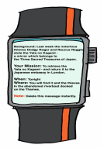
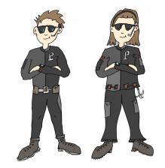

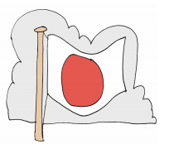
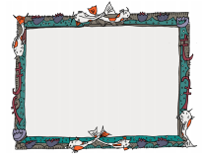

Day 1 | English
Character Names
This page is going to help you create a name for the main characters in your story – the goodies and the baddies. Characters ’names in stories are often very important and can hint at their personality or job. I always think that certain names suit certain kinds of people. Charles Dickens, David Walliams and Roald Dahl regularly use the names as a clue to what the character is like or what they do. For example:
- Mr and Mrs Twit in Roald Dahl’s book: ‘The Twits’ are… twits! Mr Willy Wonka is a silly name for a silly man!
- Miss Root, in the book ‘The Demon Dentist’ by David Walliams, is a dentist (and not a very nice one!)
- Miss Honey and Miss Trunchbull, in Roald Dahl’s ‘Matilda’, are two very different types of teacher – can you guess which one is nice and which isn’t?
In our story, ‘Mission Possible’, we have the following characters:
- Polly Powers and Pete Powers (secret agent)
- Cyril Secret (Head of the Secret Services)
- Dodgy Rodger and Raucous Reggie (thief)
Do you think their names suggest something about them? Do you like their names? What do you notice about their names?
_______________________________________________________________________________________________________________________________________________________________________________________________________________
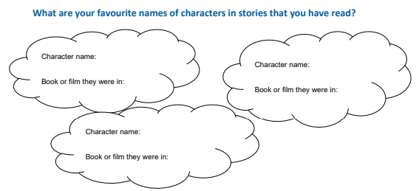
Day 1 | English
Let’s invent some character names for your story
Here are 3 ideas for coming up with a name for a character
1. Find the origin of a name (where the name comes from) For example, the name Peter comes from the Greek meaning ‘rock’. When you find the origin, you can think whether it suits your character. (You will need the internet for this so surf safely and with an adult present.)
2. List names Find some story books and write two lists – one of the author’s first names and another list with all of the second names. Put the lists side by side and match the first names and surnames with ones that you think work well, for example, Roald Donaldson. Or you could list all your friends name, or all the names of people you know, and then rearrange them to come up with names that fit the characters you want to invent.
3. Use jobs or special features In real life, some surnames originally suggested the owner’s job or special feature. Could you invent a surname to fit your character e.g. name + special feature: • an evil surgeon could be called Doctor Slice • a tall teacher: Mr Longlegs • a boy who can run fast: Samuel Speed • a girl who is good at scoring goals: Gail Goodshot.
Name ideas for goodies | Name ideas for baddies
Atleast 5 in each box

Day 1 | Maths
Today’s video: https://vimeo.com/499229510
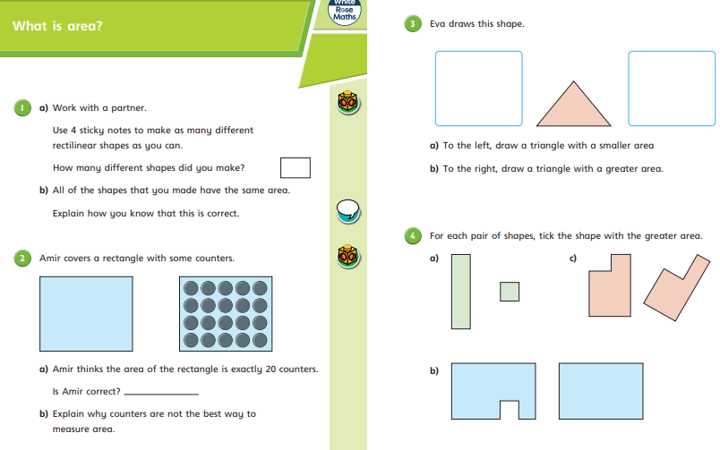
Day 1 | Maths
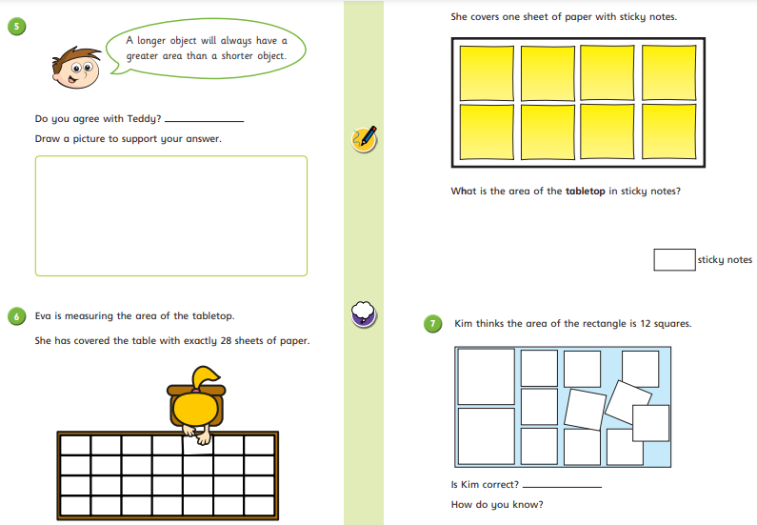

Day 1 | Flashback 4
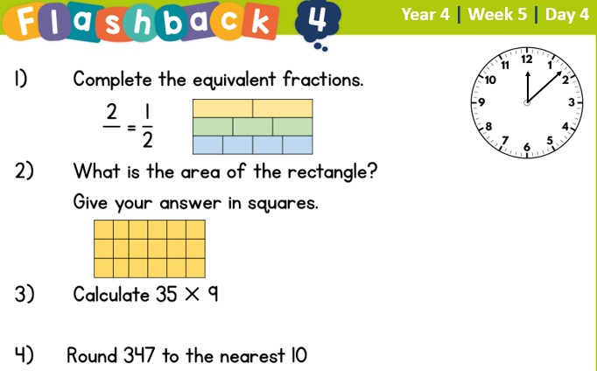


Day 1 | Reading Comprehension
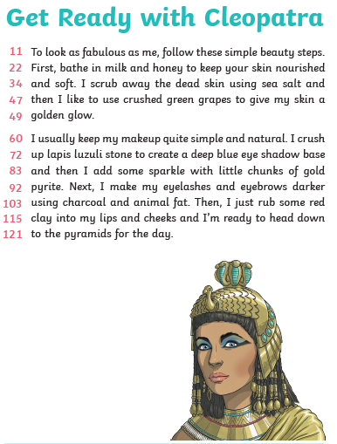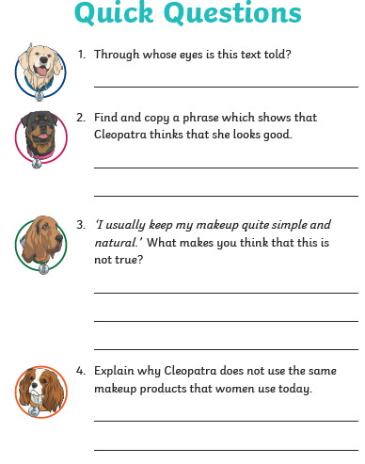
Day 1 | Topic

The seven continents

Go to this website:
https://classroom.thenational.academy/units/seven-continents-cf8c
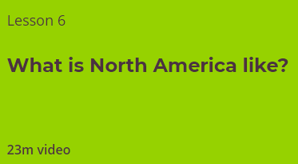
Click on lesson 6 (above). Watch the video.

When you have finished, you can complete the online quiz at the end.

Day 2 | English
Character descriptions
Learning from Other Writers
It is great to read another writer’s work and use their ideas to influence our own. Let’s do some reading and look at this paragraph about a teacher:
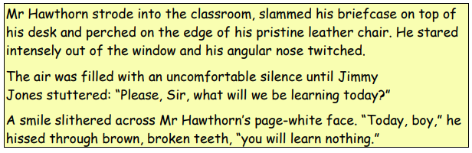
From reading the paragraph above what do you know about Mr Hawthorn?
Is he nice? How do you know?
_____________________________________________________________________
What does he look like?
_____________________________________________________________________
How does he move?
_____________________________________________________________________
How does he speak? What does that tell us?
_____________________________________________________________________
Do you think he suits his name?
_____________________________________________________________________
Do you think other people like him? How do you know?
_____________________________________________________________________
Do you like him? Explain your answer.
_____________________________________________________________________
_____________________________________________________________________
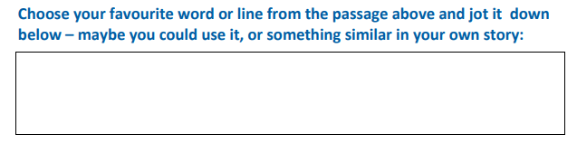

Day 2 | Maths
Today’s video: https://vimeo.com/500381471
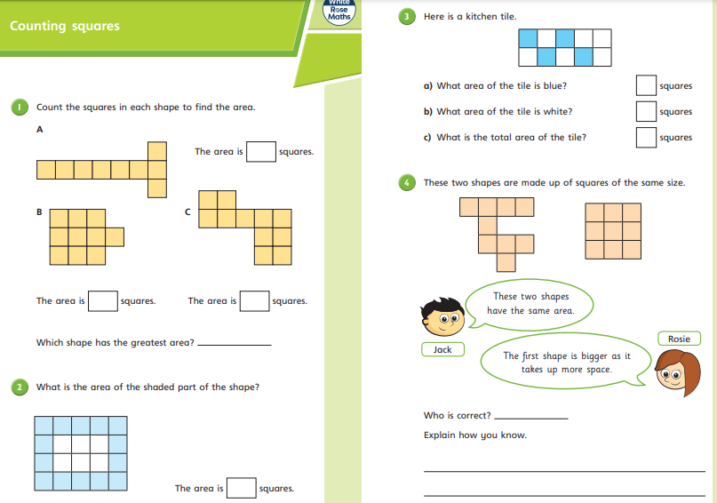

Day 2 | Maths
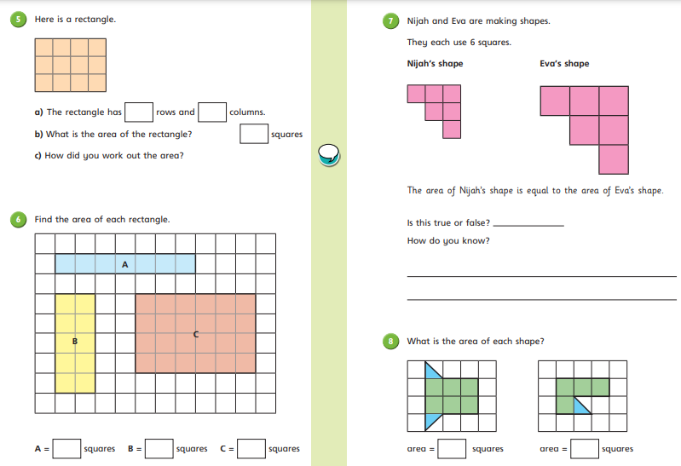

Day 2 | Flashback 4
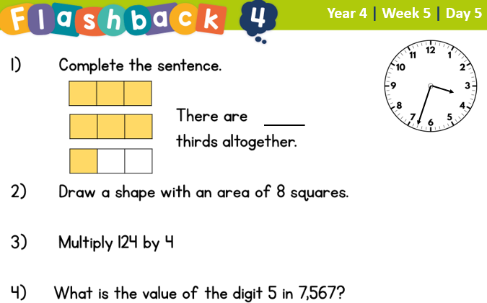
Day 2 | GPS

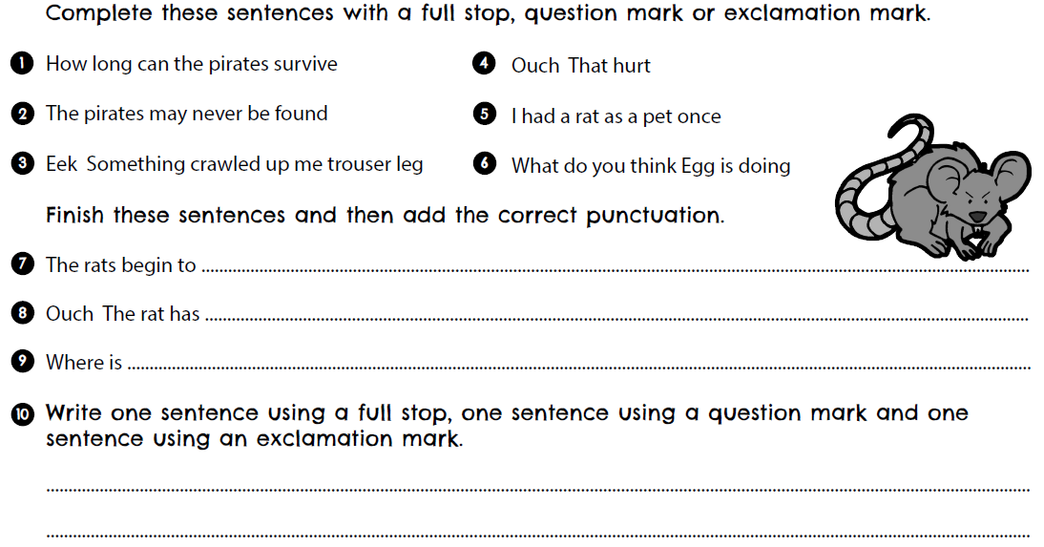

Day 2 | Topic

The seven continents

Go to this website:
https://classroom.thenational.academy/units/seven-continents-cf8c
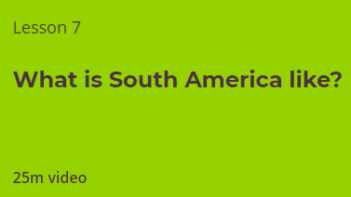
Click on lesson 7 (above). Watch the video and complete the questions.

When you have finished, you can complete the online quiz at the end.
Day 3 | English
Your characters
Now you have got a name for the characters in your story, create a character profile for them
Your goodie | Your baddie
Name:  _________________________________  Age:  _________________________________  Where they live:  _________________________________  Siblings (brothers and sisters):  _________________________________  Appearance (what they look like):  _________________________________  _________________________________  _________________________________  _________________________________  _________________________________  _________________________________  Personality (what they are like):  _________________________________  _________________________________  _________________________________  _________________________________  _________________________________  _________________________________  Draw a picture of what they look like: | Name:  _________________________________  Age:  _________________________________  Where they live:  _________________________________  Siblings (brothers and sisters):  _________________________________  Appearance (what they look like):  _________________________________  _________________________________  _________________________________  _________________________________  _________________________________  _________________________________  Personality (what they are like):  _________________________________  _________________________________  _________________________________  _________________________________  _________________________________  _________________________________  Draw a picture of what they look like:

Day 3 | Maths
Today’s video: https://vimeo.com/500864228
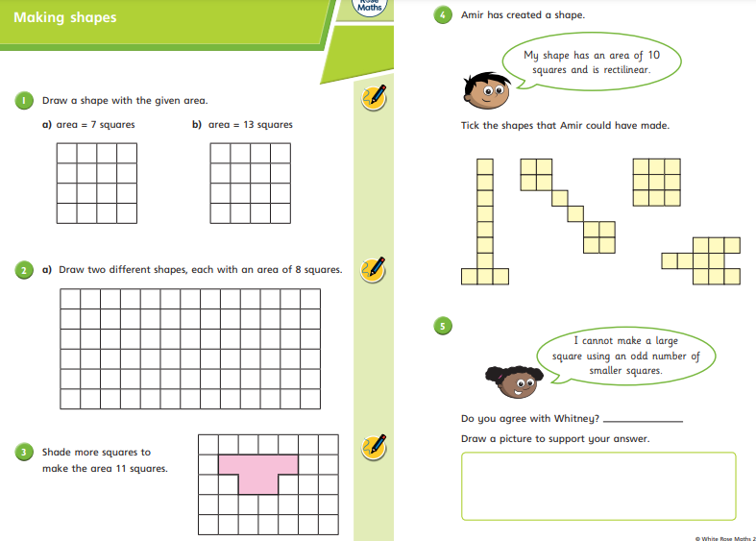
Day 3 | Maths
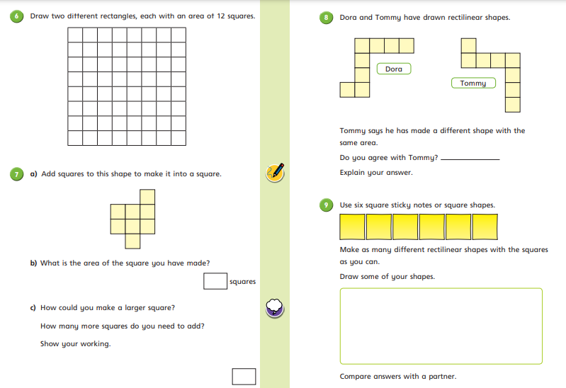

Day 3 | Flashback 4
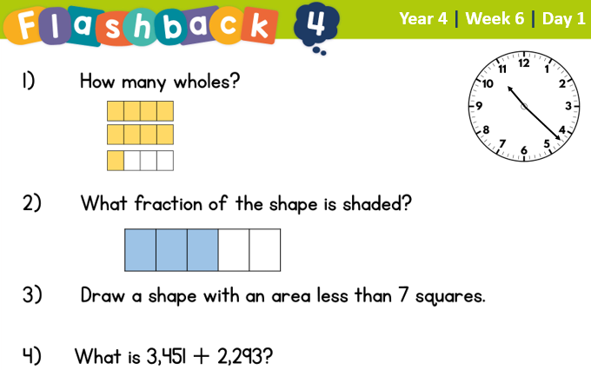

Day 3 | Spellings

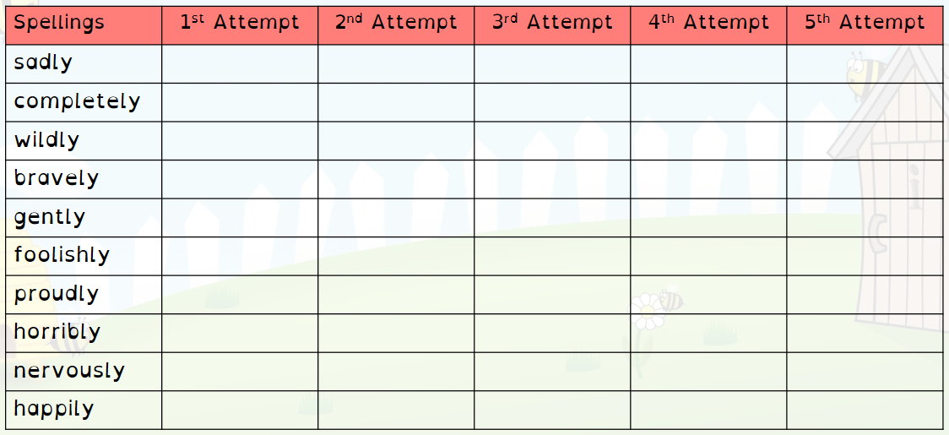
Day 3 | Topic

The seven continents

Go to this website:
https://classroom.thenational.academy/units/seven-continents-cf8c
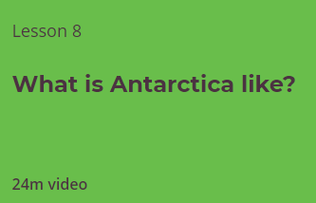
Click on lesson 8 (above). Watch the video.

When you have finished, you can complete the online quiz at the end.

Day 4 | English
Settings
Settings (where the story takes place) are really important. They can make the reader feel safe or scare them. What settings from stories or films can you think of? List them here:

‘Mission Possible ’is set in London and the sacred treasure is hidden on an abandoned riverboat on the Thames (a famous river that runs through London). The author chose the abandoned riverboat at night because they thought that it would be a bit scary.
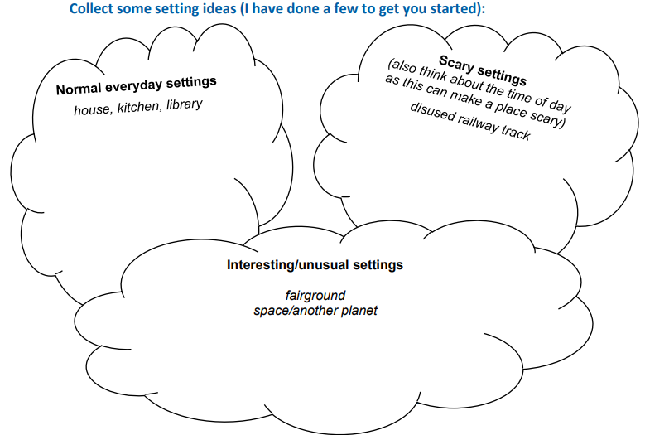
Choose where your story is going to be set. You can have more than one setting if your characters are going to be going to a special destination. Record your thoughts below:
Day 4 | English
Fill in the information below for your setting. There are two boxes if you have more than one setting.
Setting 1 is _______________________
What can be seen? | What can he heard?
What can be touched? | What can be smelt?

Setting 2 is _______________________
What can be seen? | What can he heard?
What can be touched? | What can be smelt?

Day 4 | Maths
Today’s video: https://vimeo.com/501678823
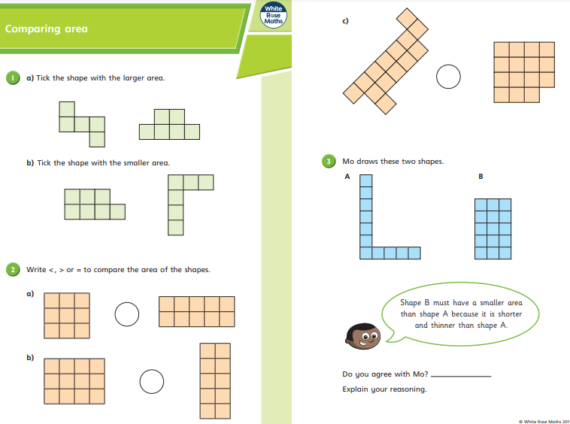
Day 4 | Maths
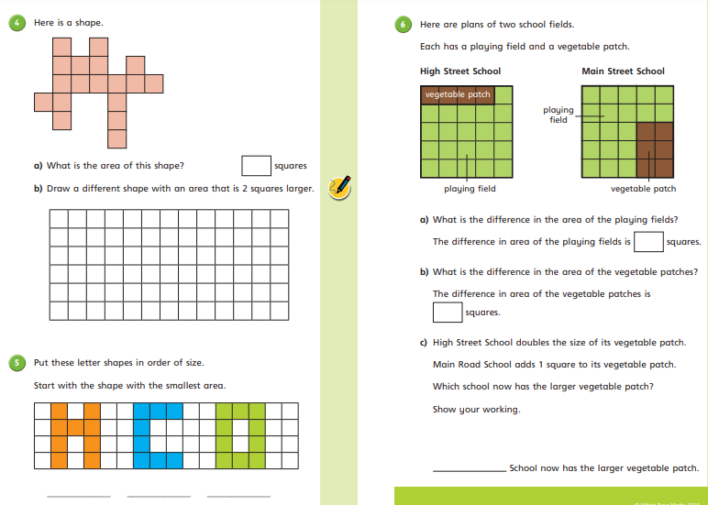

Day 4 | Flashback 4
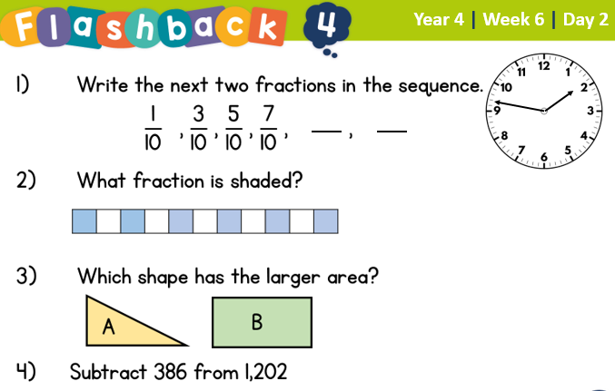

Day 4 | Reading Comprehension
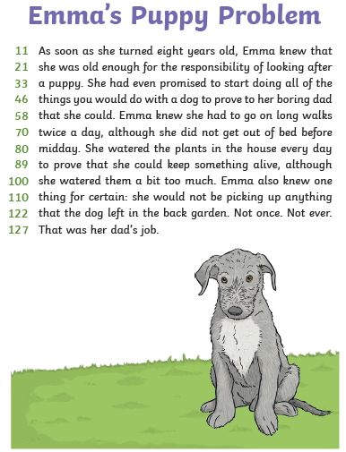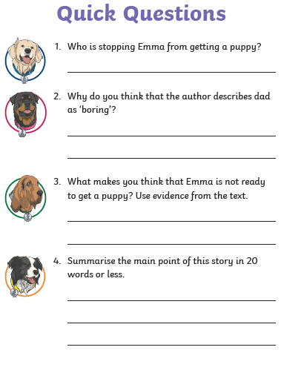
Day 4 | Topic

The seven continents

Go to this website:
https://classroom.thenational.academy/units/seven-continents-cf8c
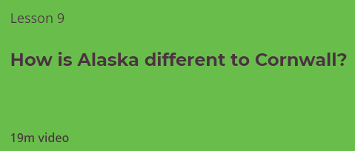
Click on lesson 9 (above). Watch the video.

When you have finished, you can complete the online quiz at the end.

Day 5 | English
Setting descriptions
Read the following extract called ‘Grandma’s attic’

The room was long and gloomy and filled with mixed-up shapes and threatening angles. Light seeped in from three grimy skylights and the air swam with dust. Fresh rain tapped its fingertips on the roof and wind whipped through the trees outside. Cole felt very far away from everyone, as if the world and everything in it were trapped within the attic itself. He stuffed Grandma Jenny’s keys into his pocket and fumbled around the doorway until he found an old-fashioned light switch on a chain. When he pulled, a smattering of ancient bulbs in ornate light fittings blinked on.

What is good about this extract?
__________________________________________________________________________________________________________________________________________
A good setting description builds the picture in a reader’s mind. Using what you have read above, can you draw the attic?
We would now like you to write a setting description for ONE of your settings in your story. You must include:
- Adjectives
- Correct punctuation- capital letters, full stops
- Show not tell- (Instead of saying ‘dirty’ you could say ‘hidden beneath a blanket of dust and grime’.
We have added a word mat to help you with your description. Your description must be atleast 6 sentences long.

Day 5 | English
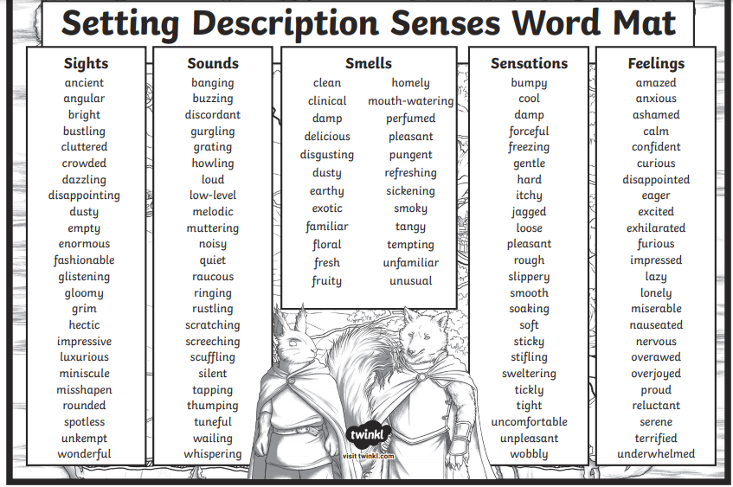

Day 5 | English
My setting
Picture:

Day 5 | Maths
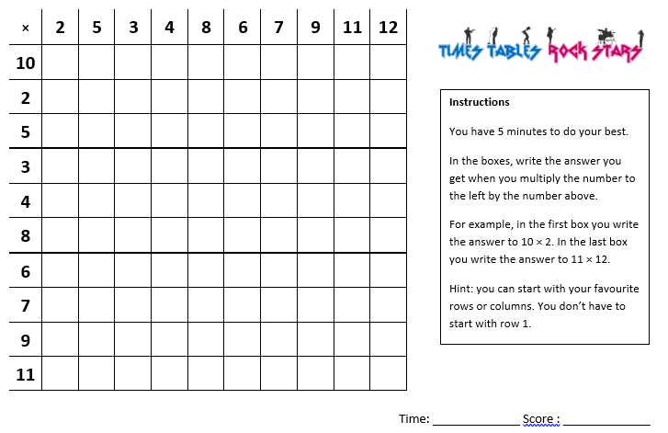
Once complete, go on TTRockstars for atleast 30 minutes. Email your teacher if you have forgotten your log in details.

Day 5 | Flashback 4
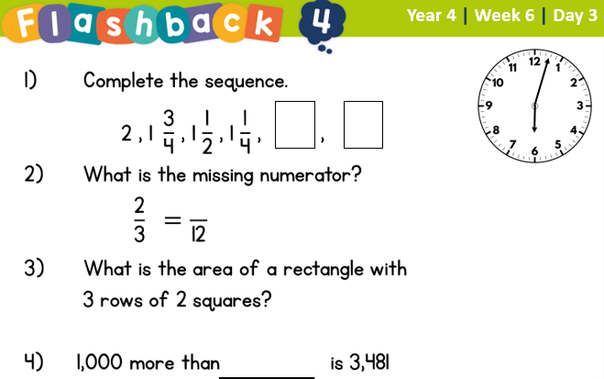

Day 5 | GPS

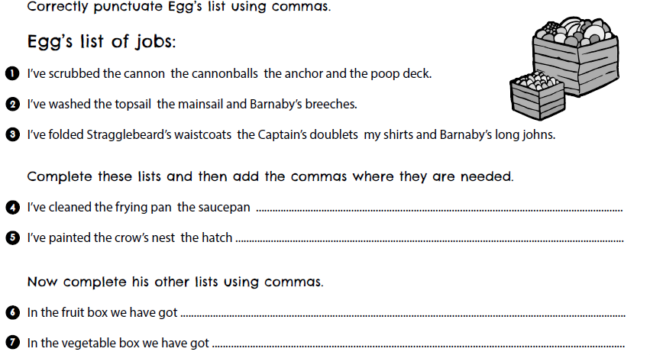
Day 5 | Topic

The seven continents

Go to this website:
https://classroom.thenational.academy/units/seven-continents-cf8c
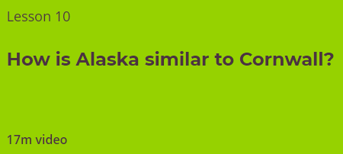
Click on lesson 10 (above). Watch the video.

When you have finished, you can complete the online quiz at the end.

Optional Projects

Using scraps from the cardboard recycle bin, some glue and maybe a dash of paint, choose your favourite continent, and make a 3D model of it, ensuring the shape and terrain is recognizable. Take a photo of it for our Facebook page and bask in the adoration of your friends!  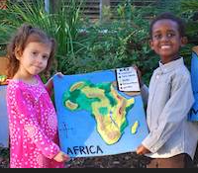 | Imagine if the oceans have overtaken the continents and you have to make a raft from recycled materials. Why not make a model of a raft that can float on water, perhaps out of discarded plastic bottles? How will you attach the bottles together? Think about other scraps of waste material we throw away from packaging. How about using some Lego characters as guinea pigs! If you have adult supervision, and only if you have, why not test your creation in the bath – you don’t have to get in the bath!  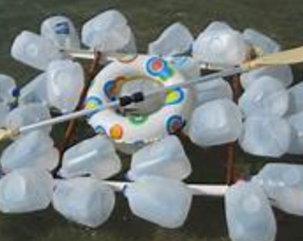  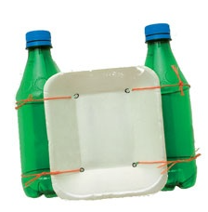
What do you say to getting busy with the felt tips, creating a colour key and exploding a map of the world with crazy colours? You could then photograph your creation, and get your adult to email it to mbellamy@asquith.notts.sch.uk, so Mr. Bellamy can make a montage of all the pictures received to put onto the school’s website! 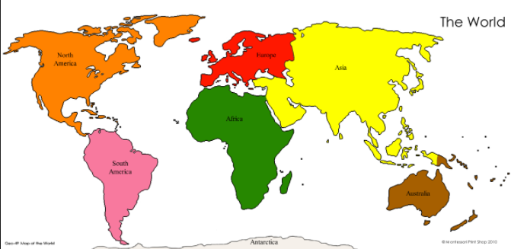https://www.twinkl.co.uk/resource/t-g-273-the-seven-continents-labelling-activity-sheet | 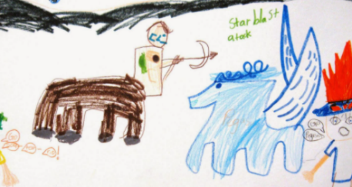  Can you see the cardboard box in the corner? No, not that corner, the other one! Yes, that dog-eared box gathering dust. Take a gentle stroll over to it, and have a peep inside. You have stumbled upon an ancient teleportation device, which allows the traveller – you - to close their eyes, think of a continent, and then a country in that continent, and you will find your self transported to that very spot on the globe. Take a few moments with your eyes wide open to obsorb your surroundings. What you see? What might you hear? How does it feel? Can you teste or smell anything unsual?  Draw a picture to show yourself in this new place surrounded by all that you can imagine! Or, get a cardboard box, and decorate it with illustrations from your travels.
Finished your work but still need something to do?
Check out these educational websites below:

Educational games
https://www.bbc.co.uk/cbeebies/games
Want to learn how to type properly on a keyboard?
https://www.typingclub.com/
Learn coding online
https://scratch.mit.edu/
Maths Games
https://www.topmarks.co.uk/maths-games/7-11-years/ordering-and-sequencing
Learn your maths facts fast!
https://www.topmarks.co.uk/maths-games/hit-the-button
Primary Games
https://www.bbc.co.uk/bitesize/collections/primary-games/1
Love music? Play these instruments online:
https://www.virtualmusicalinstruments.com/
Loads of maths challenges:
http://www.mathematicshed.com/
Loads of literacy things:
https://www.literacyshedplus.com/en-gb#resources
Like maths challenges? Try these!
https://www.transum.org/Software/SW/Starter_of_the_day/index.htm
Do you love to write? Check out this picture site, choose a picture and write, write, write!
https://www.onceuponapicture.co.uk/
List of sites/games
https://www.popsugar.co.uk/parenting/free-online-educational-resources-for-kids-47312329

Some of these websites are updated daily. Check them out every day!

*Found another website that you want to share with other students? Email it to your teacher and we’ll add it to the list!*

