Name: Class:

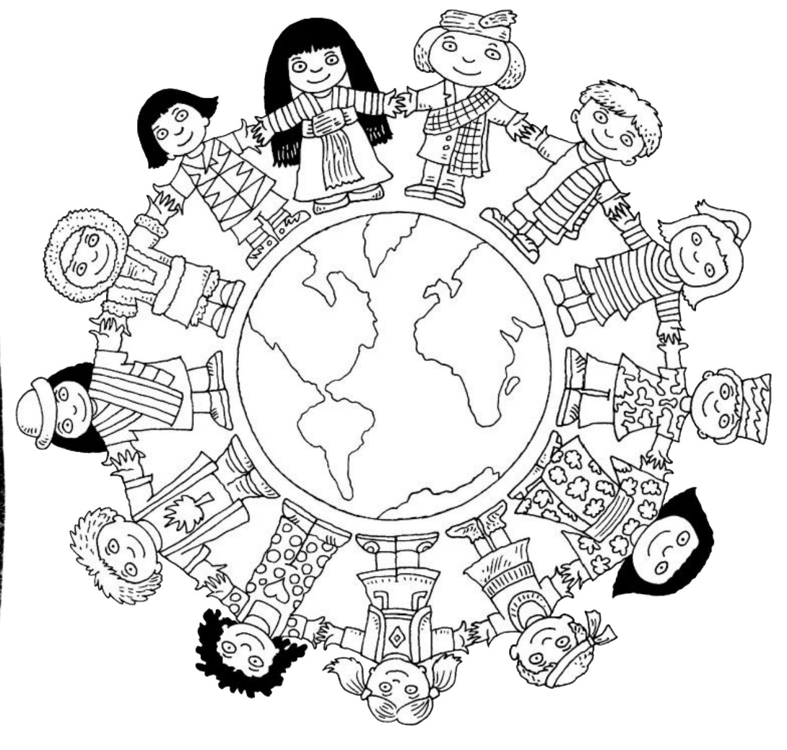

Dahl
Workbook:
Adventures

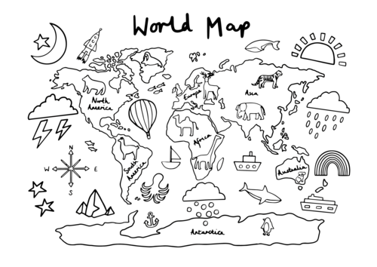

Contents
Day 1 | English – 45 minutes
Day 1 | Maths – 45 minutes
Day 1 | Flashback 4 – 5 minutes
Day 1 | Reading Comprehension – 30minutes
Day 1 | Topic– 45 minutes
Day 2 | English – 45 minutes
Day 2 | Maths – 45 minutes
Day 2 | Flashback 4 – 5 minutes
Day 2 | GPS – 30 minutes
Day 2 | Topic– 45 minutes
Day 3 | English – 45 minutes
Day 3 | Maths – 45 minutes
Day 3 | Flashback 4 – 5 minutes
Day 3 | Spellings – 30 minutes
Day 3 | Topic– 45 minutes
Day 4 | English – 45 minutes
Day 4 | Maths – 45 minutes
Day 4 | Flashback 4 – 5 minutes
Day 4 | Reading Comprehension – 30 minutes
Day 4 | Topic– 45 minutes
Day 5 | English – 45 minutes
Day 5 | Maths – 45 minutes
Day 5 | Flashback 4 – 5 minutes
Day 5 | GPS – 30 minutes
Day 5 | Topic– 45 minutes
Optional Projects + Extra Educational Websites
Have you completed your weekly homework? |  | Date  Completed
Spellings Practise
On Spelling Shed or handwritten
Timetables Rock Stars Task
3 Reads (at least 10 minutes out loud with a grown-up)

OPTIONAL
Any comments or messages from grown-ups that you would like to share with your teacher:
Any comments or messages from the student that you would like to share with your teacher:
Day 1 | English
Helpful video: https://www.youtube.com/watch?v=KUzWCPiPthM
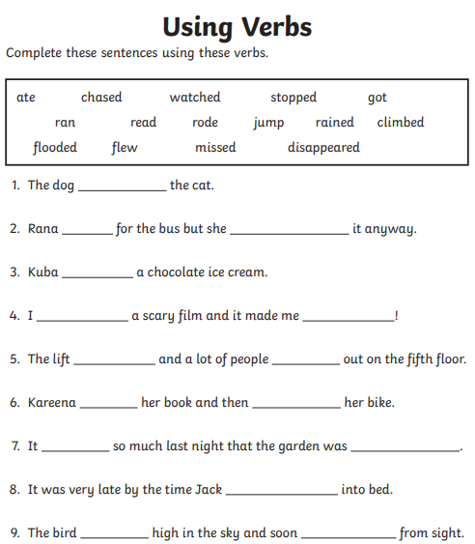 Can you write you own sentence using a verb?
____________________________________________________________________________________________

Day 1 | Maths
Today’s video: https://vimeo.com/492603273
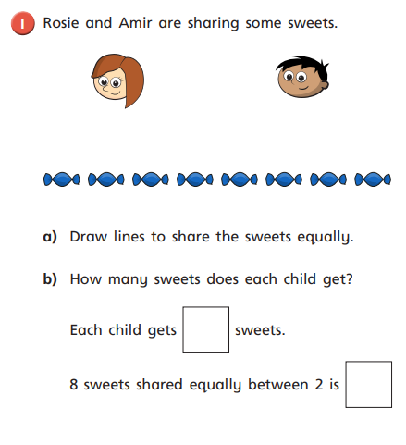
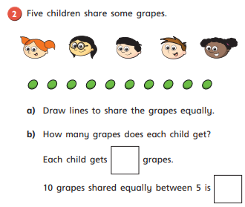

Day 1 | Maths
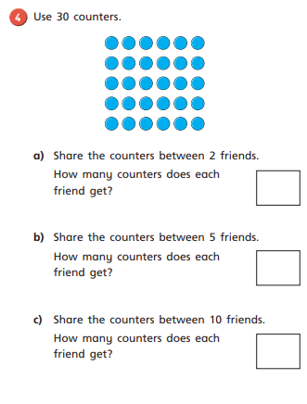
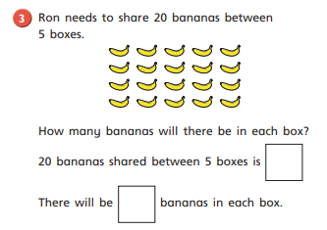

Day 1 | Flashback 4
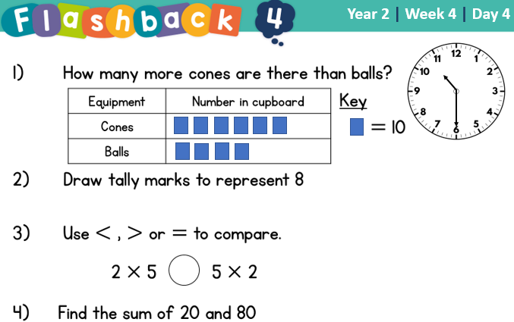


Day 1 | Reading Comprehension
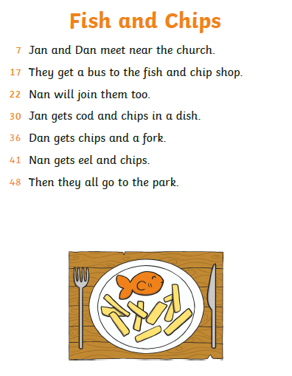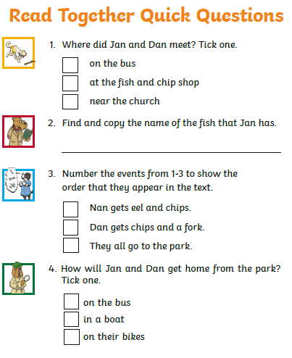
Day 1 | Topic

The seven continents

Go to this website:
https://classroom.thenational.academy/units/seven-continents-cf8c
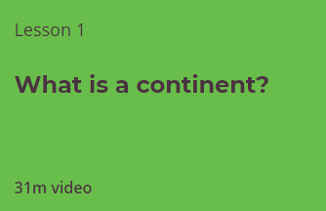

Click on lesson 1 (above). Watch the video.

When you have finished, you can complete the online quiz at the end.

Day 2 | English
Helpful video: https://www.youtube.com/watch?v=-3S_4d2Fs9E
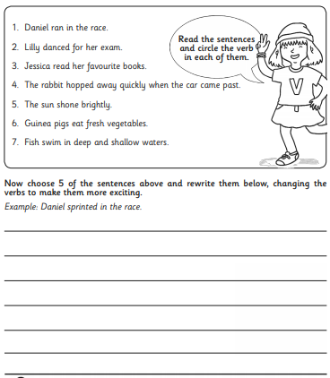

Day 2 | Maths
Today’s video: https://vimeo.com/492603633
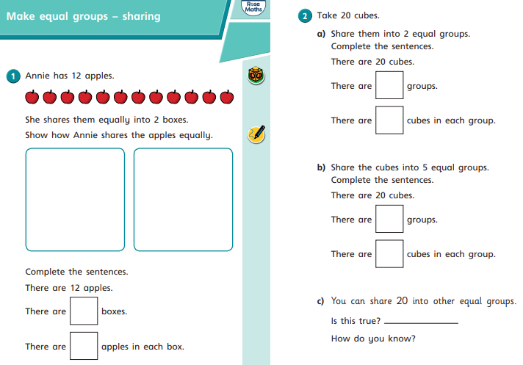

Day 2 | Maths
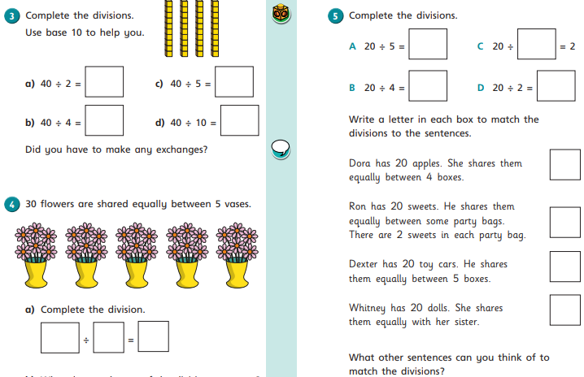

Day 2 | Flashback 4
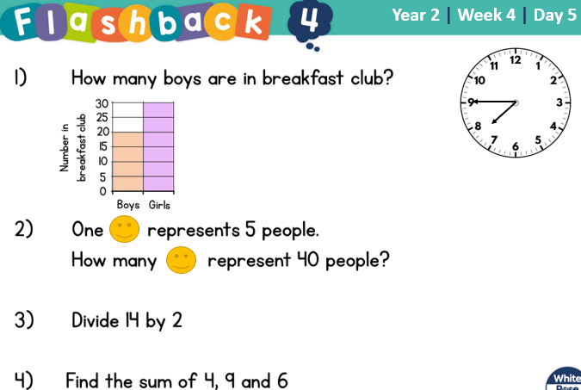
Day 2 | GPS
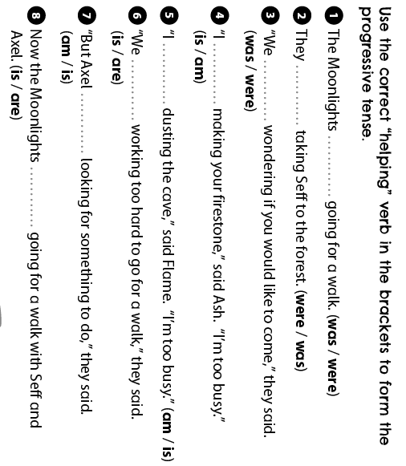
Day 2 | Topic
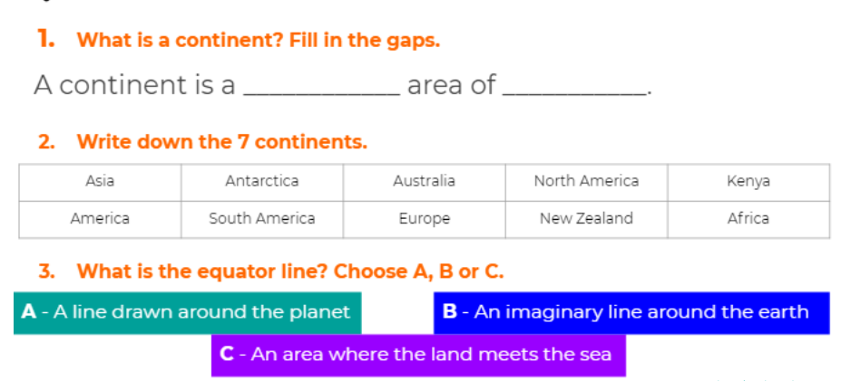

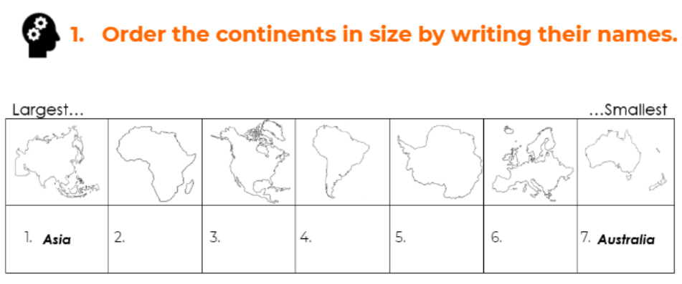

The seven continents

Go to this website:
https://classroom.thenational.academy/units/seven-continents-cf8c
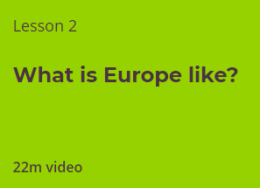

Click on lesson 2 (above). Watch the video and complete the questions.

When you have finished, you can complete the online quiz at the end.

Day 3 | English
Understanding verbs

Can you place these verbs into the correct box based on their meaning.
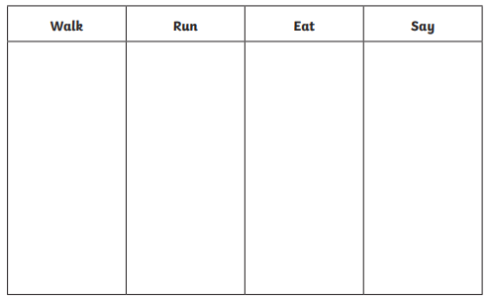
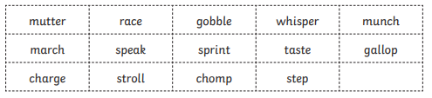
Write these words into the correct box

Day 3 | Maths
Today’s video: https://vimeo.com/492603899
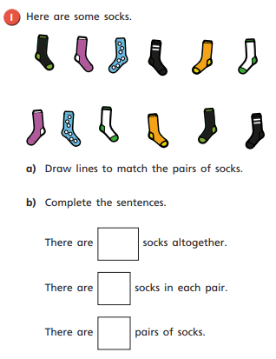
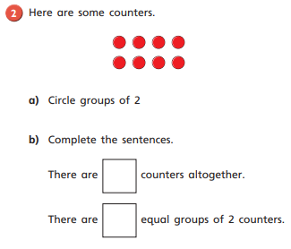
Day 3 | Maths
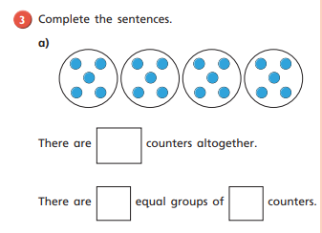
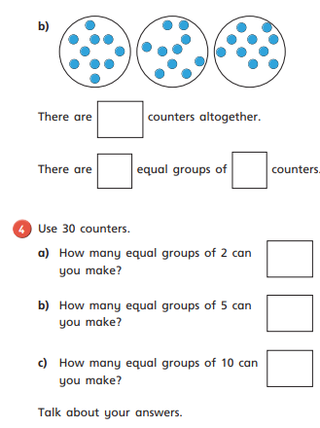

Day 3 | Flashback 4
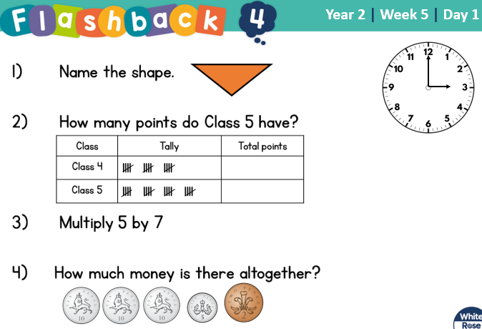

Day 3 | Spellings

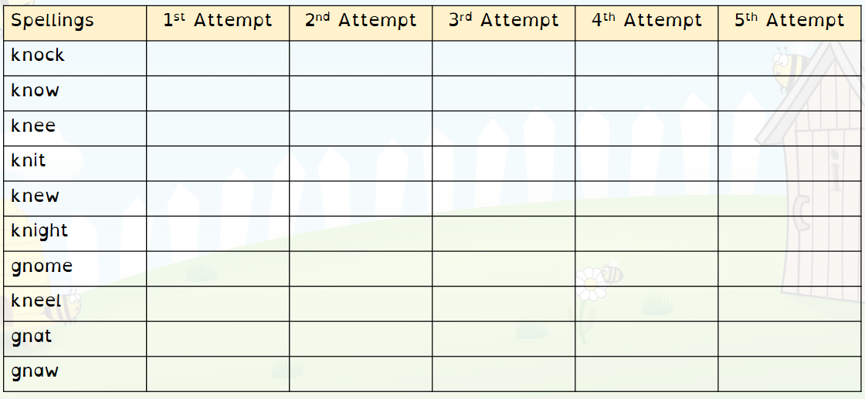
Day 3 | Topic

The seven continents

Go to this website:
https://classroom.thenational.academy/units/seven-continents-cf8c
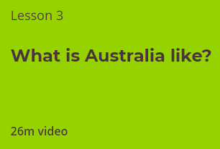
Click on lesson 3 (above). Watch the video.

When you have finished, you can complete the online quiz at the end.

Day 4 | English
Helpful video: https://www.youtube.com/watch?v=QVLKQjUALOM
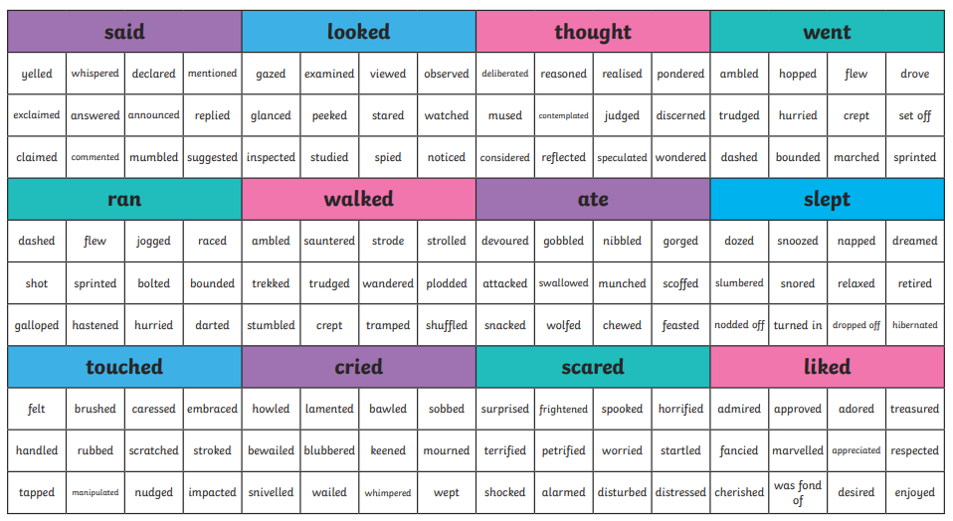
Day 4 | English
Using the word mat to help you, write a sentence for each of these pictures using a powerful verb in your sentence.
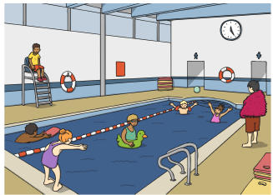
____________________________________________________________________________________________
______________________________________________
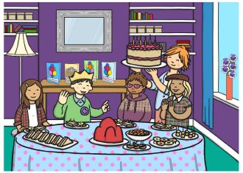
____________________________________________________________________________________________
______________________________________________

Day 4 | English

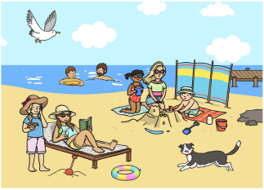
____________________________________________________________________________________________
______________________________________________

Draw a picture yourself then create a sentence with a powerful verb in it:

____________________________________________________________________________________________
______________________________________________

Day 4 | Maths
Today’s video: https://vimeo.com/492603961
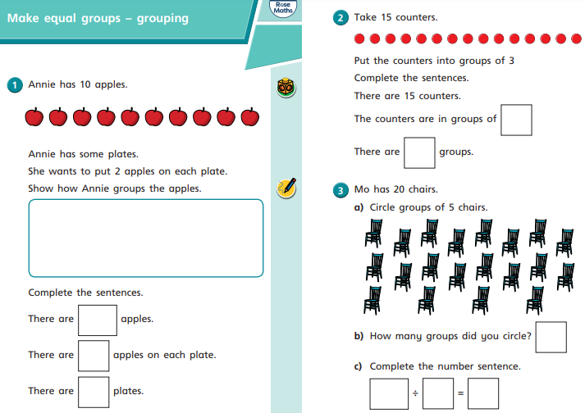
Day 4 | Maths
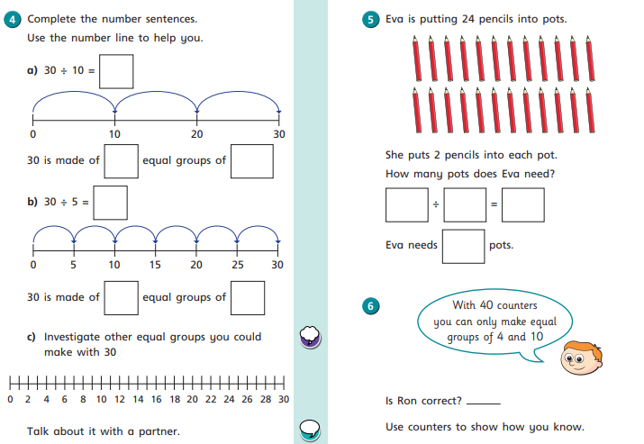

Day 4 | Flashback 4
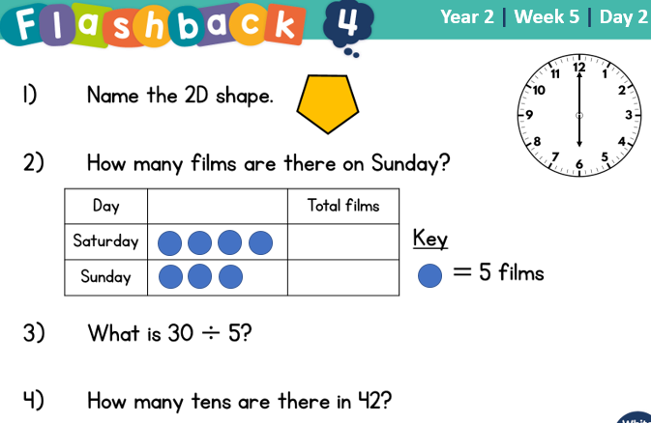

Day 4 | Reading Comprehension
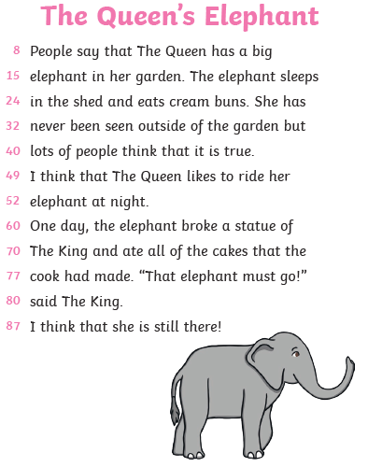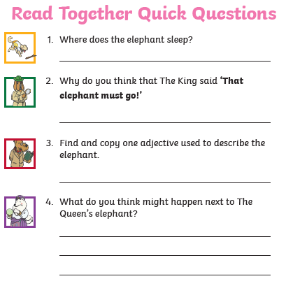
Day 4 | Topic

The seven continents

Go to this website:
https://classroom.thenational.academy/units/seven-continents-cf8c
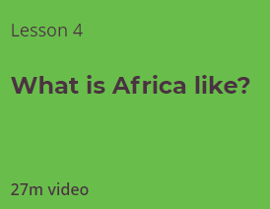
Click on lesson 4 (above). Watch the video.

When you have finished, you can complete the online quiz at the end.

Day 5 | English
Writing blast
Below you have a picture. I would like you to write 5 or more sentences, using powerful verbs. You have to check the following:
- Capital letters
- Full stops
- Your sentences make sense
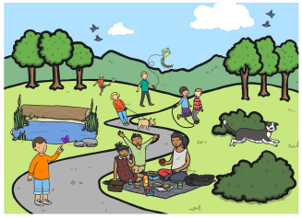
- You’ve checked your spellings

______________________________________________________________________________________________________________________________________________________________________________________________________________________________________________________________________________________________________________________________________________________________________________________________________________________________

Day 5 | Maths
Today’s video: https://vimeo.com/498260506
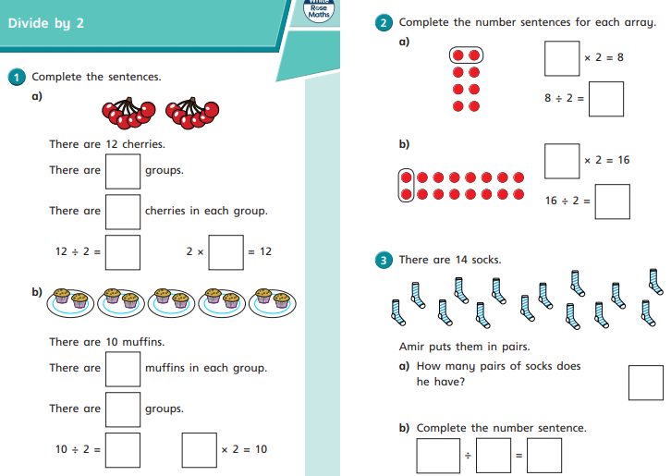
Day 5 | Maths
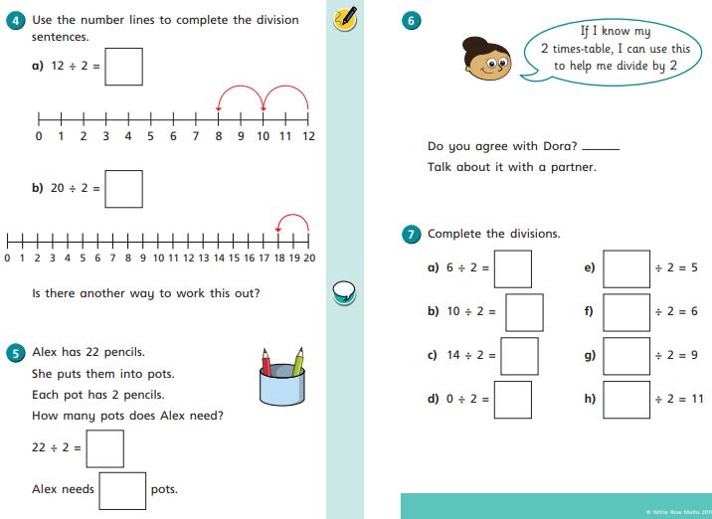

Day 5 | Flashback 4
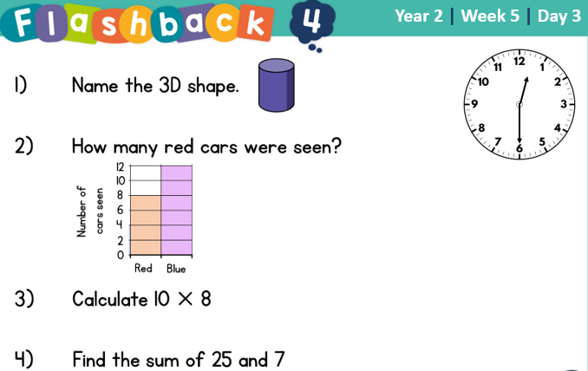

Day 5 | GPS
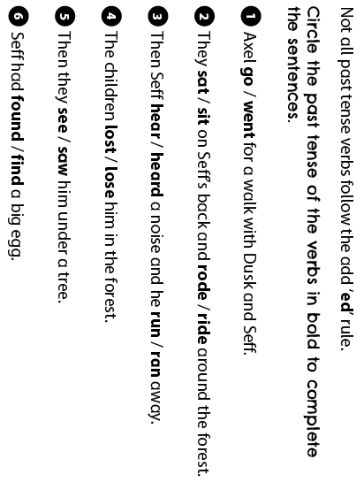
Day 5 | Topic

The seven continents

Go to this website:
https://classroom.thenational.academy/units/seven-continents-cf8c
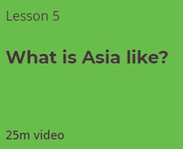
Click on lesson 4 (above). Watch the video.

When you have finished, you can complete the online quiz at the end.

Optional Projects

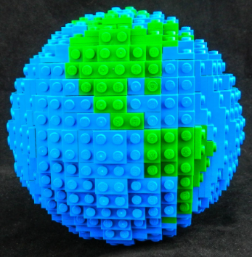  Make a model of the 7 continents inside the house or in your garden and take a picture of it for our Facebook page. Hint: you could use Lego pieces, pebbles, small rocks or playdoh. Anything you can lay your hands on.  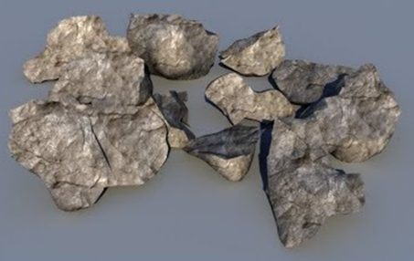 | Design and construct a colourful model of our continents using items from the home. Hint: paper plates – yes, the round ones! make an excellent starting point. Cut out shapes to resemble the continents and get busy with the paint!  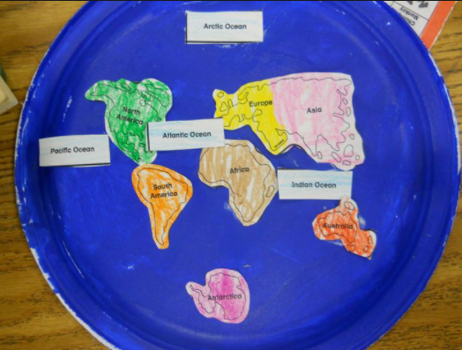
Have fun creating continent cookies! Grab a packet cookie mix next time you go shopping, and go crazy shaping the delicious treats to resemble the 7 continents. Mmmm!    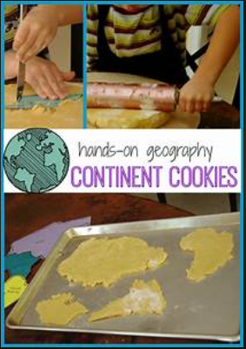 | Design your own planet and its continents. How will it differ from Earth? This could be drawn in the space at the back of the workbook, or physically made into a 3D model from ‘bits n bobs’ lying around at home. Go on, let your imagination run riot! Take a photo for our Facebook page.  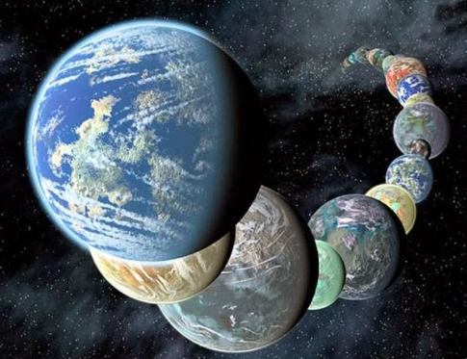
Finished your work but still need something to do?
Check out these educational websites below:

Educational games
https://www.bbc.co.uk/cbeebies/games
Want to learn how to type properly on a keyboard?
https://www.typingclub.com/
Learn coding online
https://scratch.mit.edu/
Maths Games
https://www.topmarks.co.uk/maths-games/7-11-years/ordering-and-sequencing
Learn your maths facts fast!
https://www.topmarks.co.uk/maths-games/hit-the-button
Primary Games
https://www.bbc.co.uk/bitesize/collections/primary-games/1
Love music? Play these instruments online:
https://www.virtualmusicalinstruments.com/
Loads of maths challenges:
http://www.mathematicshed.com/
Loads of literacy things:
https://www.literacyshedplus.com/en-gb#resources
Like maths challenges? Try these!
https://www.transum.org/Software/SW/Starter_of_the_day/index.htm
Do you love to write? Check out this picture site, choose a picture and write, write, write!
https://www.onceuponapicture.co.uk/
List of sites/games
https://www.popsugar.co.uk/parenting/free-online-educational-resources-for-kids-47312329

Some of these websites are updated daily. Check them out every day!

*Found another website that you want to share with other students? Email it to your teacher and we’ll add it to the list!*

