Name: Class:

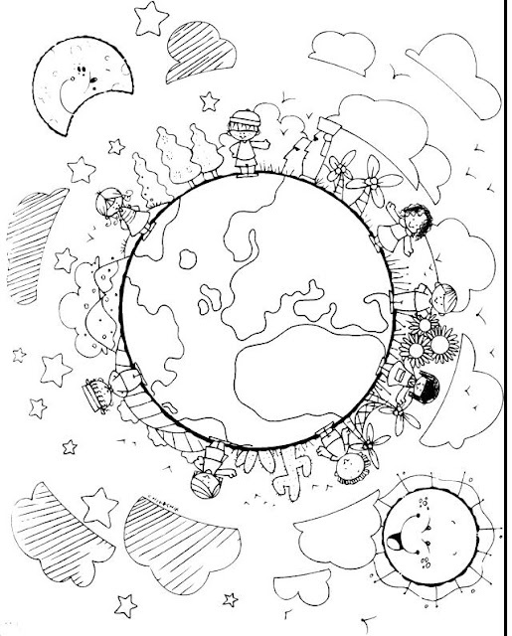

Walliams
Workbook:
Adventures

Contents
Day 1 | English – 45 minutes - 1 hour
Day 1 | Maths – 45 minutes – 1 hour
Day 1 | Flashback 4 – 5 minutes
Day 1 | Reading Comprehension – 30minutes
Day 1 | Topic– 45 minutes
Day 2 | English – 45 minutes - 1 hour
Day 2 | Maths – 45 minutes – 1 hour
Day 2 | Flashback 4 – 5 minutes
Day 2 | GPS – 30 minutes
Day 2 | Topic– 45 minutes
Day 3 | English – 45 minutes - 1 hour
Day 3 | Maths – 45 minutes – 1 hour
Day 3 | Flashback 4 – 5 minutes
Day 3 | Spellings – 30 minutes
Day 3 | Topic– 45 minutes
Day 4 | English – 45 minutes - 1 hour
Day 4 | Maths – 45 minutes – 1 hour
Day 4 | Flashback 4 – 5 minutes
Day 4 | Reading Comprehension – 30 minutes
Day 4 | Topic– 45 minutes
Day 5 | English – 45 minutes - 1 hour
Day 5 | Maths – 45 minutes – 1 hour
Day 5 | Flashback 4 – 5 minutes
Day 5 | GPS – 30 minutes
Day 5 | Topic– 45 minutes
Optional Projects + Extra Educational Websites
Have you completed your weekly homework? |  | Date  Completed
Spellings Practise
On Spelling Shed or handwritten
Timetables Rock Stars Task
3 Reads (at least 10 minutes out loud with a grown-up)

OPTIONAL
Any comments or messages from grown-ups that you would like to share with your teacher:
Any comments or messages from the student that you would like to share with your teacher:
Day 1 | English
You can listen to an audio version of the story here: https://soundcloud.com/talkforwriting/mission/s-qMLb31YjpM7
Mission Possible
Pete and Polly were completely ordinary, totally normal and utterly boring twins – or so everyone thought. They wore ordinary clothes, took part in normal, everyday activities and were, in fact, boring – or so everyone thought. You see, Pete and Polly Powers had a secret. It wasn’t an ordinary, normal or boring secret and it was a secret that lived just between them (and you, in a moment, if you keep on reading!) Not even their teachers, parents or Scout Leader knew about their secret. No one ... until now. Now, this secret can only be entrusted to the most daring, brave and adventurous of children – do you think you can be trusted? Okay then ... well ... here we go ... Pete and Polly are spies! It all began last summer when they saw an article in the local newspaper advertising for two undercover agents to help fight global crime. Pete and Polly wasted no time in applying and, after a rigorous induction process, they were accepted into the governments’ secret Spy Programme. Their assignments have involved the most daring of adventures like rescuing the Prime Minister from a sudden volcanic eruption and preventing the kidnap of the Queen’s corgis from Buckingham Palace! Pete and Polly were very good at their job and very good at keeping their identity a secret. One spring morning, while having breakfast, Pete’s watch lit up – it was a message from the Government’s top chief of security, Cyril Secret, and it read:
“Background: Last week the notorious thieves Dodgy Roger and Raucus Reggie stole the Yata no Kagami - a mirror which belongs to the Three Sacred Treasures of Japan. Your Mission: To retrieve the Yata no Kagami - and return it to the Japanese embassy in London. When: Tonight Where: You will find it and the thieves in the abandoned riverboat docked on the Thames. Note: Delete this message instantly.”
Pete and Polly looked at each other and, in unison, smirked: “No problem.” Pete, quickly switched his phone off and threw it into his school bag. The day soon passed and, at precisely midnight, the sharp shrill of an alarm woke the twins. Instantly, they jumped out of bed, grabbed their spy bags and flew down the stairs, closing the front door quietly behind them so as to not wake anyone else. Ten minutes later, they found themselves on the edge of the Thames staring at the abandoned riverboat. Outside the cold wind howled and bit at their ears, street lights flickered and an uncomfortable mist slithered across the dangerously deep water. Inside the boat, Pete and Polly saw the silhouette of two large men sitting hunched across a table from one another with the only light coming from an old oil lantern. They seemed to be arguing. With hearts pounding and hands trembling, Pete and Polly snuck into the boat and hid behind the broken door. On the table, they could see the Emperor’s mirror. “What now?” asked Pete in trepidation. “You distract ‘em and I will grab the mirror,” replied Polly confidently. They both nodded. They knew what they had to do. Without hesitation, Pete dropped a small green capsule which filled the boat with a fine green mist. At the same time, Polly ran towards the table where the men sat, grabbed the mirror, flung
Day 1 | English
it into her rucksack and then they both sprinted back up onto the deck. Suddenly, coming from the cabin, they heard the unmistakable sound of fast-paced, heavy footsteps and loud angry voices. “Quick!” Shouted Polly and, on that command, they fled. They didn’t look back. They didn’t stumble. They were trained for moments like this. Fast, focused and determined they continued sprinting until eventually the angry footsteps and loud shouting faded. On the way to school the next morning, Polly and Pete made a small detour to a beautiful Victorian building in Piccadilly, Mayfair, that had a large Japanese flag blowing gentle in the breeze. On the doorstep they carefully placed an object concealed in brown cloth and gave each other a high five and knowing wink. “Mission possible!” Polly chuckled. Just then, Pete stopped suddenly. Slowly, he looked down at his wrist to see his watch flashing once more. It was another message from Cyril Secret …
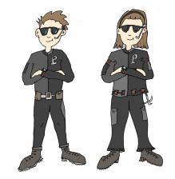
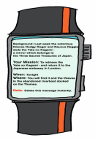

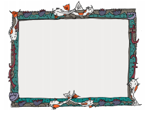
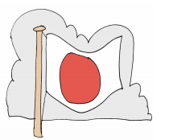

Day 1 | English
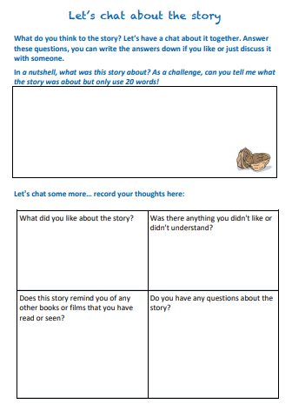

Day 1 | Maths
Today’s video: https://vimeo.com/489844871
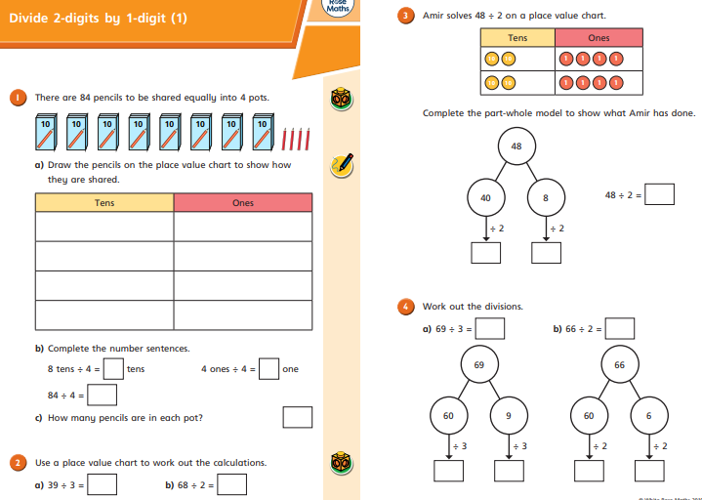
Day 1 | Maths
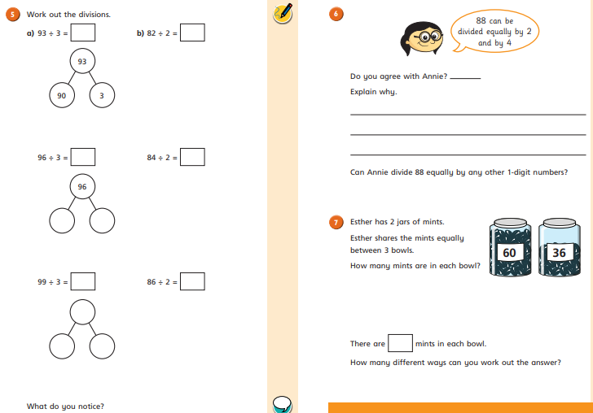

Day 1 | Flashback 4
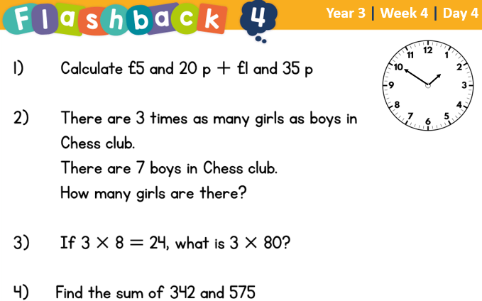


Day 1 | Reading Comprehension
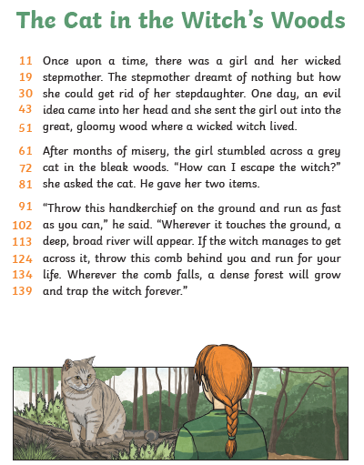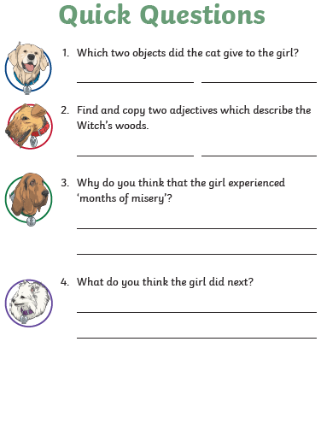
Day 1 | Topic

The seven continents

Go to this website:
https://classroom.thenational.academy/units/seven-continents-cf8c
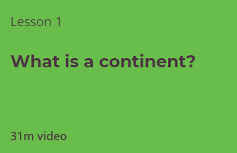

Click on lesson 1 (above). Watch the video.

When you have finished, you can complete the online quiz at the end.

Day 2 | English
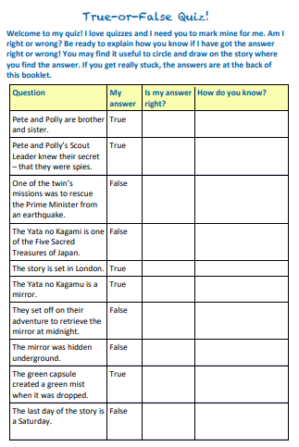

Day 2 | English

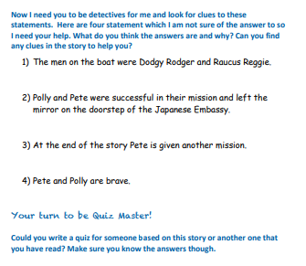

Day 2 | Maths
Today’s video: https://vimeo.com/489845622
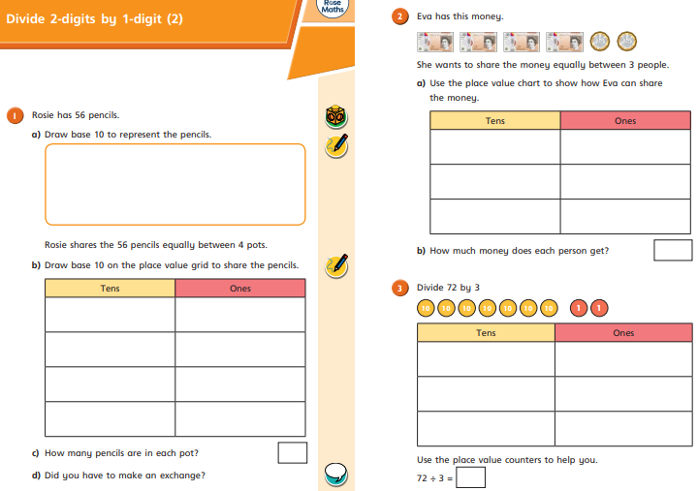

Day 2 | Maths
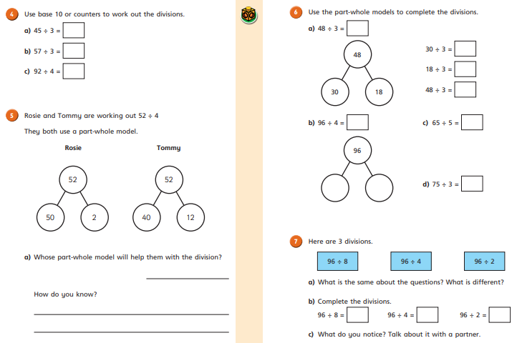

Day 2 | Flashback 4
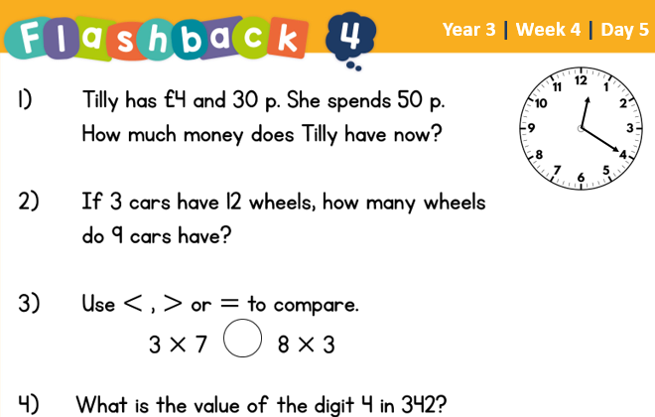
Day 2 | GPS
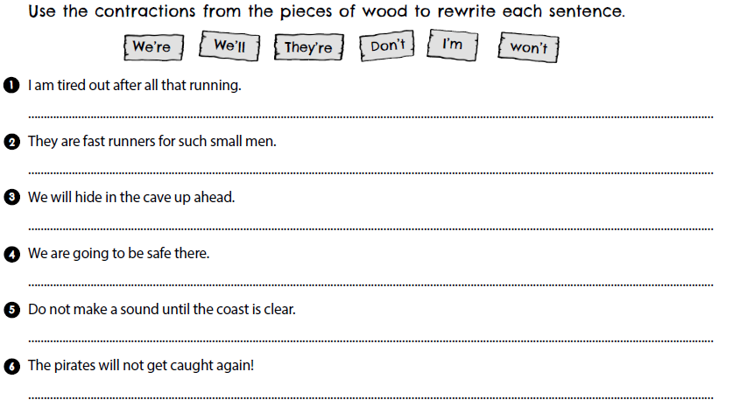

Day 2 | Topic
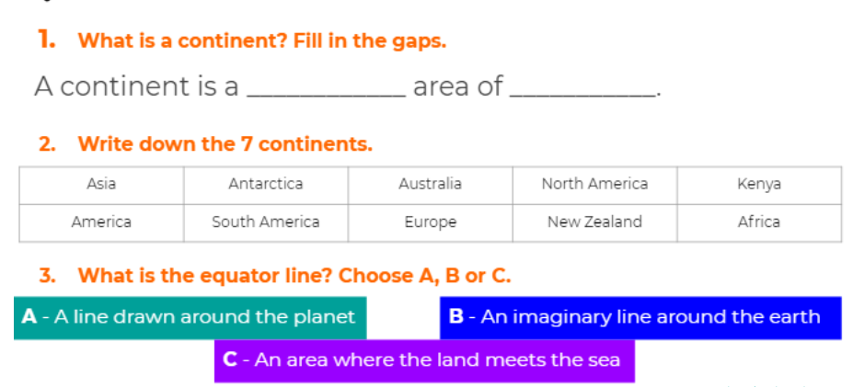

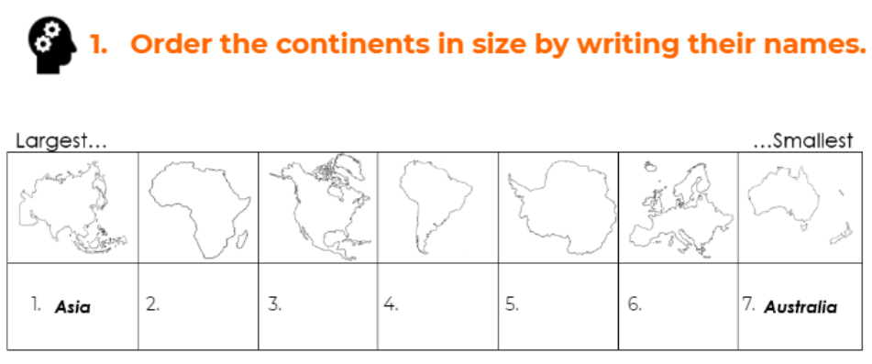

The seven continents

Go to this website:
https://classroom.thenational.academy/units/seven-continents-cf8c
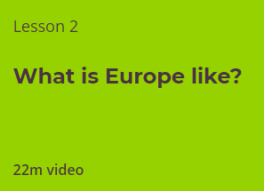

Click on lesson 2 (above). Watch the video and complete the questions.

When you have finished, you can complete the online quiz at the end.

Day 3 | Topic
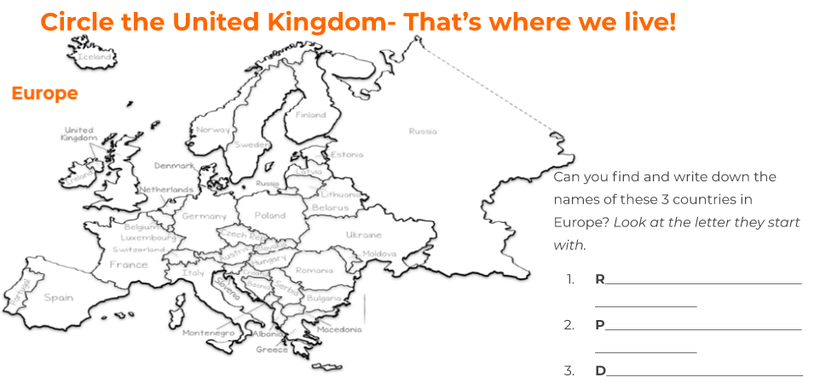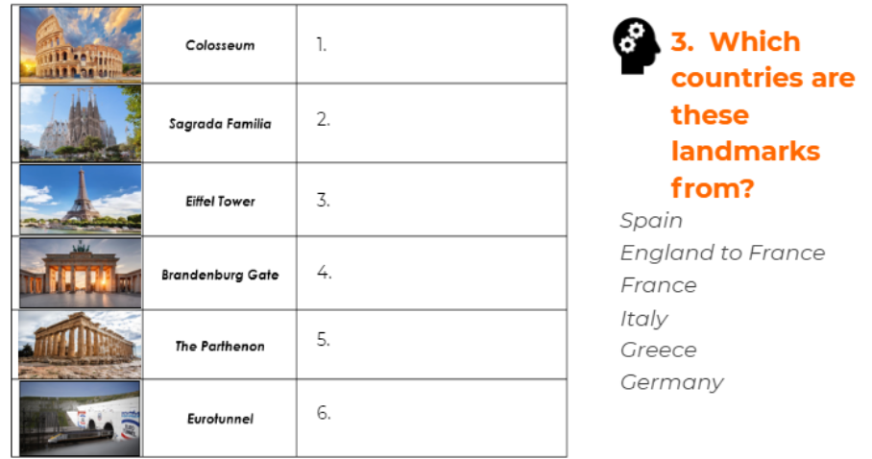
Day 3 | English
Can you put these parts of the story in order? You can number them 1-5.
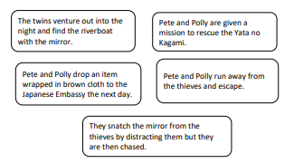
On the back of most books, you will find a ‘blurb’. A blurb gives a short description of the book, without giving away the ending. It is supposed to entice the reader into choosing the book to read.
Can you create a blurb for the model text below:
______________________________________________________________________________________________________________________________________________________________________________________________________________________________________
Extension:
Create a blurb for your favourite book or your current reading book below:
______________________________________________________________________________________________________________________________________________________________________________________________________________________________________

Day 3 | Maths
Today’s video: https://vimeo.com/489848691
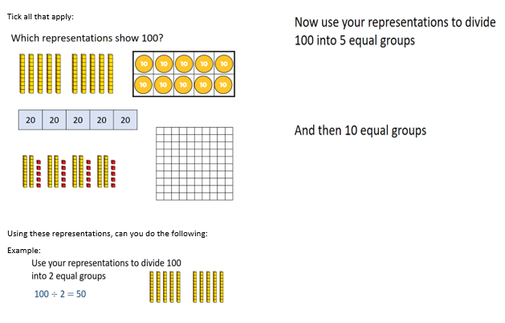
Day 3 | Maths
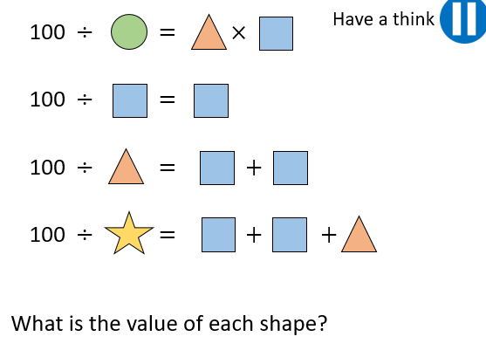

Day 3 | Flashback 4
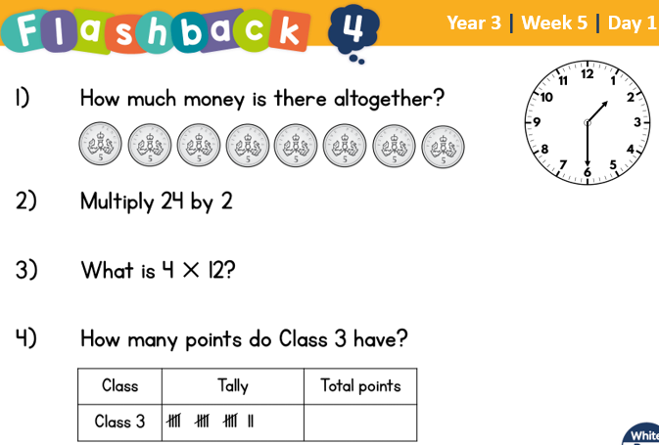

Day 3 | Spellings

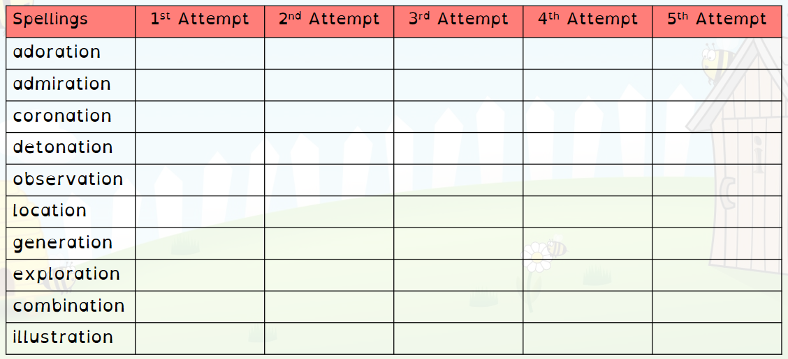
Day 3 | Topic

The seven continents

Go to this website:
https://classroom.thenational.academy/units/seven-continents-cf8c
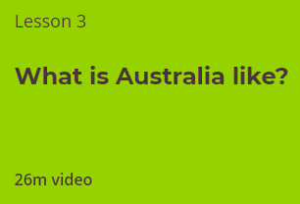
Click on lesson 3 (above). Watch the video.

When you have finished, you can complete the online quiz at the end.

Day 4 | English
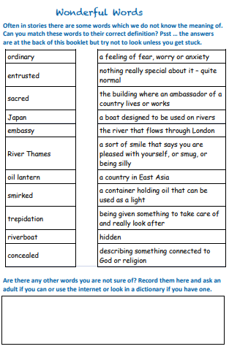
Day 4 | English

Extension:
Choose 4 of the words from Day 4 to write into a sentence

Word 1: _______________
__________________________________________________________________________________________________________________________________________

Word 2: _______________
__________________________________________________________________________________________________________________________________________

Word 3: _______________
__________________________________________________________________________________________________________________________________________

Word 4: _______________
__________________________________________________________________________________________________________________________________________

Day 4 | Maths
Today’s video: https://vimeo.com/494127943
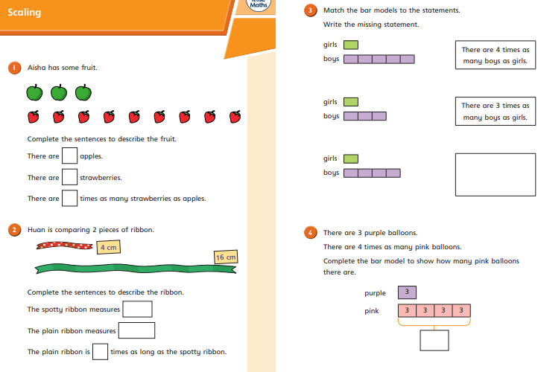
Day 4 | Maths
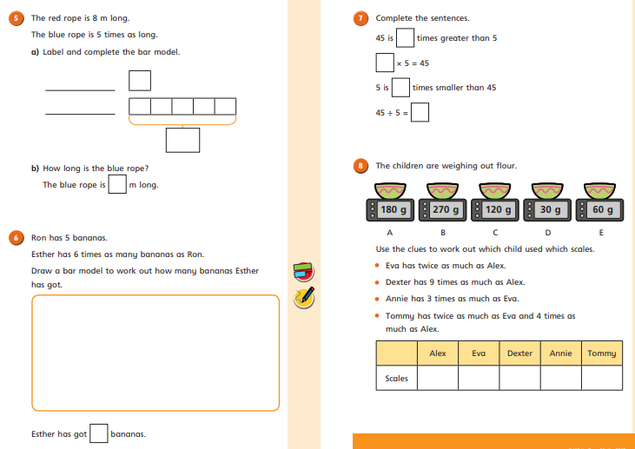

Day 4 | Flashback 4
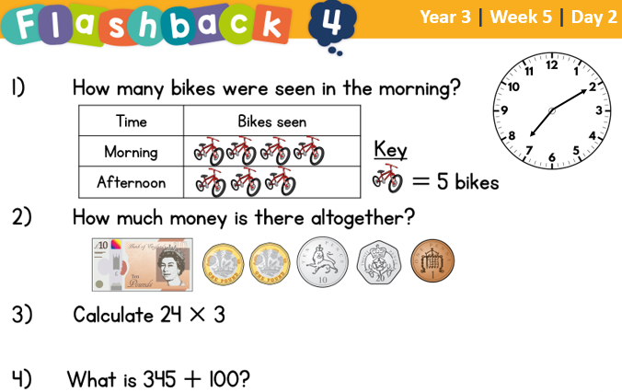

Day 4 | Reading Comprehension
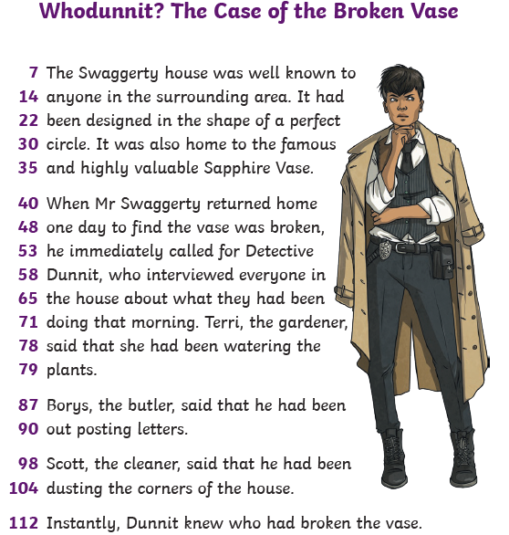
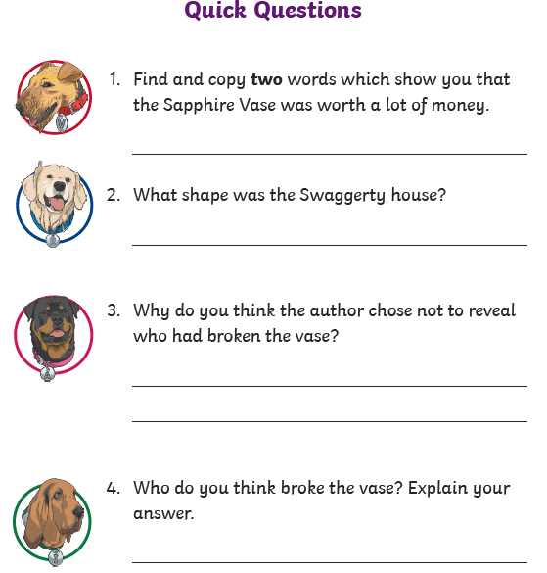
Day 4 | Topic

The seven continents

Go to this website:
https://classroom.thenational.academy/units/seven-continents-cf8c
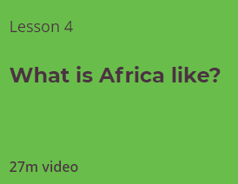
Click on lesson 4 (above). Watch the video.

When you have finished, you can complete the online quiz at the end.

Day 5 | English
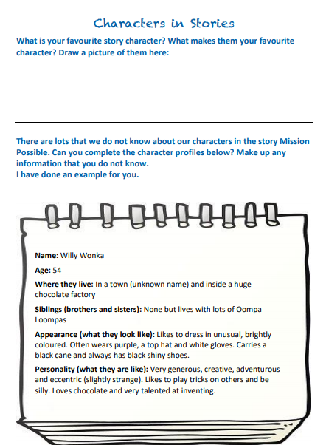

Day 5 | English
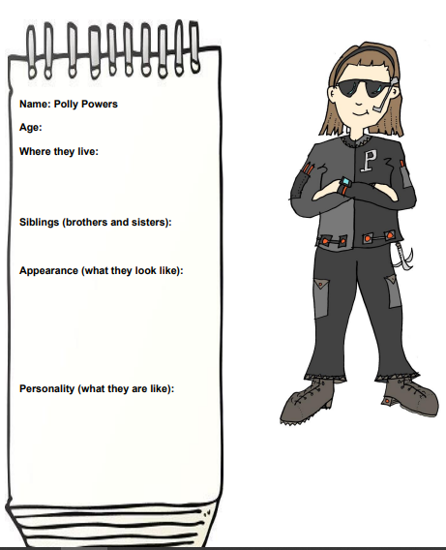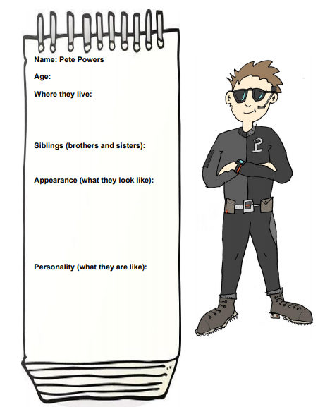

Day 5 | English
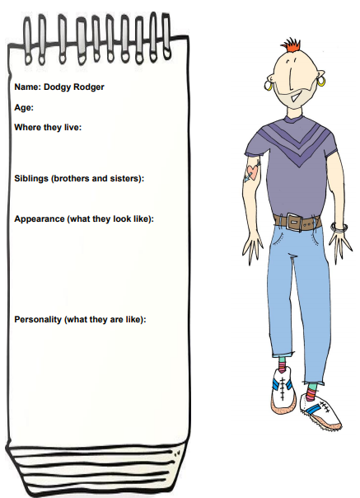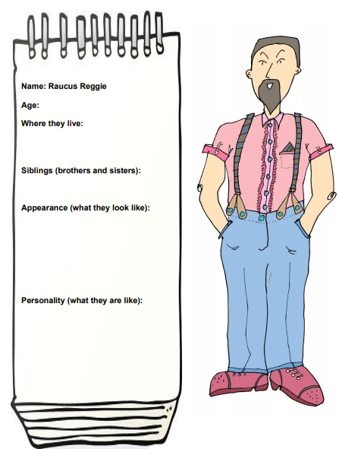
Day 5 | Maths
Today’s video: https://vimeo.com/496812718
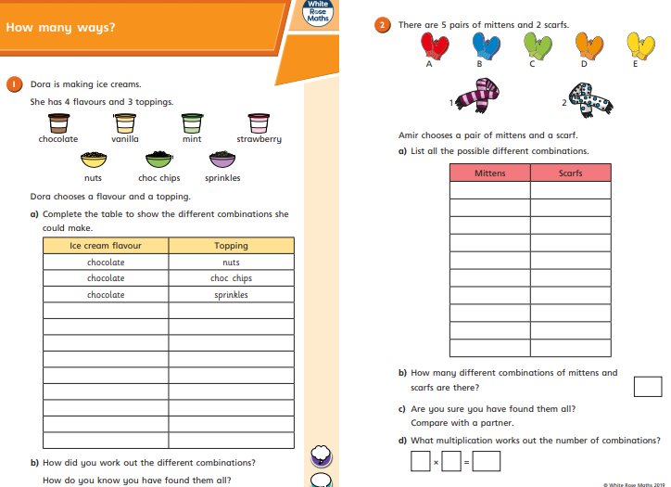
Day 5 | Maths
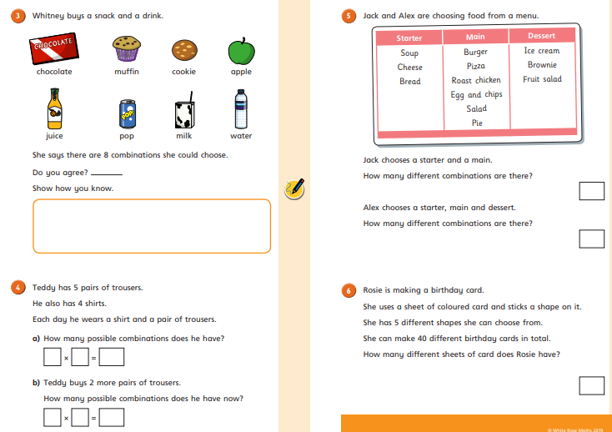

Day 5 | Flashback 4

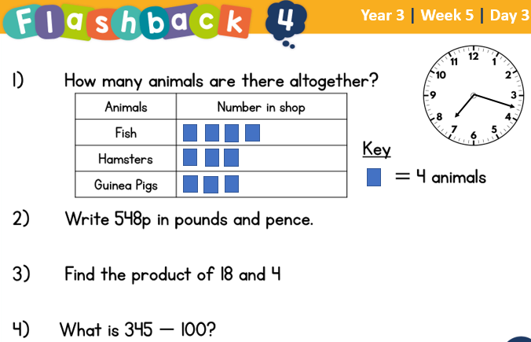

Day 5 | GPS
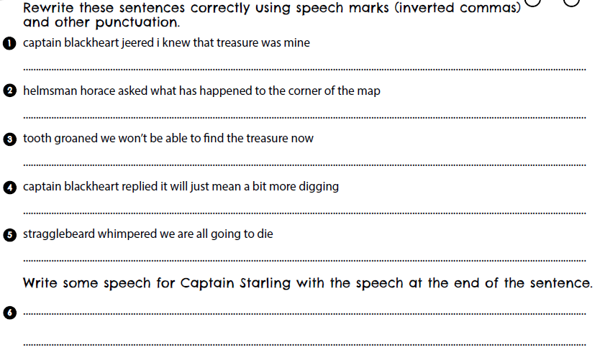

Day 5 | Topic

The seven continents

Go to this website:
https://classroom.thenational.academy/units/seven-continents-cf8c
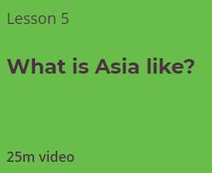
Click on lesson 4 (above). Watch the video.

When you have finished, you can complete the online quiz at the end.

Optional Projects

  Make a model of the 7 continents inside the house or in your garden and take a picture of it for our Facebook page. Hint: you could use Lego pieces, pebbles, small rocks or playdoh. Anything you can lay your hands on.  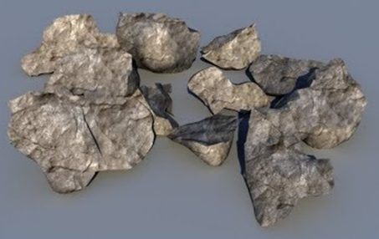 | Design and construct a colourful model of our continents using items from the home. Hint: paper plates – yes, the round ones! make an excellent starting point. Cut out shapes to resemble the continents and get busy with the paint!  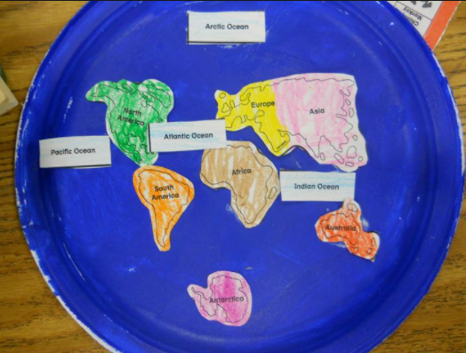
Have fun creating continent cookies! Grab a packet cookie mix next time you go shopping, and go crazy shaping the delicious treats to resemble the 7 continents. Mmmm!    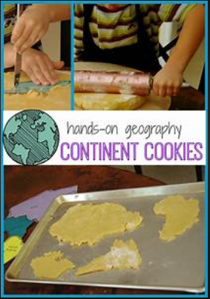 | Design your own planet and its continents. How will it differ from Earth? This could be drawn in the space at the back of the workbook, or physically made into a 3D model from ‘bits n bobs’ lying around at home. Go on, let your imagination run riot! Take a photo for our Facebook page.  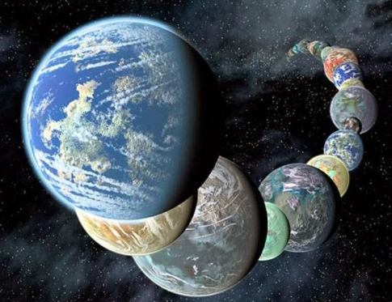
Finished your work but still need something to do?
Check out these educational websites below:

Educational games
https://www.bbc.co.uk/cbeebies/games
Want to learn how to type properly on a keyboard?
https://www.typingclub.com/
Learn coding online
https://scratch.mit.edu/
Maths Games
https://www.topmarks.co.uk/maths-games/7-11-years/ordering-and-sequencing
Learn your maths facts fast!
https://www.topmarks.co.uk/maths-games/hit-the-button
Primary Games
https://www.bbc.co.uk/bitesize/collections/primary-games/1
Love music? Play these instruments online:
https://www.virtualmusicalinstruments.com/
Loads of maths challenges:
http://www.mathematicshed.com/
Loads of literacy things:
https://www.literacyshedplus.com/en-gb#resources
Like maths challenges? Try these!
https://www.transum.org/Software/SW/Starter_of_the_day/index.htm
Do you love to write? Check out this picture site, choose a picture and write, write, write!
https://www.onceuponapicture.co.uk/
List of sites/games
https://www.popsugar.co.uk/parenting/free-online-educational-resources-for-kids-47312329

Some of these websites are updated daily. Check them out every day!

*Found another website that you want to share with other students? Email it to your teacher and we’ll add it to the list!*

