Name: Class:
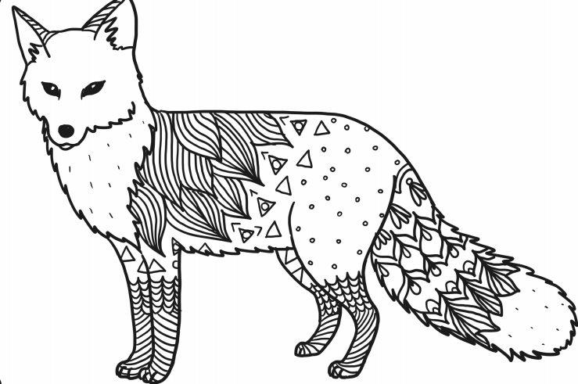

Walliams
Workbook:
Animal Kingdom Part 1

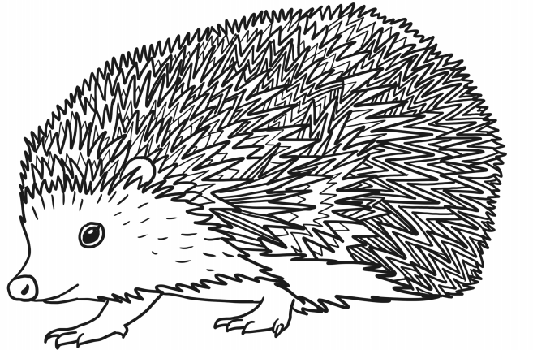

Contents
Day 1 | Spellings – 30 minutes
Day 1 | GPS – 30 minutes
Day 1 | English – 45 minutes - 1 hour
Day 1 | Maths – 45 minutes – 1 hour
Day 1 | Flashback 4 + Arithmetic – 20 minutes
Day 1 | Handwriting – 10 minutes
Day 1 | Topic – 30minutes – 45 minutes
Day 2 | Spellings – 30 minutes
Day 2 | GPS – 30 minutes
Day 2 | English – 45 minutes - 1 hour
Day 2 | Maths – 45 minutes – 1 hour
Day 2 | Flashback 4 + Arithmetic – 20 minutes
Day 2 | Reading Comprehension – 30 minutes
Day 2 | Topic – 30minutes – 45 minutes
Day 3 | Spellings – 30 minutes
Day 3 | GPS – 30 minutes
Day 3 | English – 45 minutes - 1 hour
Day 3 | Maths – 45 minutes – 1 hour
Day 3 | Flashback 4 + Arithmetic – 20 minutes
Day 3 | Handwriting – 10 minutes
Day 3 | Topic – 30minutes – 45 minutes
Day 4 | Spellings – 30 minutes
Day 4 | GPS – 30 minutes
Day 4 | English – 45 minutes - 1 hour
Day 4 | Maths – 45 minutes – 1 hour
Day 4 | Flashback 4 + Arithmetic – 20 minutes
Day 4 | Reading Comprehension – 30 minutes
Day 4 | Topic – 30minutes – 45 minutes
Day 5 | Spellings – 30 minutes
Day 5 | GPS – 30 minutes
Day 5 | English – 45 minutes - 1 hour
Day 5 | Maths – 45 minutes – 1 hour
Day 5 | Flashback 4 + Arithmetic – 20 minutes
Day 5 | Handwriting – 10 minutes
Day 5 | Topic – 30minutes – 45 minutes
Optional Projects + Extra Educational Websites
Have you completed your weekly homework? |  | Date  Completed
Spellings Practise
On Spelling Shed or handwritten
Timetables Rock Stars Task
3 Reads (at least 10 minutes out loud with a grown-up)

OPTIONAL
Any comments or messages from grown-ups that you would like to share with your teacher:
Any comments or messages from the student that you would like to share with your teacher:

Day 1 | Spellings
Here are this week’s spellings. Can you match the word to the definition?

information |  | A gift of money or items that the giver to does not expect to be paid for
sensation |  | The feeling of something
preparation |  | Knowledge and facts about something
vibration |  | How much time something last
decoration |  | The amount of people that live in a certain area
donation |  | Something used to make something else more attractive or beautiful
duration |  | Great strength and will do something / to keep going at something that is difficult
registration |  | Fast, small movements that go forwards and backwards
population |  | The act of getting ready for something
determination |  | The act of listing all the people that are present in a class or event

Day 1 | GPS
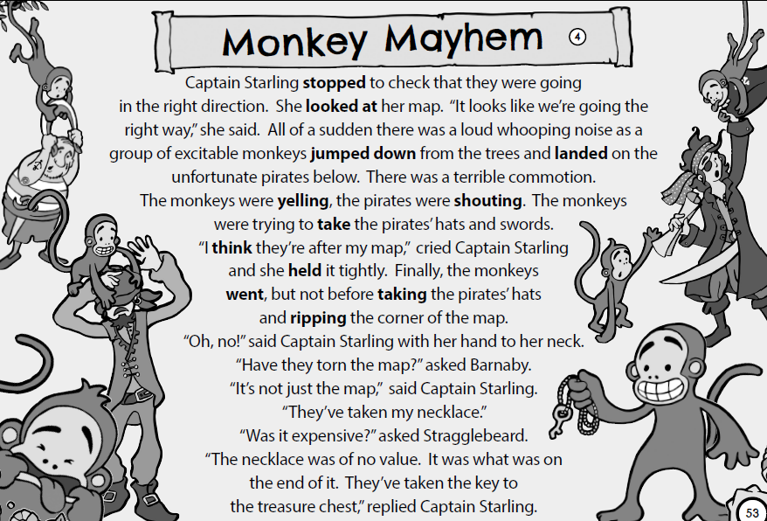
Day 1 | GPS
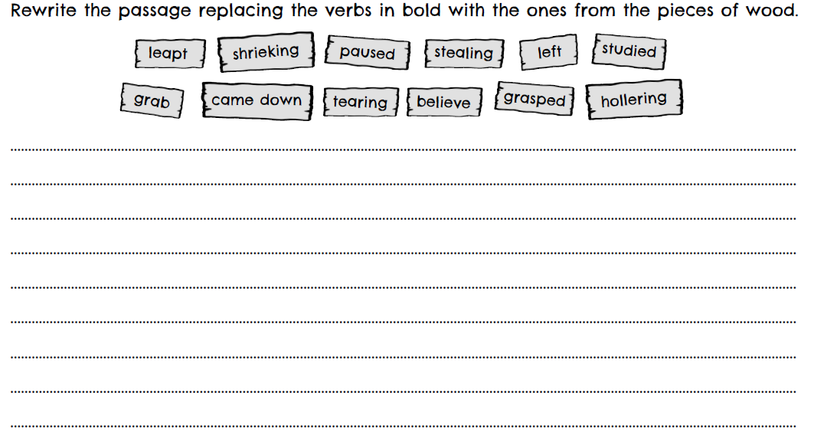
Day 1 | English
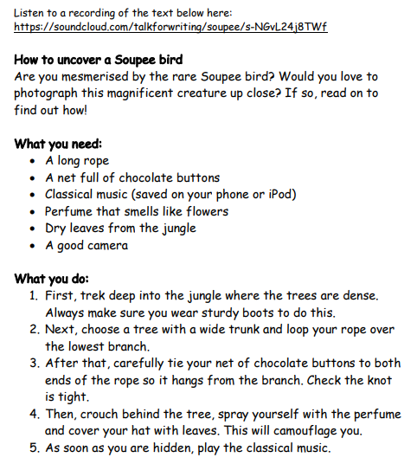
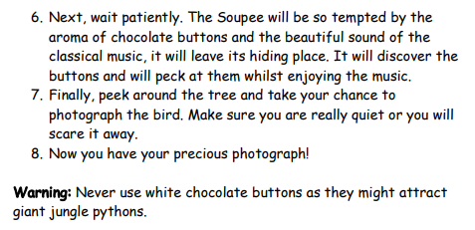
Day 1 | English
Reading comprehension
Using the text on the previous page, answer the following questions:

- What fronted adverbials are used in this text? List 3 below:
_______________________
_______________________
_______________________
- What word describes the Soupee bird in the first paragraph?
_____________________________________________
- Why does the reader need to pack a camera?
_____________________________________________
- What does the word ‘aroma’ mean in sentence 6 of the ‘What you need to do’ section?
_____________________________________________
_____________________________________________
- Why must you never use white chocolate buttons?
_____________________________________________
_____________________________________________
- Why do you think the author wants you to wear ‘sturdy’ boots?
_____________________________________________
_____________________________________________

- Where will you find a Soupee bird?
_____________________________________________

Day 1 | Maths
Today’s video: https://vimeo.com/485432791
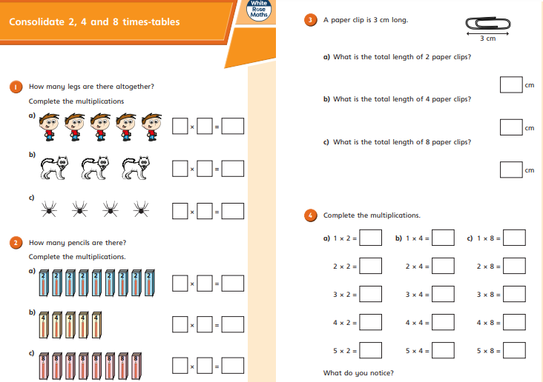
Day 1 | Maths
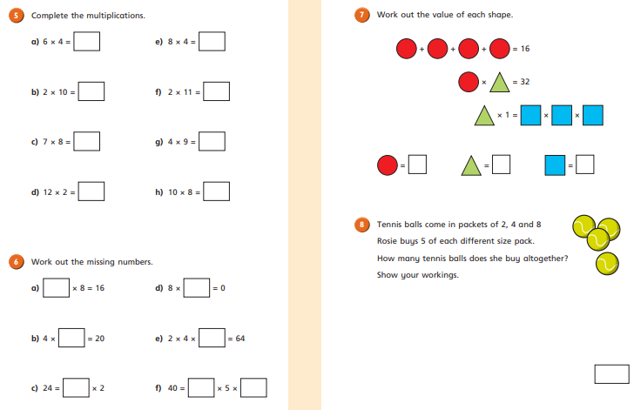
Day 1 | Flashback 4 & Arithmetic
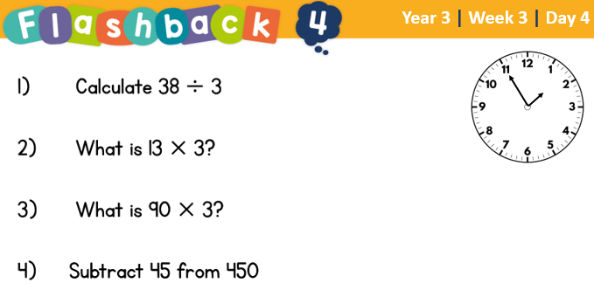
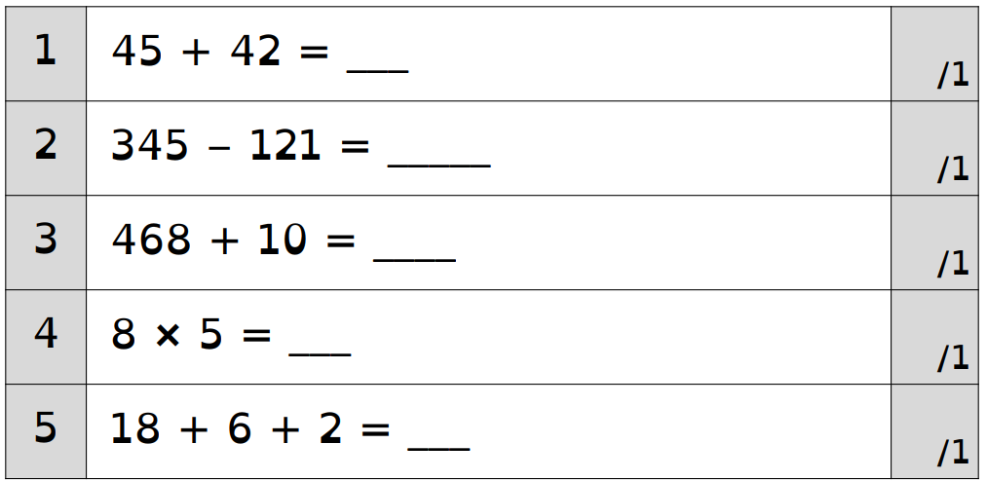
There is square paper on the next page if you need space for workings out.

Day 1 | Handwriting
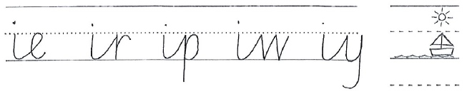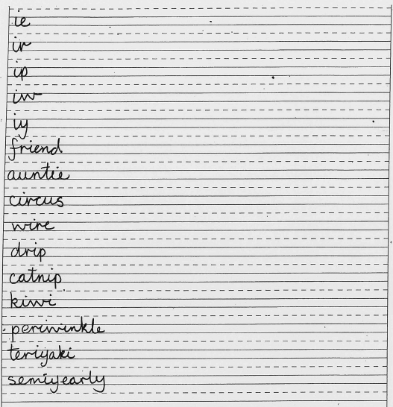
Practise each of these words to the end of the line.
Remember to take your time and look at how the joins are connected.

Day 1 | Topic
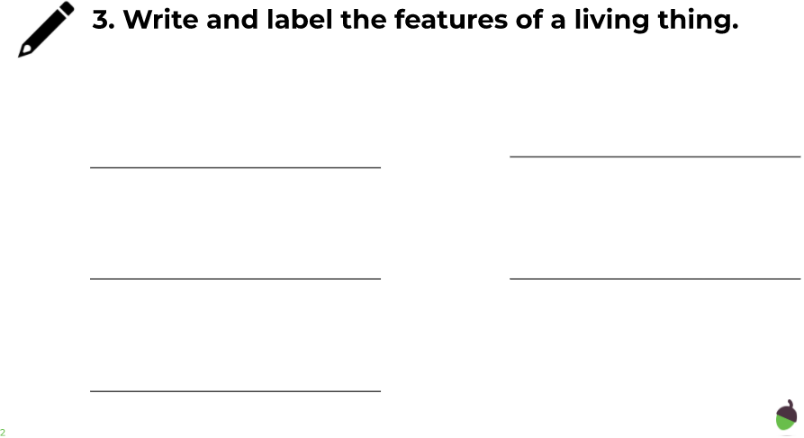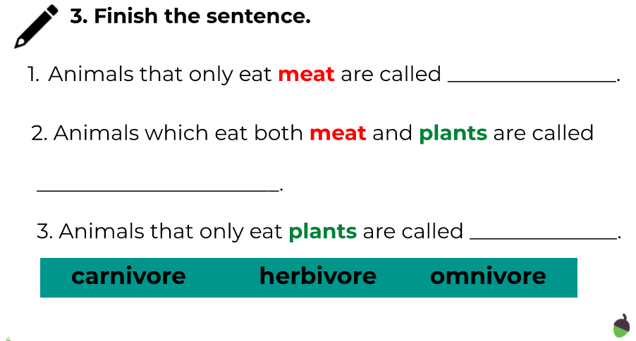

The animal kingdom

Go to this website:
https://classroom.thenational.academy/units/the-animal-kingdom-3cfa

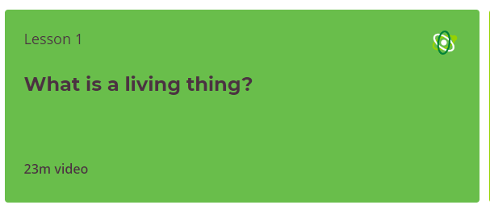

Click on lesson 1 (above). Watch the video and then complete the questions.

When you have finished, you can complete the online quiz at the end.
Day 2 | Spellings
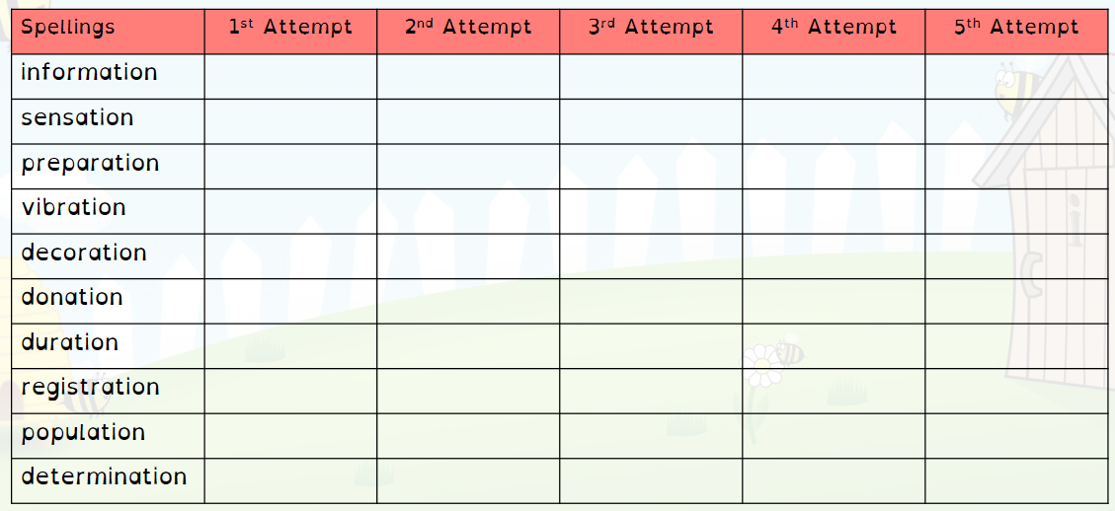
Practise writing each word 5 times.
Challenge – Can you cover the word and spell it correctly without seeing it?

Day 2 | GPS
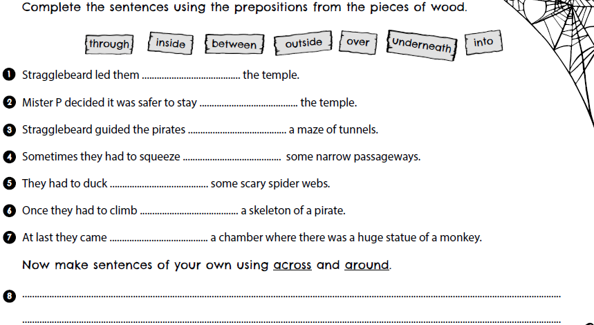

Day 2 | GPS
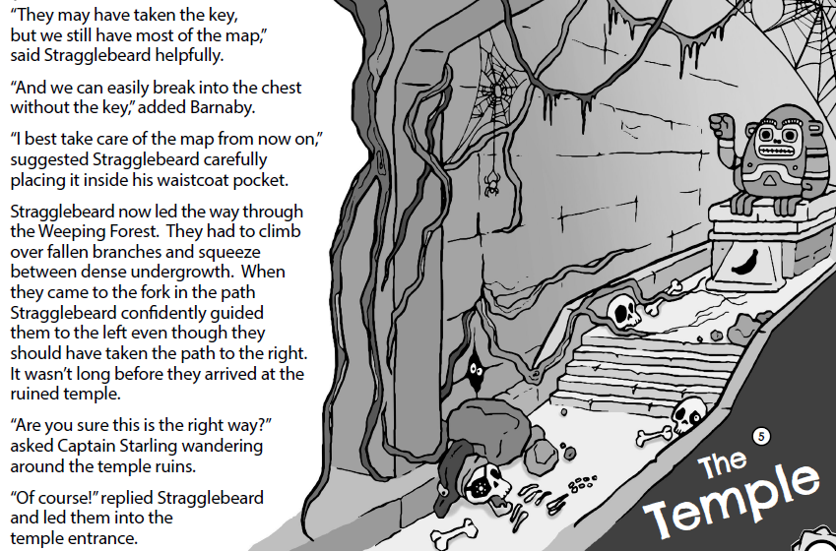
Day 2 | English
Look at the meaning of these words used in the model text:
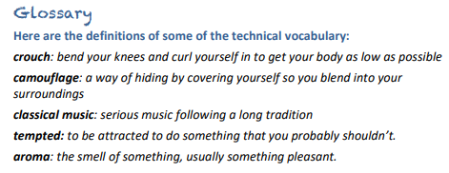
Can you use these words in a sentence? Below, create a sentence for each word/phrase. Make your sentence interesting using fronted adverbials, conjunctions and adjectives.
crouch
______________________________________________________________________________________________________________________
camouflage
______________________________________________________________________________________________________________________
classical music
______________________________________________________________________________________________________________________
tempted
______________________________________________________________________________________________________________________
aroma
______________________________________________________________________________________________________________________
Day 2 | English
Extension
Choose 3 other words from the model text that you find interesting to create a sentence for.
Here are some ideas to help you:
Mesmerised, magnificent, dense, sturdy, patiently

Day 2 | Maths
Today’s video: https://vimeo.com/485433674
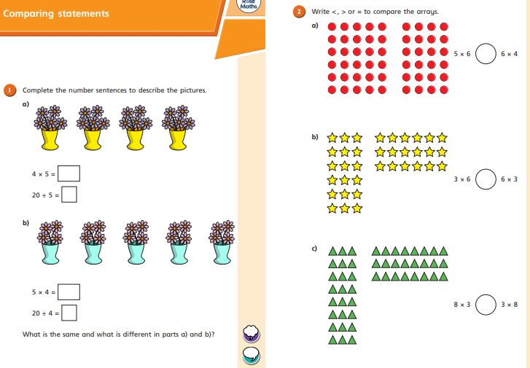
Day 2 | Maths
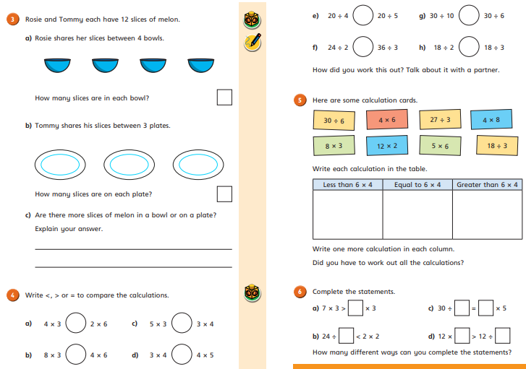
Day 2 | Flashback 4 & Arithmetic
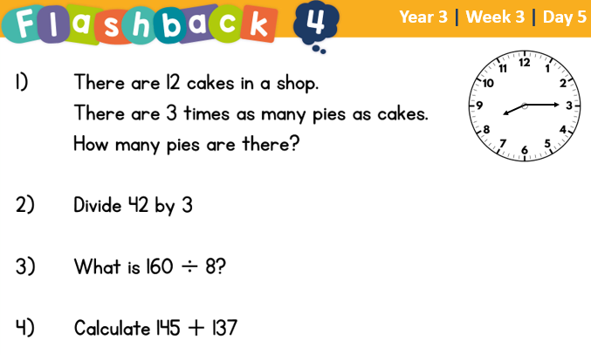
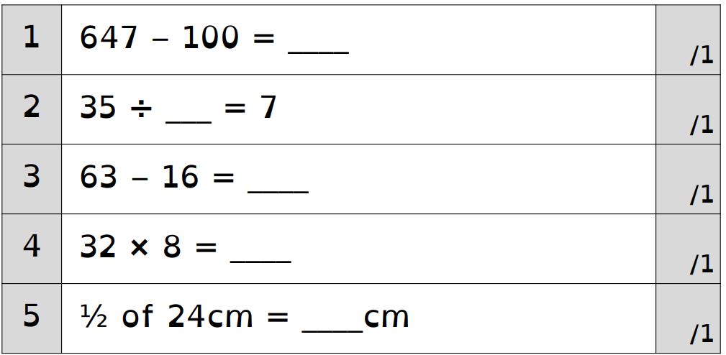
There is square paper on the next page if you need space for workings out.
Day 2 | Reading Comprehension
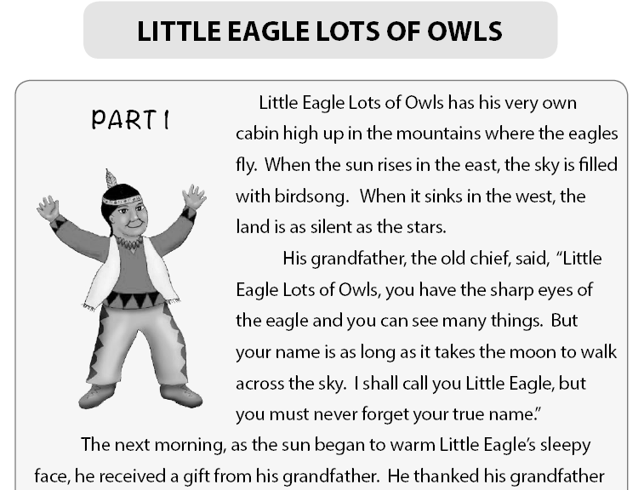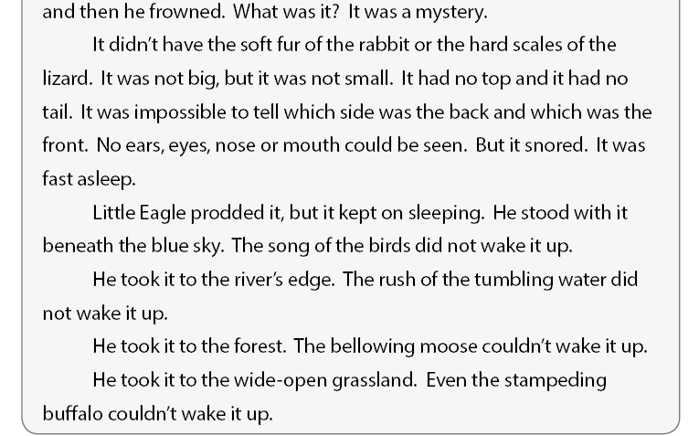
Day 2 | Reading Comprehension
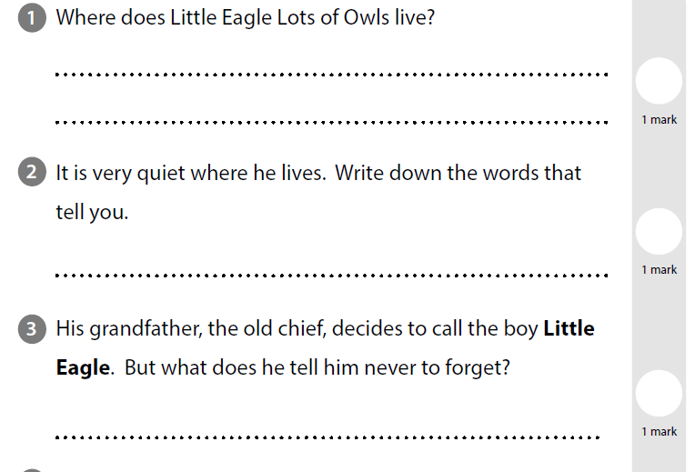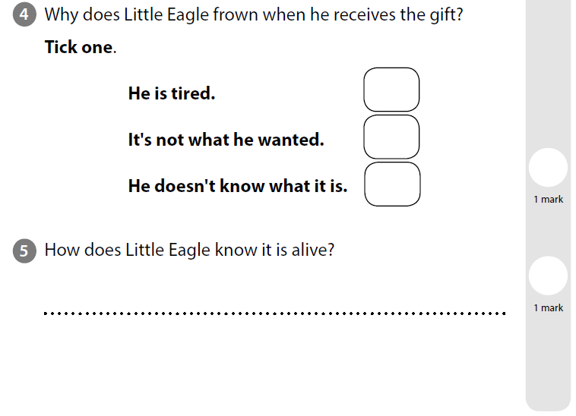
Day 2 | Reading Comprehension
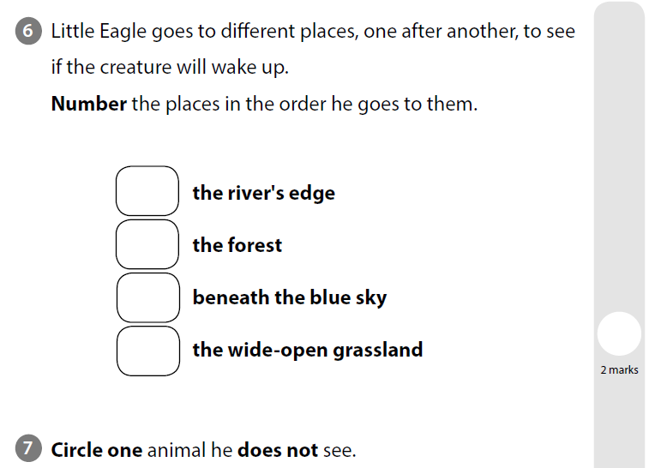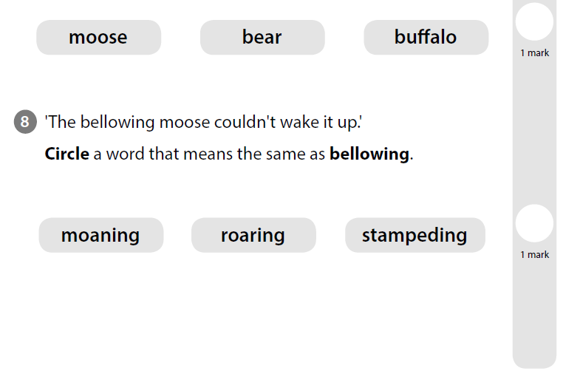

Day 2 | Topic

The animal kingdom

Go to this website:
https://classroom.thenational.academy/units/the-animal-kingdom-3cfa

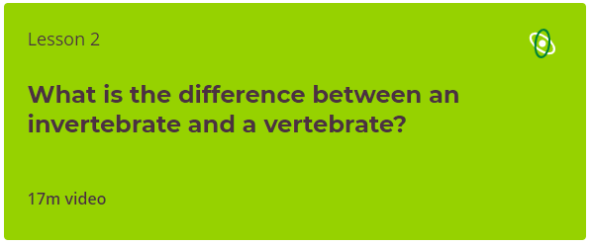

Click on lesson 2 (above). Watch the video and then complete the questions.

When you have finished, you can complete the online quiz at the end.
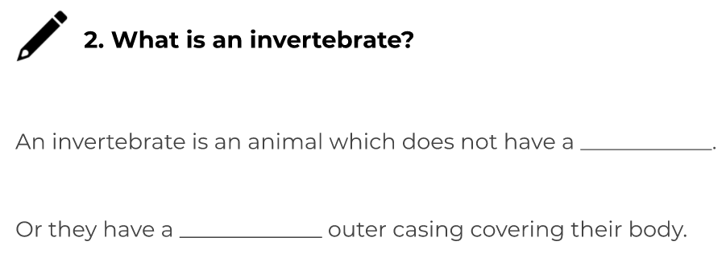

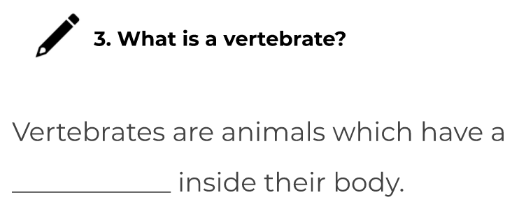
Day 3 | Spellings
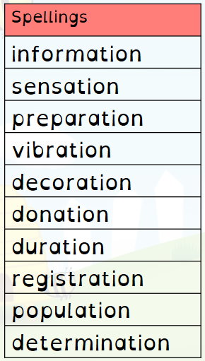
Think you know your spellings? Prove it! Write a sentence for each word. Remember, it’s not about writing short sentences. You should be able to understand the meaning of the word from your sentence.
Challenge – Can you include fronted adverbials, conjunctions and a variety of punctuation?
- __________________________________________ ____________________________________________
- __________________________________________ ____________________________________________
- __________________________________________ ____________________________________________
- ___________________________________________ ________________________________________________________
Day 3 | Spellings
- ________________________________________________________________________________________________________________
- ________________________________________________________________________________________________________________
- ________________________________________________________________________________________________________________
- ________________________________________________________________________________________________________________
- ________________________________________________________________________________________________________________
- ________________________________________________________________________________________________________________
Day 3 | GPS
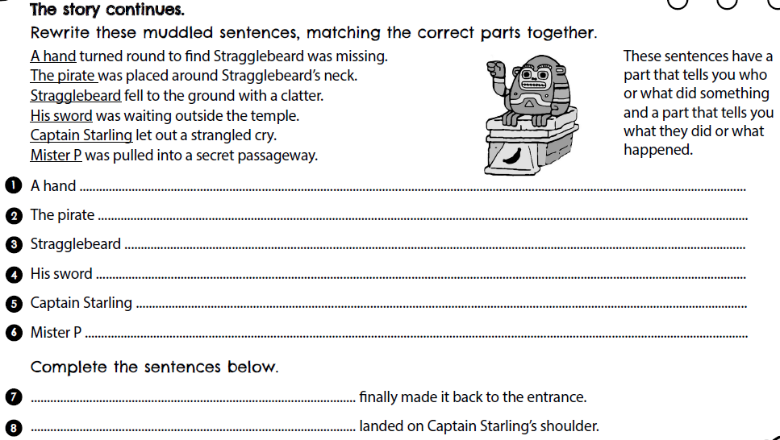

Day 3 | GPS
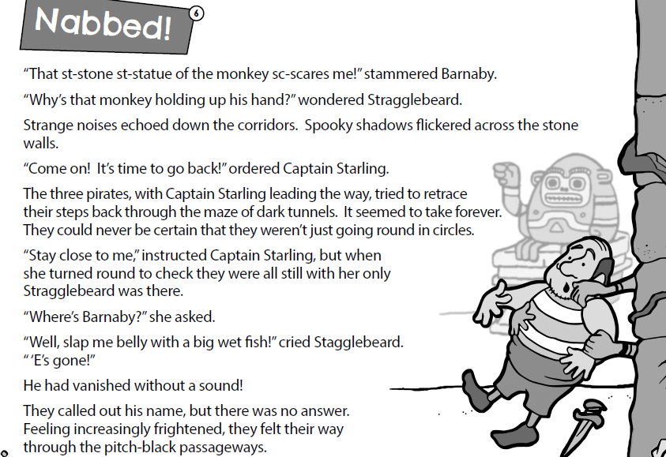
Day 3 | English
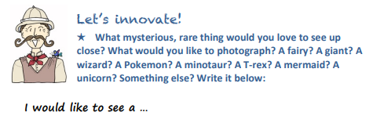 Design challenge!
What would tempt your chosen creature out of their hiding place? Below, use the space below to draw and label a trap to tempt your creature out of it’s hiding place.

Continue onto the next page

Day 3 | English
Now, we would like you to verbally plan your instructions.
Using your picture, and the help below, can you tell an adult your instructions. You do not need to write them down today, we would just like you to practise saying your sentences.
If you haven’t got an adult free, could you record yourself saying your instructions and listen back to it?
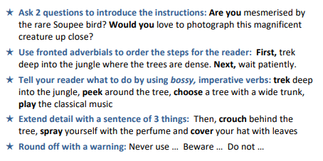


Day 3 | Maths
Today’s video: https://vimeo.com/486330232
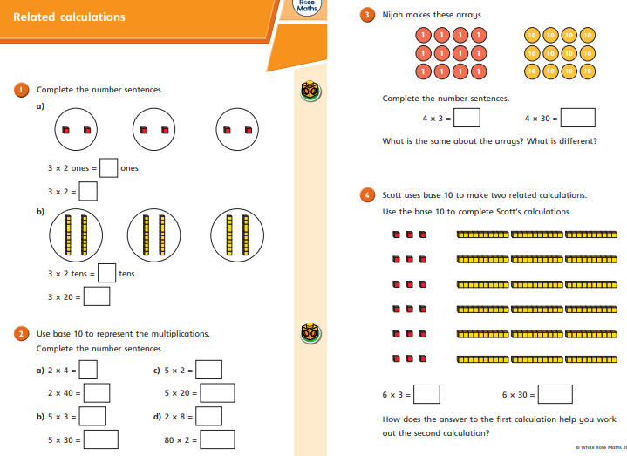
Day 3 | Maths
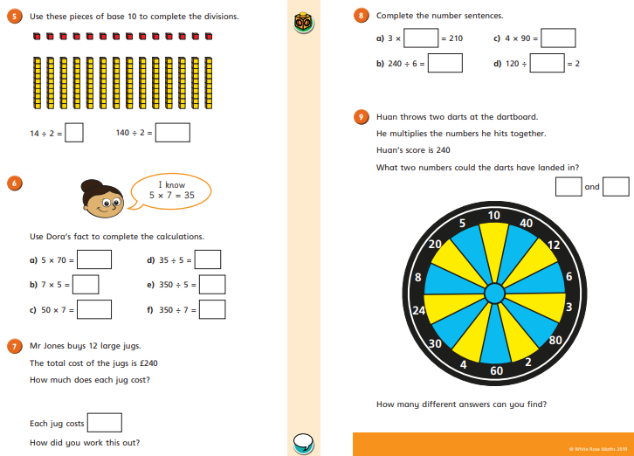

Day 3 | Flashback 4 & Arithmetic
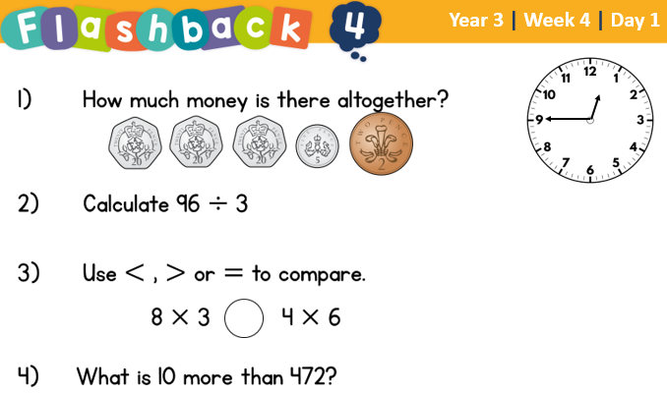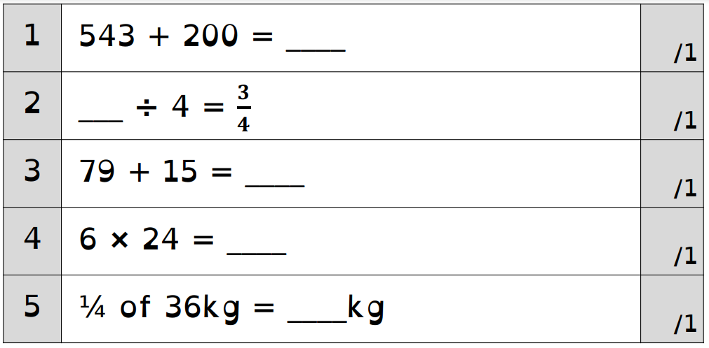

There is square paper on the next page if you need space for workings out.

Day 3 | Handwriting
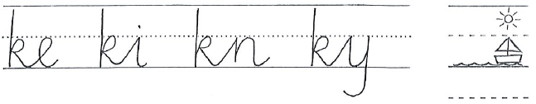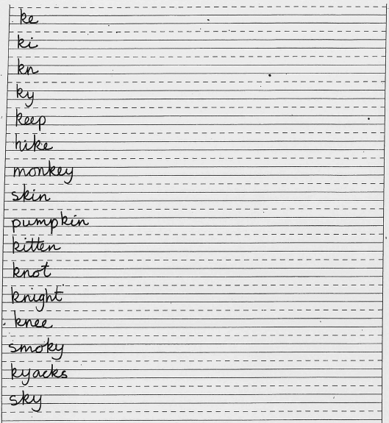
Practise each of these words to the end of the line.
Remember to take your time and look at how the joins are connected.

Day 3 | Topic

The animal kingdom

Go to this website:
https://classroom.thenational.academy/units/the-animal-kingdom-3cfa

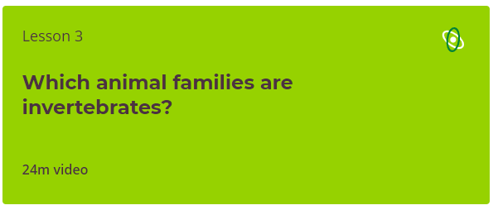

Click on lesson 3 (above). Watch the video.

When you have finished, you can complete the online quiz at the end.
Day 4 | Spellings

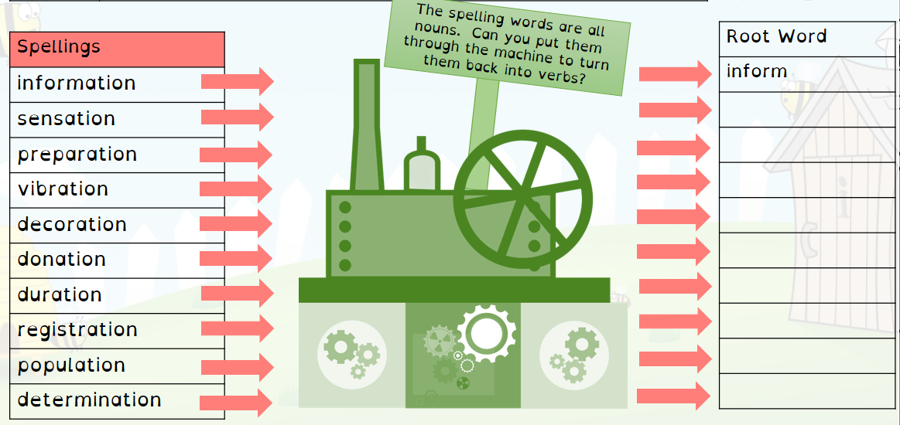

Day 4 | GPS
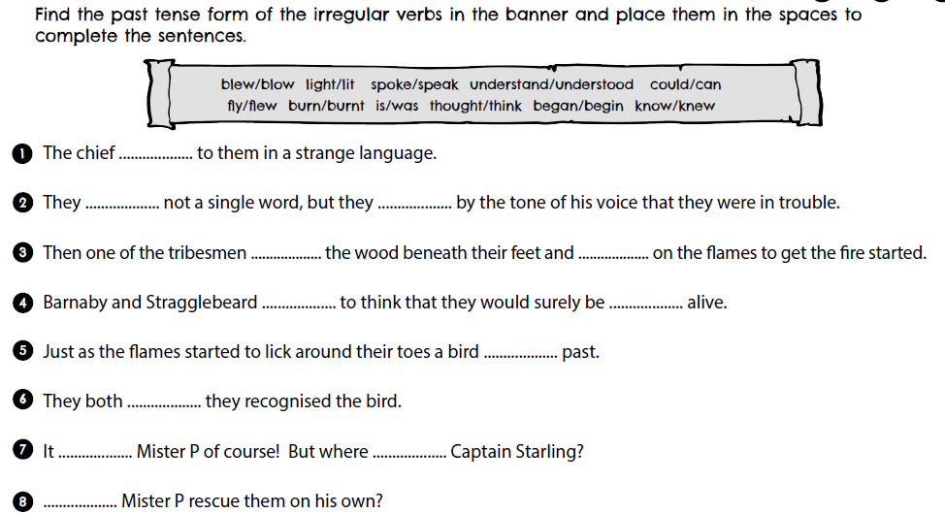

Day 4 | GPS
Day 4 | English
Yesterday, you practised saying your instructions. Today, you need to write down your plan for your big write tomorrow. Use the model text to help you.
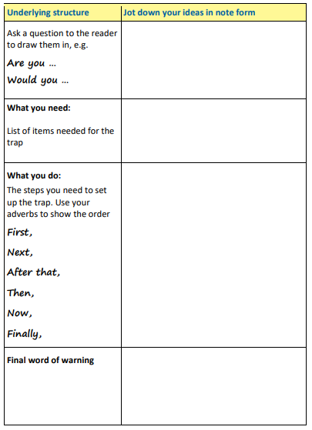

Day 4 | Maths
Today’s video: https://vimeo.com/486513593
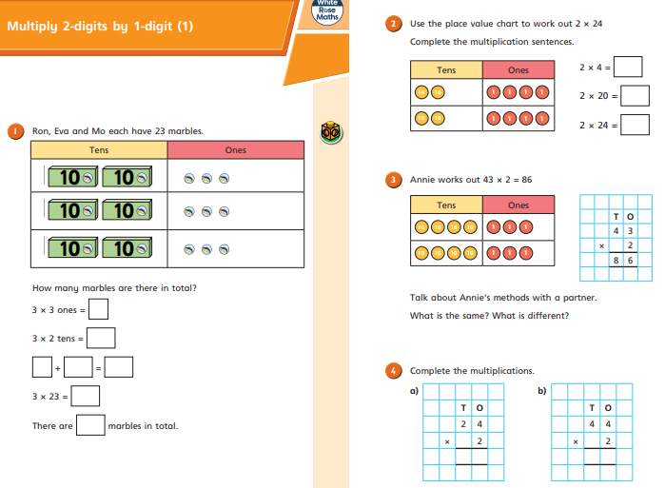
Day 4 | Maths
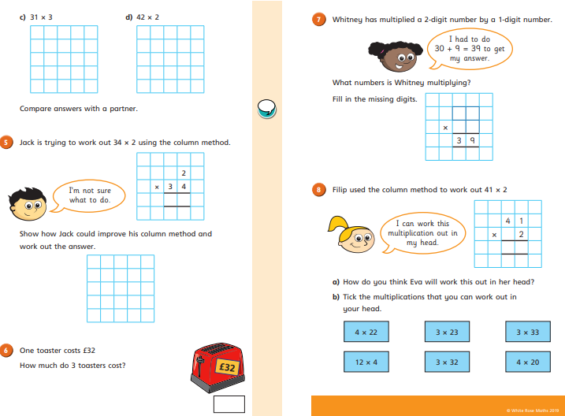
Day 4 | Flashback 4 & Arithmetic
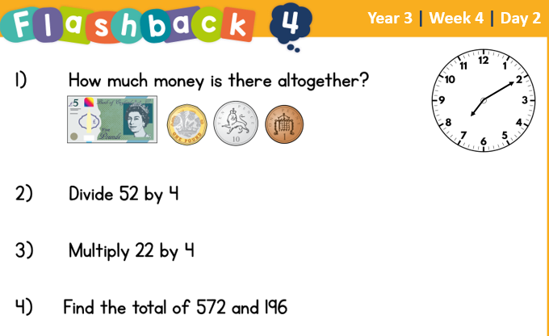
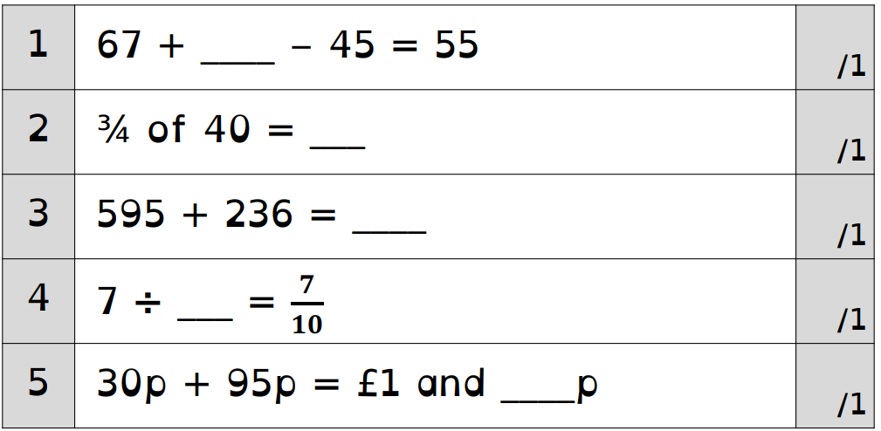
There is square paper on the next page if you need space for workings out.
Day 4 | Reading Comprehension
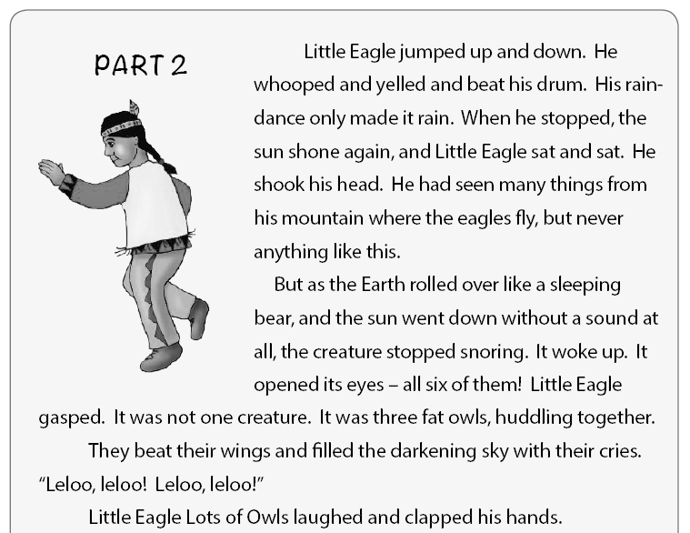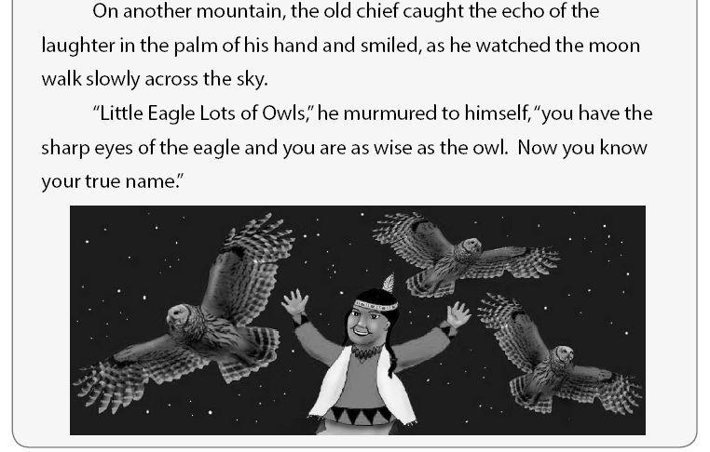
Day 4 | Reading Comprehension
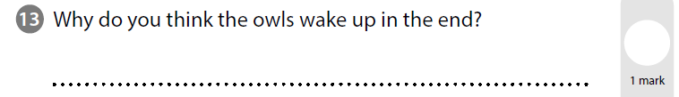
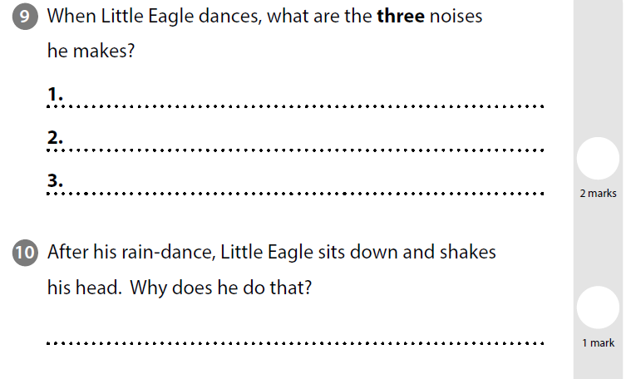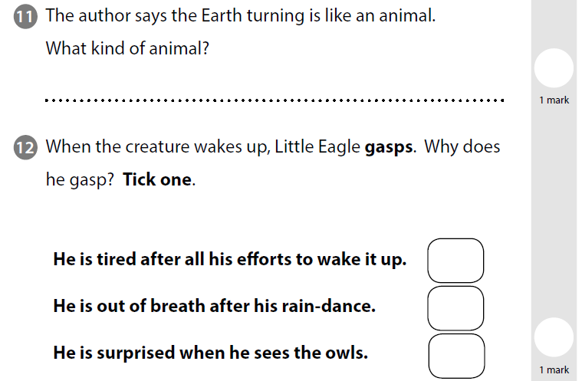

Day 4 | Topic

The animal kingdom

Go to this website:
https://classroom.thenational.academy/units/the-animal-kingdom-3cfa

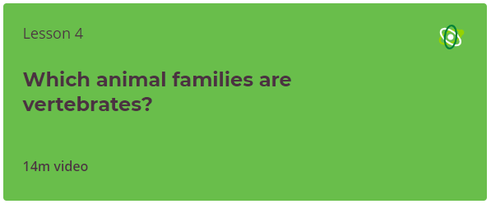

Click on lesson 4 (above). Watch the video.

When you have finished, you can complete the online quiz at the end.
Day 5 | Spellings

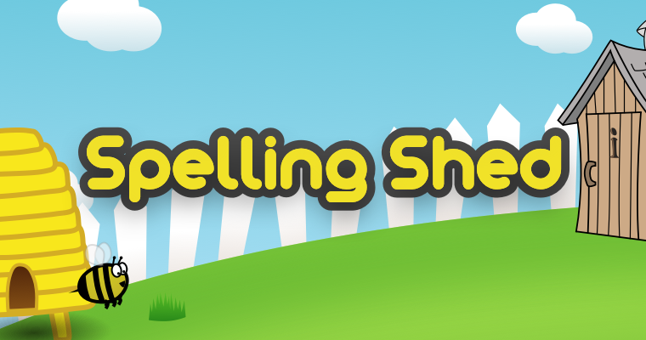
Go online and practise your spellings on Spelling Shed. You must spend at least 30 minutes practicing.
Remember, I can go online and check how long you’ve spent playing!
Your login details are in your reading diary. If you have lost these details, please email your teacher and they will email you your details.

Day 5 | GPS
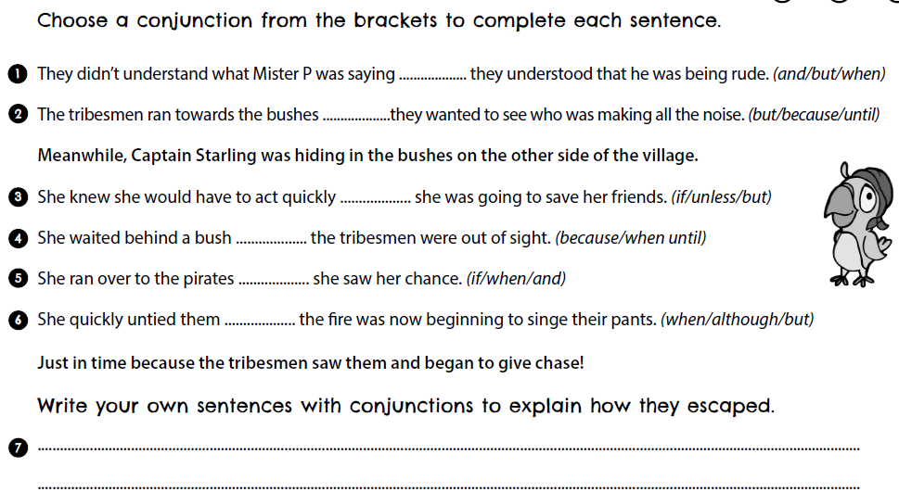
Day 5 | GPS
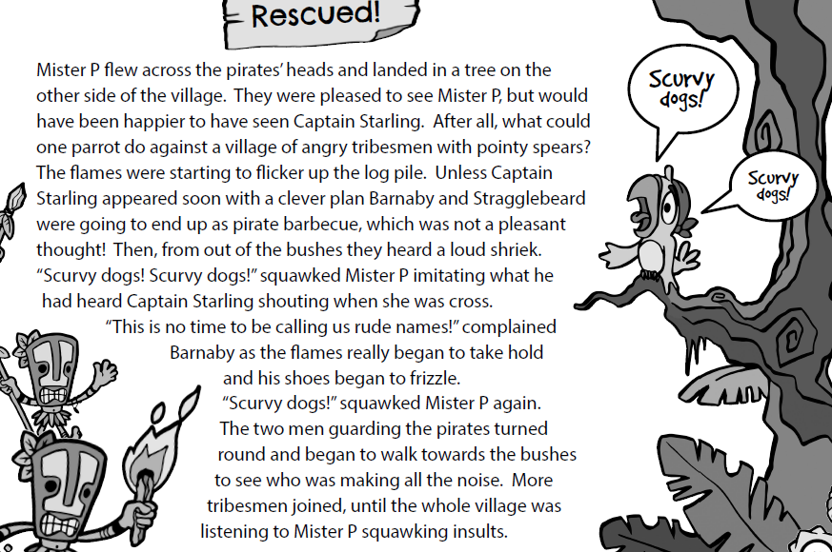
Day 5 | English
Today, you are going to be writing up your instructions!
Before we begin, go back and read the model text and your plan.
As you are writing, make sure you include:
- 2 Questions ( Would you….? Are you…? )
- A list of what you need
- What you need to do
- Adjectives (beautiful, rare, amazing etc)
- Fronted adverbials (first, next, then)
- Conjunctions (and, if, but, so, because)
- Adverbs (slowly, quickly, patiently…)

Tick the boxes below each time you use one of these key features
Tick every time you use this feature
Questions
Adjectives
Fronted adverbials
Conjunctions
Adverbs

You can start your writing on the next page

Day 5 | English

Day 5 | Maths
Today’s video: https://vimeo.com/489850121
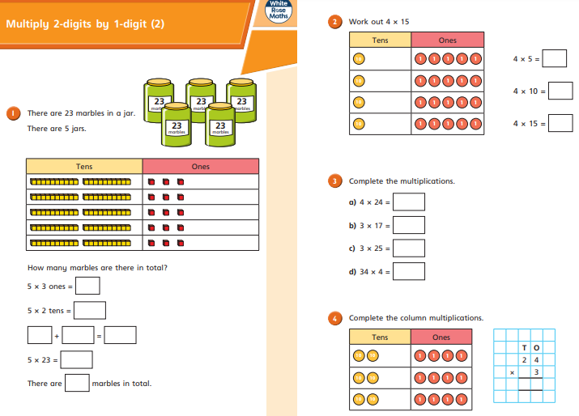
Day 5 | Maths
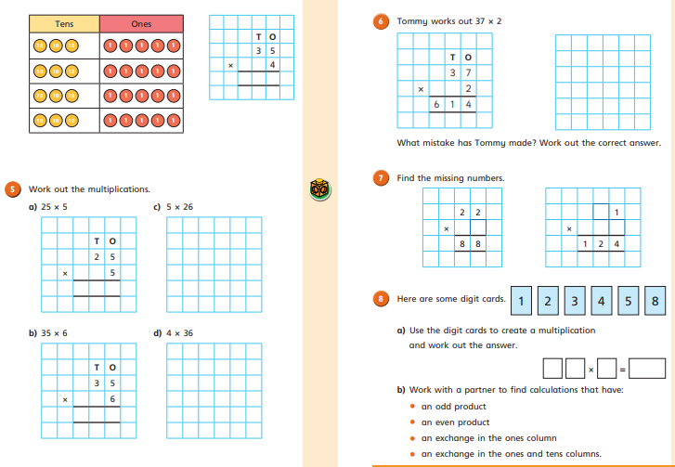

Day 5 | Flashback 4 & Arithmetic
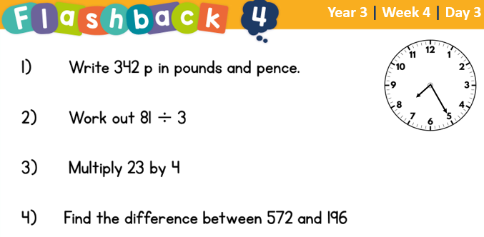
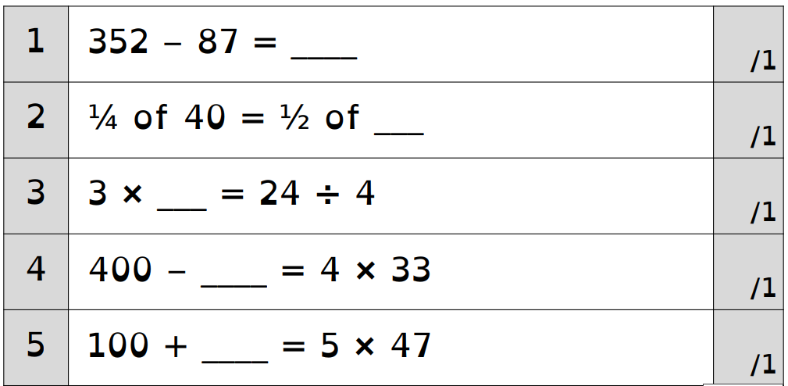

There is square paper on the next page if you need space for workings out.

Day 5 | Handwriting
Practise each of these words to the end of the line.
Remember to take your time and look at how the joins are connected.

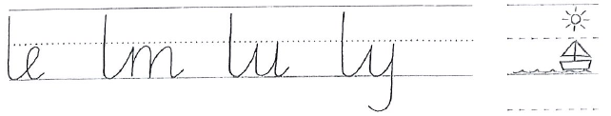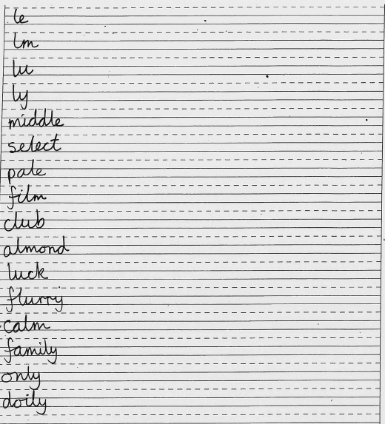
Day 5 | Topic

The animal kingdom

Go to this website:
https://classroom.thenational.academy/units/the-animal-kingdom-3cfa

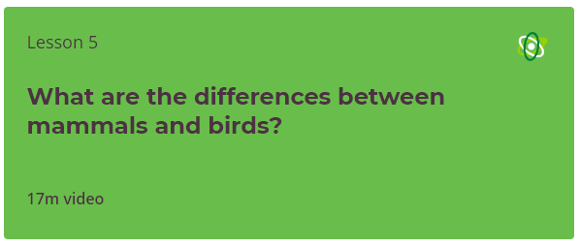

Click on lesson 5 (above). Watch the video.

When you have finished, you can complete the online quiz at the end.

Optional Projects

Go for a walk!  Can you identify all the birds you’ve seen?  Make a tally chart! | 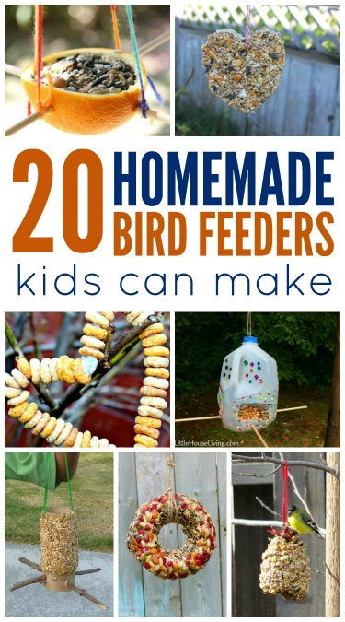  Create a bird feeder  http://lastingthumbprints.com/homemade-bird-feeders-kids-can-make/
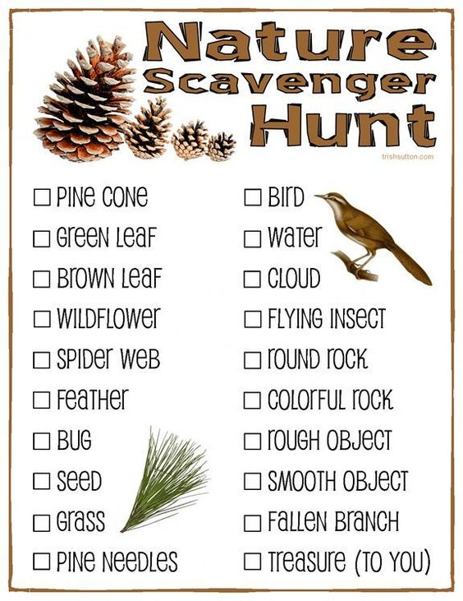  Nature Scavenger Hunt  http://trishsutton.com/nature-scavenger-hunt-free-printable-for-kids/ |   https://bake-eat-repeat.com/birds-nest-cookies-recipe/

Finished your work but still need something to do?
Check out these educational websites below:
Educational games
https://www.bbc.co.uk/cbeebies/games
Want to learn how to type properly on a keyboard?
https://www.typingclub.com/
Learn coding online
https://scratch.mit.edu/
Maths Games
https://www.topmarks.co.uk/maths-games/7-11-years/ordering-and-sequencing
Learn your maths facts fast!
https://www.topmarks.co.uk/maths-games/hit-the-button
Primary Games
https://www.bbc.co.uk/bitesize/collections/primary-games/1
Love music? Play these instruments online:
https://www.virtualmusicalinstruments.com/
Loads of maths challenges:
http://www.mathematicshed.com/
Loads of literacy things:
https://www.literacyshedplus.com/en-gb#resources
Like maths challenges? Try these!
https://www.transum.org/Software/SW/Starter_of_the_day/index.htm
Do you love to write? Check out this picture site, choose a picture and write, write, write!
https://www.onceuponapicture.co.uk/
List of sites/games
https://www.popsugar.co.uk/parenting/free-online-educational-resources-for-kids-47312329
Some of these websites are updated daily. Check them out every day!

*Found another website that you want to share with other students? Email it to your teacher and we’ll add it to the list!*

