Name: Class:

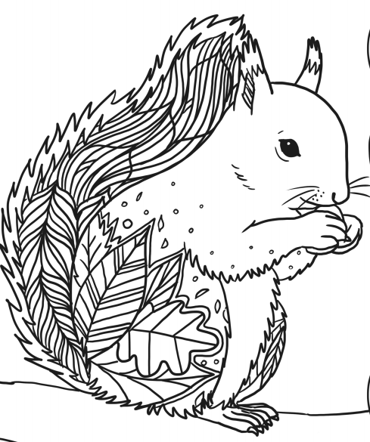

Dahl
Workbook:
Animal Kingdom Part 1

Contents
Day 1 | Spellings – 30 minutes
Day 1 | GPS – 30 minutes
Day 1 | English – 45 minutes - 1 hour
Day 1 | Maths – 45 minutes – 1 hour
Day 1 | Flashback 4 + Arithmetic – 20 minutes
Day 1 | Handwriting – 10 minutes
Day 1 | Topic – 30minutes – 45 minutes
Day 2 | Spellings – 30 minutes
Day 2 | GPS – 30 minutes
Day 2 | English – 45 minutes - 1 hour
Day 2 | Maths – 45 minutes – 1 hour
Day 2 | Flashback 4 + Arithmetic – 20 minutes
Day 2 | Reading Comprehension – 30 minutes
Day 2 | Topic – 30minutes – 45 minutes
Day 3 | Spellings – 30 minutes
Day 3 | GPS – 30 minutes
Day 3 | English – 45 minutes - 1 hour
Day 3 | Maths – 45 minutes – 1 hour
Day 3 | Flashback 4 + Arithmetic – 20 minutes
Day 3 | Handwriting – 10 minutes
Day 3 | Topic – 30minutes – 45 minutes
Day 4 | Spellings – 30 minutes
Day 4 | GPS – 30 minutes
Day 4 | English – 45 minutes - 1 hour
Day 4 | Maths – 45 minutes – 1 hour
Day 4 | Flashback 4 + Arithmetic – 20 minutes
Day 4 | Reading Comprehension – 30 minutes
Day 4 | Topic – 30minutes – 45 minutes
Day 5 | Spellings – 30 minutes
Day 5 | GPS – 30 minutes
Day 5 | English – 45 minutes - 1 hour
Day 5 | Maths – 45 minutes – 1 hour
Day 5 | Flashback 4 + Arithmetic – 20 minutes
Day 5 | Handwriting – 10 minutes
Day 5 | Topic – 30minutes – 45 minutes
Optional Projects + Extra Educational Websites
Have you completed your weekly homework? |  | Date  Completed
Spellings Practise
On Spelling Shed or handwritten
Timetables Rock Stars Task
3 Reads (at least 10 minutes out loud with a grown-up)

OPTIONAL
Any comments or messages from grown-ups that you would like to share with your teacher:
Any comments or messages from the student that you would like to share with your teacher:

Day 1 | Spellings
Here are this week’s spellings. Can you match the word to the definition?

race |  | A small room for prisoners or monks 2. The smallest parts of an animal or plant
ice |  | A competition to see who is the fastest at something
cell |  | The cold solid made when water freezes
city |  | Special/ has lots of decoration
fancy |  | A round shape
lace |  | A large town where lots of people live and work
space |  | A common food/ white and brown seeds
circle |  | An empty area. 2. A gap between things 3. The area outside the earth that contains stars and planets and appears black.
circus |  | A show that moves around and often has clowns
rice |  | A long piece of material used to tie up shoes 2. A type of fabric that is finely decorated

Day 1 | GPS
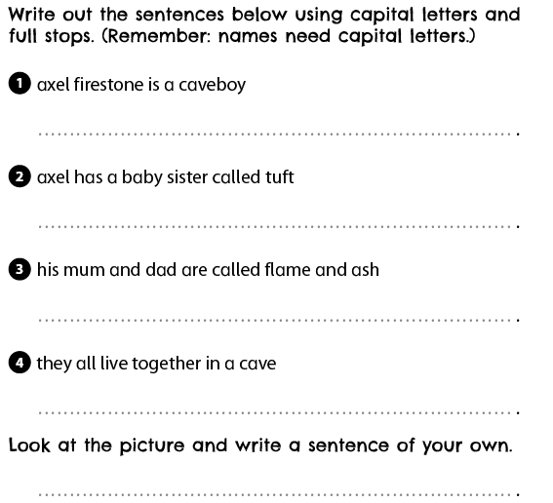
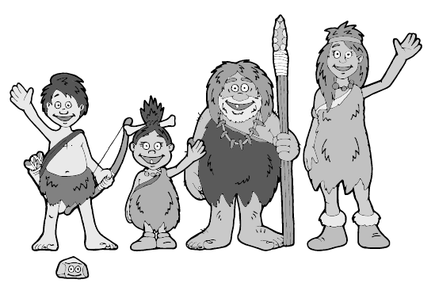
Day 1 | English
Fill in the information for each picture then try to put this into a sentence. For example:
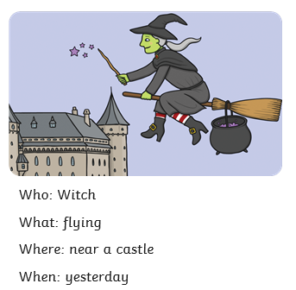

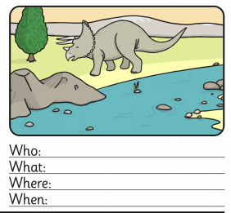

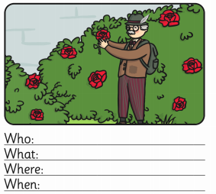
Yesterday, the witch was flying on her broomstick near a giant castle.
Your turn:

Day 1 | English
Day 1 | English

Day 1 | English
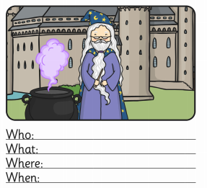
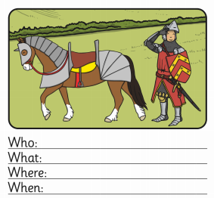

Day 1 | Maths
Today’s video: https://vimeo.com/490417143
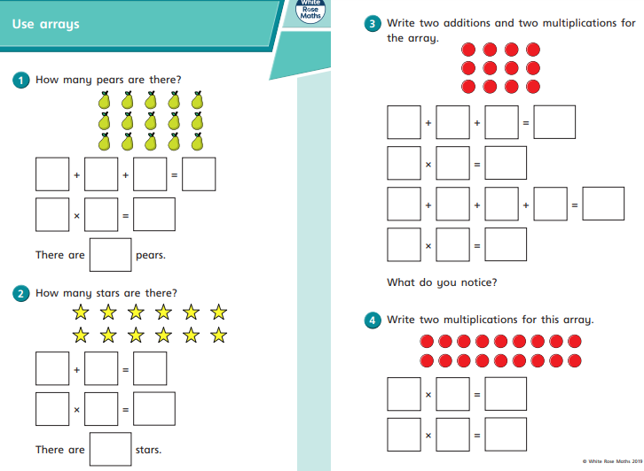
Day 1 | Maths
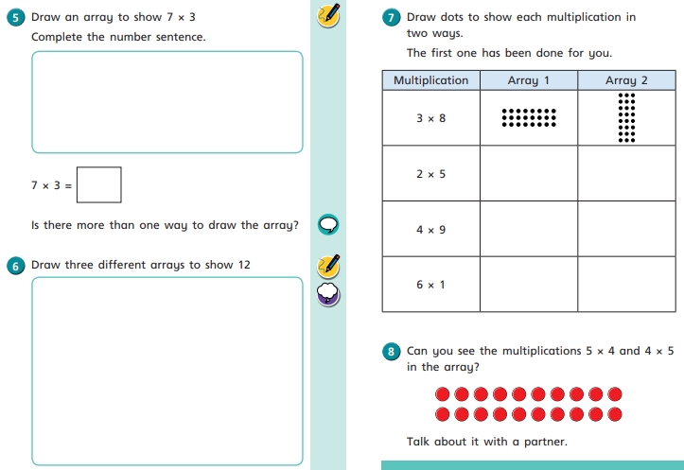
Day 1 | Flashback 4 & Arithmetic
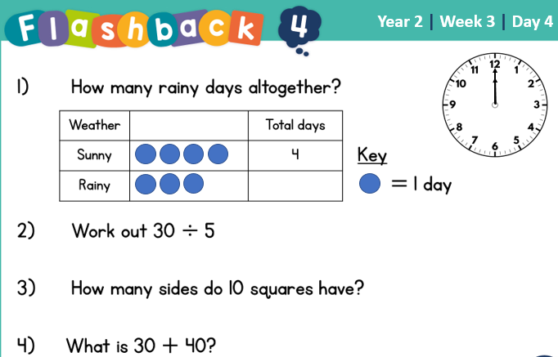
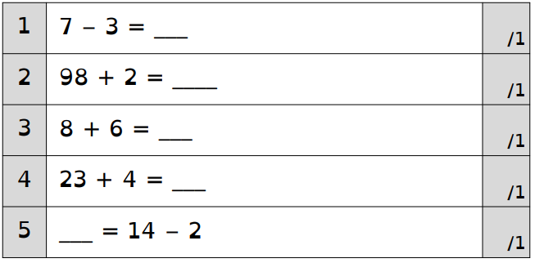
There is square paper on the next page if you need space for workings out.

Day 1 | Handwriting
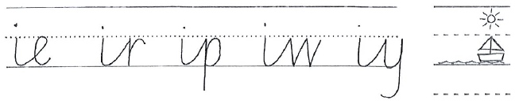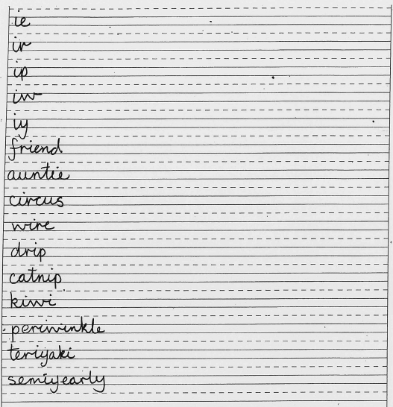
Practise each of these words to the end of the line.
Remember to take your time and look at how the joins are connected.

Day 1 | Topic
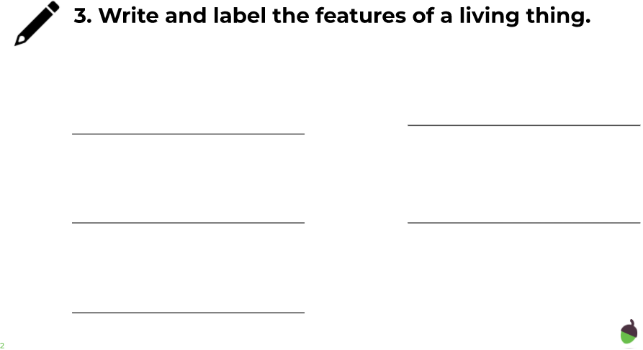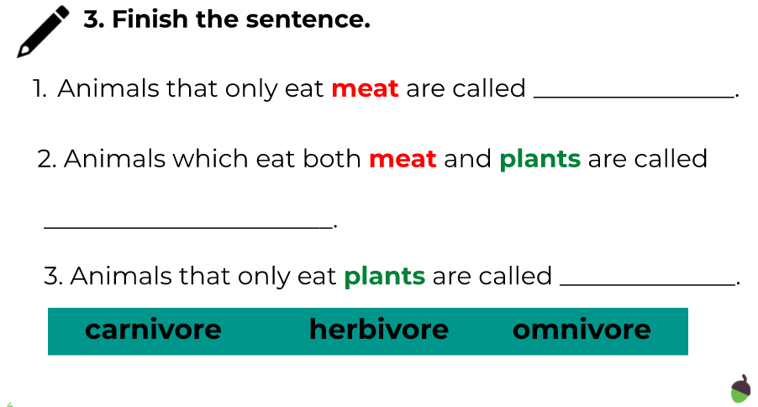

The animal kingdom

Go to this website:
https://classroom.thenational.academy/units/the-animal-kingdom-3cfa

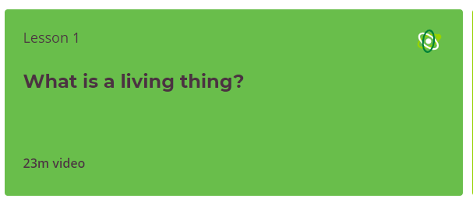

Click on lesson 1 (above). Watch the video and then complete the questions.

When you have finished, you can complete the online quiz at the end.
Day 2 | Spellings
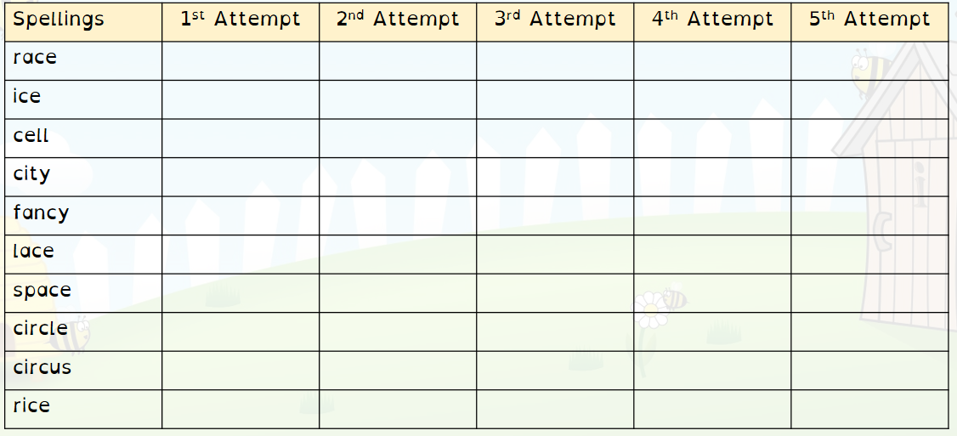
Practise writing each word 5 times.
Challenge – Can you cover the word and spell it correctly without seeing it?

Day 2 | GPS
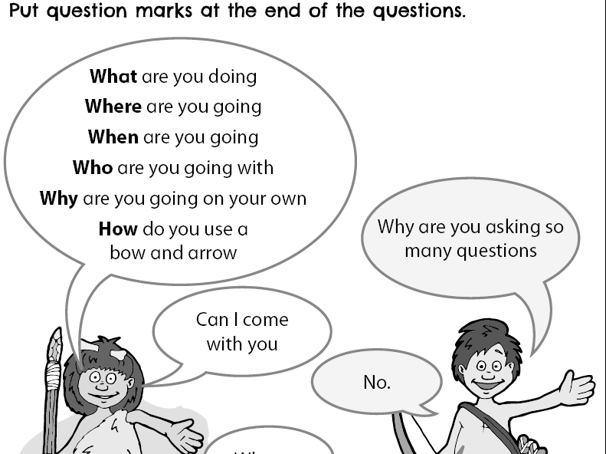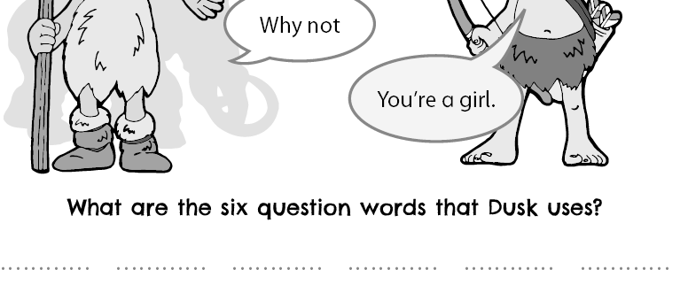

Day 2 | English
For each of the pictures/ sentences below, you need to think about:
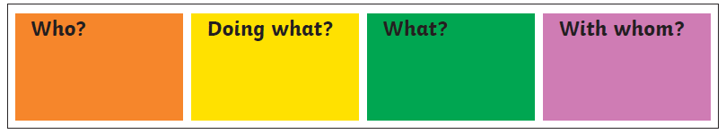
For example:
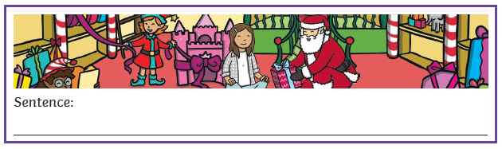
The sentence would be:
Look at how the colours link to the words.
Have a go at creating your own sentences using these 4 blocks below:
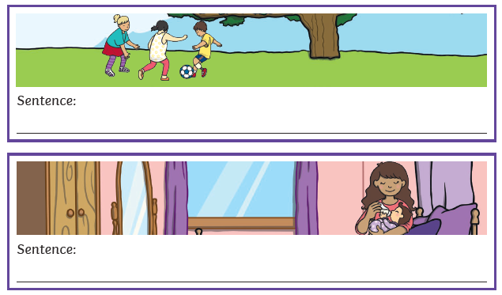
Day 2 | English
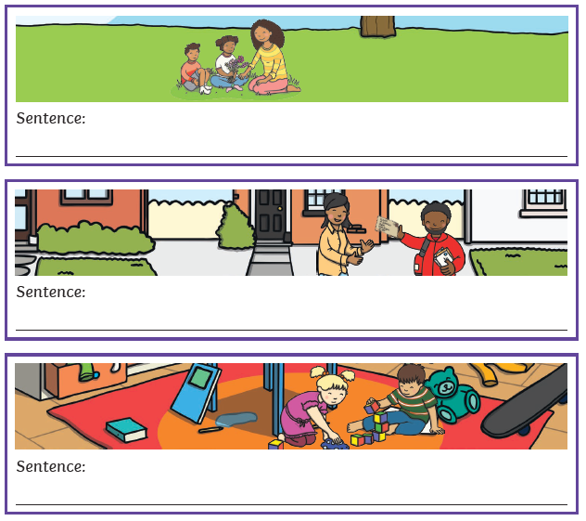 Now go back and check you have used capital letters and full stops.

Day 2 | Maths
Today’s video: https://vimeo.com/490420115
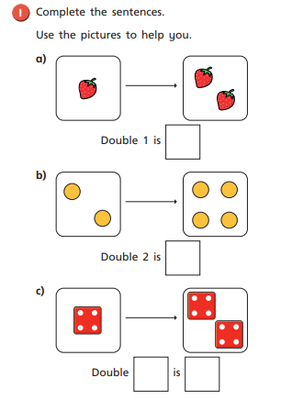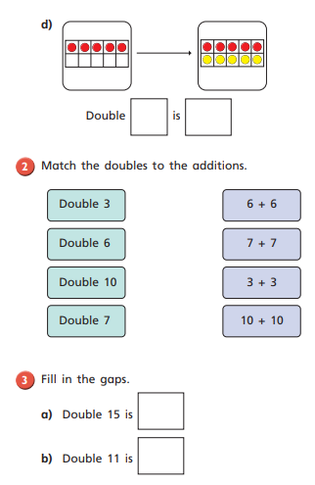
Day 2 | Maths
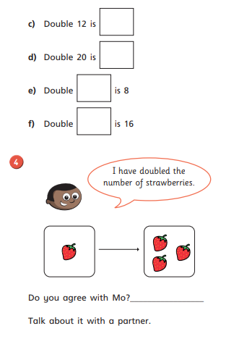
Day 2 | Flashback 4 & Arithmetic
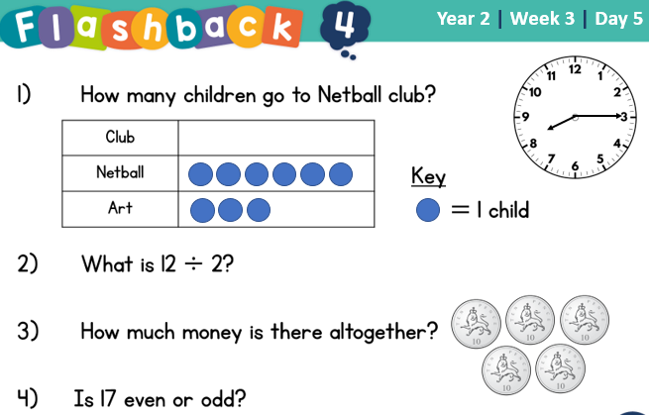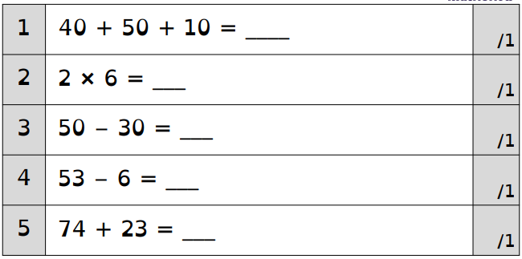
There is square paper on the next page if you need space for workings out.
Day 2 | Reading Comprehension
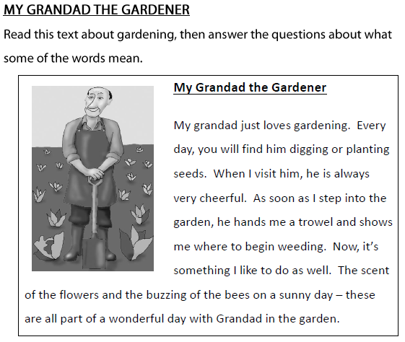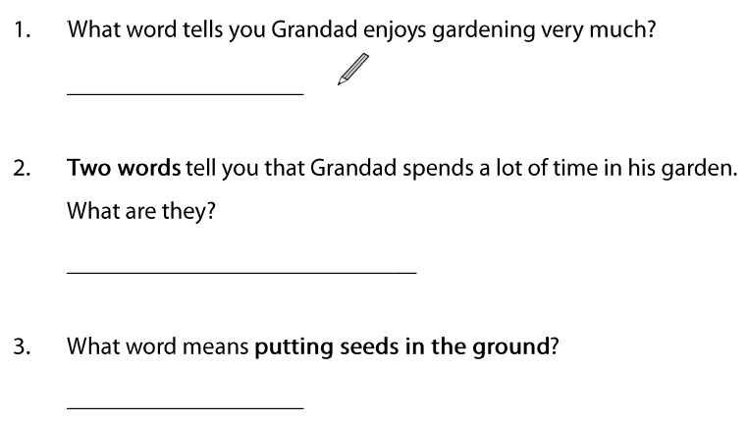
Day 2 | Reading Comprehension
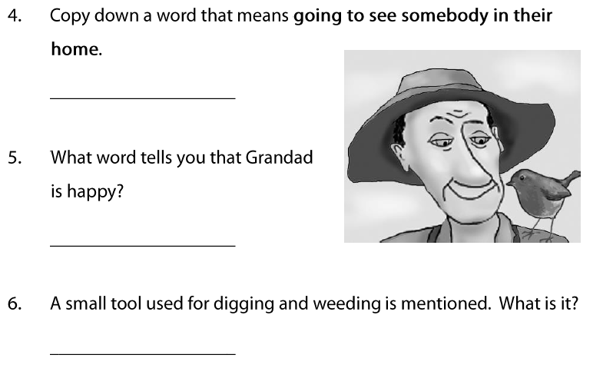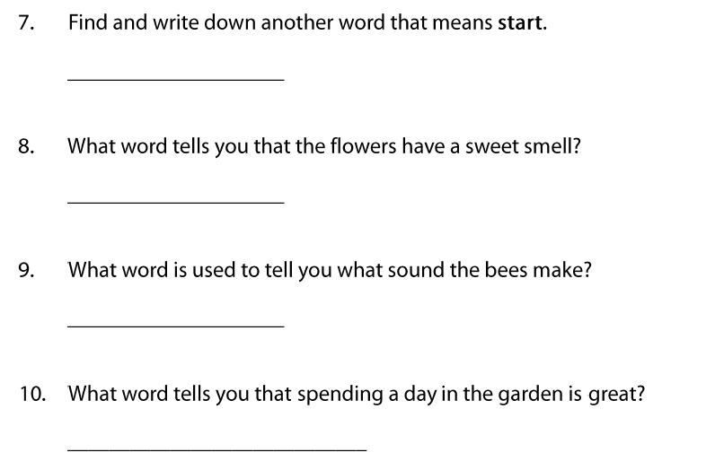

Day 2 | Topic

The animal kingdom

Go to this website:
https://classroom.thenational.academy/units/the-animal-kingdom-3cfa

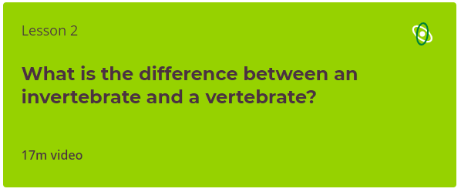

Click on lesson 2 (above). Watch the video and then complete the questions.

When you have finished, you can complete the online quiz at the end.
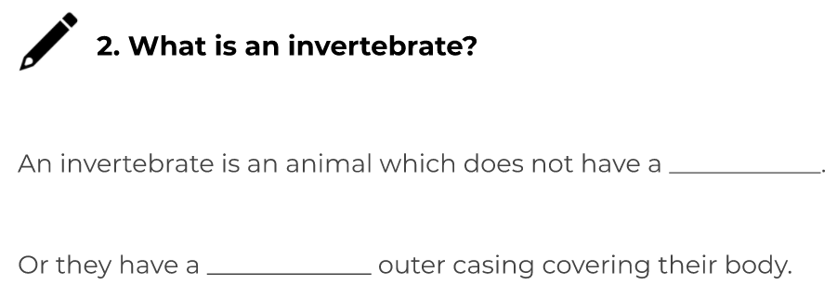

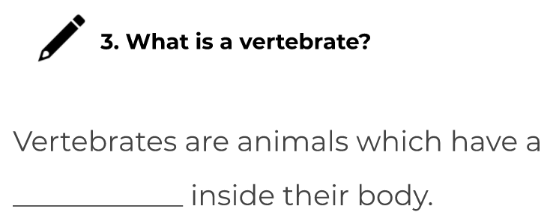
Day 3 | Spellings
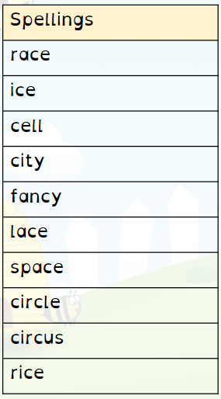
Think you know your spellings? Prove it! Write a sentence for each word. Remember, it’s not about writing short sentences. You should be able to understand the meaning of the word from your sentence.
Challenge – Can you include fronted adverbials, conjunctions and a variety of punctuation?
- __________________________________________ ____________________________________________
- __________________________________________ ____________________________________________
- __________________________________________ ____________________________________________
- ___________________________________________ ________________________________________________________
Day 3 | Spellings
- ________________________________________________________________________________________________________________
- ________________________________________________________________________________________________________________
- ________________________________________________________________________________________________________________
- ________________________________________________________________________________________________________________
- ________________________________________________________________________________________________________________
- ________________________________________________________________________________________________________________

Day 3 | GPS
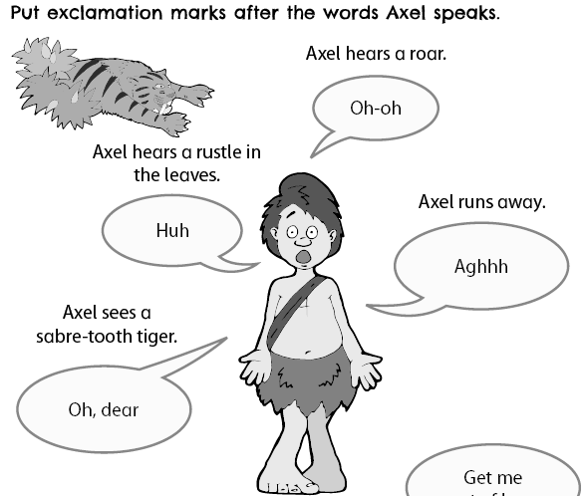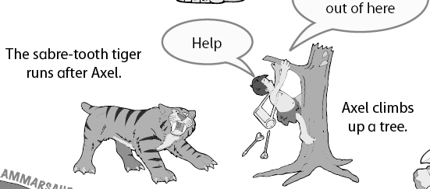
Day 3 | English
Watch this video if you need help knowing where to place capital letters and full stops: https://www.bbc.co.uk/teach/supermovers/ks1-english-capital-letters-full-stops/zjmrhbk
Once you understand how to use capital letters and full stops, have a go at correcting the sentences below:
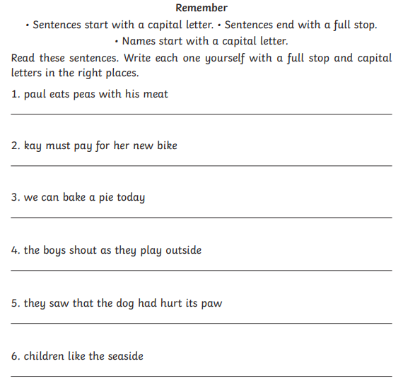

Day 3 | Maths
Today’s video: https://vimeo.com/490420447
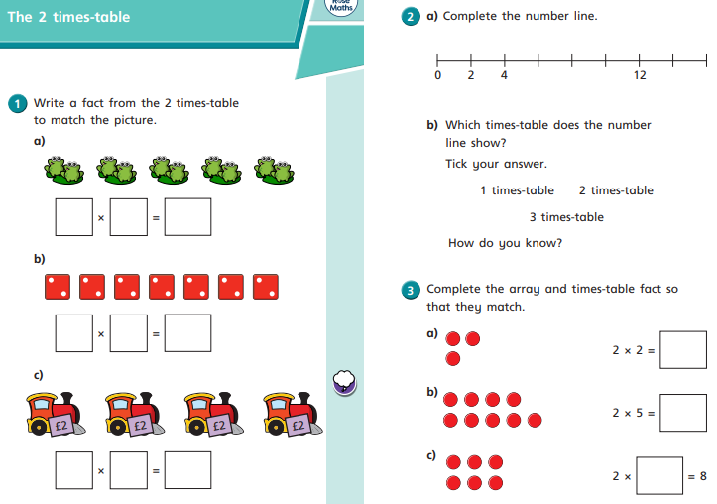
Day 3 | Maths
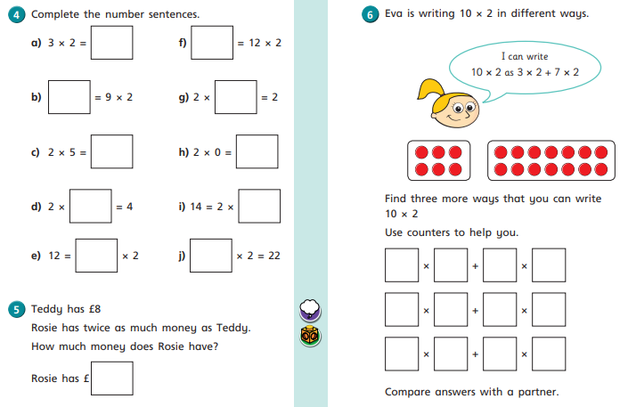

Day 3 | Flashback 4 & Arithmetic
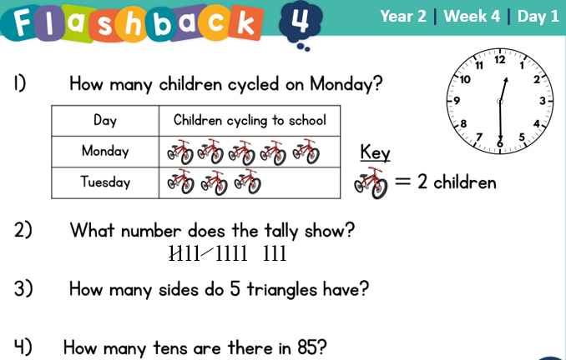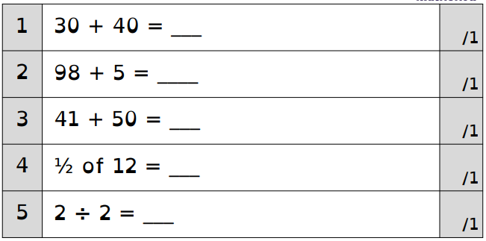
There is square paper on the next page if you need space for workings out.
Day 3 | Handwriting
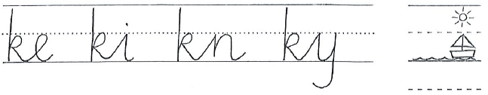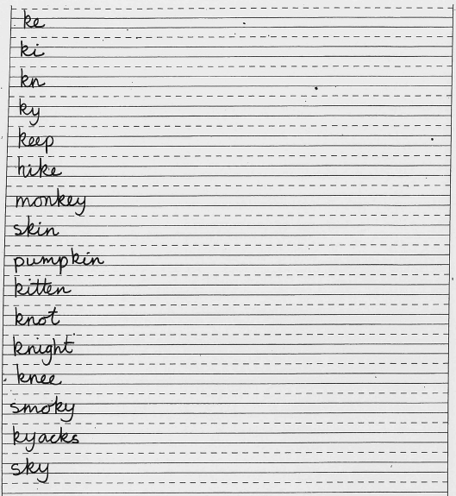
Practise each of these words to the end of the line.
Remember to take your time and look at how the joins are connected.

Day 3 | Topic

The animal kingdom

Go to this website:
https://classroom.thenational.academy/units/the-animal-kingdom-3cfa

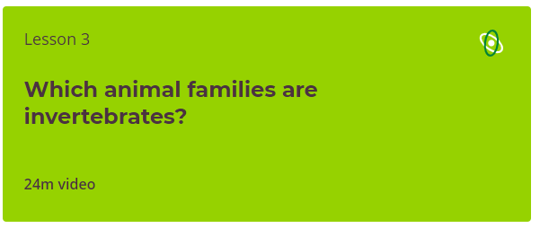

Click on lesson 3 (above). Watch the video.

When you have finished, you can complete the online quiz at the end.
Day 4 | Spellings

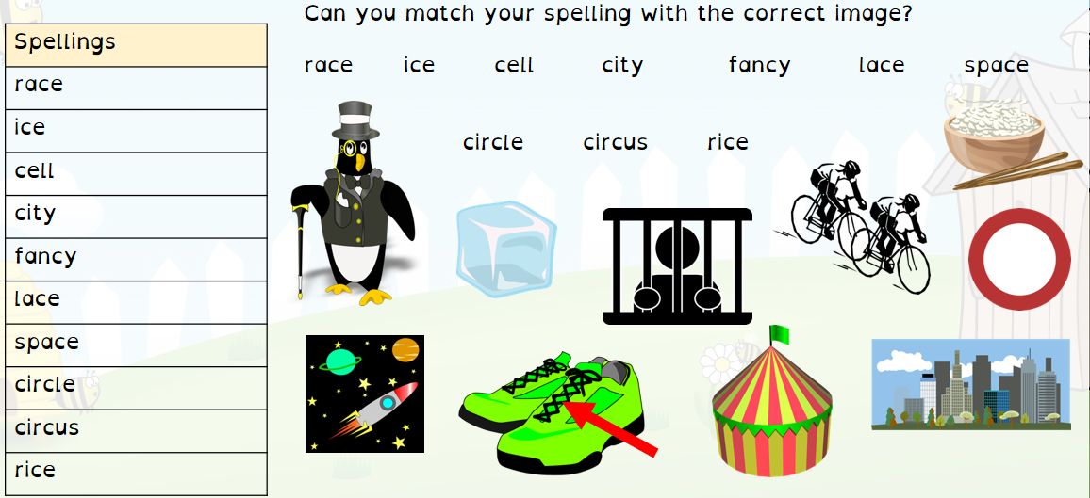

Day 4 | GPS
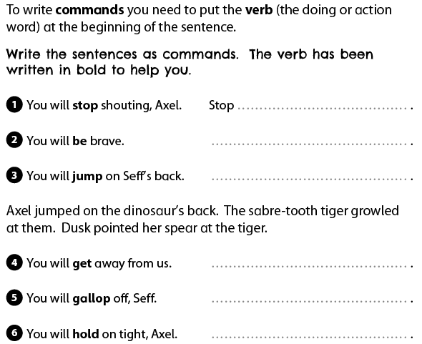
Day 4 | English
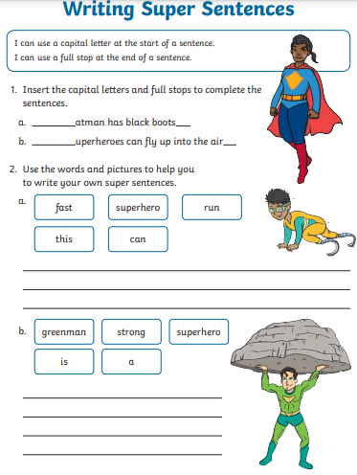

Day 4 | English
Now write your own superhero sentences with capital letters and full stops.
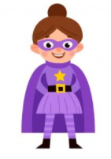
______________________________________________________________________________________________________________________

______________________________________________________________________________________________________________________

Day 4 | Maths
Today’s video: https://vimeo.com/490421314
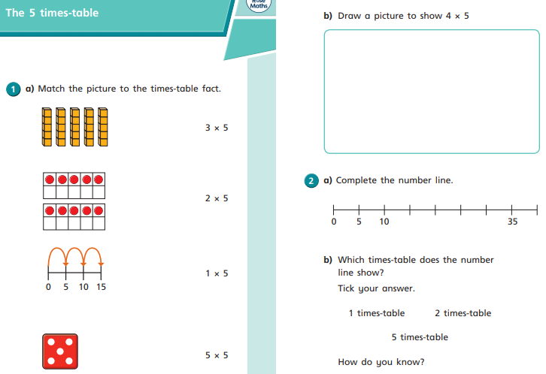
Day 4 | Maths
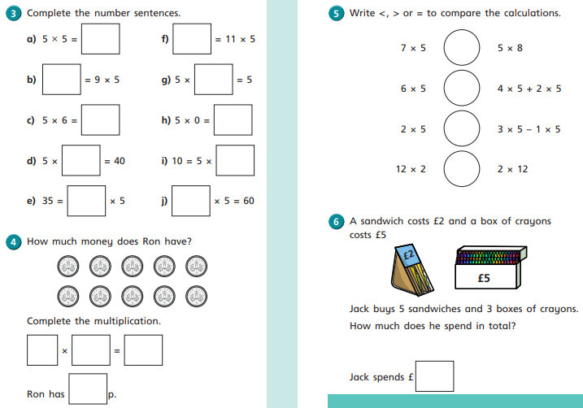
Day 4 | Flashback 4 & Arithmetic
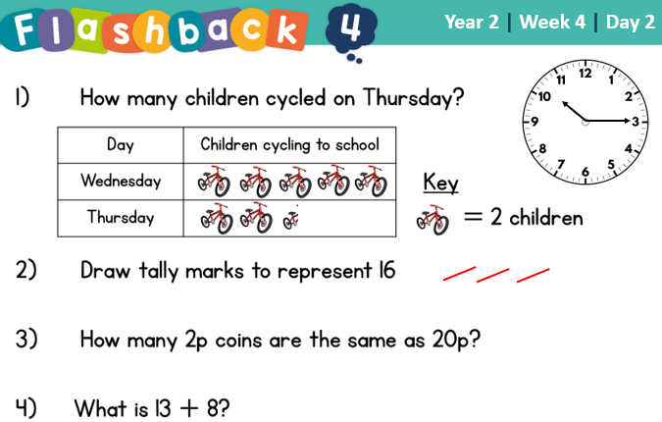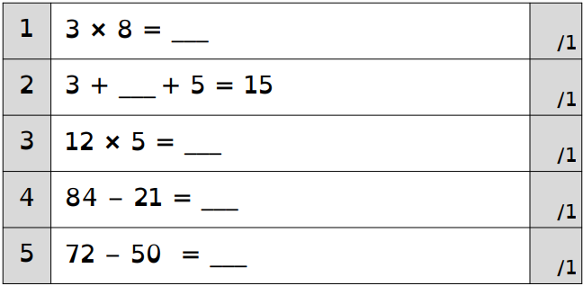
There is square paper on the next page if you need space for workings out.

Day 4 | Reading Comprehension
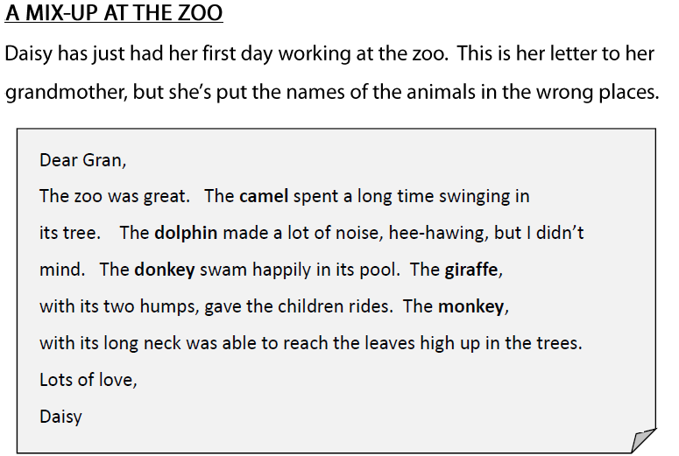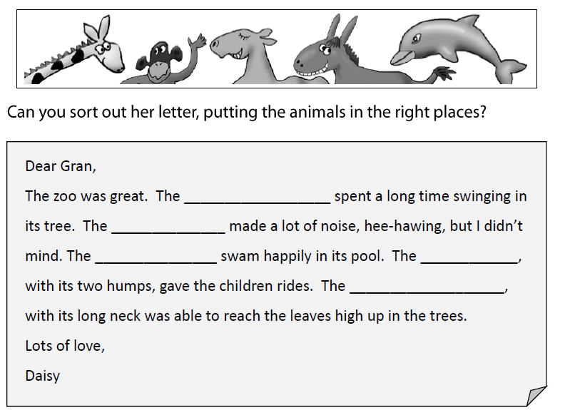

Day 4 | Topic

The animal kingdom

Go to this website:
https://classroom.thenational.academy/units/the-animal-kingdom-3cfa

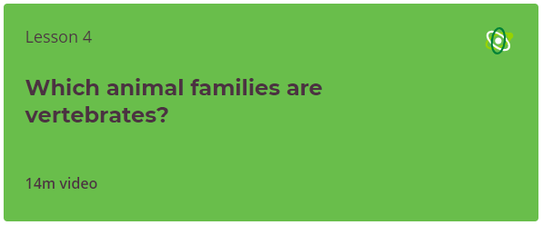

Click on lesson 4 (above). Watch the video.

When you have finished, you can complete the online quiz at the end.
Day 5 | Spellings

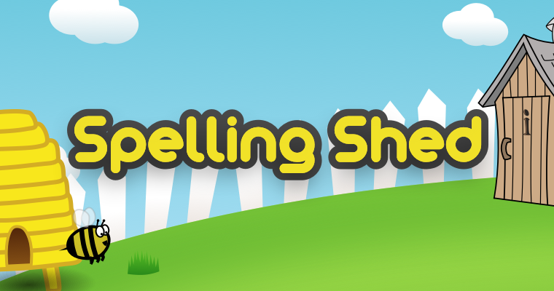
Go online and practise your spellings on Spelling Shed. You must spend at least 30 minutes practicing.
Remember, I can go online and check how long you’ve spent playing!
Your login details are in your reading diary. If you have lost these details, please email your teacher and they will email you your details.

Day 5 | GPS
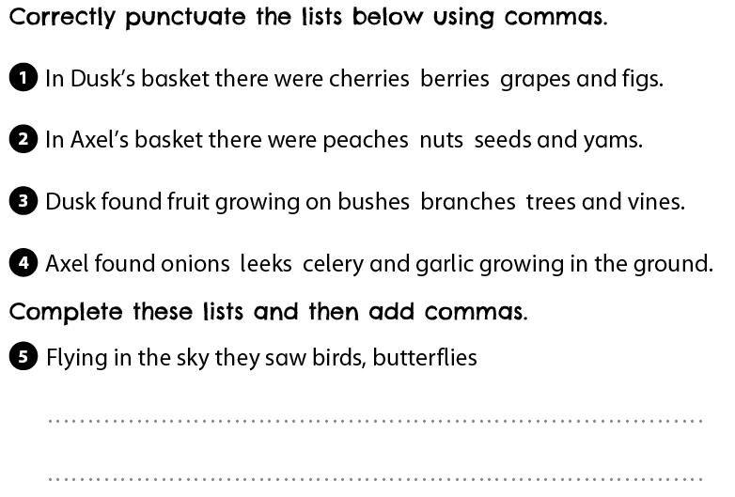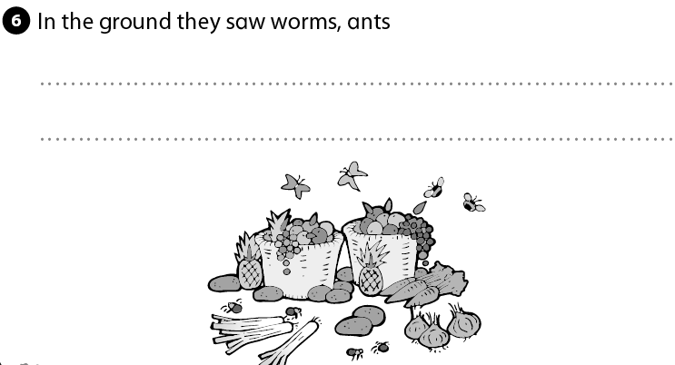
Day 5 | English
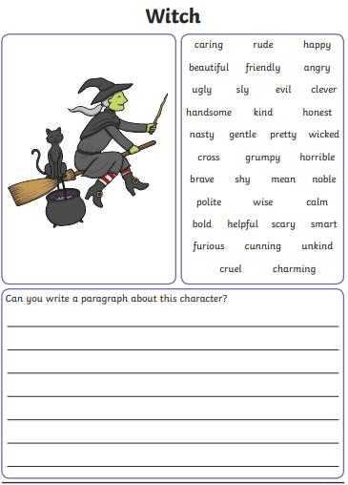
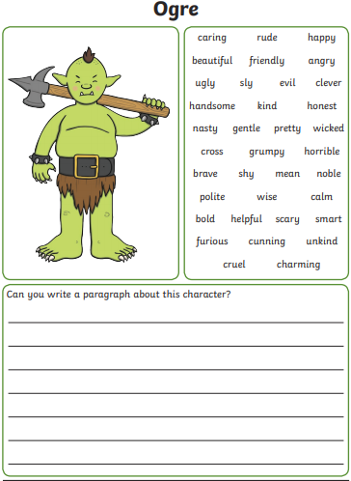
Using the skills you have practises this week, try and write 2-3 sentences for each of the pictures below. There are adjectives next to the pictures to help you.

Day 5 | Maths
Today’s video: https://vimeo.com/490421912
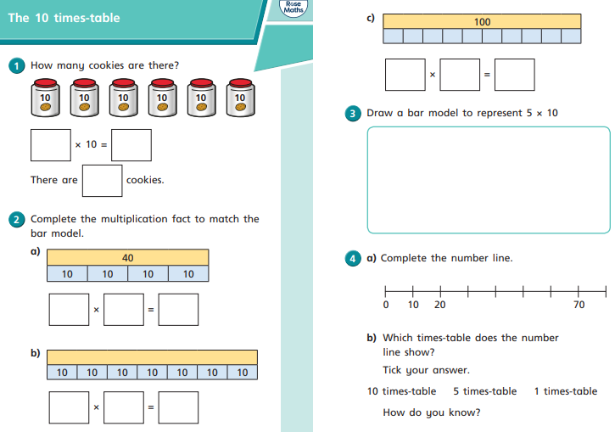
Day 5 | Maths
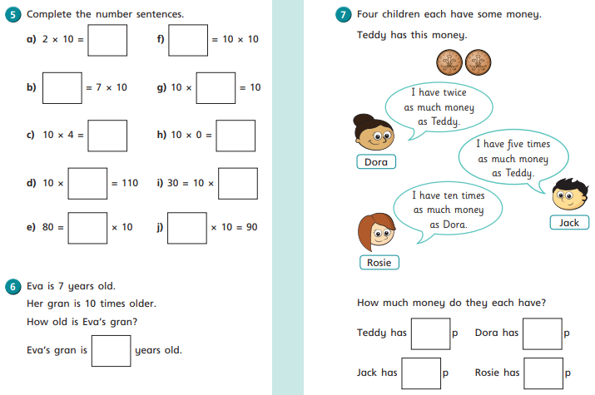

Day 5 | Flashback 4 & Arithmetic
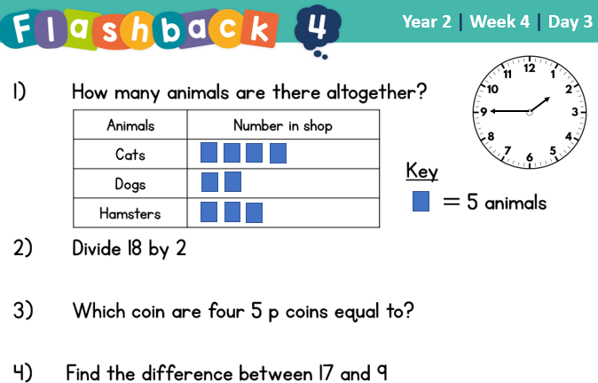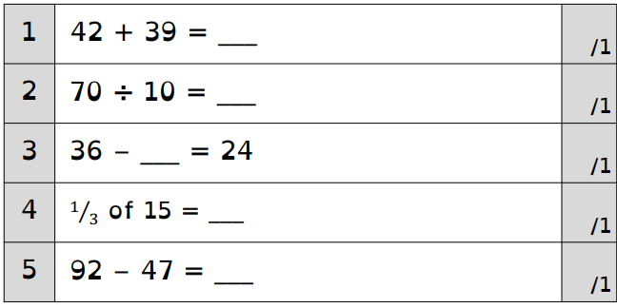

There is square paper on the next page if you need space for workings out.
Day 5 | Handwriting
Practise each of these words to the end of the line.
Remember to take your time and look at how the joins are connected.

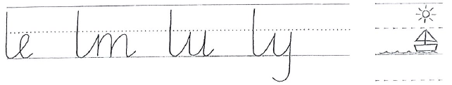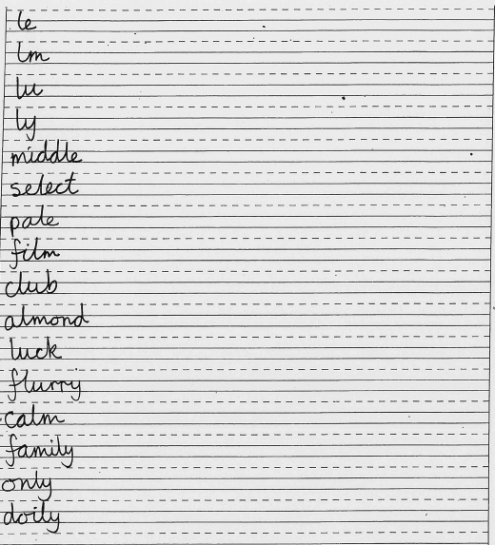
Day 5 | Topic

The animal kingdom

Go to this website:
https://classroom.thenational.academy/units/the-animal-kingdom-3cfa

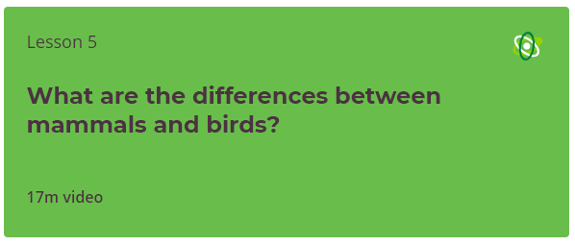

Click on lesson 5 (above). Watch the video.

When you have finished, you can complete the online quiz at the end.

Optional Projects

Go for a walk!  Can you identify all the birds you’ve seen?  Make a tally chart! | 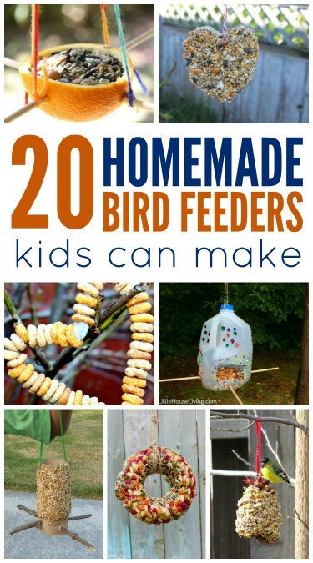  Create a bird feeder  http://lastingthumbprints.com/homemade-bird-feeders-kids-can-make/
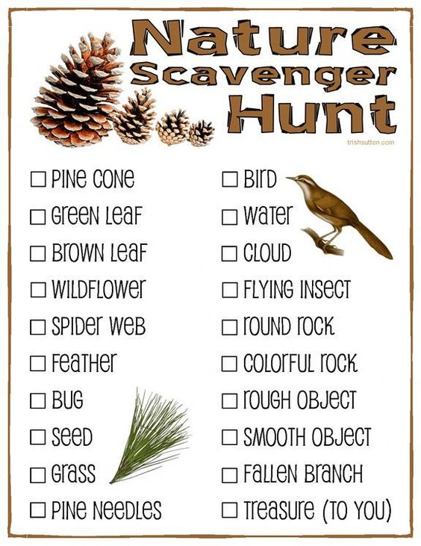  Nature Scavenger Hunt  http://trishsutton.com/nature-scavenger-hunt-free-printable-for-kids/ | 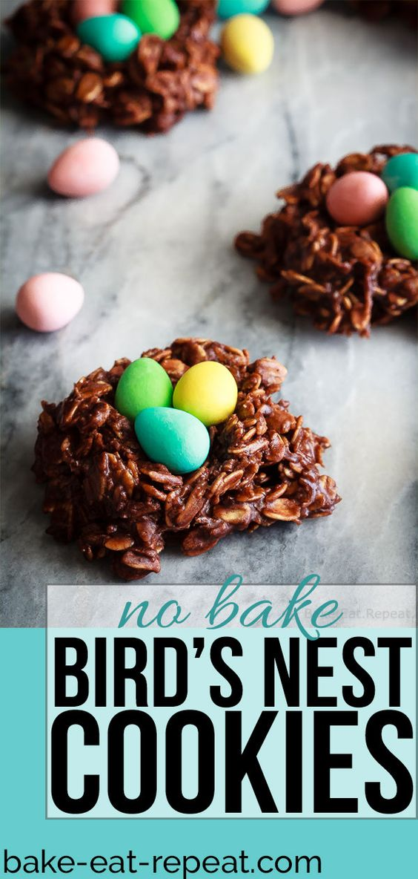  https://bake-eat-repeat.com/birds-nest-cookies-recipe/

Finished your work but still need something to do?
Check out these educational websites below:
Educational games
https://www.bbc.co.uk/cbeebies/games
Want to learn how to type properly on a keyboard?
https://www.typingclub.com/
Learn coding online
https://scratch.mit.edu/
Maths Games
https://www.topmarks.co.uk/maths-games/7-11-years/ordering-and-sequencing
Learn your maths facts fast!
https://www.topmarks.co.uk/maths-games/hit-the-button
Primary Games
https://www.bbc.co.uk/bitesize/collections/primary-games/1
Love music? Play these instruments online:
https://www.virtualmusicalinstruments.com/
Loads of maths challenges:
http://www.mathematicshed.com/
Loads of literacy things:
https://www.literacyshedplus.com/en-gb#resources
Like maths challenges? Try these!
https://www.transum.org/Software/SW/Starter_of_the_day/index.htm
Do you love to write? Check out this picture site, choose a picture and write, write, write!
https://www.onceuponapicture.co.uk/
List of sites/games
https://www.popsugar.co.uk/parenting/free-online-educational-resources-for-kids-47312329
Some of these websites are updated daily. Check them out every day!

*Found another website that you want to share with other students? Email it to your teacher and we’ll add it to the list!*

