Day 1 | Maths
Please watch today’s video: https://vimeo.com/480759672
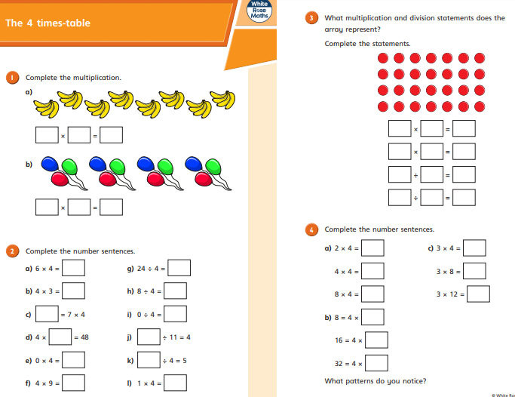
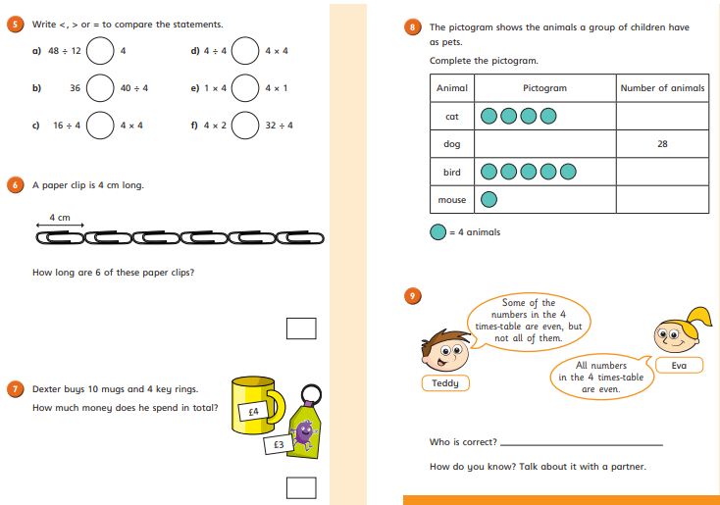
Day 2 | Maths
Please watch today’s video: https://vimeo.com/480761211
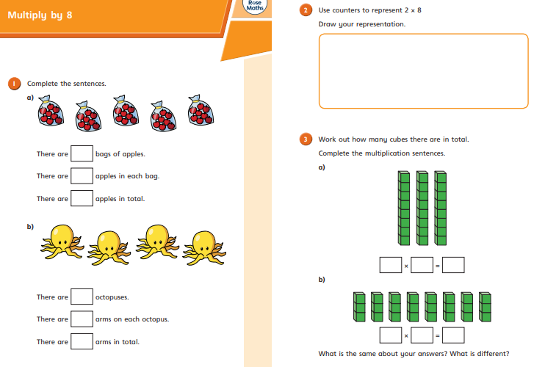
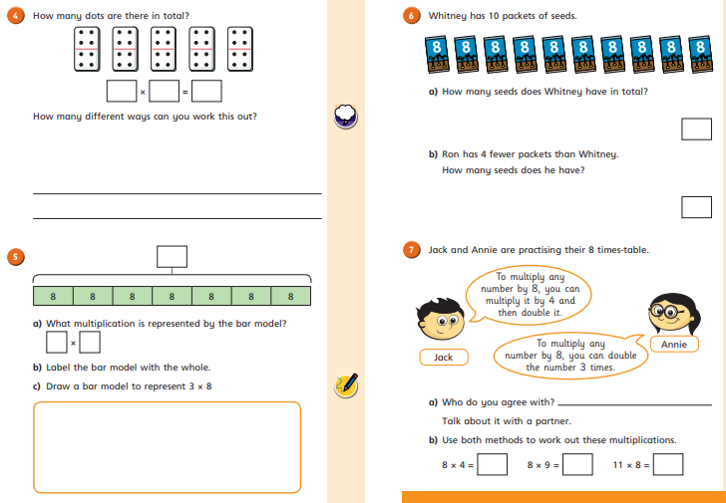
Day 3 | Maths
Please watch today’s video: https://vimeo.com/480761847
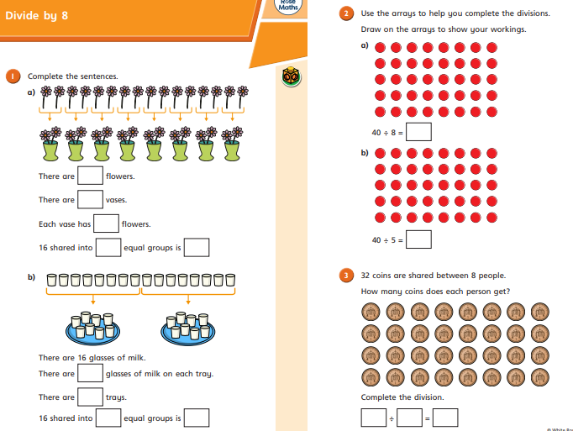
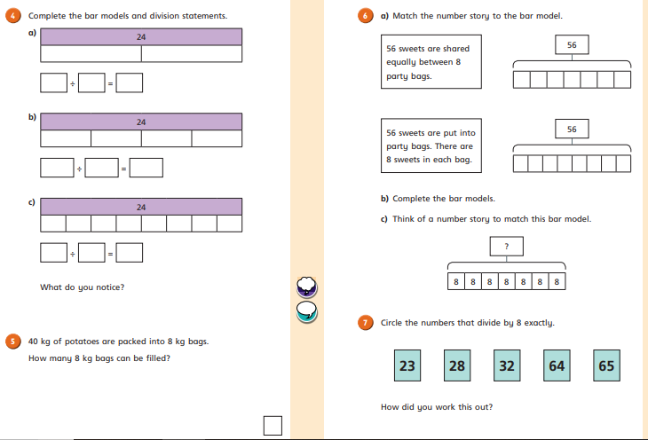
Day 4 | Maths
Please watch today’s video: https://vimeo.com/480763110
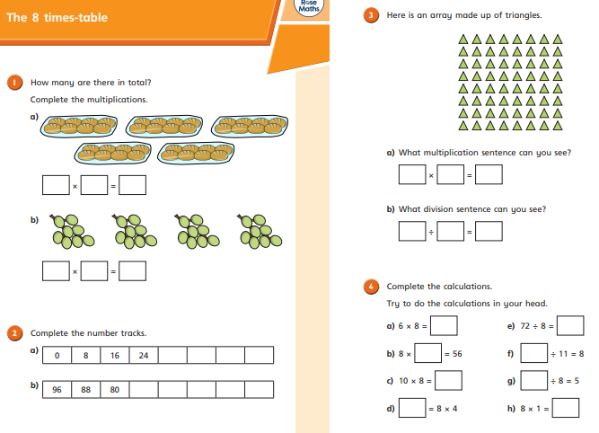
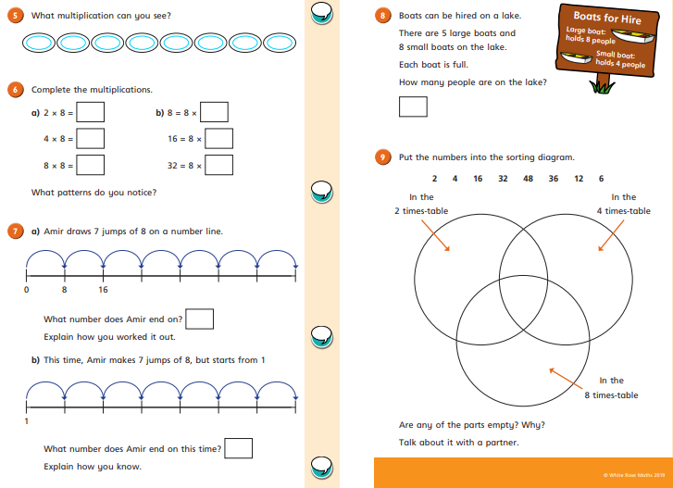

Day 5 | Maths
Please watch today’s video: N/A


