Day 1 | Maths
Please watch today’s video: https://vimeo.com/488106597
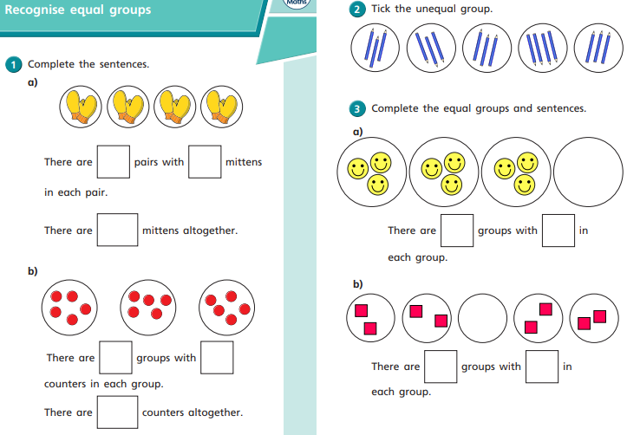
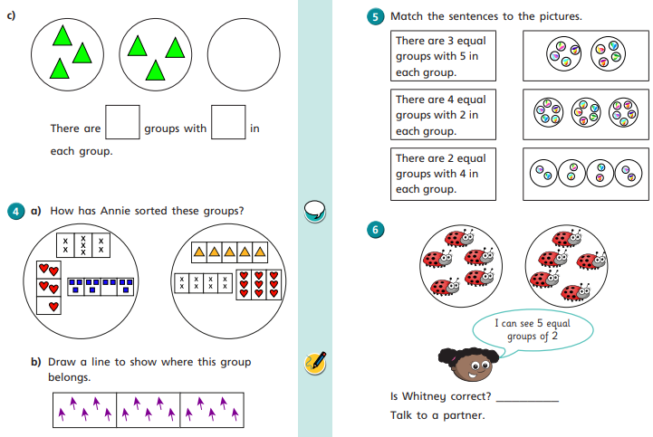
Day 2 | Maths
Please watch today’s video: https://vimeo.com/488108584
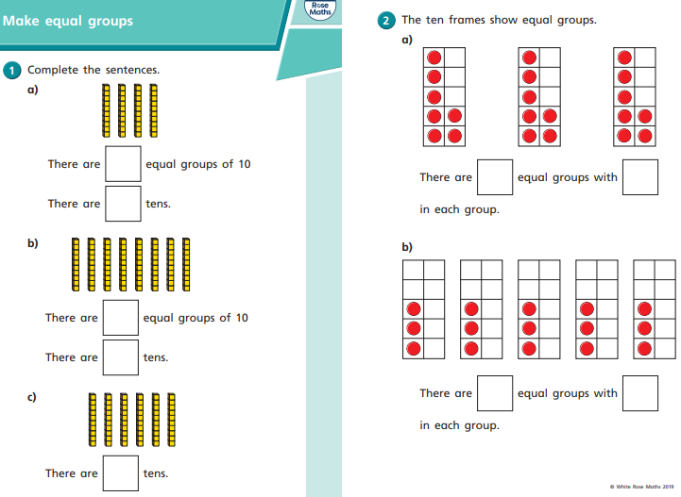
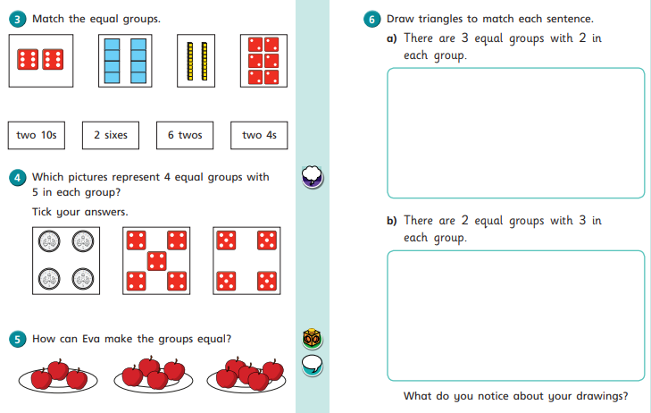

Day 3 | Maths
Please watch today’s video: https://vimeo.com/488110327
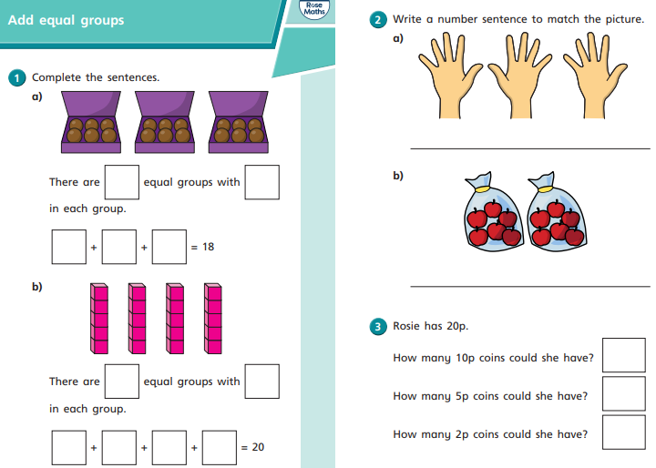
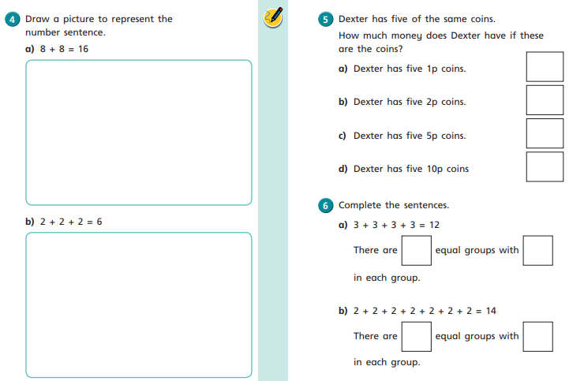
Day 4 | Maths
Please watch today’s video: https://vimeo.com/488111269
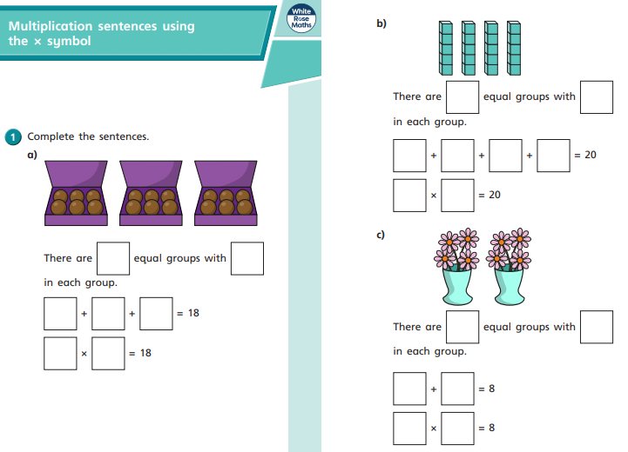
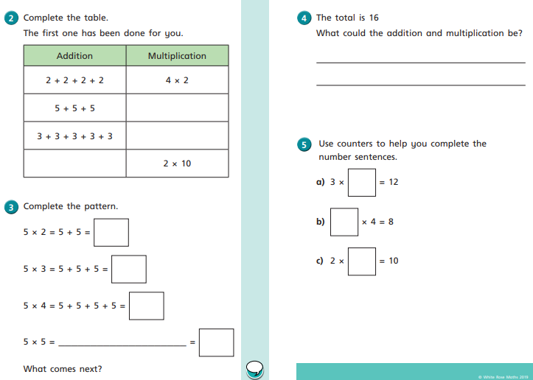
Day 5 | Maths
Please watch today’s video: https://vimeo.com/488113679


