Day 1 | Maths
For today’s video, please visit: https://www.bbc.co.uk/teach/supermovers/ks2-maths-the-9-times-table/zr2gt39
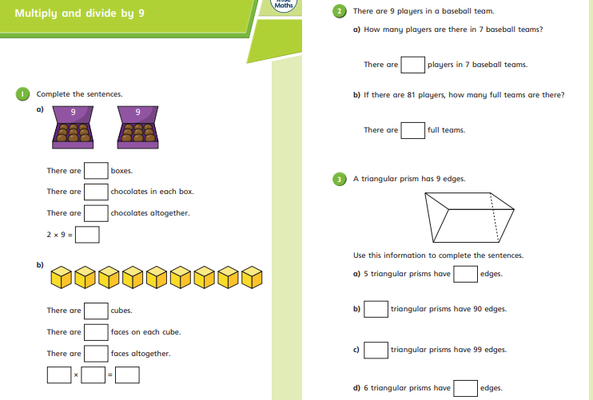
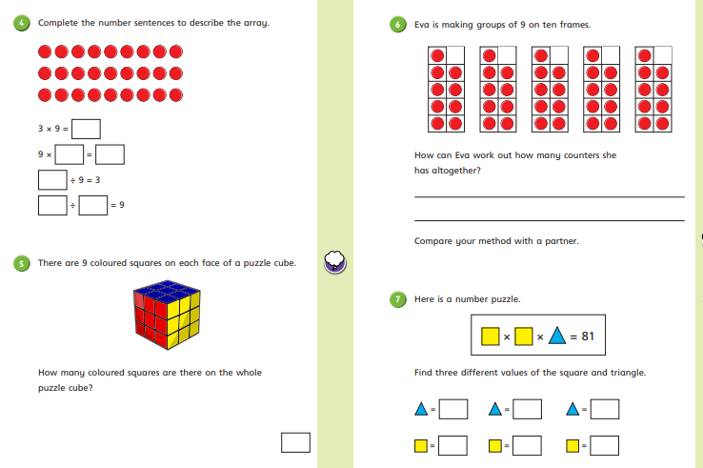
Day 2 | Maths
For today’s video, please visit: (optional) https://www.youtube.com/watch?v=NCoFSkG3XqI
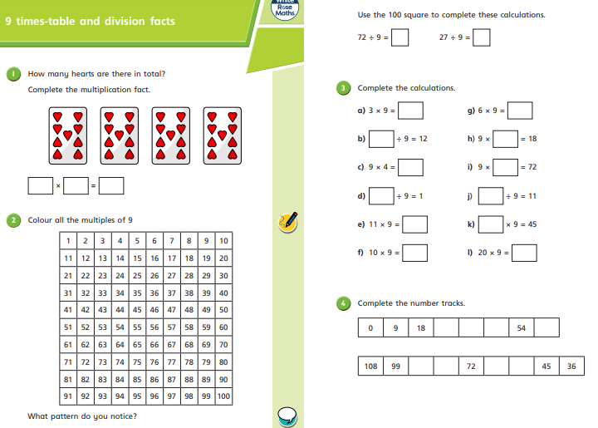
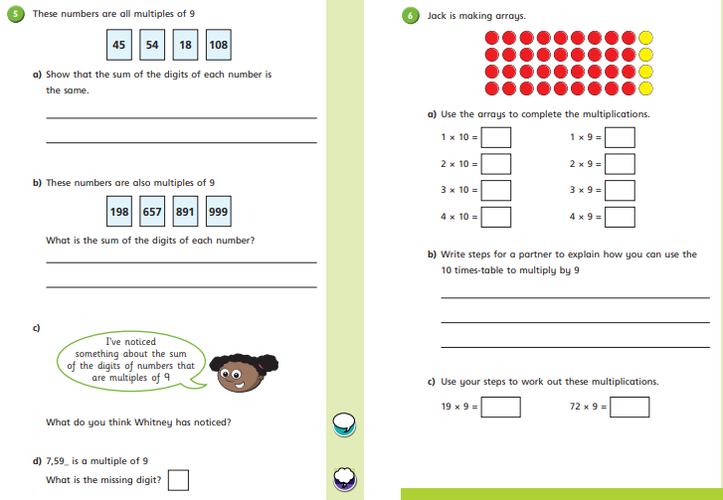
Day 3 | Maths
For today’s video, please visit: (optional) https://www.youtube.com/watch?v=5_RZ6RjUmLo
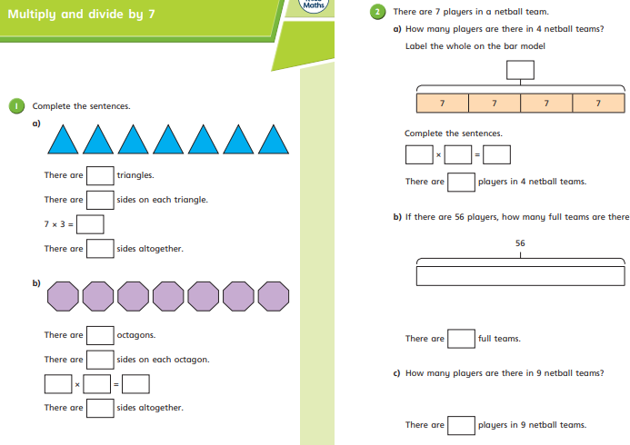
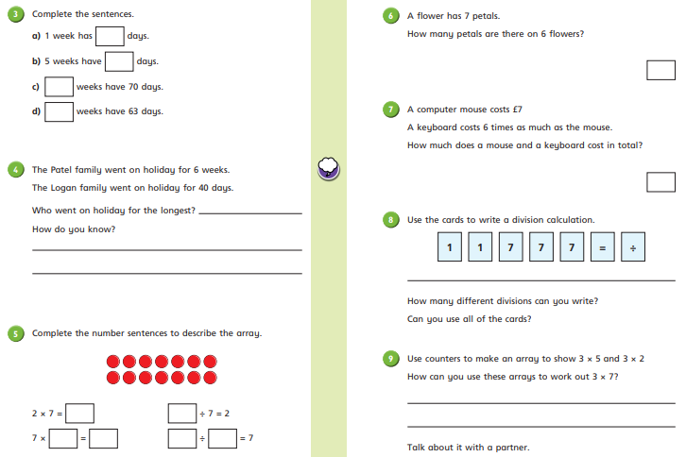
Day 4 | Maths
For today’s video, please visit: (optional) https://www.bbc.co.uk/teach/supermovers/first-seven-times-table/zd2747h

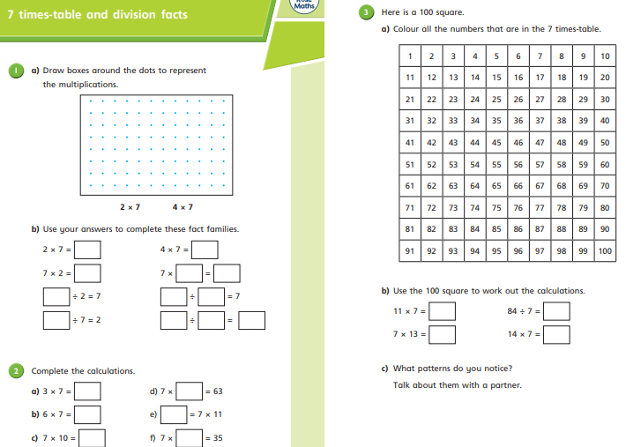
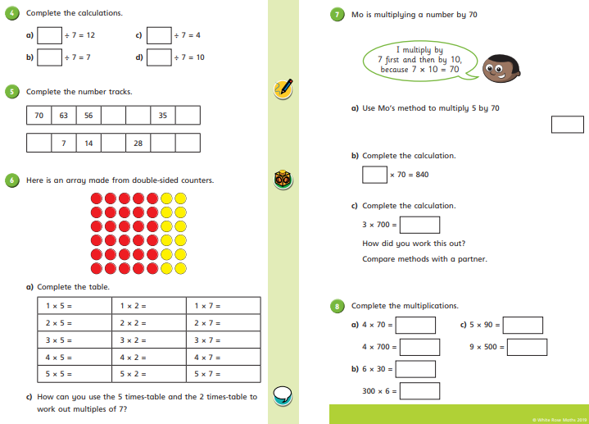

Day 5 | Maths


