Nikodem’s Salad!
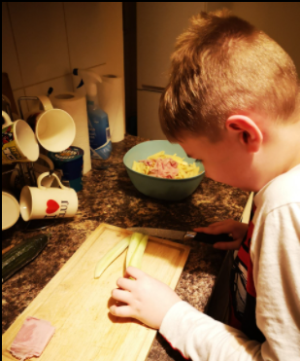
It’s good to see Nik helping out at home.



