How to access Oxford Owl eBooks – Key Stage 2
- Google www.oxfordowl.co.uk
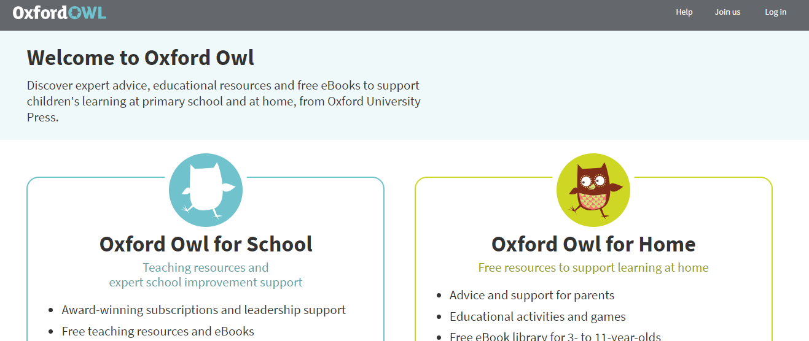
- Log in on the Oxford Owl home page

- Click on ‘Students’
- Enter your child’s username and password. This can be found in their home learning booklet.
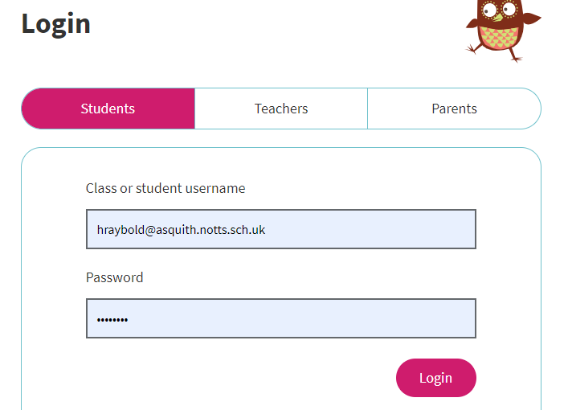

- Click on ‘Oxford owl’. eBook Library’
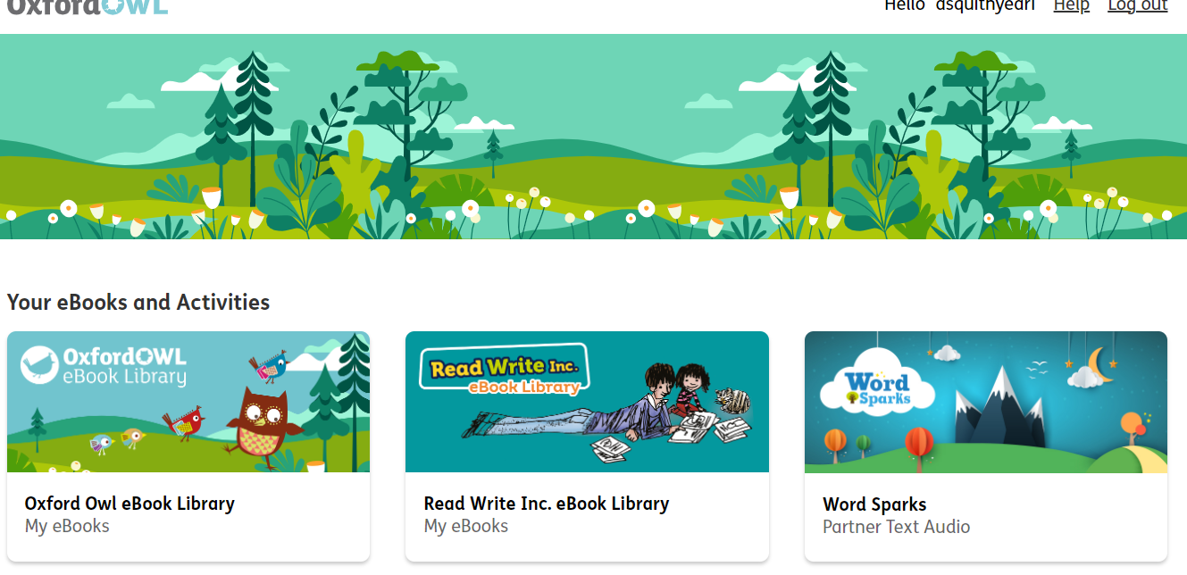

- Click on ‘Levels’ and scroll down the list to find your child’s Book Band colour.
- Click on their Book Band level.

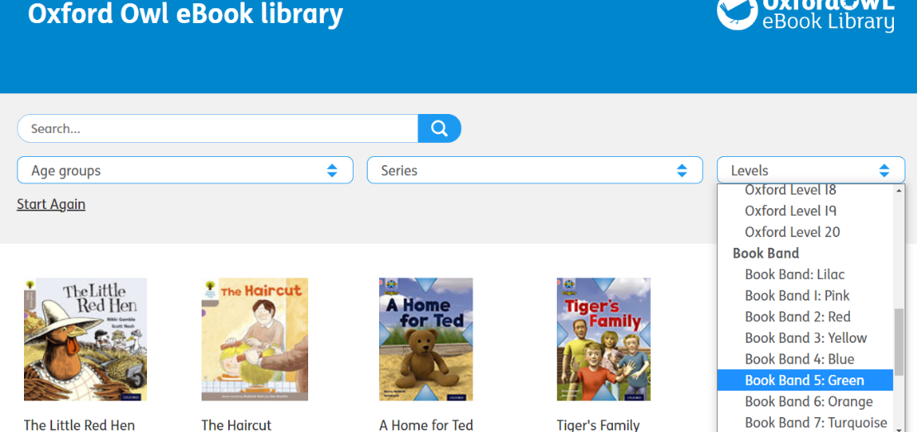

- Choose a book to read and double click on it
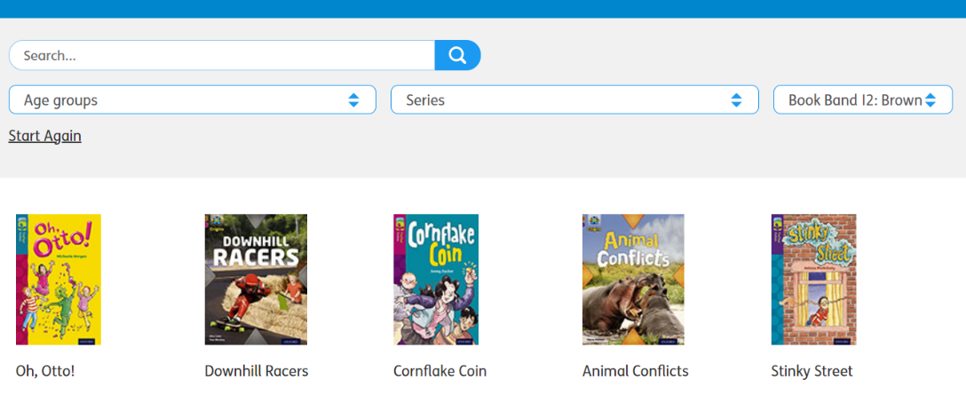

- Use the arrows at the bottom to then move through the pages of the book.


