Ewan’s amazing Minecraft world.
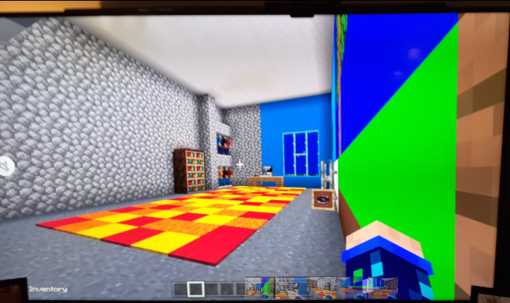
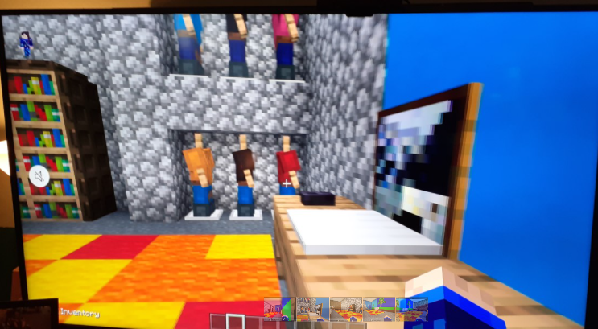
Ewan had a Minecraft themed bedroom and has recreated it in Minecraft itself. Impressive Ewan!



