T: 0115 9773740
E: fhmansfield@nottscc.gov.uk
W: Family Hub Networks | Nottinghamshire County Council
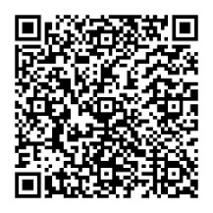
If you want to find out more about our Toilet Training Workshop:

- Get in touch by phone or email
- Scan the QR code
- Just walk into one of our Hubs where staff will be happy to help.

Are you thinking about toilet training?

Our Service deliver a Toilet Training workshop.

The workshop covers:

- Building blocks to establish a routine
- Introduction of pants.
- Praise and positive reinforcement
- Becoming dry at night.
- What to do if things don’t go to plan!


